PROJECT PROGRESS REPORT
Autonomous Zero-Day Attack Detection Framework for Satellite Constellations Using Explainable Federated Learning
Master of Data Science
Submitted by
Aliya Zuha (2548404)
Divyang Patel (2548420)
Shantanu Chowdhury (2548424)
Guide: Dr. Divya Shree
Department of Computer Science, School of Science
CHRIST (Deemed to be University), Bangalore Yeshwanthpur Campus
August 2026

Table of Contents

Right-click the table above and choose “Update Field” in Word to populate page numbers.

1. Introduction
Satellite constellations play a vital role in communication, navigation, weather monitoring, and defense. As satellite networks expand, they become increasingly vulnerable to cyber threats, especially zero-day attacks that cannot be detected using traditional signature-based methods. Existing security solutions largely rely on centralized monitoring, which raises privacy concerns and increases communication overhead.
This project proposes a cybersecurity framework that combines Federated Learning, Anomaly Detection, and Explainable Artificial Intelligence (XAI) to identify unknown cyberattacks in satellite networks. Federated Learning enables collaborative model training without sharing raw data, while XAI techniques provide transparent explanations for detected threats.
This report documents the progress made on the project so far. It covers the completed work — dataset analysis, data preprocessing, autoencoder-based anomaly detection, and a dedicated zero-day detection experiment — together with the actual results obtained. The remaining components of the pipeline (model evaluation, federated learning, and explainable AI) are outlined as planned next steps and are yet to be implemented.

2. Objectives
- To develop a Federated Learning-based framework for distributed attack detection.
- To identify zero-day attacks using anomaly detection techniques.
- To integrate Explainable AI methods for transparent decision-making.
- To reduce communication overhead by enabling decentralized learning.
- To improve cybersecurity resilience in satellite constellation networks.

3. Methodology Overview
The overall system, as designed, is a distributed cybersecurity framework in which each satellite node collects and preprocesses local data and trains a local model. Only model parameters — never raw data — are shared with a central Federated Learning server, which aggregates them into a global model. The global model is used for anomaly and zero-day detection; detected anomalies are scored for severity and explained using SHAP/LIME before being surfaced on a monitoring dashboard.
The work completed to date builds and validates the core anomaly-detection component of this pipeline on the UNSW-NB15 benchmark dataset, ahead of the federated and explainability layers. The stages covered in this report are:
- Dataset analysis and validation (UNSW-NB15)
- Data preprocessing (encoding, scaling, pipeline persistence)
- Autoencoder-based anomaly detection, trained only on normal traffic
- A dedicated zero-day simulation experiment using a withheld attack category
Model evaluation, federated learning, and explainable AI are planned next and are scoped in Sections 8–10.

4. Dataset Analysis
The project uses the UNSW-NB15 benchmark dataset as the primary source of network traffic for model development. UNSW-NB15 is a widely used intrusion-detection dataset containing labeled normal and attack traffic across multiple attack categories; it is used here as a stand-in for satellite telemetry/communication traffic, consistent with the project proposal. Analysis was performed with no changes to the underlying training or testing CSV files.

4.1 Dataset Summary
Metric | Value
Training samples | 175,341
Testing samples | 82,332
Number of features | 45
Numerical features | 41
Categorical features | 4
Missing values | 0
Duplicate records | 0
Normal samples (train + test) | 93,000
Attack samples (train + test) | 164,673
The dataset required no missing-value handling and contained no duplicate records, so no cleaning was necessary beyond the encoding/scaling steps described in Section 5.

4.2 Class and Attack-Category Distribution
The binary target (label) is imbalanced toward attacks in the training split (68.1% attack vs. 31.9% normal) and closer to balanced in the testing split (55.1% attack vs. 44.9% normal). Ten attack categories are present, ranging from Generic (the largest, 22.8% of the combined data) down to Worms, which is extremely rare at only 174 combined records (0.07%) — a property that is deliberately exploited later in the zero-day experiment (Section 7).
Attack Category | Train Count | Test Count | Combined | % of Combined
Normal | 56,000 | 37,000 | 93,000 | 36.09%
Generic | 40,000 | 18,871 | 58,871 | 22.85%
Exploits | 33,393 | 11,132 | 44,525 | 17.28%
Fuzzers | 18,184 | 6,062 | 24,246 | 9.41%
DoS | 12,264 | 4,089 | 16,353 | 6.35%
Reconnaissance | 10,491 | 3,496 | 13,987 | 5.43%
Analysis | 2,000 | 677 | 2,677 | 1.04%
Backdoor | 1,746 | 583 | 2,329 | 0.90%
Shellcode | 1,133 | 378 | 1,511 | 0.59%
Worms | 130 | 44 | 174 | 0.07%
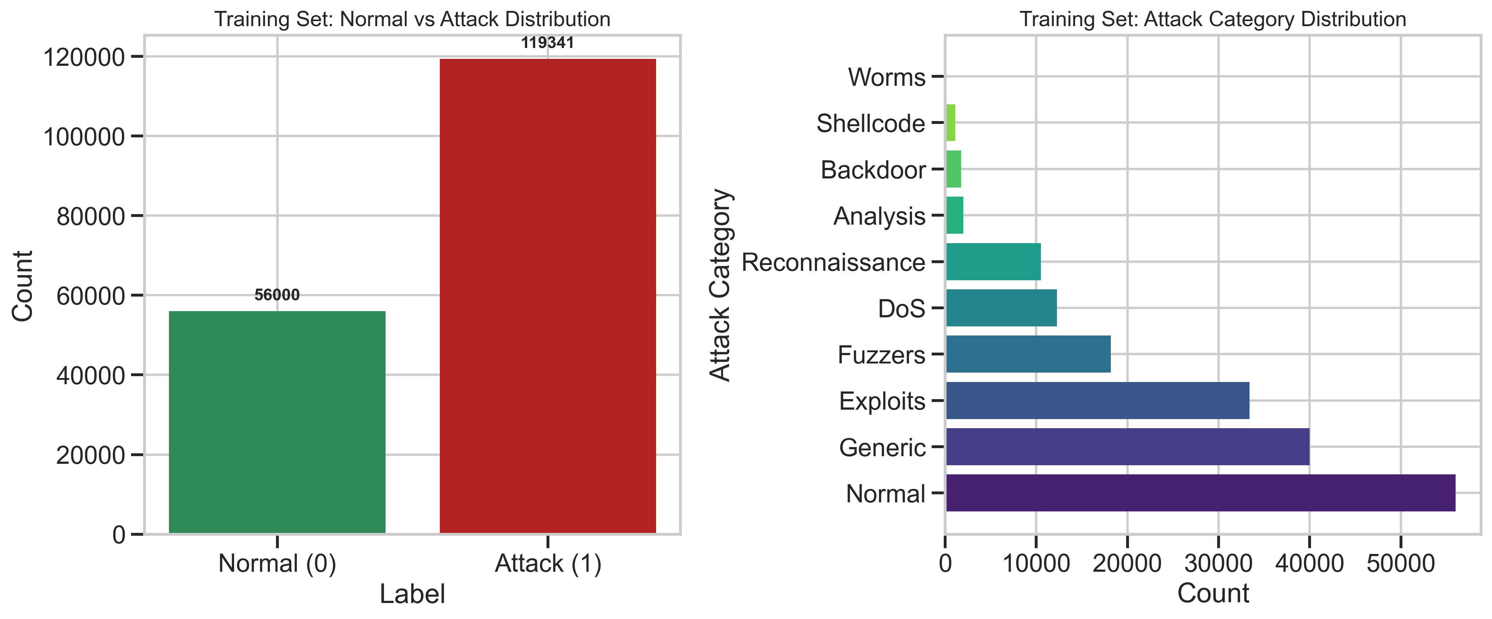
Figure 1. Training set label distribution and attack category distribution.
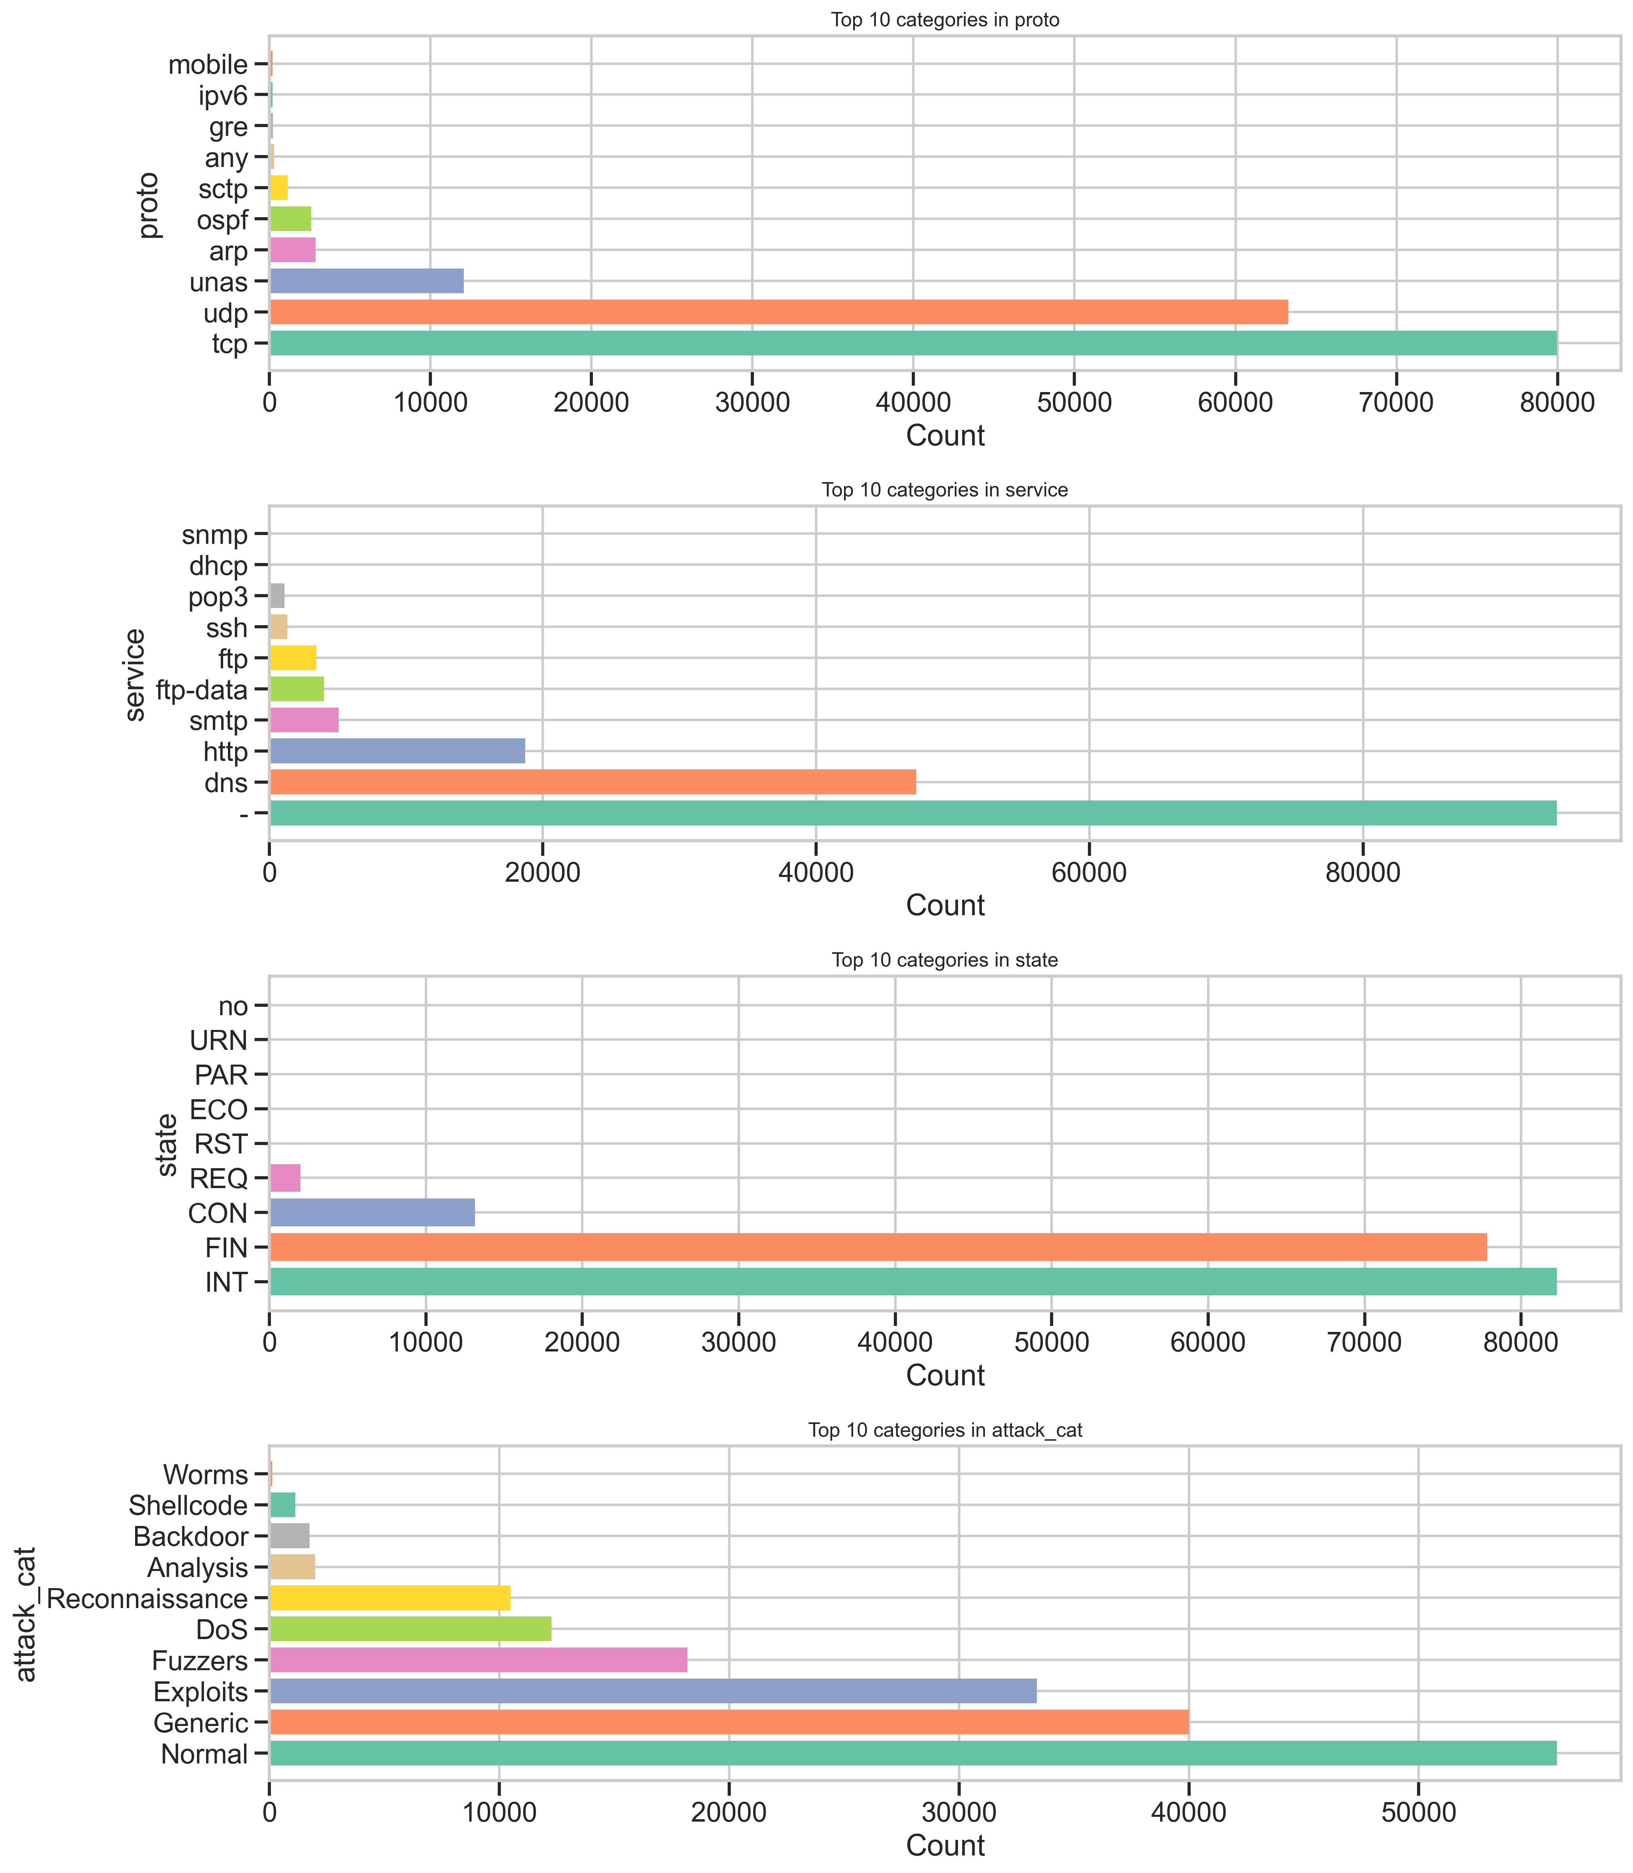
Figure 2. Top categories for protocol, service, connection state, and attack category.

4.3 Feature Correlation
A correlation analysis was run across the 41 numerical features against the binary label. The strongest positive correlations with the attack label were id, sttl (source-to-destination time-to-live) and ct_state_ttl, while the strongest negative correlations were dload, dmean, and swin — giving an early signal of which raw features carry the most separating power before any encoding or scaling was applied.
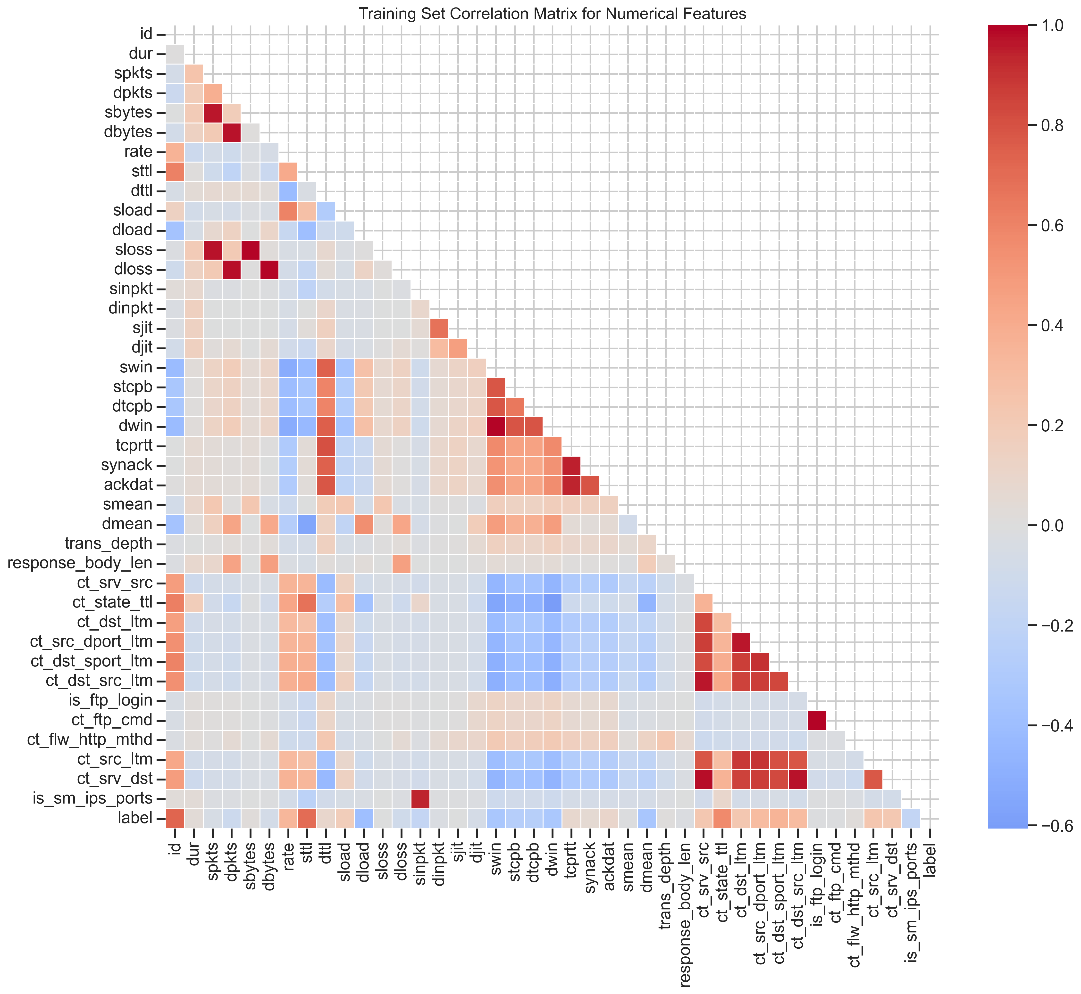
Figure 3. Correlation matrix of numerical features (training set).
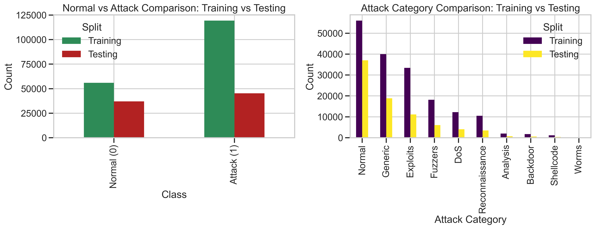
Figure 4. Label and attack-category counts compared across the training and testing splits.

5. Data Preprocessing
A preprocessing pipeline was built using scikit-learn's ColumnTransformer so that it can be reused identically across every later stage (anomaly detection, zero-day evaluation, and eventually the federated clients) without being refit. The binary label column is kept as the primary supervised target, while attack_cat is preserved separately so it remains available for the zero-day experiment. The original CSV files are never modified.

5.1 Pipeline Design
- Categorical features (proto, service, state — 3 columns) are One-Hot Encoded, with unknown categories at inference time safely ignored.
- Numerical features (40 columns) are standardized using StandardScaler (zero mean, unit variance).
- The encoder and scaler are fit only on the training data to prevent data leakage from the test set.
- The fitted pipeline is persisted to models/preprocessing_pipeline.pkl so every downstream notebook reuses the exact same transformation.

5.2 Result
Item | Before Preprocessing | After Preprocessing
Feature columns | 43 (40 numeric + 3 categorical) | 195 (numeric scaled + one-hot expanded)
Training matrix shape | 175,341 × 43 | 175,341 × 195
Testing matrix shape | 82,332 × 43 | 82,332 × 195
Missing values | 0 | 0
The one-hot expansion of the three categorical columns (with a high-cardinality proto field in particular) is what grows the feature space from 43 to 195 dimensions; this expanded representation is what feeds the autoencoder in Section 6.

6. Anomaly Detection Model — Autoencoder
An autoencoder was chosen as the core anomaly detector because it can be trained purely on normal traffic and does not require attack labels — a necessary property for a system meant to eventually flag previously unseen (zero-day) behavior. It was trained exclusively on the 56,000 normal-labelled rows of the training set (label == 0); no attack samples of any kind were used to fit the model or calibrate its threshold.

6.1 Architecture
Layer | Output Shape | Parameters
Input | (None, 195) | —
encoder (Dense, ReLU) | (None, 64) | 12,544
latent (Dense, ReLU) | (None, 32) | 2,080
decoder (Dense, ReLU) | (None, 64) | 2,112
reconstruction (Dense, Linear) | (None, 195) | 12,675
Total trainable parameters: 29,411. The 195-dimensional input (post one-hot/scaling) is compressed to a 32-dimensional latent representation and reconstructed back to 195 dimensions; the model is trained to minimize mean-squared reconstruction error.

6.2 Training and Threshold Calibration
- Optimizer: Adam (learning rate = 1e-3), Loss: MSE
- Normal training data (56,000 rows) split 80/20 → 44,800 rows to fit the autoencoder, 11,200 held out purely for threshold calibration
- Trained for 20 epochs, batch size 256, with early stopping (patience = 3, monitoring validation loss)
- Best validation loss achieved: 0.000914
- Anomaly threshold set at the 95th percentile of reconstruction error on the held-out normal calibration set: 0.002627 — test labels were never used to pick this threshold
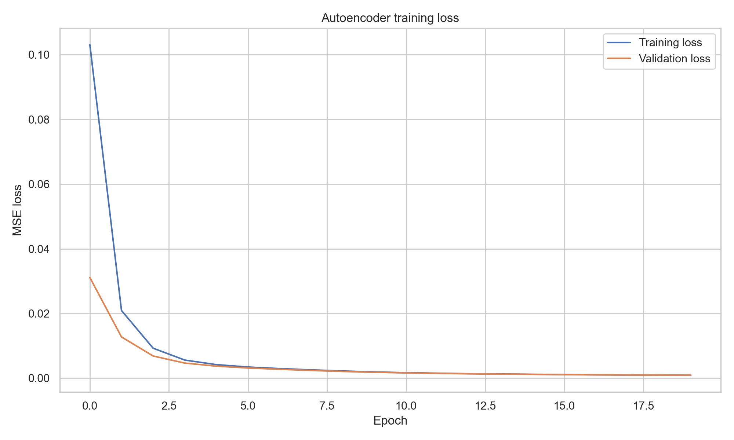
Figure 5. Autoencoder training vs. validation loss across epochs.

6.3 Evaluation on the Test Set
The calibrated threshold was applied to the entire (untouched) test set of 82,332 rows to classify each sample as normal or anomalous based purely on reconstruction error.
Metric | Value
Accuracy | 0.8240
Precision | 0.9108
Recall | 0.7542
F1-Score | 0.8251
ROC-AUC | 0.8843
Confusion matrix (rows = true label, columns = predicted label; 0 = Normal, 1 = Attack/Anomaly):
 | Predicted Normal | Predicted Anomaly
Actual Normal | 33,652 | 3,348
Actual Attack | 11,143 | 34,189
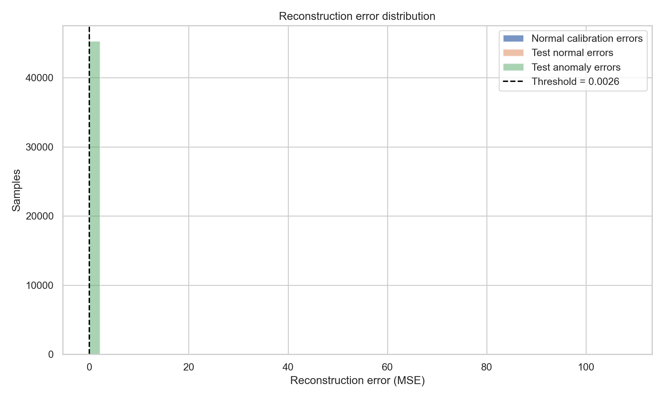
Figure 6. Reconstruction-error distributions for calibration data, test-normal, and test-attack samples, with the 95th-percentile threshold marked.
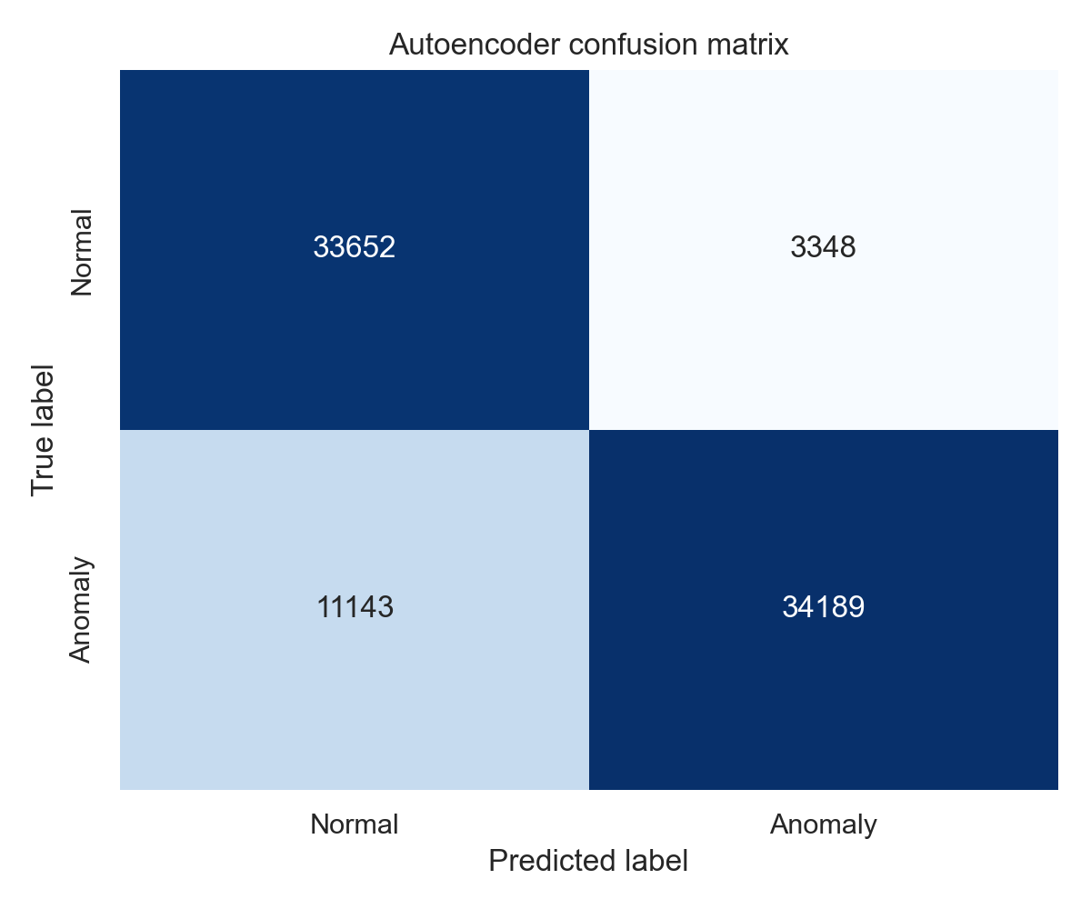
Figure 7. Confusion matrix for the autoencoder on the full test set.
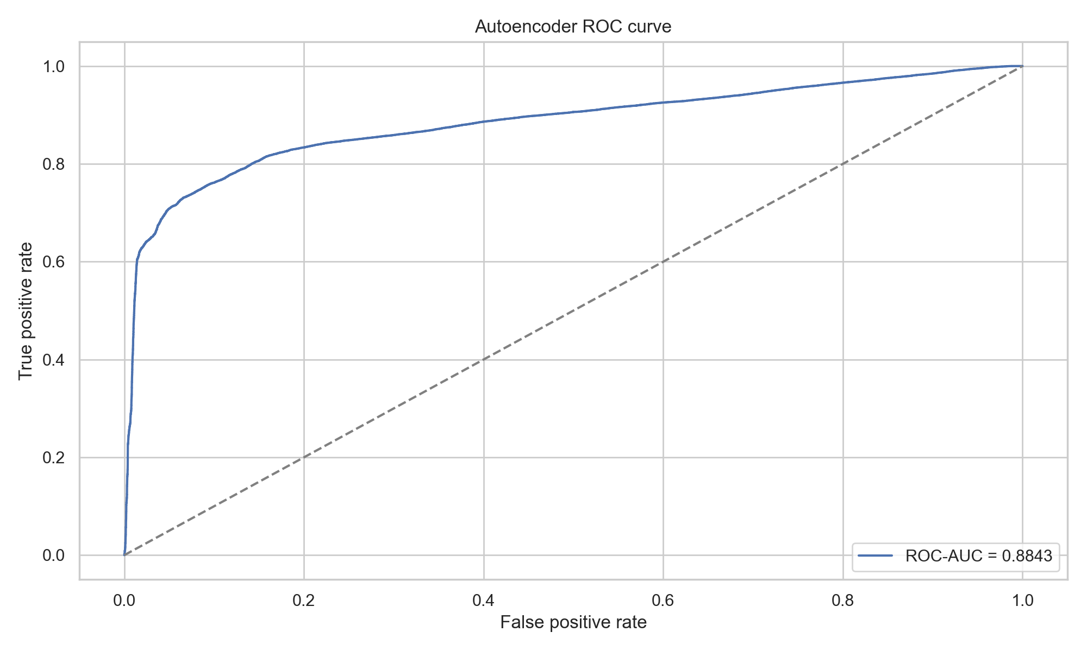
Figure 8. ROC curve (AUC = 0.8843).
The model reaches 82.4% accuracy and an F1-score of 0.825 on the full test set, with high precision (0.911) but comparatively lower recall (0.754) — i.e., when it flags something as anomalous it is usually right, but it misses a meaningful share of attacks. This trained autoencoder and its calibrated threshold are reused unchanged in the zero-day experiment below.

7. Zero-Day Detection Experiment
To evaluate the system's ability to catch genuinely novel attacks rather than just attacks statistically similar to what it has seen, the Worms attack category was designated as the “unseen” / zero-day class. Worms is the rarest category in UNSW-NB15 (only 130 training rows and 44 testing rows), making it a realistic stand-in for a novel attack family. The Step-6 autoencoder and its threshold — both fit only on normal traffic, with no attack category involved in training or calibration — were reused without any retraining.
For evaluation, the test set was split into three groups:
- Normal — benign traffic (label = 0)
- Known attack — every attack category except Worms
- Unseen: Worms — the withheld category, treated as the simulated zero-day class

7.1 Results
Metric | Value
Accuracy | 0.8240
Precision | 0.9108
Recall | 0.7542
F1-Score | 0.8251
Known-attack detection rate | 0.7546
Unseen (Worms) detection rate | 0.3182
Normal false-positive rate | 0.0905
Group | Samples | Mean Recon. Error | Median Recon. Error | Flagged as Anomaly | Detection Rate
Normal | 37,000 | 0.001481 | 0.000530 | 3,348 | 9.05%
Known attack | 45,288 | 0.042699 | 0.015172 | 34,175 | 75.46%
Unseen: Worms | 44 | 0.007473 | 0.001935 | 14 | 31.82%
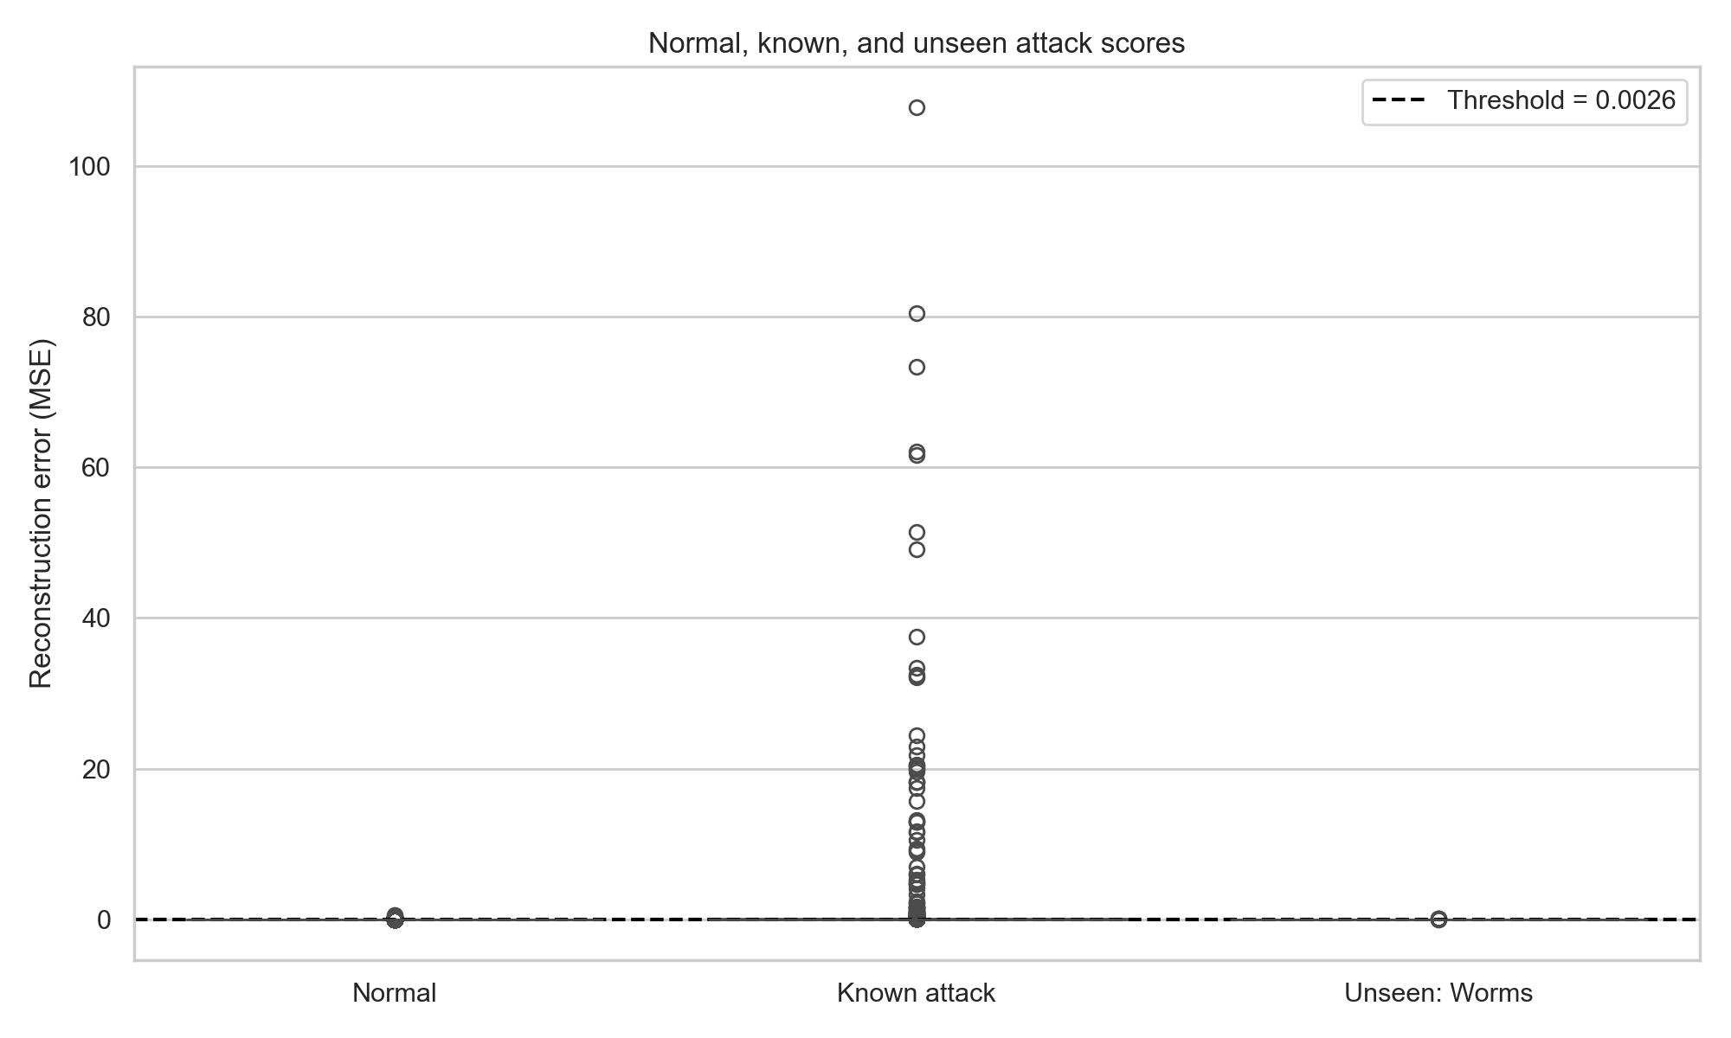
Figure 9. Reconstruction error by group (Normal / Known attack / Unseen: Worms), with the detection threshold marked.
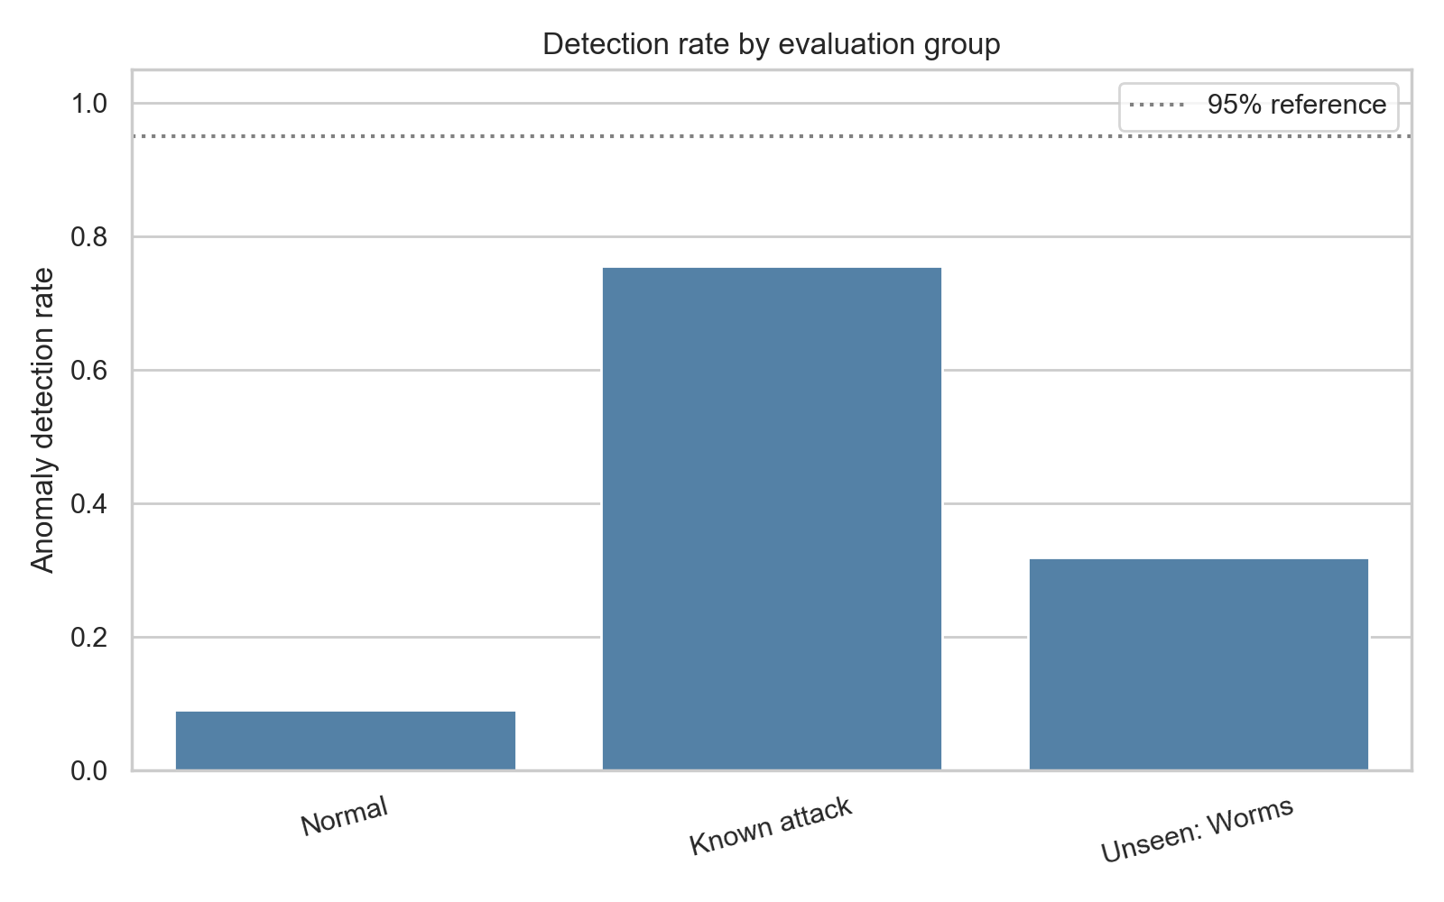
Figure 10. Detection rate by evaluation group.
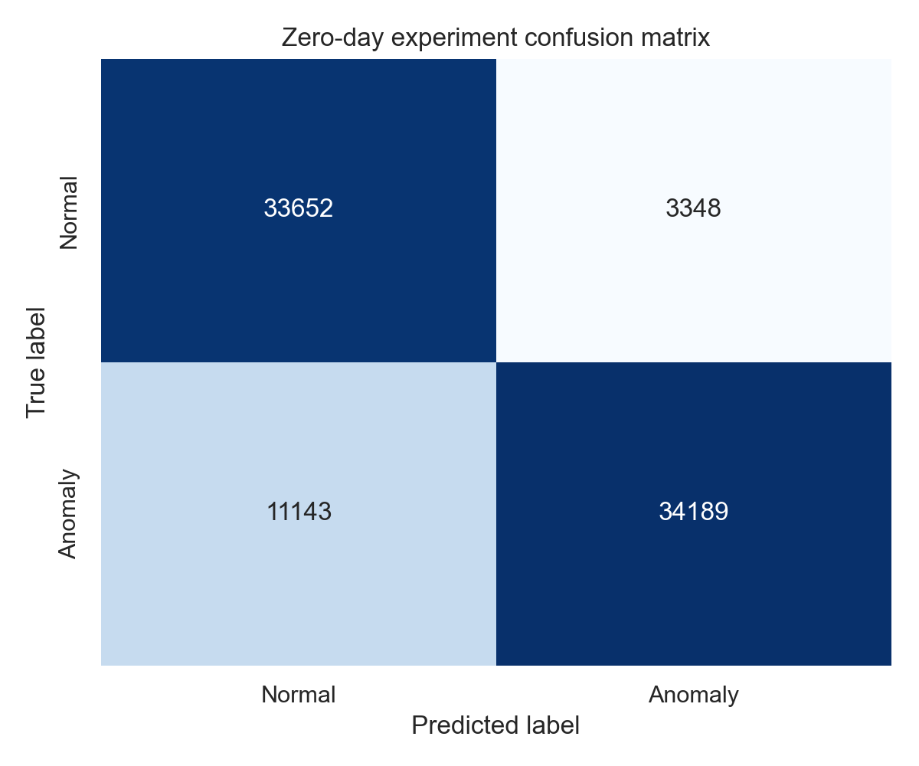
Figure 11. Confusion matrix for the zero-day evaluation run.

7.2 Discussion
The headline metrics (82.4% accuracy, F1 = 0.825, precision = 0.911) look strong, but they are dominated by the much larger “Known attack” group. Breaking detection down by group tells a different story: the model catches 75.5% of known attacks but only 31.8% of the withheld Worms samples (14 out of 44), against a 9.1% false-positive rate on normal traffic.
This gap is the central finding of the experiment so far. It confirms that reconstruction-error-based anomaly detection, while attack-label-free and therefore well suited to a zero-day setting in principle, does not automatically generalize to an attack family with a distinct behavioural footprint — detecting roughly 1 in 3 unseen attacks is a meaningful signal, but far from reliable on its own. This motivates the remaining planned components of the project: federated aggregation across multiple simulated nodes to broaden the model's exposure to varied “normal” behaviour, explainable AI to help an analyst understand and validate borderline detections, and a threat-scoring layer to prioritize the anomalies that are found.

8. Model Evaluation
This section is planned but not yet implemented (see notebooks/05_Model_Evaluation.ipynb in the project repository, currently a stub). Content will be added once this stage of the work is complete.
Planned scope: a consolidated evaluation notebook comparing the autoencoder against the Isolation Forest baseline already trained (models/trained_models/isolation_forest_model.pkl), with side-by-side accuracy, precision, recall, F1, and ROC-AUC, and a discussion of which detector to carry forward into the federated setting.

9. Federated Learning Implementation
This section is planned but not yet implemented (see notebooks/06_Federated_Learning.ipynb in the project repository, currently a stub). Content will be added once this stage of the work is complete.
Planned scope: partitioning the dataset across simulated satellite nodes and implementing federated training with the Flower framework (federated/client.py, federated/server.py, federated/strategy.py), aggregating local model updates into a global model without sharing raw data, per the architecture in the System Design Document.

10. Explainable AI (SHAP / LIME)
This section is planned but not yet implemented (see notebooks/07_Explainable_AI.ipynb in the project repository, currently a stub). Content will be added once this stage of the work is complete.
Planned scope: applying SHAP and LIME (explainability/shap_analysis.py, explainability/lime_analysis.py) to the trained anomaly detector to identify which input features drive individual anomaly/zero-day predictions, so that flagged events can be explained to a security analyst rather than presented as an opaque score.

11. Conclusion and Next Steps
Work to date has established a validated, leakage-free data pipeline for the UNSW-NB15 dataset and a working autoencoder-based anomaly detector, trained exclusively on normal traffic and evaluated with a full metric suite (accuracy, precision, recall, F1, ROC-AUC, confusion matrix). A dedicated zero-day simulation — withholding the rare Worms attack category entirely from model development — shows the detector generalizes reasonably to known attack types (75.5% detection) but considerably less well to a genuinely unseen attack family (31.8% detection), which is a realistic and useful baseline to improve upon.
The immediate next steps are:
- Complete Model Evaluation (Section 8): benchmark the autoencoder against the already-trained Isolation Forest model.
- Implement Federated Learning (Section 9) using the Flower framework across simulated satellite nodes.
- Implement Explainable AI (Section 10) using SHAP and LIME on top of the anomaly detector.
- Build the threat-scoring module and the Streamlit monitoring dashboard, per the System Design Document.

12. References
1. McMahan, B., et al. (2017). Communication-Efficient Learning of Deep Networks from Decentralized Data.
2. Flower Federated Learning Framework. https://flower.ai
3. SHAP Documentation. https://shap.readthedocs.io
4. LIME Documentation. https://lime-ml.readthedocs.io
5. UNSW-NB15 Dataset Documentation. https://research.unsw.edu.au/projects/unsw-nb15-dataset
6. CICIDS2017 Dataset Documentation. https://www.unb.ca/cic/datasets/ids-2017.html
7. TensorFlow Documentation. https://www.tensorflow.org

