GeGI Assay Driver: Physics and Measurement Campaign Analysis
PHDS GeGI HPGe Compton imaging spectrometer - ROS driver assay commissioning at the 0.58 m operational geometry.
Measurement campaigns of 26 August and 3-4 September 2026; report second edition, 4 September 2026.
This report documents (i) the physics implemented in the GeGI ROS driver for quantitative activity assay and isotope identification, and (ii) the analysis of the commissioning experiments: efficiency validation, repeatability, background and detection limits, source-position sensitivity with and without the new imaging-based position correction, shielding attenuation with 0/1/2 additional steel plates, mixed-field activity ratio, and rate/dead-time behaviour. The second edition adds three major findings of the September campaign: an imaging-based position-aware activity correction validated to +/-1 % across the tray; the discovery that the detector re-streams retained spectral content unless fully cleared before every run (with the consequent clean recalibration); and the measured broad-beam shielding transmission tables that replace the narrow-beam exponential model. A dedicated section quantifies the minimum detectable activity of the setup.

1. Instrument and geometry
The detector is a PHDS GeGI planar high-purity germanium (HPGe) imaging spectrometer: a 90 mm diameter, 11 mm thick crystal (crystal radius r = 0.045 m) operated as both a spectrometer and a Compton imager. The detector streams list-mode events over TCP; the ROS driver parses one-site and two-site interactions, publishes calibrated event energies, accumulates spectra, computes activities, identifies isotopes and reconstructs source directions.
Operational assay geometry: the source sits on a plywood table 0.580 m above the upward-facing detector, with one permanent 5 mm steel plate and the 11 mm plywood permanently in the beam. Calibration is performed in place, so the permanent attenuators and the exact standoff are absorbed into the empirical calibration factors; only ADDITIONAL steel plates receive an explicit attenuation correction (Section 2.6). Certificated reference sources: Cs-137 (BH-4106, 2.88 MBq) and Co-60 (BH-4103, 1.13 MBq), both referenced to 1 June 2026 with 3 % expanded uncertainty (k = 2), PTB-traceable. A Eu-152 source is used for multi-line energy and response characterisation.

2. Physics of the measurement chain

2.1 Event stream, spectrum formation and per-run cleanliness
The GeGI reports each interaction with its 3-D position and energy. Two-site events (Compton scatter followed by absorption) carry both interaction energies; their sum recovers the full photon energy, and the pair defines a Compton cone used for imaging (Section 2.11). The driver histograms calibrated event energies into 15,000 channels of 0.2 keV (0-3000 keV), matching the binning of the detector's native N42 export.
Per-run cleanliness required a September discovery (Section 4.1): the detector re-streams a few per cent of previously acquired spectral content into subsequent acquisitions unless its FULL onboard clear (data AND windows) is issued. Every recording therefore now begins with the full hardware clear, a short settle, and a reset of every software accumulator, making runs statistically independent. The driver-side data-only clear used previously was demonstrated to be insufficient.

2.2 Energy calibration, correction and resolution
Event energies arrive calibrated by the detector's onboard electronics. A ten-line measurement spanning 122-1408 keV (Eu-152, Cs-137, Co-60) showed the onboard scale reads high by a factor growing with energy: +0.10 keV at 122 keV to +0.98 keV at 1332 keV. A linear correction fits this drift as well as a quadratic (RMS residual 0.14 keV over ten lines):
E_true = -0.086 + 0.999431 x E_measured (keV)
i.e. a +0.057 % gain error, applied to every parsed interaction energy at the single entry point of the event stream. Photopeak centroids subsequently fall on evaluated line energies to within ~0.2 keV across the range. The detector resolution model used by the identification layer was also measured from the same reference spectrum: FWHM(E) = sqrt(0.0104 E + 1.57) keV (2.9 keV at 662 keV, 3.9 keV at 1332 keV, including the 0.2 keV binning). Adopting the measured widths resolved two long-ambiguous peaks at 409/446 keV as genuine Eu-152 lines (411.1/444.0 keV) that the previous, two-times-too-narrow model had rejected on match tolerance.

2.3 Photopeak net area
Each assayed gamma line has a fixed region of interest (ROI) around the photopeak and two flanking sideband windows. The continuum under the peak is estimated by linear interpolation between the mean sideband levels and subtracted channel-by-channel:
N_net = N_gross - N_continuum
with Poisson counting uncertainty sigma = sqrt(N_gross + N_continuum). Sideband placement is interference-aware: the Co-60 1332 keV left sideband spans 1304-1322 keV, deliberately above Eu-152's 1299.1 keV line, whose presence in the original window was measured to depress the 1332 keV net area by ~18 % in mixed fields.

2.4 Dead time
Dead time is taken from the detector's own real-time/live-time counters, polled every 15 s during each run over the shared TCP link (counters are reset at every run start, so the value is the true per-run dead time). The correction factor
f_dt = t_real / t_live = 1 / (1 - DT)
multiplies the net peak area before activity conversion. At the campaign's rates (~1-2.4 kcps input) dead times were 0.6-2.6 %. Because command replies share the detector's single TCP socket with the event stream, roughly one run in six loses every run-info reply; such runs now fall back to the most recent valid dead time of the session (clearly flagged as estimated; dead time is composition-stable to ~0.5 %). Two observations are referred to the manufacturer: the reported dead time depends on field composition rather than rate alone (Co-60-only ~2.5 %, Cs-137-only ~0.7 %, mixed ~1.3 % at a HIGHER total rate), and a dedicated command channel would eliminate the reply losses (Section 8). Live time is accumulated only while the detector is genuinely streaming: zero-count snapshots contribute no time.

2.5 Activity determination
Activity is derived from the net photopeak rate through a geometry-explicit efficiency chain. An empirical calibration factor CF (Bq per net photopeak cps) is measured for each line with a certificated source at the calibration distance. From CF the driver derives the detector's intrinsic full-energy-peak efficiency, a geometry-independent detector constant:
eps_intrinsic = 1 / ( CF x (Omega/4pi)(d_cal) x I_gamma )
where I_gamma is the emission probability and the geometric solid-angle fraction for a point source on the axis of a circular crystal of radius r at distance d is
Omega/4pi = 0.5 x ( 1 - d / sqrt(d^2 + r^2) )
(= 1.498e-3 at d = 0.580 m, r = 0.045 m). The assayed activity at any source distance d is then
A = N_net x f_dt / ( eps_intrinsic x (Omega/4pi)(d) x I_gamma x t_live x T_shield x f_pos )
where f_pos is the imaging-based off-axis factor of Section 2.7. At the calibration distance, on axis and with no extra shielding this reduces to A = CF x net cps x f_dt. Co-60 is quantified on both of its lines (1173.2 and 1332.5 keV) and reported as their mean; the line-to-line spread is an internal consistency check (best observed: 0.03 %).

2.6 Shielding attenuation: measured broad-beam transmission
When N additional 5 mm steel plates are inserted for high-activity trays, each assayed line is corrected by the plate transmission. The campaign established (Section 3.6) that in this geometry - plates stacked directly above the detector, source 0.58 m away - the transmission is NOT a single exponential: the first plate transmits at essentially the narrow-beam NIST value, while the second plate adds a measurable build-up excess (scattered photons that remain within the photopeak acceptance). The driver therefore uses MEASURED per-plate-count transmissions:
Line | Narrow-beam T per plate | Measured T (1 plate) | Measured T (2 plates)
662 keV | 0.751 | 0.792 | 0.613
1173 keV | 0.811 | 0.835 | 0.718
1332 keV | 0.820 | 0.825 | 0.703
Table 1. Measured broad-beam transmissions per additional-plate count (clean source-untouched sequences, 4 Sep 2026; single-determination uncertainty ~3 %, the 1-plate Co values are means of two independent determinations). Counts beyond the table extrapolate with fitted effective mu (48.6 / 35.5 / 35.0 per metre).
The source standoff is simultaneously increased by 5 mm per plate. Forcing a single exponential through both plate counts costs +/-3 % depending on plate count; the table removes that model error.

2.7 Position-aware solid-angle correction (new)
The solid-angle term of Section 2.5 assumes the source sits ON the detector axis. A source displaced laterally by rho sits at the slant distance d' = sqrt(d0^2 + rho^2) and is measured low if assayed with the on-axis solid angle - up to -17 % at a tray corner. The driver now corrects this from its own Compton image: the imaged hotspot of each assayed nuclide provides rho, and the efficiency is scaled by
f_pos = ( d0 / d' )^2 , d' = sqrt( d0^2 + rho^2 )
i.e. inverse-square dilution ONLY. The naive flat-disk model would add a cos(theta) foreshortening factor ((d0/d')^3 in total), but measurement decided against it: with a corner source, applying the slant distance alone recovered the certificate to +1.6 %, showing that the disk foreshortening is cancelled by the longer oblique chord a slanted ray traverses through the 11 mm planar crystal. The hotspot position is vector-averaged over the counting window (~100 imaging frames) to suppress per-frame localisation jitter of a few centimetres, and an extra slant-path term corrects the additional steel traversed obliquely when extra plates are present. If no hotspot is available for a nuclide the assay falls back to the on-axis assumption. Validation: Section 4.2 (all five tray positions within +/-1 % of certificate). Validity envelope: the correction is validated to rho <= ~0.25 m (the tray footprint); beyond ~0.3 m the imager underestimates large offsets and the correction fails low.

2.8 Ambient background subtraction
A no-source reference run records the ambient net rate b (cps) of every assayed line. For each assay run the expected ambient counts are subtracted from the run total:
N_source = N_net,total - b x t_live
and the variance of the reference measurement is propagated into both the detection threshold and the reported uncertainty. The current reference (1 h soak, 3 Sep 2026, sources in the distant lead store) measured ZERO ambient rate in all three assay ROIs (Section 5).

2.9 Detection decision and detection limits (Currie)
A line is DETECTED when its background-subtracted run total exceeds the Currie critical level at 95 % confidence:
L_C = 2.33 x sqrt(B), detect if N_source > max(L_C, 5 counts)
where B collects the sideband continuum counts, the subtracted ambient counts and the ambient reference variance. The 5-count absolute floor guards the B ~ 0 pathology in which L_C collapses toward zero and a few stray counts in a short window would otherwise 'detect'. The decision is made on the RUN total, not per counting window. A configured nuclide with no detected line is reported as a bounded non-detection with the Currie detection limit converted to activity:
L_D = 2.71 + 4.65 x sqrt(B), MDA = L_D x f_dt / ( K x t_live )
with K = eps_abs x I_gamma x T_shield the line's efficiency product. Section 5 evaluates the MDA of the setup quantitatively.

2.10 Isotope identification (screening layer)
Independent of the calibrated assay, a screening layer identifies ANY nuclide from a 30-nuclide SNM/industrial/NORM library, following the matched-filter approach of Becquerel-style automatic peak sensing with a hardened identification stage. Peak sensing correlates a zero-sum Gaussian-curvature kernel (scaled to the MEASURED FWHM of Section 2.2) with the spectrum; the kernel has zero response to constant and linear continuum and its response is normalised by its Poisson standard deviation, giving a per-channel signal-to-noise ratio. Library matching scores each nuclide by the fraction of its detectability-weighted line set found (weight = emission probability x shield transmission). A nuclide is identified when its representative line is found with sufficient score, OR when three or more of its lines match. Shared peaks are resolved by evidence and flagged; physics guards annotate annihilation and backscatter features. Identifications carry no activity - quantification remains exclusive to the calibrated assay lines.

2.11 Compton imaging
Two-site events define a cone of possible incidence directions: the cone axis is the line between the two interaction points and the opening angle follows from Compton kinematics,
cos(theta) = 1 - m_e c^2 x ( 1/E_scattered - 1/E_total )
Back-projecting many cones onto a sphere concentrates at the source direction. Events are selected in an energy band per identified isotope, so each isotope receives its own image and co-located sources are separated spectrally. Ghost suppression requires candidate hotspots to be supported by a sufficient fraction of event cones and to persist across imaging frames. Imaging localisation accuracy at the tray scale is +/-3 cm per frame (suppressed by the window averaging of Section 2.7); in mixed fields the weaker source's hotspot is pulled 1-2 cm toward the field centroid, worth a few per cent of its activity at a corner (Section 4.3).

2.12 Uncertainty budget
The reported expanded uncertainty combines per-run counting statistics (Type A) with systematic terms (Type B) in quadrature at k = 2. The September campaign re-measured every dominant term on the clean pipeline; the budget is assembled in Section 6.

3. Campaign results
Sections 3.1-3.8 follow the original experiment plan (A-G). Results superseded by the September clean-pipeline campaign are presented alongside their replacements; the September-specific findings (retention, position correction, mixed field) are elaborated in Section 4.

3.1 Reference spectrum, energy scale and response
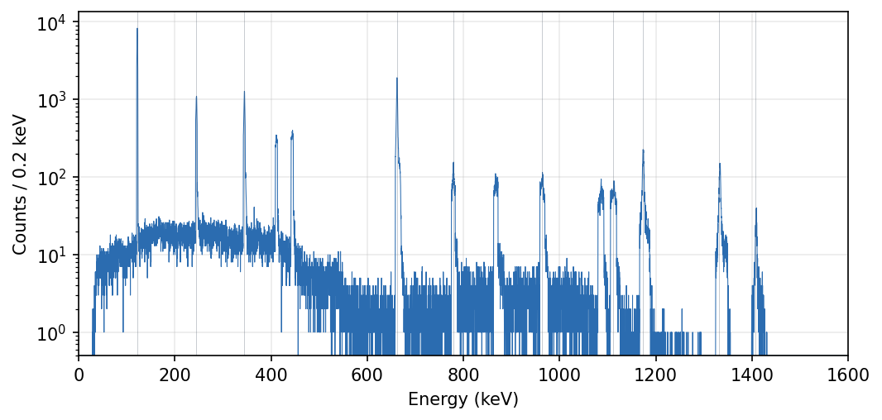
Figure 1. Mixed-source reference spectrum (Cs-137 + Co-60 + Eu-152, 903 s live, 0.2 keV channels). Vertical guides mark the ten reference lines used for the energy-scale fit.
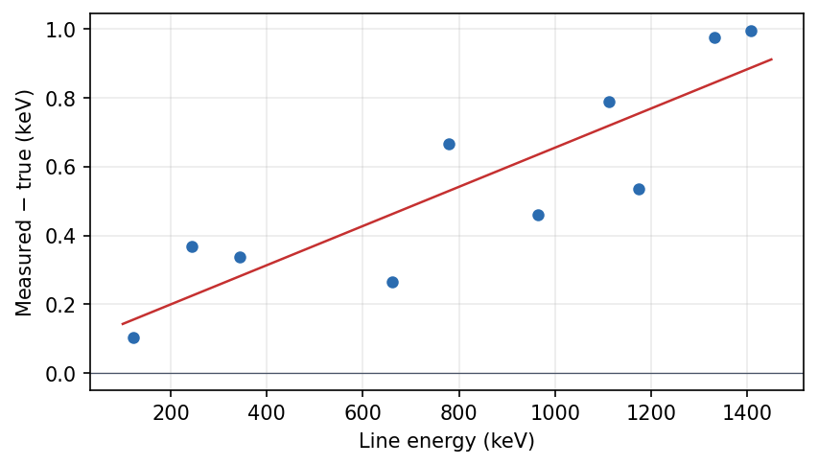
Figure 2. Onboard energy-scale error: measured minus evaluated line energy for the ten reference lines (points) and the fitted linear correction (line). RMS residual 0.14 keV.
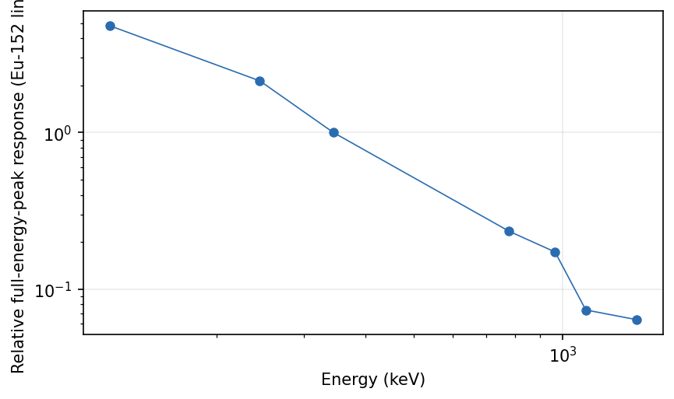
Figure 3. Relative full-energy-peak response along the Eu-152 line set (net area / emission probability, normalised at 344 keV).

3.2 Experiment A - background
Ambient background and detection limits are treated in the dedicated Section 5. Summary: with sources in the distant lead store the assay ROIs measure ZERO ambient rate (1 h reference soak), so detection limits sit at the Currie zero-background floor - about 0.7 kBq (Cs-137) and 1.4-2.0 kBq (Co-60) for a 300 s assay.

3.3 Experiment B - efficiency validation against certificates
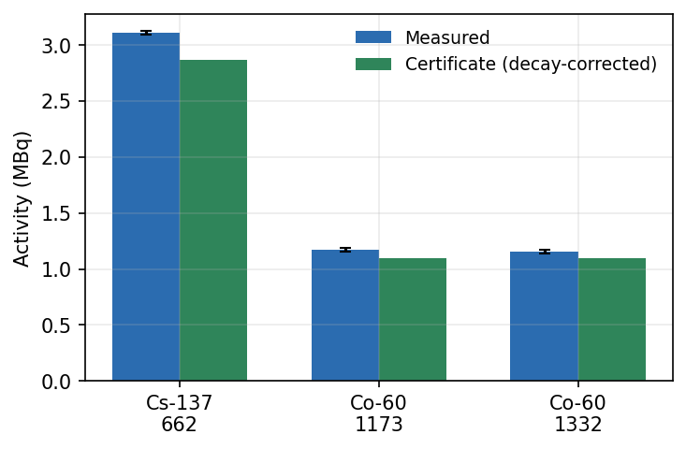
Figure 4. Measured activity versus decay-corrected certificate for the three assay lines (26 Aug 2026 campaign, pre-recalibration).
The August validation found all lines within the 10 % acceptance band with a consistent +6-9 % bias, traced to live-time accounting in the then-current calibration and corrected by recalibration (Section 4.1). After the September clean-pipeline recalibration, single-run validation anchors read: Cs-137 -0.3 % (2.853 MBq vs 2.863), Co-60 +0.8 % / -0.3 % on independent clean anchors - all within single-run counting statistics.

3.4 Experiment D - repeatability
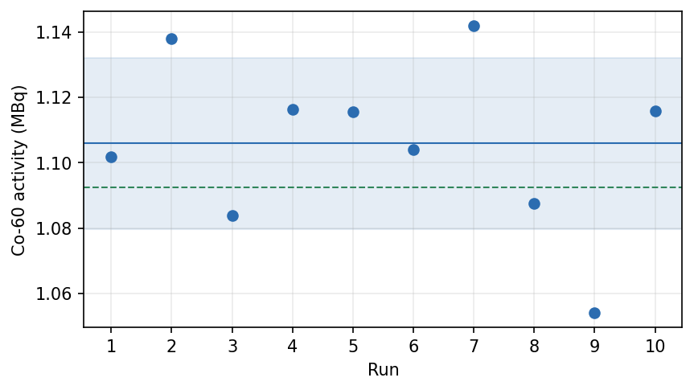
Figure 5. Ten repeated 5-minute Co-60 assays on the corrected pipeline (3 Sep 2026), mean and +/-1 SD band (shaded), decay-corrected certificate (dashed).
Ten fixed-geometry repeats (source untouched between runs) give a combined-line mean of 1.106 MBq (+1.2 % vs certificate) with RSD 2.4 %. Per-run counting statistics alone contribute 1.8 %, so the excess repeatability term is ~1.6 % - within the 2.1 % budget allowance. A separate, larger term applies when the SOURCE is re-placed between runs: Co-60 absolute rates scattered +/-3 % across re-placements (capsule seating/height, invisible to the lateral position correction), while Cs-137 re-placements repeat to +/-1 %.

3.5 Experiment E - source-position sensitivity, before and after correction
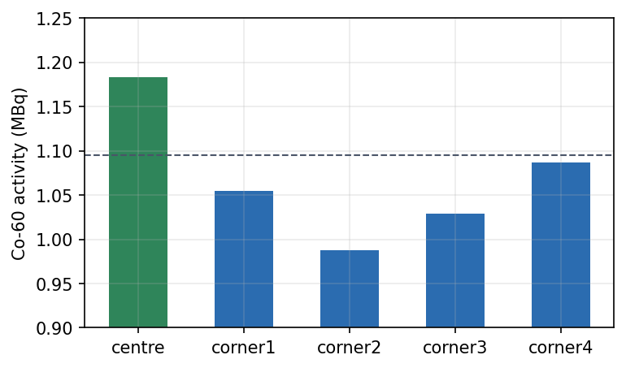
Figure 6. BEFORE: Co-60 assay at the tray centre and four corners with the on-axis assumption (26 Aug 2026). Corners read 8-17 % low; RSD 6.9 %.
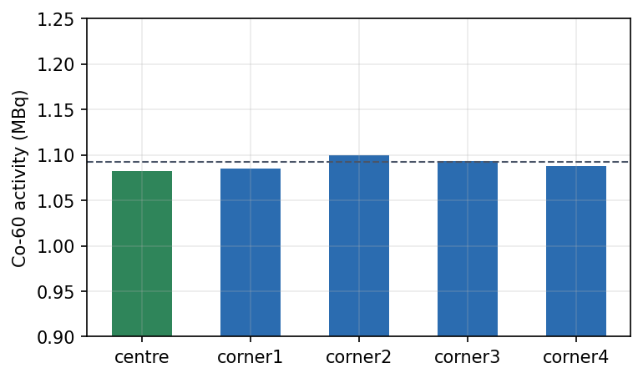
Figure 7. AFTER: the same five positions with the imaging-based position correction (3 Sep 2026). All positions within +/-1 % of certificate; RSD 0.65 %.
The position-aware correction (Sections 2.7 and 4.2) reduces the position term of the uncertainty budget by an order of magnitude: from 6.9 % RSD (corners -8 to -17 %) to 0.65 % RSD with every position within +/-1 % of the certificate. This was the dominant assay systematic; it is now subdominant.

3.6 Experiment F - shielding attenuation (0, 1, 2 additional plates)
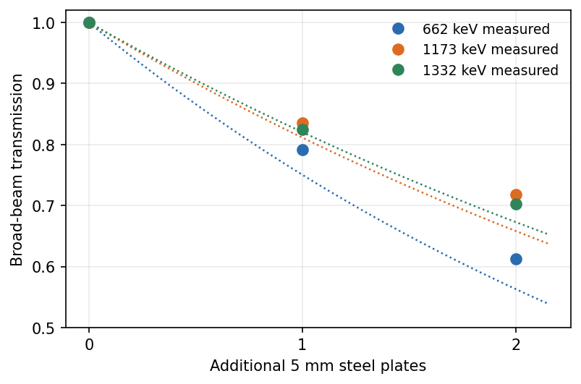
Figure 8. Measured broad-beam transmission versus additional plate count for the three assay lines (points; 1-plate Co values are means of two independent source-untouched determinations), with the narrow-beam exponential models (dotted).
The clean, source-untouched sequences of 4 Sep 2026 resolved the shielding model: the first plate attenuates at essentially the narrow-beam coefficient (fitted mu_eff 41.1 / 40.1 per metre at 1173/1332 keV versus NIST narrow-beam 41.8 / 39.6), while the second plate adds a build-up excess (~+9 % transmission over the exponential extrapolation at 1173 keV). Build-up grows with thickness, so no single exponential fits all plate counts; the driver's measured transmission table (Section 2.6) reproduces certificate activities at 0, 1 and 2 plates with balanced residuals (-0.9 % / +2.5 % on the two independent 1-plate verifications). Shielded assays carry ~2.5 % per-plate systematic from the single-determination uncertainty of the table entries.

3.7 Experiment G - mixed-field Cs-137 : Co-60 activity ratio
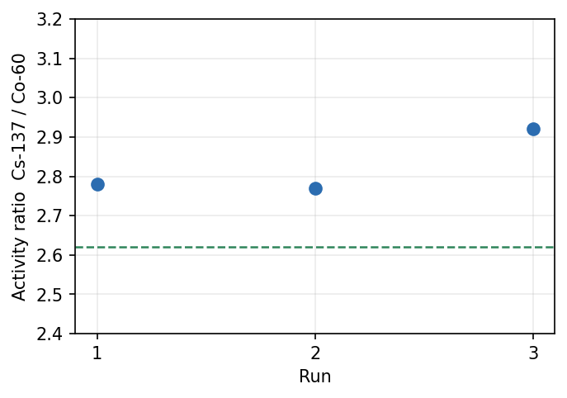
Figure 9. Cs-137/Co-60 activity ratio in three clean mixed-source runs at the tray diagonal corners (3 Sep 2026); dashed: decay-corrected certificate ratio 2.62.
Clean mixed runs give a stable ratio (2.77-2.92) but biased ~+9 % above the certificate ratio. Unlike the August campaign - where the bias was attributed to source positioning - the September sequential test (Section 4.3) demonstrates the residual bias is a genuine composition-dependent response of the detector itself: the Cs-137 photopeak rate rises ~+5 % when Co-60 is present (capsules physically untouched), with a smaller Co-60 suppression. With empirical mixed-field factors (Cs x0.949, Co x1.033 at these activities) the ratio centres on the certificate; alternatively the +9 % ratio bias is documented and applied as a correction with ~3 % uncertainty.

3.8 Experiment C - rate and dead-time behaviour
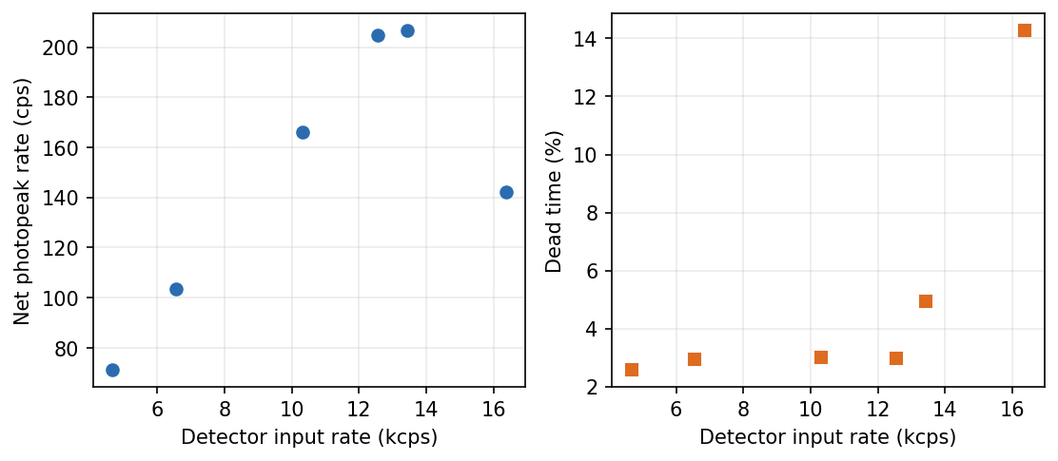
Figure 10. Net photopeak throughput (left) and per-run dead time (right) versus the detector's reported input rate (26 Aug 2026, 4.7-16.4 kcps).
The photopeak fraction of the input rate is constant to +/-4 % from 4.7 to 13.4 kcps, with dead time below 5 %; throughput collapses only at ~16 kcps (dead time 14 %). All assay operations (1-2.4 kcps) sit far inside the linear regime, and the flatness to 13 kcps excludes rate-dependent photopeak losses as an explanation for the mixed-field effect of Section 4.3.

4. September campaign findings

4.1 Detector data retention and the clean recalibration
The September campaign uncovered the root cause of every 'phantom peak' episode of the commissioning history: the GeGI retains spectral content onboard and re-streams of order 5 % of a previous run's rates into subsequent acquisitions unless its FULL clear (data AND windows) is issued; the data-only clear does not remove it. The signature that finally isolated it was a persistent 2.4 cps Cs-137 line in Co-only runs that survived source removal to a shielded safe, vanished instantly on a full clear, and stayed absent afterwards (zero ambient in the 1 h background soak). Operationally the effect had been masked for weeks by the operator's habit of manually issuing full clears between runs; when that habit was dropped the artefact surfaced within hours. Every recording now begins with an automatic full clear.
Consequence for calibration: the 26 Aug calibration runs carried retention contamination, inflating their net rates and deflating the Cs-137 calibration factor by ~3.4 % (clean runs then read low by the same amount; verified by bag-level event rate profiles that excluded a post-clear streaming ramp). The Cs-137 factor was re-derived from a clean run; the Co-60 factors were confirmed unchanged (four clean anchors straddle them within the +/-2.4 % placement scatter).
Line | CF 7 Aug | CF 27 Aug | CF 4 Sep (in use) | Clean anchor bias
Cs-137 662 | 82258 | 75819 | 78377 | -0.3 %
Co-60 1173 | 163431 | 152660 | 152660 (confirmed) | +0.8 %
Co-60 1332 | 228724 | 216707 | 216707 (confirmed) | -0.3 %
Table 2. Calibration factor provenance (Bq/cps). 27 Aug: live-time recalibration; 4 Sep: retention-clean recalibration (Cs) and confirmation (Co).

4.2 Position-aware correction: validation
Position | Imaged offset (m) | Correction factor | Activity (MBq) | vs certificate
centre | 0.03 | 0.995 | 1.082 | -0.9 %
corner 1 | 0.216 | 0.878 | 1.085 | -0.7 %
corner 2 | 0.208 | 0.886 | 1.100 | +0.7 %
corner 3 | 0.236 | 0.859 | 1.094 | +0.1 %
corner 4 | 0.236 | 0.859 | 1.088 | -0.4 %
Table 3. Five-position validation of the imaging-based position correction (Co-60, 3 Sep 2026). Mean bias -0.3 %, RSD 0.65 % (was 6.9 % uncorrected).
The correction model itself was selected by measurement: publishing the slant distance alone (inverse-square only) recovered a corner certificate to +1.6 %, demonstrating that flat-disk foreshortening is cancelled by the oblique-chord response of the planar crystal; the (d0/d')^3 flat-disk model would over-correct by ~15 %. The imager places a true-centre source ~3 cm off-axis (a reconstruction artefact worth only -0.5 %), and the correction is validated across the tray footprint (rho <= 0.25 m).

4.3 Mixed-field characterisation
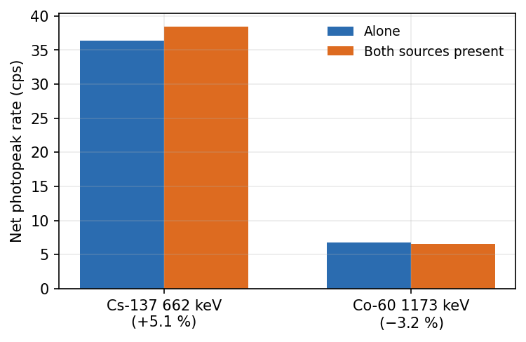
Figure 11. Sequential mixed-field test on the clean pipeline (4 Sep 2026): net photopeak rates of each nuclide alone and with the other present, capsules physically untouched between runs.
With retention eliminated, geometry frozen (capsules untouched) and rate effects excluded (Section 3.8), a genuine composition-dependent response remains: the Cs-137 662 keV photopeak rate rises +5.1 % when Co-60 enters the field (a 4-sigma effect), and the Co-60 lines drop -3.2 +/- 2.3 %. Spectroscopic mechanisms were excluded by direct measurement: no 1173 keV single-escape intensity at 662 keV, no chance-coincidence sum lines (the 2 x 662 = 1324 keV sum peak is absent to <0.01 cps), tiny sideband backgrounds, and rate linearity to 13 kcps. The residue points into the detector's onboard event processing, consistent with the composition-dependent dead-time reporting (Section 2.4). At the reference activities (2.9 MBq Cs-137 + 1.1 MBq Co-60, ~2.4 kcps) the empirical factors are Cs x0.949 and Co x1.033 (ratio x0.90); the sequential test is the calibration procedure to repeat at other intensities. The question of mechanism is referred to the manufacturer (Section 8).

5. Minimum detectable activity
This section quantifies the smallest activity the setup can detect (Currie MDA, 95 % confidence) and the smallest it can quantify to a given precision, in the operational 0.58 m geometry.

5.1 Measured background
The MDA floor is set by the background under each photopeak ROI. The clean-pipeline reference soak (1 h real time, 3 Sep 2026, sources in the distant lead store) measured ZERO net counts in the Cs-137 ROI and ~0.001-0.002 cps in the Co-60 ROIs - the room is effectively background-free at the assay lines. (The GeGI streams only ~0.6 ambient events per second in total - its onboard event filtering suppresses almost the entire ambient continuum - so the soak accumulated 494 s of live streaming time in the hour; rates are computed on live time.) Two caveats: the 95 % upper bound on the Cs-137 ambient rate from this soak is 0.006 cps, and earlier 'ambient Cs-137' observations of 0.038-2.4 cps are now attributed to detector retention (Section 4.1), not to the room. Background must be re-checked if source storage arrangements change.

5.2 MDA versus counting time
With background B = b x t counts, the Currie detection limit in activity is
MDA(t) = ( 2.71 + 4.65 x sqrt(b x t) ) x f_dt / ( K x t )
With the measured b ~ 0 the 2.71-count term dominates for all practical times and MDA falls as 1/t; K = 1/CF at the calibration geometry.
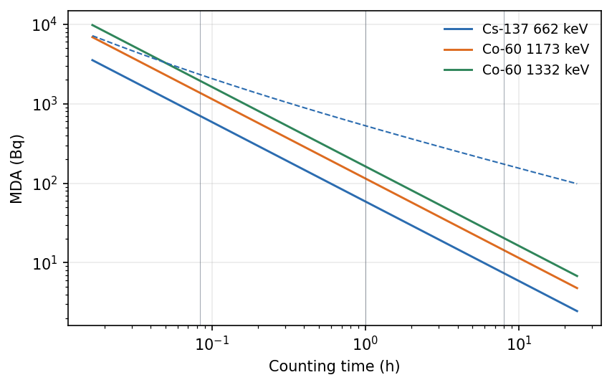
Figure 12. MDA versus counting time for the three assay lines at the measured (zero) background (solid; MDA proportional to 1/t). Dashed: Cs-137 upper bound using the background soak's 95 % rate limit (b < 0.006 cps). Guides at 5 min, 1 h, 8 h.
Counting time | Cs-137 662 | Co-60 1173 | Co-60 1332
5 min | 0.71 kBq | 1.38 kBq | 1.96 kBq
1 h | 59 Bq (<0.53 kBq) | 115 Bq | 163 Bq
8 h | 7.4 Bq (<0.15 kBq) | 14 Bq | 20 Bq
Table 4. Zero-background Currie MDA per line (values in parentheses: conservative upper bound using b < 0.006 cps for Cs-137). Divide-by-transmission applies behind extra plates (x1.26 per plate at 662 keV, x1.2 at the Co-60 lines).
Practical notes. (i) These are DETECTION limits; quantification to ~5 % counting precision (the driver's 400-net-count validity hint) requires far more activity: within a 300 s window, 105 kBq (Cs-137), 204 kBq (Co-60 1173) or 289 kBq (1332), scaling as 400 x CF / t for other times. (ii) In MIXED fields the weaker line's MDA rises with the stronger nuclide's continuum under its ROI - the Currie machinery accounts for this automatically through the measured sideband counts; Co-60 continuum under the 662 keV ROI is the reason Co-60 remains the primary reference for trace work. (iii) Geometry is the strongest lever: at 5 cm standoff the efficiency rises ~100x and every MDA above falls ~100x (detection-only: the calibrated assay geometry is fixed at 0.58 m). (iv) Storage matters: a Cs-137 source stored where it adds even 0.04 cps to the ROI raises the 1 h Cs-137 MDA ~20x; sources should remain in the distant lead store during assays.

6. Uncertainty budget (clean pipeline, position-corrected)
Component | Type | Basis | 1-sigma (%)
Source position in tray | B | position correction, Sec. 4.2 (measured 0.65) | 1.0
Repeatability (fixed source) | A/B | Exp D clean, excess over counting | 2.1
Calibration certificate | B | 3 % at k=2 | 1.5
Efficiency scale transfer | B | Exp B Co-60 line spread | 1.1
Shielding (per extra plate) | B | transmission table determination | (2.5/plate)
Dead-time correction | B | run-info counters; estimated runs +/-0.5 | 0.6
Background subtraction | B | zero-background reference | 0.1
Table 5. Assay uncertainty budget, second edition. Systematic total (unshielded, single-nuclide) u_sys = 3.2 %.
Combined with typical 1.5 % counting statistics: u_c = 3.5 %, expanded U = 7.1 % (k = 2, 95 %) - halved twice over from the first edition's 14.6 %, thanks to the position correction and the clean recalibration. Conditional terms are added where applicable: ~2.5 % per additional shield plate; +/-3 % source-handling scatter when loose capsules are re-placed by hand (does not apply to trays resting on the table plane); and in mixed Cs+Co fields either the empirical composition factors of Section 4.3 (residual ~2 %) or, uncorrected, +5 % (Cs), -3 % (Co) and +9 % (ratio) systematic offsets.

7. Operating procedure (assay-critical points)
- Start runs through the driver only. Every run start issues the FULL detector clear automatically; NEVER issue manual clears between runs (the data-only clear is insufficient, and mid-sequence manual clears were implicated in run-info losses).
- Plate changes happen in TWO places at once: the physical stack AND the n_shielding_plates setting. Verify via the effective-distance readout (0.580 + 0.005 x N metres) before starting the run - the campaign recorded two plate/software mismatches, each costing a run.
- Check the saved CSV's dead-time column after each run: a value flagged as estimated (rate = 0) means the run-info replies were lost and the dead time was borrowed from the previous run (+/-0.5 %).
- Sources not under assay belong in the distant lead store (Section 5.2 note iv).
- For activity RATIOS of co-present nuclides, prefer co-located sources (geometry cancels) and apply the mixed-field factors of Section 4.3.
- The position correction is validated across the tray footprint; do not assay sources beyond rho ~ 0.25 m from the detector axis.
- After any detector recalibration by the manufacturer: re-fit the energy-scale correction (tools/fit_energy_cal.py), the FWHM model, and re-derive calibration factors.

8. Open questions referred to PHDS
- Retained-data re-streaming: what onboard state does the 'clear data and windows' command reset that 'clear data' does not, and why does retained content re-enter the list-mode stream of subsequent acquisitions (~5 % of prior rates)?
- Composition-dependent dead time: why does reported dead time track field composition rather than total rate (Co-60-only ~2.5 % at 1.1 kcps; Cs-137-only ~0.7 % at 1.4 kcps; mixed ~1.3 % at 2.4 kcps)?
- Mixed-field photopeak redistribution: with geometry frozen, the Cs-137 662 keV photopeak rate rises ~5 % when Co-60 is present and the Co-60 lines drop ~3 %; no spectroscopic mechanism (escape, summing, pile-up) survives measurement. Is this an event-builder/acceptance behaviour?
- Run-info reliability: command replies share the event socket and roughly one run in six loses every reply; does the instrument support a second, dedicated command connection?
- List-mode throughput ceiling ~13-16 kcps (photopeak fraction collapses at 16 kcps): is this a firmware or link limit, and is it configurable?

9. Conclusions
- The assay chain reproduces certificated activities on every line within single-run counting statistics after the clean recalibration (validation anchors -0.3 % to +0.8 %), with 2.4 % ten-run repeatability and 0.03 % best Co-60 line-pair agreement.
- The imaging-based position-aware correction removes the formerly dominant systematic: all five tray positions assay within +/-1 % of certificate (RSD 0.65 %, was 6.9 %). The inverse-square model was selected by measurement; flat-disk foreshortening is cancelled by the planar crystal's oblique-chord response.
- The detector retains and re-streams spectral content across acquisitions unless fully cleared; the driver now issues the full clear at every run start. This closed the phantom-peak history and motivated the clean recalibration (Cs-137 CF +3.4 %).
- Shielded operation uses measured broad-beam transmission tables (first plate ~narrow-beam, second plate +9 % build-up); certificate recovery at 0-2 plates with balanced residuals.
- Mixed Cs+Co fields carry a real, characterised composition effect (+5 % Cs, -3 % Co, +9 % ratio) attributable to the detector's onboard processing; empirical factors correct it and the mechanism is referred to PHDS.
- Detection capability: with measured zero ambient background the MDA is ~0.7 kBq (Cs-137) / ~1.4-2.0 kBq (Co-60) in 5 minutes, falling as 1/t to tens of Bq in extended counts - orders of magnitude below the intended assay range.
- The expanded assay uncertainty is 7.1 % (k = 2), halved twice over from the first edition, dominated now by fixed-source repeatability and the calibration certificate.

Appendix A - analysis tool outputs (26 Aug campaign)
Verbatim outputs of the repository analysis tools for the August campaign (validate_efficiency.py, repeatability.py, position_check.py, shielding_check.py, ratio_check.py, mda.py). September-campaign numbers appear in the body tables; raw run data resides under data/ with per-run manifests.
================================================================
GeGI efficiency validation (DJR Assay Experiment B)
================================================================
Nuclide : Cs137
Certificate : 2.88 MBq on 2026-06-01
Elapsed / half-life: 86.0 d (T1/2 = 10986.7 d)
Decay factor : 0.99459
Reference activity @ 2026-08-26 : 2.86442 MBq <-- truth
----------------------------------------------------------------
Cs137 : measured 3.10767 MBq (n=1, SD 0.017) net=33256 live=880s DT=0.7%
bias +8.5% -> PASS (tol +-10%)
================================================================
================================================================
GeGI efficiency validation (DJR Assay Experiment B)
================================================================
Nuclide : Co60
Certificate : 1.13 MBq on 2026-06-01
Elapsed / half-life: 86.0 d (T1/2 = 1925.3 d)
Decay factor : 0.96951
Reference activity @ 2026-08-26 : 1.09555 MBq <-- truth
----------------------------------------------------------------
Co60_1173 : measured 1.17285 MBq (n=1, SD 0.016) net=5969 live=832s DT=2.3%
bias +7.1% -> PASS (tol +-10%)
Co60_1332 : measured 1.1563 MBq (n=1, SD 0.018) net=4205 live=832s DT=2.3%
bias +5.5% -> PASS (tol +-10%)
----------------------------------------------------------------
Combined (mean of lines): 1.16457 MBq bias +6.3% line-to-line spread 1.4%
================================================================
========================================================================
GeGI repeatability analysis (DJR Assay Experiment D)
========================================================================
Nuclide : Co60 runs : 10 partial-window cut : net < 0.75 x median
Reference (decay-corrected) : 1.0955 MBq
------------------------------------------------------------------------
run 1173 1332 combined
20260826_174920_activity.csv 1.1778 1.1883 1.1831
20260826_181352_activity.csv 1.1701 1.1081 1.1391
20260826_182151_activity.csv 1.1974 1.1679 1.1826
20260826_182921_activity.csv 1.1839 1.1594 1.1716
20260826_183519_activity.csv 1.1673 1.1967 1.1820
20260826_184119_activity.csv 1.1432 1.1787 1.1609
20260826_184748_activity.csv 1.2015 1.1432 1.1724
20260826_185348_activity.csv 1.2214 1.1344 1.1779
20260826_185959_activity.csv 1.1796 1.1722 1.1759
20260826_190707_activity.csv 1.2122 1.1293 1.1707
------------------------------------------------------------------------
Co60_1173 : mean 1.1854 MBq SD 0.02322 RSD 1.96% (n=10) bias +8.2%
Co60_1332 : mean 1.1578 MBq SD 0.02836 RSD 2.45% (n=10) bias +5.7%
------------------------------------------------------------------------
COMBINED per-run activity:
mean : 1.1716 MBq
SD (Type A) : 0.0133 MBq -> repeatability RSD = 1.14%
SEM : 0.004206 MBq (SD/sqrt(10))
range : 1.1391 - 1.1831 MBq
accuracy : mean bias +6.9% vs certificate
========================================================================
======================================================================
GeGI position sensitivity (DJR Assay Experiment E) nuclide=Co60
======================================================================
position activity_MBq vs max
centre 1.1831 100.0%
corner1 1.0542 89.1%
corner2 0.9872 83.4%
corner3 1.0291 87.0%
corner4 1.0870 91.9%
----------------------------------------------------------------------
across all 5 positions : mean 1.0681 MBq, SD 0.0739 (6.9% RSD)
======================================================================
==========================================================================
GeGI shielding transmission check (DJR Assay Experiment F)
==========================================================================
plate thickness t=0.0050 m, base_shield_plates=0, baseline=0 extra
source assumed MOVING (solid angle divided out)
--------------------------------------------------------------------------
Co60_1173 (config mu = 41.8 /m)
extra net_cps T_measured T_model ratio
0 7.417 1.0000 1.0000 1.000
1 6.249 0.8570 0.8114 1.056
2 5.032 0.7020 0.6584 1.066
fitted mu = 35.4 /m (config 41.8 /m, -15.3%)
--------------------------------------------------------------------------
Co60_1332 (config mu = 39.6 /m)
extra net_cps T_measured T_model ratio
0 4.937 1.0000 1.0000 1.000
1 4.388 0.9040 0.8204 1.102
2 3.523 0.7382 0.6730 1.097
fitted mu = 30.4 /m (config 39.6 /m, -23.3%)
==========================================================================
T_measured = net-rate ratio vs baseline; T_model = exp(-mu*n*t).
ratio near 1.0 and fitted mu near config mu => mu values confirmed.
==========================================================================
====================================================================
GeGI Cs-137 : Co-60 ratio check (DJR Assay Experiment G)
====================================================================
Certificate (decay-corrected to 2026-08-26):
Cs-137 2.864 MBq / Co-60 1.096 MBq -> ref ratio = 2.6146 <-- truth
--------------------------------------------------------------------
20260826_191708_activity.csv : A(Cs)/A(Co)=2.9646 net(Cs)/net(Co)=3.4109 bias +13.4% FAIL
20260826_192434_activity.csv : A(Cs)/A(Co)=3.1687 net(Cs)/net(Co)=3.6543 bias +21.2% FAIL
20260826_193024_activity.csv : A(Cs)/A(Co)=3.0878 net(Cs)/net(Co)=3.5635 bias +18.1% FAIL
--------------------------------------------------------------------
Activity ratio : mean 3.0737 SD 0.1028 (RSD 3.3%, n=3)
Count ratio : mean 3.5429 SD 0.1230 (RSD 3.5%, n=3) [calibration-independent]
Activity ratio bias vs certificate: +17.6%
====================================================================
Note: activity_ratio validates BOTH calibrations at once; count_ratio is a
calibration-free fingerprint of the source mix. Co-60 is the PRIMARY
reference (its continuum sits under the Cs-137 662 keV peak, not vice-versa).
==========================================================================
GeGI limits of detection (DJR Assay Experiment A)
==========================================================================
Background CSV : data/Experiment A - Background/20260810_114222_activity.csv
Geometry : d=0.580 m (base 0.580 + 0 plate(s) x 0.005), count time T=300 s
Solid angle : Omega_op/4pi=0.001498 (cal 0.001498 at 0.58 m)
--------------------------------------------------------------------------
line bg_cps B(T) L_C L_D MDA LoQ(400ct)
Co60_1173 0.00000 0.0 0.0 2.7 1476 Bq 2.179e+05 Bq
Co60_1332 0.00000 0.0 0.0 2.7 2066 Bq 3.05e+05 Bq
Cs137 0.00000 0.0 0.0 2.7 743.1 Bq 1.097e+05 Bq
--------------------------------------------------------------------------
MDA = detection limit (Currie 95%). LoQ(400ct) = activity giving the
driver's 400-net-count validity gate (~5%% counting precision).
==========================================================================

