A

TECHNICAL REPORT

ON

STUDENT INDUSTRIAL WORK EXPERIENCE SCHEME (SIWES)

UNDERTAKEN AT

KENT COMPUTER TRAINING CENTER, JOS SOUTH LGA, PLATEAU STATE

BY

ALIYU MAIGIDA JARMAI

MATRIC NO: 230993

SUBMITTED TO

DEPARTMENT OF SOFTWARE ENGINEERING

SQI COLLEGE OF ICT, OGBOMOSO.

IN PARTIAL FULFILMENT OF THE REQUIREMENTS FOR THE

AWARD OF NATIONAL INNOVATION DIPLOMA IN (Software engineering)

SUPERVISOR: Mr. Oluwaseyi R. Odekomaya

JANUARY, 2025

# **CERTIFICATION**

This is to certify that I, Aliyu Jarmai Maigida with matriculation 230993 of the Department of Computer Software Engineering (Data Science). At SQI College of ICT Ogbomoso wrote this report and carried out all the work done mentioned.

Mr. Odekomaya Oluwaseyi Date

*SIWES Supervisor*

Mr. Oluwaseyi Odekomaya Date

*Head of Department*

# **DEDICATION**

To God Almighty, the source of all wisdom and knowledge, who has given me the strength, wisdom, and opportunity to complete my Students Industrial Work Experience Scheme (SIWES). May His name be praised forever?

# 

# **ACKNOWLEDGEMENT**

I would like to express my heartfelt gratitude to the following individuals who have contributed significantly to the success of my Students' Industrial Work Experience Scheme (SIWES) program:

First and foremost, I thank Aunty Iyinoluwa for her unwavering support, words of encouragement, and financial assistance throughout my SIWES journey. Your kindness and generosity have been a constant source of motivation for me.

I also extend my deepest gratitude to Daddy Otto for his financial support, prayers, and words of encouragement. Your selflessness and concern for my well-being have been a blessing to me.

Furthermore, I thank Pastor Jerry Jeremiah and his family for their prayers, financial support, and unwavering encouragement. Your spiritual guidance and support have been invaluable to me.

To my mother, I express my deepest appreciation for your love, support, and encouragement throughout my SIWES program. Your sacrifices and prayers have not gone unnoticed.

Additionally, I thank Mr. Emmanuel and his friend Mr. Joseph for providing me with free accommodation during my SIWES program. Your kindness and generosity have been a significant blessing to me.

Once again, I thank each and every one of you for your contributions to my SIWES program. May God bless and reward you abundantly for your kindness and generosity

# 

# **ABSTRACT**

This report provides a comprehensive overview of my four-month Students' Industrial Work Experience Scheme (SIWES) at Kent Computer Training Center, Department of ICT, located at Wurin Alheri Bek-Ratyi Du, Jos South LGA, Plateau State. From 5th August to December 2024, I undertook an intensive training program that equipped me with practical skills in ICT, complementing my theoretical knowledge.

During my SIWES program, I acquired hands-on experience in OS installation on desktop computers, which enhanced my understanding of computer hardware and software integration. Additionally, I had the opportunity to take a course in Peace Building, which broadened my knowledge of conflict resolution and management. This course helped me develop essential skills in negotiation, mediation, and problem-solving.

Furthermore, I gained foundational knowledge in Introduction to Cyber security, which introduced me to the fundamental principles of cyber security, including threat analysis, risk management, and security protocols. This knowledge has equipped me with the skills to identify and mitigate potential security threats in ICT systems.

I also started learning Corel Draw, a graphic design software that has enabled me to develop basic design skills. This training has opened up new opportunities for me to explore the field of graphic design and digital media.

My four-month SIWES program at Kent Computer Training Center has been an enriching experience that has equipped me with practical skills in ICT, peace building, cybersecurity, and graphic design. This experience has not only broadened my knowledge but also developed my skills in problem-solving, critical thinking, and teamwork. I am confident that the skills and knowledge acquired during this program will enhance my career prospects and enable me to make meaningful contributions to the ICT industry.

Table of Contents

**CERTIFICATION** i

**DEDICATION** ii

**ACKNOWLEDGEMENT** iii

**ABSTRACT** iv

1.1 INTRODUCTION TO SIWES 1

1.2 BACKGROUND OF SIWES 1

1.3 OBJECTIVES OF SIWES 3

1.4 BODIES INVOLVED IN THE MANAGEMENT OF SIWES 3

**CHAPTER TWO** 5

2.1 INTRODUCTION 5

2.2 HISTORY OF KENT COMPUTER TRAINING CENTER 5

2.3 ORGANOGRAM 7

2.4 STRUCTURE OF THE ORGANISATION 8

2.5 TEAM/DEPARTMENT 8

2.6 CONTACT INFORMATION 8

**CHAPTER THREE** 10

3.0 DURING MY SIWES PROGRAM, I ACQUIRED THE FOLLOWING SKILLS**.** 10

3.1 PEACE BUILDING 10

3.2 OS INSTALLATION ON DESKTOP COMPUTERS/ TROUBLESHOOTINGSOFTWARE ISSUES. 19

3.3 INTRODUCTION TO CYBER SECURITY. 21

3.4 GRAPHIC DESIGN USING COREL DRAW 25

3.5 RESPONSIBILITIES/ACTIVITIES CARRIED OUT 26

3.6 CHALLENGES FACE 27

3.7 HOW I MANAGED TO OVERCOME THE CHALLENGES 28

**CHAPTER FOUR** 28

4.1 CONCLUSION 28

4.2 RECOMMENDATIONS BASED ON THE SKILLS AND EXPERIENCES. 29

**Reference** 31

**Table of Figures**

Figure 1: 2.1.0 Organization Organogram 7

Figure 2: 2.2.0 CFI Wurin Alheri DU: Google map. 9

Figure 3: 3.1.0 Conflict tree method. 13

Figure 4: 3.2.0 during one of our Peace Building class. 15

Figure 5: 3.3.0 we built a conflict map. 15

Figure 6: 3.4.0 1during one of our practical class. 20

Figure 7: 3.5.0 trying to install OS on window desktop comp. 20

Figure 8: 3.6.0 Assist Student. 27

**CHAPTER ONE**

**INTRODUCTION**

### 1.1 INTRODUCTION TO SIWES

The Students Industrial Work Experience Scheme (SIWES) is a unit under the Vice-Chancellor’s Office.  It was established in 2016. The Students Industrial Work Experience Scheme (SIWES) is a skills training programmed designed to expose and prepare students of universities and other tertiary institutions for the Industrial Work situation they are likely to meet after graduation.

The Students Industrial Work Experience Scheme (SIWES), is the accepted training programed, which is part of the approved Minimum Academic Standard in the various degree programed for all Nigerian Universities.  The scheme is aimed at bridging the existing gap between theory and practice of Sciences, Agriculture, Medical Sciences (including Nursing), Engineering and Technology, Management, Information and Communication Technology, and other professional educational programmed in the Nigerian tertiary institutions.  It is aimed at exposing students to machines and equipment, professional work methods, and ways of safeguarding the work areas and workers in industries, offices, laboratories, hospitals, and other organizations.

It is a cooperative industrial internship program that involves institutions of higher learning, industries, the Federal Government of Nigeria, the Industrial Training Fund (ITF), and the Nigerian Universities Commission (NUC).

### 1.2 BACKGROUND OF SIWES

SIWES was founded in 1973 by ITF (Industrial Training Funds) to address the problem of tertiary institution graduates' lack of appropriate skills for employment in Nigerian industries. The Students' Industrial Work Experience Scheme (SIWES) was founded to be a skill training

Programmed to help expose and prepare students of universities, Polytechnics and colleges of education for the industrial work situation to be met after graduation.

This system facilitates the transfer from the classroom to the workplace and aids in the application of knowledge. The program allows students to become acquainted with and exposed to the experience required in handling and operating equipment and machinery that are typically not available at their schools.

Prior to the establishment of this scheme, there was a rising concern and trend among industrialists that graduates from higher education institutions lacked appropriate practical experience for employment. Students who entered Nigerian universities to study science and technology were not previously trained in the practical aspects of their chosen fields. As a result of their lack of work experience, they had difficulty finding work.

As a result, employers believed that theoretical education in higher education was unresponsive to the needs of labor employers. Thousands of Nigerians faced this difficulty till 1973. The fund's main motivation for establishing and designing the scheme in 1973/74 was launched against this context.

The ITF (Industrial Training Fund) organization decided to aid all interested Nigerian students and created the SIWES program. The federal government officially approved and presented it in 1974. During its early years, the scheme was entirely supported by the ITF, but as the financial commitment became too much for the fund, it withdrew in 1978. The National Universities Commission (NUC) and the National Board for Technical Education (NBTE) were given control of the scheme by the federal government in 1979. The federal government handed over supervision and implementation of the scheme to ITF in November 1984. It was taken over by the Industrial Training Fund (ITF) in July 1985, with the federal government bearing entire responsibility for funding.

### 1.3 OBJECTIVES OF SIWES

The Industrial Training Fund’s Policy Document No. 1 of 1973 which established SIWES outlined the objectives of the scheme as:

* Provide an avenue for students in Institutions of higher learning to acquire industrial skills and experience in their respective courses of study.
* Prepare students for the Industrial Work situation they are likely to experience after graduation.
* Expose students to work methods and techniques of handling equipment and machinery that may not be available in their Institutions.
* Make the transition from school to the world of work easier; and enhance students’ networks for later job placements.
* Provide students with an opportunity to apply their knowledge to real work situations, thereby bridging the gap between theory and practice; and
* Enlist and strengthen Employers’ involvement in the entire educational process; thereby preparing the students for employment in Industry and Commerce

### 1.4 BODIES INVOLVED IN THE MANAGEMENT OF SIWES

➢The Federal Government of Nigeria;

➢ Institutions of Higher Learning;

➢The Industrial Training Fund (ITF);

➢The Employers of Labor

➢ National Universities Commission (NUC);

➢ National Board for Technical Education (NBTE);

➢ National Commission for Colleges of Education (NCCE);

# **CHAPTER TWO**

**BACKGROUND OF ORGANIZATION**

### 2.1 INTRODUCTION

Kent Computer Training Center was established in June 2017 in the Bukuru community of Jos-South Local Government Area, Plateau State, Nigeria, as a response to the devastating effects of religious and ethnic violence. Founded by Christian Faith Ministries with the support of Professor Kent Hodge from Australia, the center’s mission is to use technology as a means of fostering peace, reconciliation, and socioeconomic empowerment. By providing free or low-cost computer training, the center seeks to bridge divides, equip individuals with essential digital skills, and promote collaboration and understanding among diverse ethnic and religious groups. Over the years, Kent Computer Training Center has expanded its reach to other conflict-affected communities, becoming a symbol of hope and transformation for many.

### 2.2 HISTORY OF KENT COMPUTER TRAINING CENTER

Kent Computer Training Center was founded with a singular, transformative mission: to use technology as a tool for fostering peace and reconciliation in communities ravaged by violent conflict. It stands as a beacon of hope for individuals who have experienced the devastating effects of religious and ethnic division, offering them the opportunity to rebuild their lives through digital skills development.

The Kent Computer Training Center was officially launched in June 2014 in the Bukuru community of Jos-South Local Government Area, an area that had experienced religious violence between Muslims and Christians. With support from Christian Faith Ministries, Jos, and Professor Kent Hodge from Australia, the center opened its doors to young people, community leaders, and displaced individuals eager to rebuild their lives. The founders (Christian Faith Ministries) and community leaders in Bukuru recognized that technology could transcend ethnic and religious lines, offering a neutral ground for collaboration and understanding.

The center’s primary goal was to provide free or low-cost computer training to individuals from diverse ethnic and religious backgrounds. Recognizing that many students came from communities that had been pitted against each other by violence, the training program included components that encouraged teamwork, conflict resolution, and life skills.

As the success of the initial programs became evident, the training center expanded its reach to other communities in various local government areas and states in Nigeria affected by conflict. The communities benefiting from Kent Computer Training Center include:

* Du, Jos-South, Plateau State
* Dutse Uku, Jos-North, Plateau State
* Katako, Barkin-Ladi, Plateau State
* Bisichi, Barkin-Ladi, Plateau State
* Mangu, Plateau State
* Miango, Bassa, Plateau State
* Badarisa, Adamawa State

The Kent Computer Training Center’s journey reflects the power of education and technology in overcoming the scars of violent conflict. By equipping young people with tools to succeed in the digital age and promoting dialogue between divided communities, the center has made a profound impact on peace-building efforts. The legacy of Kent Computer Training Center serves as a testament to the idea that technology, when used thoughtfully, can not only rebuild economies but also foster understanding, trust, and ultimately, reconciliation in even the most divided societies.

### 2.3 ORGANOGRAM

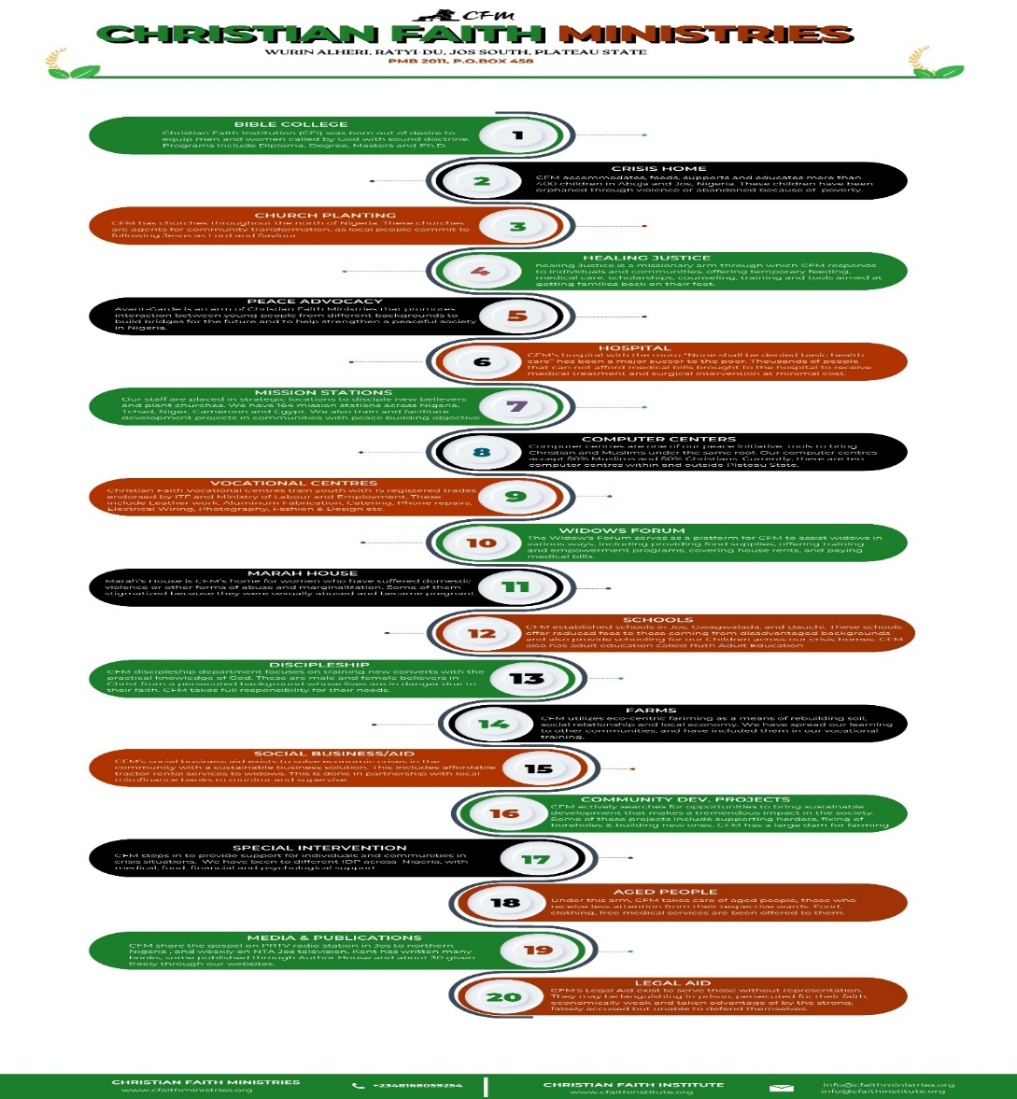

Figure 1: 2.1.0 Organization Organogram

### 2.4 STRUCTURE OF THE ORGANISATION

The Kent Computer Training Center operates under a well-defined organizational structure that ensures effective delivery of its mission and goals. The structure includes governance, administrative, and operational layers that work collaboratively to manage the center’s programs and initiatives. The main components of the organizational structure include:

Board of Directors

↓

Executive Leadership

↓

├── Administrative Unit

├── Training and Programs Unit

├── Community Outreach and Engagement Unit

└── Technical Support Unit

### 2.5 TEAM/DEPARTMENT

* Director
* Training Department
* Administrative Department
* ICT Department

### 2.6 CONTACT INFORMATION

Phone Number: +2347037273726, +2348069248871

Email:kicheadquaters@gmail.com

Facebook:KentComputerTrainingCenter

Head Office: Wurin Alheri, Bek-Ratyi Du, Jos South, plateau State

Google map: CFI wurin alheri Du.

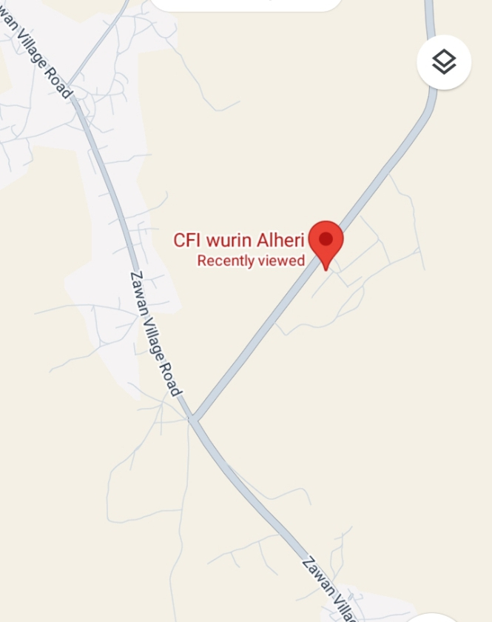

Figure 2: 2.2.0 CFI Wurin Alheri DU: Google map.

# **CHAPTER THREE**

**INDUSTRIAL EXPERIENCE**

As I reflect on my SIWES experience, I am reminded of the first day I walked into Kent Computer Training Center. I was nervous, unsure of what to expect, and wondering if I was truly ready for the challenges that lay ahead. But as I began to work alongside my colleagues, I quickly realized that this experience was not just about gaining skills, but about discovering my own strengths, weaknesses, and passions.

### 3.0 DURING MY SIWES PROGRAM, I ACQUIRED THE FOLLOWING SKILLS**.**

1. Peace Building.
2. OS installation on desktop computers/ Debugging and troubleshooting software issues.
3. Introduction to Cyber security.
4. Graphic design with Corel Draw.

3.1 PEACE BUILDING

Peace building is a crucial course offered by the institution, aiming to foster unity and mutual understanding among people of different religious beliefs, particularly Muslims and Christians. The course is designed to equip participants with the knowledge, tools, and skills necessary to manage and resolve conflicts peacefully, thereby promoting harmony within communities.

**3.1.0 Key Things learnt and discussed in peace building**

**Definition of Conflict**

Conflict was defined as a disagreement or clash of interests, values, or ideas between individuals or groups. It can arise from misunderstandings, unmet needs, or competing interests.

Conflict in another perspective can be an opportunity for change within or between parties.

**Conflict Analysis**

Conflict analysis involves a systematic examination of the factors that contribute to a conflict. It provides a deeper understanding of the underlying causes and dynamics of a conflict, enabling the formulation of effective strategies for resolution.

**3.1.1 Key Aspects to Consider When Analyzing Conflict**

History/Background of the Conflict

Understanding the origins and evolution of the conflict is essential. This includes identifying when and how it began, key incidents, and the role of historical grievances.

**Nature of the Conflict**

Assessing the type of conflict (e.g., political, social, economic, or religious) helps to understand its scope and intensity. For example, is the conflict localized, or does it affect broader regions or populations?

**Parties’ Needs, Fears, and Demands**

Analyzing the perspectives of all parties involved is vital. This involves identifying:

Needs: What do the parties genuinely require for their well-being and survival?

Fears: What concerns or anxieties drive their actions?

Demands: What are they explicitly asking for, and how do these align with or contradict their needs and fears?

**3.1.2 Quality of a conflict analyst.**

**Flexibility**

Flexibility enables a conflict analyst to adapt to rapidly changing dynamics, diverse perspectives, and unexpected developments. Conflicts often unfold in unpredictable ways, requiring analysts to pivot their approach as new information emerges. This adaptability is essential when engaging with stakeholders from various cultural, social, and political contexts.

**Objectivity**

Objectivity is fundamental in analyzing conflicts impartially and without bias. By maintaining a neutral stance, a conflict analyst can accurately assess the motivations, needs, and interests of all parties involved. This ensures that recommendations and analyses are based on facts and evidence, rather than personal opinions or external pressures.

**Independence**

Independence allows a conflict analyst to operate without undue influence from external actors. This autonomy is critical for maintaining credibility and trust, especially when working with sensitive or high-stakes situations. An independent approach ensures that the analysis remains focused on the conflict dynamics and not swayed by external agendas.

**3.1.3 Some used tools in conflict analysis include:**

**Conflict Tree Method**

The conflict tree method is a visual tool that helps break down a conflict into three main components:

**Roots**: These represent the underlying causes or structural issues that give rise to the conflict, such as inequality, poverty, or systemic discrimination.

**Trunk**: The core issues or the main problem driving the conflict.

**Branches**: These are the effects or visible manifestations of the conflict, such as violence, protests, or political instability

**Example of the conflict tree below.**

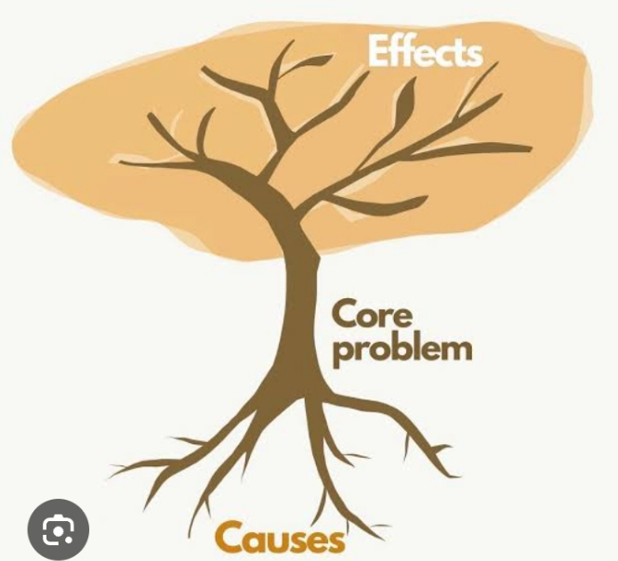

Loss of job and poverty can cause

Beating his wife

Drinking /smoking

Figure 3: 3.1.0 Conflict tree method.

**Pyramid Method**

The pyramid method focuses on the different levels of actors involved in a conflict and their roles:

Base (Grassroots): The general population or communities directly affected by the conflict.

Middle Tier: Organizations, NGOs, and local leaders who act as mediators or facilitators.

Top Tier (Elites): Key decision-makers, such as political leaders, military officials, or influential stakeholders.

This method emphasizes the need for tailored strategies at each level and highlights the interconnectedness between grassroots, intermediary actors, and elites.

**Onion Method**

The onion method involves peeling back the "layers" of a conflict to uncover the different levels of interest and needs:

Positions: What the parties publicly state they want (e.g., demands).

Interests: The reasons or motivations behind their positions.

Needs: The fundamental, non-negotiable requirements that must be met for resolution (e.g., security, identity, or basic survival).

This method is particularly useful in negotiations, as it helps move parties away from rigid positions to addressing deeper interests and needs.

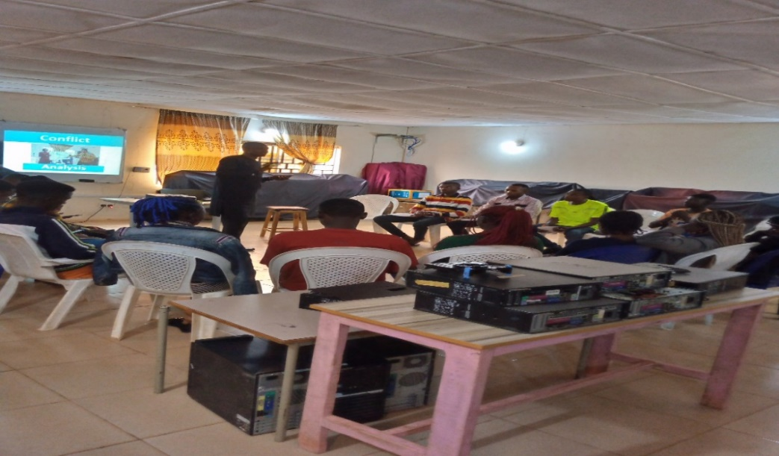

Figure 4: 3.2.0 during one of our Peace Building class.

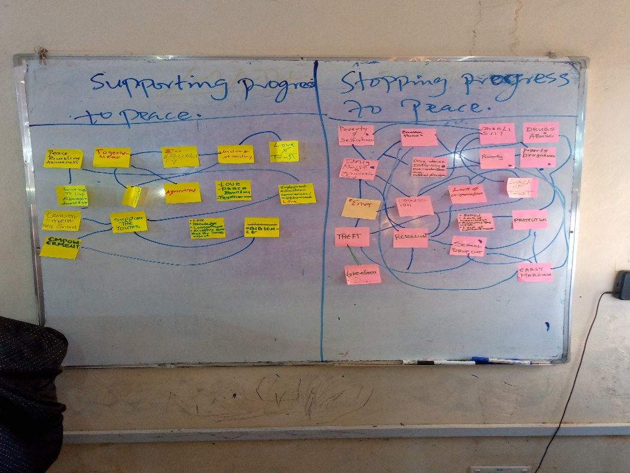

Figure 5: 3.3.0 we built a conflict map.

3.1.4 Lessons I learnt from a book call **life skills facilitator’s manual**

**Definition of Adventure**

I learnt that adventure is a journey filled with opportunities, risks, and rewards.

In my adventure I need to Preparation for the Journey by equipping myself with the right tools and knowledge.

Seek guidance from experienced and trustworthy mentors.

**3.1.5 Always remember that Challenges are Inevitable**

Be prepared to face difficulties and uncertainties along the way.

**Discernment of Voices**

In life, you will encounter many voices and influences.

Learn to identify the right voice one that aligns with truth and purpose.

**Awareness of Danger**

Recognize that dangers and temptations lie ahead.

Approach them with wisdom and caution.

**Faith as a Compass**

The Bible and God should be my ultimate guides.

Never reject God, as He provides direction, strength, and purpose.

This teaches me to approach life thoughtfully, remain anchored in faith, and navigate challenges with confidence. A powerful reminder to keep God at the center of our journey.

**3.1.6 THE GOAL OF PEACE BUILDING**

The goal of **peace building**, as highlighted by Kent Computer Training Center, revolves around creating sustainable peace in post-conflict areas.

**Disarmament**

**Disarmament** involves collecting, securing, and disposing of weapons held by combatants and civilians in a conflict area.

The objective is to reduce the potential for violence by removing tools of war and promoting a sense of security.

Disarmament is a critical first step to ensure safety, build trust among communities, and lay the foundation for reconciliation and peace.

**Demobilization**

Definition: This process involves disbanding armed groups and transitioning combatants from military to civilian life.

To reduce the number of active fighters and reintegrate them into society.

Registering and educating ex-combatants.

Providing psychological support to help them adjust to civilian roles.

It prevents the resurgence of violence and encourages former fighters to become peaceful contributors to their communities.

**Reintegration**

Reintegration is the social, economic, and political process of helping ex-combatants and displaced persons transition back into their communities.

To ensure former combatants and displaced individuals find meaningful roles in society, thus reducing the risk of recidivism into conflict.

This can be done by:

Vocational training and education.

Access to employment and economic opportunities.

Community reconciliation programs to foster acceptance and healing.

Reintegration strengthens community bonds, creates economic stability, and ensures long-term peace.

**Reconstruction**

Reconstruction focuses on rebuilding physical, social, and economic infrastructure destroyed during conflict.

To restore normalcy and improve the quality of life in post-conflict areas.

Components:

Rebuilding schools, hospitals, roads, and homes.

Establishing effective governance and rule of law.

Reviving local economies and creating employment opportunities.

Reconstruction not only repairs the physical damage of war but also addresses the root causes of conflict, promoting stability and development.

**3.1.7 Overall Goal of Peace building**

The ultimate goal is to create a stable, inclusive, and sustainable society where individuals and communities can thrive without the threat of recurring conflict. This process requires collaboration among governments, international organizations, NGOs, and local communities to ensure holistic and lasting peace.

### 3.2 OS INSTALLATION ON DESKTOP COMPUTERS/ TROUBLESHOOTINGSOFTWARE ISSUES.

I learned how to install an operating system on a Windows desktop computer. This process involved preparing the system, configuring BIOS settings, and ensuring a smooth and error-free installation, the steps is as follows:

1. Prepare the bootable DVD.
2. Restart your computer.
3. Enter the BIOS/UEFI setting by pressing F2 for desktop.
4. Set the boot order to prioritize DVD drive.
5. Save changes and exit the BIOS.
6. Begin windows settings

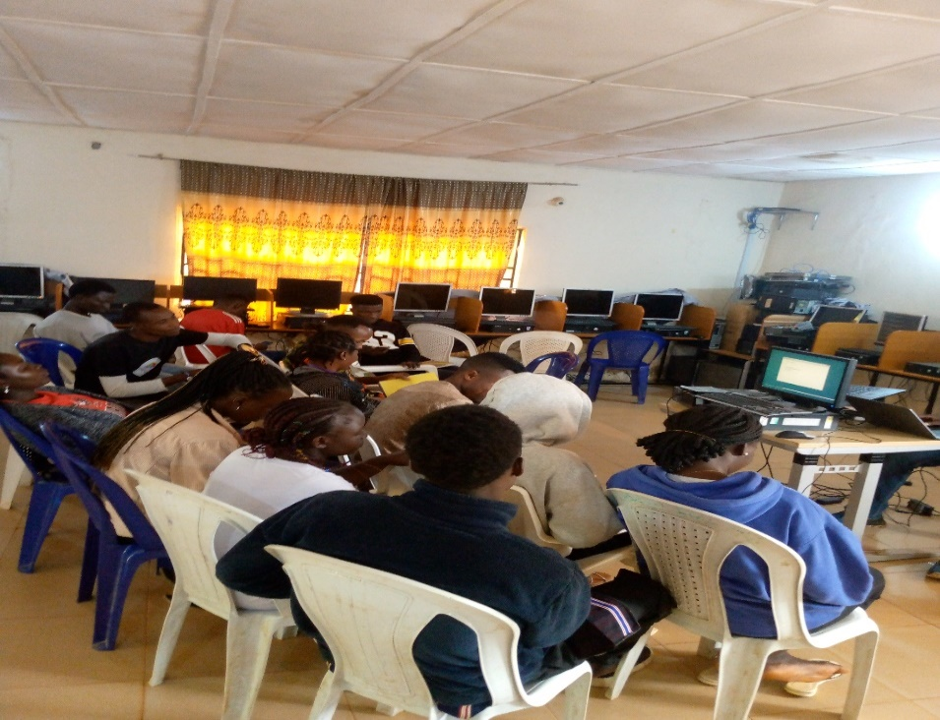

Figure 6: 3.4.0 1during one of our practical class.

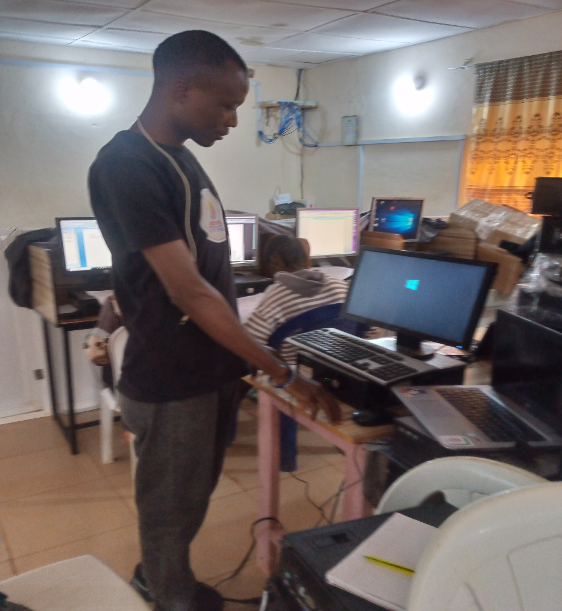

Figure 7: 3.5.0 trying to install OS on window desktop comp.

I also developed **troubleshooting software issues**, which allowed me to address and resolve various software issues. One of thing I learnt is how to fix some common problem with laptop such as external devices not being recognized, blue screen of death, app crashes or freezes, poor Wi-Fi signal, and unexpected shutdown.

**Also learnt the function of:**

Resource Monitor: which monitor system's performance and resource usage, such as CPU, memory, disk, and network activity.

Windows Defender: Scans and removes malicious software that could cause system issues.

These experiences gave me practical knowledge and boosted my confidence in managing and resolving common IT challenges.

### 3.3 INTRODUCTION TO CYBER SECURITY.

Cybersecurity is the practice of protecting individual, organizational and government systems, networks, and data from digital attacks, theft, and damage.

It encompasses a wide range of measures to ensure information remains secure from unauthorized access, misuse, or destruction.

**I learnt that we have offline data & online data**

**Offline Data:**

Information stored locally on devices, such as hard drives, USBs, or paper records.

Protected by physical security measures (e.g., locks, restricted access) and device-level encryption.

**Online Data:**

Information stored or accessed over the internet, such as cloud storage or data shared via email.

Secured using encryption, firewalls, and authentication protocols.

**Foundational Principles of Cyber security**

**Confidentiality**:

Ensuring that only authorized individuals have access to sensitive information.

Techniques include encryption, access controls, and multi-factor authentication.

**Integrity:**

Protecting data from being altered or tampered with by unauthorized entities.

**Availability:**

Ensuring that data and systems are accessible to authorized users when needed.

Achieved through regular maintenance, and protection against denial-of-service (DoS) attacks.

**Stages of Data Protection**

**Processing:**

Safeguarding data while it's being used in applications or analyzed.

Measures include secure coding practices and runtime data encryption.

**Storage:**

Protecting data at rest, such as in databases or on physical drives.

Encryption, backups, and restricted access are commonly used.

**Transmission:**

Securing data as it moves between systems or over networks.

Techniques include Virtual Private Networks (VPNs), and secure file transfer protocols.

**Types of Hackers**

**White Hat:**

Ethical hackers who work to find and fix security vulnerabilities.

Often employed by organizations to improve cybersecurity.

**Black Hat:**

Malicious hackers who exploit vulnerabilities for personal or financial gain.

Their actions are illegal and harmful.

**Gray Hat:**

Individuals who fall between white and black hats.

They may exploit vulnerabilities without permission but not for malicious purposes, often revealing their findings to the affected party.

**Sources of Cyber Attacks**

**Internal Threats:**

Attacks originating from within the organization, such as employees or careless insiders.

Examples: unauthorized access, leaking sensitive information.

**External Threats:**

Attacks initiated by individuals or groups outside the organization.

Examples: hacking, phishing, ransom ware.

**Methods of Infiltration**

**Social Engineering:**

Manipulating individuals into divulging confidential information.

Examples: phishing emails, pretexting, baiting.

**Denial of Service (DoS):**

Overloading a system with excessive requests, making it unavailable to users.

A Distributed Denial of Service (DDoS) attack involves multiple sources.

**SEO Poisoning:**

Using malicious websites to manipulate search engine results.

Victims are tricked into visiting harmful websites.

**Brute Force Attacks:**

Attempting to guess passwords or encryption keys by systematically trying all possible combinations.

Prevented using account lockouts and complex password policies.

I understanding of cyber security principles provides a strong foundation for further exploration. By focusing on protecting data at all stages, identifying potential threats, and recognizing attack methods.

### 3.4 GRAPHIC DESIGN USING COREL DRAW

Introduction to CorelDraw

CorelDraw is a powerful graphic design software widely used for creating vector graphics. I began by familiarizing myself with its interface, understanding how to navigate the workspace, and identifying the various tools. Learning the tools and their functions is a crucial first step for any designer.

Basic Drawing and Color Application

I started with simple tasks like drawing shapes (rectangles, circles, polygons, etc.), which is fundamental for mastering graphic design. Applying colors to these shapes helped me understand color properties, including RGB and CMYK color models, and the importance of color harmony in design.

Color Mixing

Mixing colors gave me insight into creating gradients, shading, and custom palettes, which are essential for adding depth and uniqueness to your designs. This skill is vital when working on branding or ensuring consistency in visual themes.

Working with Text

Typography is a cornerstone of graphic design. I learned to manipulate text, which likely included selecting fonts, adjusting font sizes, aligning text, and formatting text to create visually appealing layouts. I may have explored how to combine text with images for greater impact.

Designing Invitation Cards and Flyers

This practical experience honed my ability to create specific types of graphic design projects.

Invitation Cards: I learned to balance functionality, focusing on layout, font pairing, and appropriate use of colors and decorative elements to suit the occasion.

Flyers: Flyer design helped me understand how to capture attention quickly, convey messages effectively, and use visual hierarchy to guide viewers through the content.

### 3.5 RESPONSIBILITIES/ACTIVITIES CARRIED OUT

During my SIWES placement, I actively contributed to the smooth functioning and maintenance of the organization's ICT infrastructure and supported its educational activities. My responsibilities included:

**Computer Maintenance:**

Performed essential tasks such as installing operating systems and drivers to ensure system units operated efficiently.

Carried out hardware maintenance, including dismantling system units for thorough cleaning using a blower to prevent overheating and maintain performance.

**Technical Support:**

Assisted in powering and maintaining the organization’s generator, ensuring uninterrupted electricity supply critical for day-to-day operations.

**Facility Upkeep:**

I contributed to the cleanliness and organization of the computer lab, creating a conducive environment for learning and productivity.

**Educational Support:**

Supervised students during exams, maintaining order and ensuring adherence to examination protocols.

Assisted instructors in teaching computer fundamentals, providing guidance to students and reinforcing their understanding of basic ICT concepts.

These contributions not only enhanced my technical skills and understanding of IT infrastructure but also improved my teamwork, organizational abilities, and communication skills, all while adding value to the organization's operations and educational services.

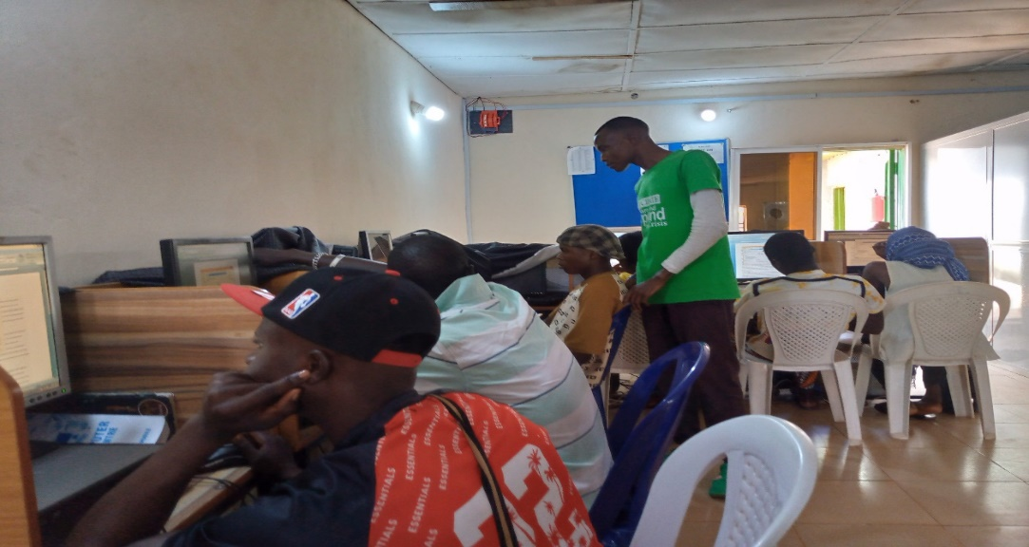

Figure 8: 3.6.0 Assist Student.

### 3.6 CHALLENGES FACE

* Insufficient power supply.
* Difficulties in installation of operating system on desktop computer with **2 RAM**
* Trekking every day, sometimes under rain.
* Financial challenges in taking care of oneself.

### 3.7 HOW I MANAGED TO OVERCOME THE CHALLENGES

**Trekking Every Day, Sometimes under the Rain:** I managed to scale through by maintaining discipline and dedication. I adopted the habit of waking up as early as 5:30AM to prepare and leave for work on time. This helped me avoid unnecessary delays and ensure punctuality despite the difficulties.

**Financial Challenges in Taking Care of Myself:** As a student, the financial burden of meeting daily needs, including transportation, feeding, and other personal expenses, was overwhelming. However, through divine intervention, God raised people who supported me financially. Their assistance provided relief and allowed me to focus on my responsibilities and learning opportunities during the program.

These challenges, though demanding, taught me resilience, discipline, and the importance of seeking and appreciating support during difficult times.

# **CHAPTER FOUR**

### 4.1 CONCLUSION

In conclusion, my SIWES program was an enriching experience that enabled me to acquire valuable skills across multiple disciplines. In peace building, I learned how to analyze and resolve conflicts through methods such as the Conflict Tree, Pyramid, and Onion techniques. These tools enhanced my understanding of conflict dynamics and the importance of flexibility, objectivity, and independence in conflict resolution.

In the realm of IT, I gained hands-on expertise in OS installation, debugging, and troubleshooting software issues, which strengthened my problem-solving abilities and confidence in managing technical challenges. My introduction to cybersecurity provided foundational knowledge about protecting data, identifying threats, and understanding hacker types, preparing me for further exploration of this critical field.

Finally, in graphic design, I learned how applied my skills to create professional invitation cards and flyers, and visual hierarchy. These experiences collectively broadened my knowledge base and equipped me with practical skills that will undoubtedly contribute to my future career development.

### 4.2 RECOMMENDATIONS BASED ON THE SKILLS AND EXPERIENCES.

**4.2.1 Peace building**

**Practical Application**: Engage in community outreach or volunteer programs to apply the conflict resolution methods learned. Collaborate with NGOs or local organizations that focus on peace building.

**Advanced Training**: Consider enrolling in advanced peace building or mediation courses to deepen your expertise.

**Networking**: Join professional organizations or forums dedicated to conflict resolution and peace studies to connect with experts and practitioners in the field.

**4.2.2 OS Installation and Troubleshooting**

**Broaden Technical Knowledge**: Explore additional operating systems (e.g., Linux, macOS) to expand your versatility in IT support.

**Hands-On Practice**: Continue practicing troubleshooting common software and hardware issues to solidify your expertise.

**4.2.3 Cyber security**

**Skill Development**: Dive deeper into cyber security topics, such as ethical hacking, network security, through online platforms like Coursers, Udemy, or Cybrary.

**Practical Experience**: Participate in cyber security challenges or internships to gain hands-on experience and stay updated on emerging threats.

Bottom of Form

# **Reference**

https://mtu.edu.ng/centers/student%27s-industrial-work-experience-scheme

<https://itf.gov.ng/pdf/SIWES%20Work.pdf>