**Login Screen**

This is our Login page where Admin can login.

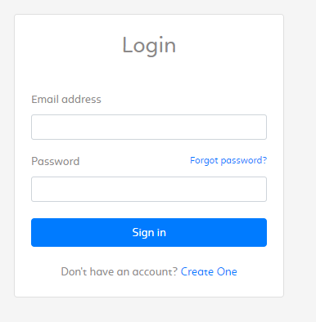

**ABOUT COMPLAINT PORTAL:**

Following is a list of functionalities of the system. More functionalities that you find

appropriate can be added to this list.

1. Admin must have a valid User Id and password to login to the system

2. After the valid user logs in he is shown the list of portal he has with the complaint.

3. On selecting the desired complaint he is taken to a page which shows the present, admin can also change complaint status.

**After login success show complaint lists**

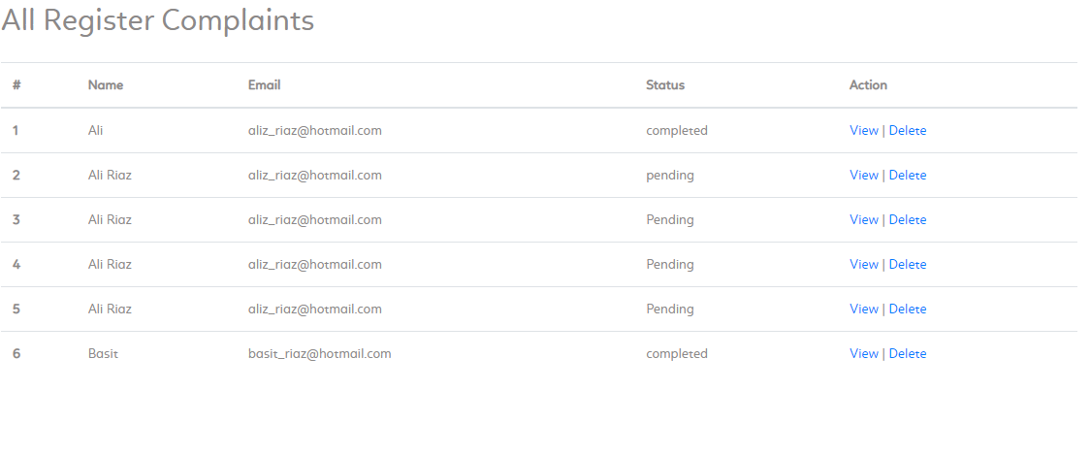

**Admin view to single complaint on click view**

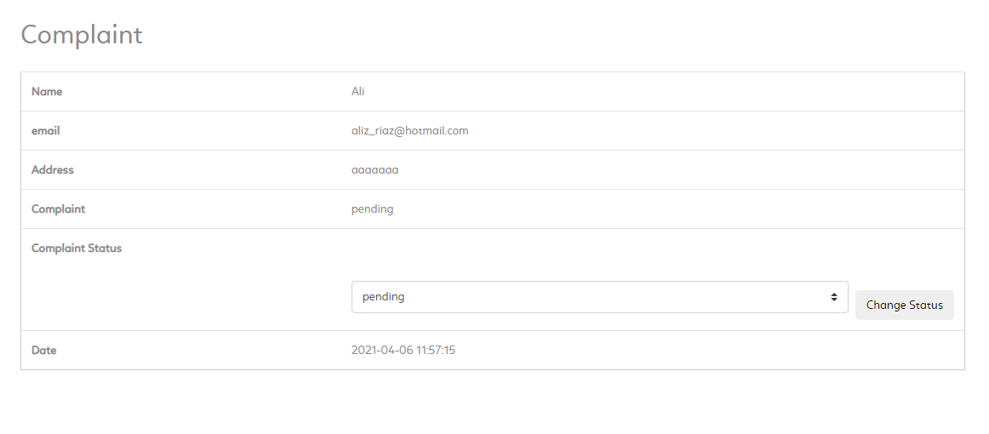

**Admin can change status of complaint**

