Assignment 3: Understanding Algorithm Efficiency and Scalability
Aliza Shrestha
MSCS-532-M70: Algorithms and Data Structures
University of the Cumberlands
Dr. Michael Solomon
September 27, 2026

Introduction
This report examines two fundamental algorithmic techniques: Randomized Quicksort and hashing with chaining. The first part implements Randomized Quicksort, analyzes its expected running time, and compares it empirically with a deterministic Quicksort that always selects the first element as the pivot. The second part implements a hash table that resolves collisions through chaining and supports insertion, search, and deletion. The hash-table implementation also tracks the load factor and dynamically resizes the table to reduce long chains. Together, the experiments illustrate how algorithm design choices affect efficiency and scalability as input characteristics change.

Part 1: Randomized Quicksort

Implementation
The Randomized Quicksort implementation selects a pivot uniformly at random from the current subarray. The selected pivot is swapped with the last element, after which a Lomuto-style partition procedure places values less than or equal to the pivot on the left and larger values on the right. The algorithm then recursively sorts the two resulting subarrays. This implementation correctly handles normal arrays, already sorted arrays, reverse-sorted arrays, arrays containing repeated values, and empty arrays.
For comparison, a deterministic version was implemented using the first element of each current subarray as the pivot. Keeping the overall recursive structure similar makes the pivot-selection strategy the main difference between the two versions.
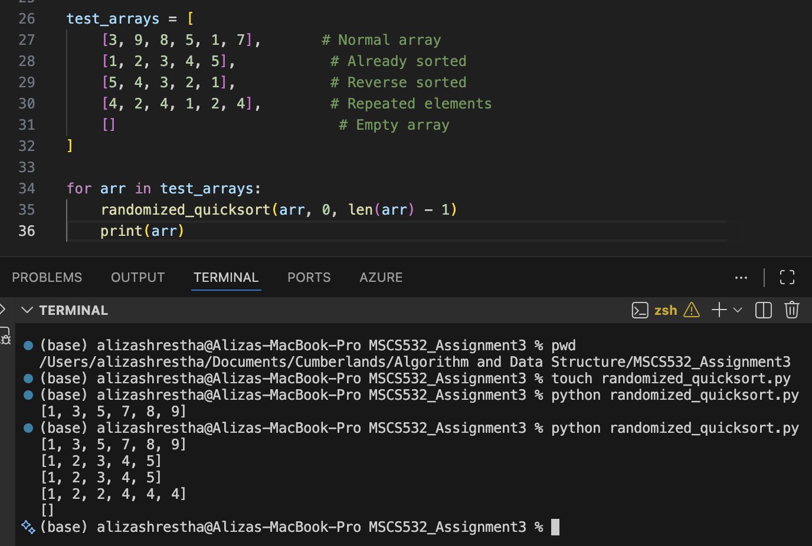
Figure 1
Randomized Quicksort Test Cases and Successful Output

Average-Case Time Complexity
Randomized Quicksort has expected running time O(n log n). One intuitive explanation is that a reasonably balanced pivot divides a problem of size n into smaller subproblems, producing approximately log n levels of recursion, while the total partitioning work across each level is O(n). Therefore, O(n) work per level multiplied by O(log n) levels gives O(n log n). Randomization is important because the pivot choice does not depend on the original ordering of the input (Cormen et al., 2022).
A more rigorous argument can be made using indicator random variables. Assume first that the keys are distinct and label the sorted keys z1 < z2 < ... < zn. Let Xij be an indicator variable that equals 1 if zi and zj are compared during Quicksort and 0 otherwise. Two keys zi and zj are compared only when the first pivot selected from the set {zi, zi+1, ..., zj} is either zi or zj. Since the pivot is chosen uniformly at random, the probability of this event is 2/(j - i + 1).
By linearity of expectation, the expected total number of comparisons is the sum of these probabilities over all pairs of keys. Thus, E[X] = Σ(i<j) 2/(j - i + 1). Grouping pairs by their distance shows that this sum is bounded by a constant multiple of n times the harmonic number Hn. Because Hn = O(log n), the expected number of comparisons is O(n log n). Partitioning work is proportional to the number of comparisons, so the expected running time is also O(n log n) (Cormen et al., 2022).
The worst case remains O(n²) if every selected pivot repeatedly produces a highly unbalanced partition. However, random pivot selection prevents a fixed input ordering, such as already sorted data, from systematically forcing the worst pivot choice. The probability of repeatedly making extreme pivot choices is small, which is why the expected performance is O(n log n).
The implementation uses a two-way partition with the condition arr[j] <= pivot. It sorts repeated values correctly, but duplicate-heavy inputs can still produce unbalanced partitions because values equal to the pivot are placed on the same side. A three-way partition can improve performance when very large numbers of duplicate keys are expected. The empirical results below reflect the behavior of the implemented two-way version rather than hiding this limitation.

Empirical Comparison
The benchmark compared Randomized Quicksort with deterministic first-pivot Quicksort using arrays of 100, 500, and 1,000 elements. Four input types were tested: random arrays, already sorted arrays, reverse-sorted arrays, and arrays with repeated elements. Each algorithm received a copy of the same generated array, and elapsed time was measured with Python's high-resolution performance counter.
Size | Input | Randomized (s) | Deterministic (s)
100 | Random | 0.000200 | 0.000134
100 | Sorted | 0.000178 | 0.000361
100 | Reverse sorted | 0.000170 | 0.000605
100 | Repeated elements | 0.000252 | 0.000182
500 | Random | 0.001073 | 0.000795
500 | Sorted | 0.001060 | 0.009253
500 | Reverse sorted | 0.001165 | 0.015729
500 | Repeated elements | 0.002920 | 0.002837
1000 | Random | 0.002427 | 0.001848
1000 | Sorted | 0.002198 | 0.034176
1000 | Reverse sorted | 0.002462 | 0.063270
1000 | Repeated elements | 0.009811 | 0.009128
Table 1
Measured Execution Times for Randomized and Deterministic Quicksort
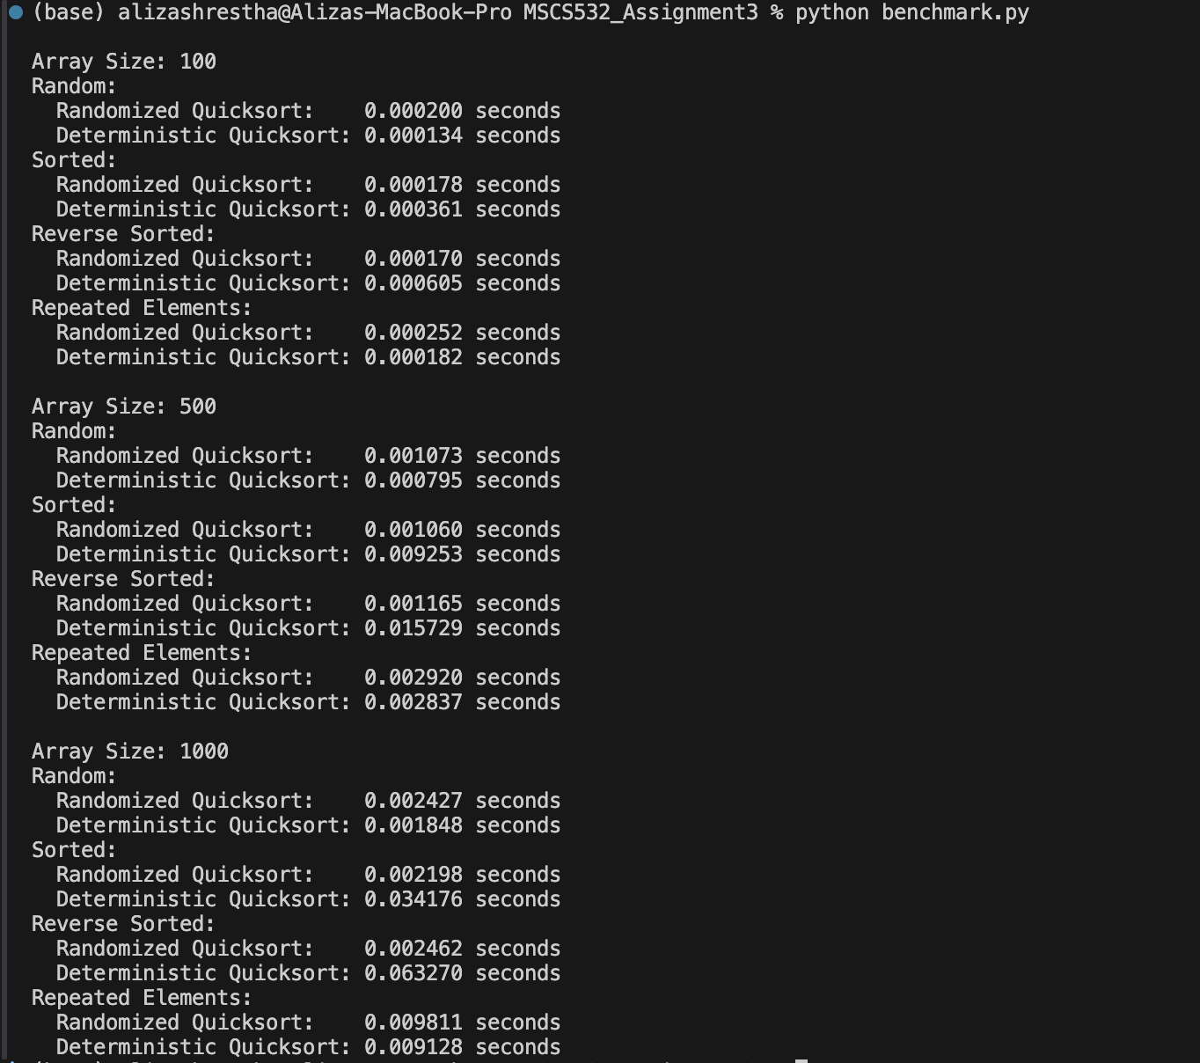
Figure 2
Terminal Output From the Quicksort Benchmark

Discussion of Quicksort Results
The results show the strongest difference on sorted and reverse-sorted inputs. At n = 1,000, deterministic Quicksort required 0.034176 seconds on the sorted array and 0.063270 seconds on the reverse-sorted array, compared with 0.002198 and 0.002462 seconds for Randomized Quicksort. With a first-element pivot, sorted or reverse-sorted data repeatedly creates extremely unbalanced partitions of sizes 0 and n - 1. This behavior produces the familiar worst-case recurrence T(n) = T(n - 1) + Θ(n), which evaluates to Θ(n²). Randomization breaks the connection between the original ordering and the pivot choice, so these ordered inputs do not systematically create the same bad partition sequence.
For random arrays, deterministic Quicksort was slightly faster in these measurements. For n = 1,000, it took 0.001848 seconds compared with 0.002427 seconds for the randomized version. This does not contradict the theoretical analysis. Random input already tends to provide reasonable first pivots, while Randomized Quicksort performs extra work to generate a random index and swap the selected pivot. At these relatively small input sizes, constant-factor overhead can therefore make the deterministic implementation faster even when both exhibit approximately O(n log n) behavior on such inputs.
The repeated-element arrays were slower for both algorithms as the input grew, and the deterministic version was slightly faster in the recorded runs. This result is consistent with the two-way partition scheme used in the implementations: many values equal to the pivot can create less balanced recursive subproblems. The benchmark therefore illustrates an important distinction between correctness and optimal handling of duplicates. Both algorithms correctly sort repeated values, but a three-way partition would be a stronger design for heavily duplicated data.
Small timing differences should also be interpreted cautiously. Execution times can vary because of operating-system scheduling, Python interpreter overhead, random pivot choices, and the exact randomly generated data. Repeating each experiment many times and reporting an average or median would reduce measurement noise. Nevertheless, the large and growing gap on ordered inputs is substantial enough to demonstrate the expected theoretical difference between random pivot selection and a fixed first-element pivot.

Part 2: Hashing with Chaining

Implementation
The hash table stores a list of buckets, and each bucket is itself a list of key-value pairs. A universal-hashing-style function of the form h(k) = ((ak + b) mod p) mod m is used, where p is a large prime, m is the current table size, and a and b are selected randomly when the table is created. The current implementation expects integer keys. If two different keys map to the same bucket index, both key-value pairs are retained in that bucket, which is the chaining collision-resolution technique.
Insertion first hashes the key to a bucket. If the key already exists in that bucket, its value is updated; otherwise, a new key-value pair is appended. Search hashes the key and scans only the corresponding bucket. Delete similarly hashes the key, locates the matching pair in the bucket, removes it, and decreases the stored-item count. These operations demonstrate that keys sharing a bucket do not overwrite one another.

Load Factor and Dynamic Resizing
The load factor is α = n/m, where n is the number of stored key-value pairs and m is the number of buckets. Under the simple uniform hashing assumption, keys are distributed among buckets approximately uniformly, so the expected chain length is α. As α grows, a search or deletion must inspect more entries in its bucket. Keeping α bounded therefore keeps expected operations efficient.
The implementation tracks the number of stored items and computes the current load factor. When α exceeds 0.75 after a new insertion, the table doubles its number of buckets. Existing key-value pairs are then reinserted so that each key is rehashed using the new table size. In the captured test, a table initialized with three buckets eventually grew to twelve buckets after five insertions, leaving a load factor of 5/12, or approximately 0.4167. Dynamic resizing uses O(n) work when a resize occurs, but geometric growth makes resizing infrequent and helps preserve efficient average behavior across many operations.

Expected Complexity Under Simple Uniform Hashing
Under simple uniform hashing, the expected number of elements in a bucket is the load factor α. An unsuccessful search therefore examines an expected Θ(1 + α) elements, including the constant-time hash computation and the expected chain traversal. A successful search has the same asymptotic expected bound, Θ(1 + α).
In this implementation, insertion checks the selected bucket for an existing copy of the key before appending a new pair, so its expected running time is also Θ(1 + α). Deletion must first locate the key in its bucket, giving expected Θ(1 + α) behavior as well. When dynamic resizing keeps α below a constant threshold, these bounds simplify to expected Θ(1) for search, insertion, and deletion. In Python, deleting from the middle of a bucket implemented as a list can also shift later list elements, but the expected bucket length remains bounded when the load factor is controlled.
Collision frequency can be reduced by using a suitable hash function, selecting a table size that provides enough buckets, and resizing when the load factor becomes too high. Chaining ensures that collisions do not cause data loss, while resizing reduces the expected length of each chain. The universal-hashing-style function further reduces dependence on predictable patterns in the integer keys by randomly selecting parameters for each table instance.
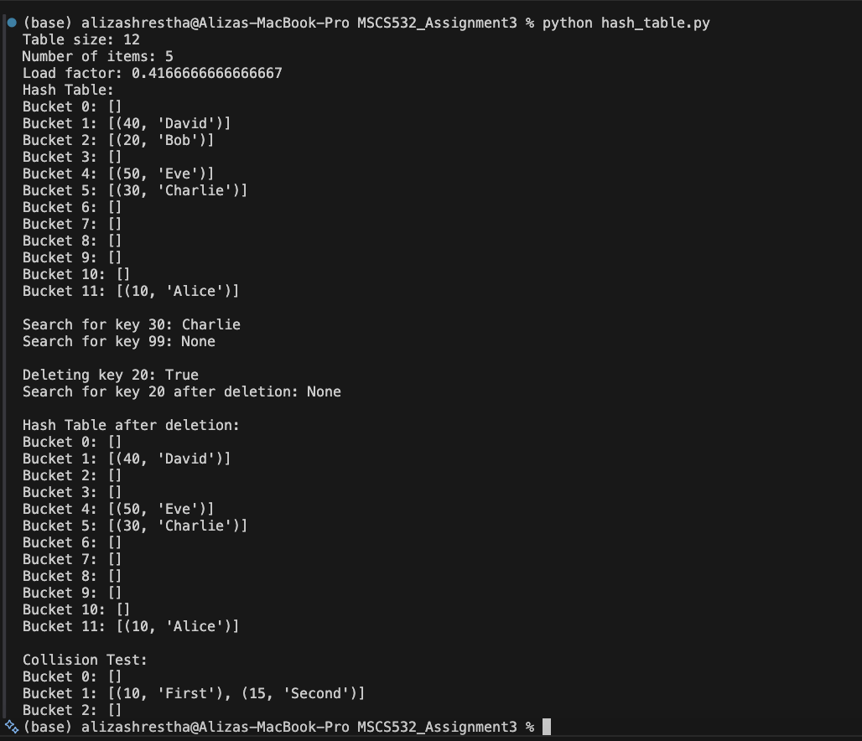
Figure 3
Hash-Table Output Showing Resizing, Search, Deletion, and a Chaining Collision
The collision test provides a direct example of chaining. Keys 10 and 15 both mapped to Bucket 1 in the captured run, producing [(10, "First"), (15, "Second")]. The two records coexist in one bucket rather than one replacing the other. The same output also verifies successful search, unsuccessful search, deletion, and the reduced load factor after resizing.

Conclusion
The implementations and experiments demonstrate how algorithmic choices influence scalability. Randomized Quicksort retains an expected O(n log n) running time because random pivot selection makes persistently poor partitions unlikely for any fixed input ordering. The empirical results support this advantage most clearly for sorted and reverse-sorted arrays, where deterministic first-pivot Quicksort degraded sharply. The hash-table implementation demonstrates chaining as a practical collision-resolution method and shows how load-factor monitoring and dynamic resizing can keep expected bucket lengths small. Under simple uniform hashing and a bounded load factor, search, insertion, and deletion have expected constant-time performance. Overall, both parts show that strong average performance depends not only on the core algorithm but also on pivot strategy, collision handling, and control of data-structure occupancy.
GitHub Repository

The complete Python implementation and README for this assignment are available in the following GitHub repository: https://github.com/aliza57606/MSCS532_Assignment3

References
Cormen, T. H., Leiserson, C. E., Rivest, R. L., & Stein, C. (2022). Introduction to algorithms (4th ed.). MIT Press.

