Quicksort Algorithm: Implementation, Analysis, and Randomization
Aliza Shrestha
University of the Cumberlands
MSCS 532: Algorithms and Data Structures
Dr. Michael Solomon
October 18, 2026c

Quicksort Algorithm: Implementation, Analysis, and Randomization
Quicksort is a divide-and-conquer sorting algorithm that selects a pivot, partitions values around that pivot, and sorts the resulting subarrays. This project compares two Python implementations: deterministic Quicksort, which chooses the final element as the pivot, and randomized Quicksort, which selects a pivot uniformly from the current subarray. The objective was to implement both methods correctly, assess their theoretical complexity, and compare measured running times on different input arrangements (Cormen et al., 2022).

Design Choices
Both algorithms use the same Lomuto-style partition routine to isolate the effect of pivot selection. Values less than or equal to the pivot move to its left; larger values remain to its right. Each public function first copies the input list, so sorting does not change the caller’s data. Choosing the last element as a deterministic pivot makes the implementation straightforward and exposes a clear worst-case pattern for ordered inputs. The randomized version uses a separate random-number generator and accepts an optional seed, allowing reproducible experiments without changing Python’s global random state.
The shared sorting helper recursively processes the smaller partition and handles the larger partition through a while loop. This deliberate choice limits recursive call-stack depth even when partitions are highly unbalanced. The implementation targets lists of integers and uses Python’s built-in list operations for partition swaps.

Implementation Details
In quicksort.py, the _partition function scans the active subarray, tracks the boundary for values less than or equal to the pivot, swaps eligible values into place, and finally positions the pivot at that boundary. The _quicksort function repeats partitioning until each subarray contains at most one element. For randomized Quicksort, the selected pivot is first swapped with the last element so both versions can share the same partition routine.
The demonstration input [9, 3, 7, 1, 5, 3, −2] produced [−2, 1, 3, 3, 5, 7, 9] for both methods while leaving the original list unchanged. The test suite checks empty and one-element lists, negative numbers, duplicates, ordered and reverse-ordered lists, multiple randomized inputs, and consistent results with a fixed random seed. All five tests passed in the local run.
Figure 1
Correct Sorting Results for Both Implementations
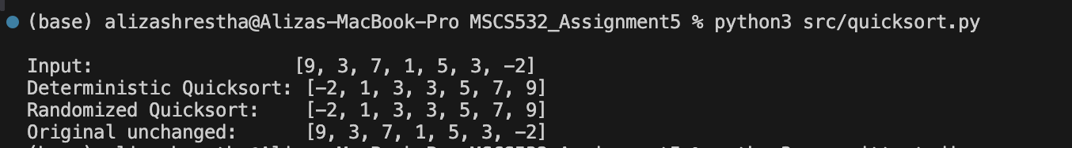
Figure 2
Automated Unit Test Results (Five Tests Passed)
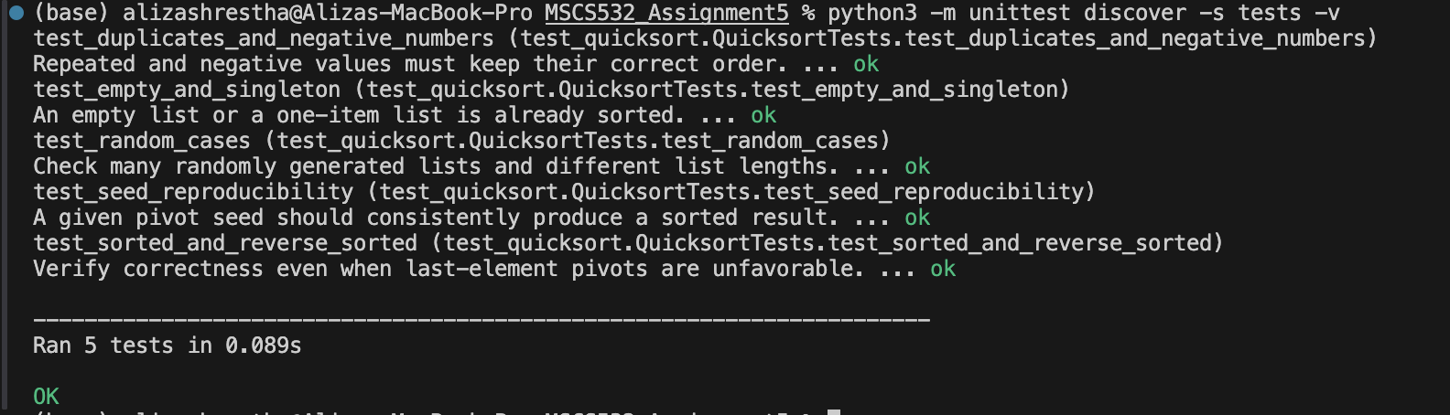

Theoretical Time and Space Complexity
Partitioning a subarray of n elements requires O(n) work. With approximately equal partitions, the recurrence T(n) = 2T(n/2) + O(n) gives O(n log n) time. An unfavorable pivot can instead leave one subarray of size n − 1, giving T(n) = T(n − 1) + O(n) and O(n²) time. Deterministic last-element pivoting encounters this pattern on already sorted and reverse-sorted distinct inputs. Random pivoting makes such consistently unfavorable choices unlikely and has expected O(n log n) running time; however, its worst-case time remains O(n²) (Cormen et al., 2022).
Partitioning rearranges values within the copied list rather than allocating new subarrays. Because the public methods return a copy, they require O(n) additional storage for that list. The smaller-side recursion strategy uses O(log n) auxiliary stack space in the worst case for this implementation, making overall extra space O(n) when the returned copy is included. These bounds distinguish the working partition procedure from the memory required by the public API.

Benchmark Method
The benchmark.py script compares both algorithms on random, sorted, and reverse-sorted integer lists of 100, 400, and 800 elements. Each size-and-distribution combination is timed over five trials using Python 3.14.6 on a MacBook Pro, with a base random seed of 2026. The reported values are average elapsed milliseconds from the most recent local benchmark run. Because the program was run on a general-purpose computer, differences in background workload and runtime conditions can affect results.
Table 1
Mean Execution Time by Input Distribution and Size (Milliseconds)
Input type | n | Fixed pivot | Random pivot
Random | 100 | 0.0467 | 0.0689
Random | 400 | 0.2521 | 0.3091
Random | 800 | 0.5978 | 0.6823
Sorted | 100 | 0.2962 | 0.0599
Sorted | 400 | 4.6251 | 0.2831
Sorted | 800 | 26.5721 | 1.5053
Reverse-sorted | 100 | 0.4882 | 0.1539
Reverse-sorted | 400 | 16.5217 | 2.9781
Reverse-sorted | 800 | 15.1034 | 0.6890
Note. Lower values indicate faster execution. Each value is the mean of five trials, transcribed from the latest local benchmark output (Python 3.14.6; base seed = 2026).

Results and Analysis
For random inputs, fixed-pivot Quicksort was slightly faster at each tested size. At n = 800, it averaged 0.5978 ms, compared with 0.6823 ms for randomized Quicksort. Random pivot selection introduces additional work without necessarily improving a partition that is already reasonably balanced.
On sorted inputs, the fixed-pivot implementation was much slower. At n = 800, it took 26.5721 ms versus 1.5053 ms for the randomized version. For reverse-sorted inputs of the same size, the measurements were 15.1034 ms and 0.6890 ms, respectively. A fixed last-element pivot repeatedly produces uneven partitions on ordered inputs, whereas a random pivot makes such consistently unfavorable splits less likely.
These findings support the theoretical advantage of randomization for ordered input distributions, but do not imply that randomized Quicksort is faster for every sample. Results also contain timing noise: for example, the reverse-sorted fixed-pivot case at n = 400 was measured at 16.5217 ms, slightly above its n = 800 result of 15.1034 ms. Short timings, runtime overhead, and system activity can disrupt monotonic trends. The limited sizes and five-trial sample should not be treated as a broad performance characterization.
Figure 3
Benchmark Output Across Input Distributions
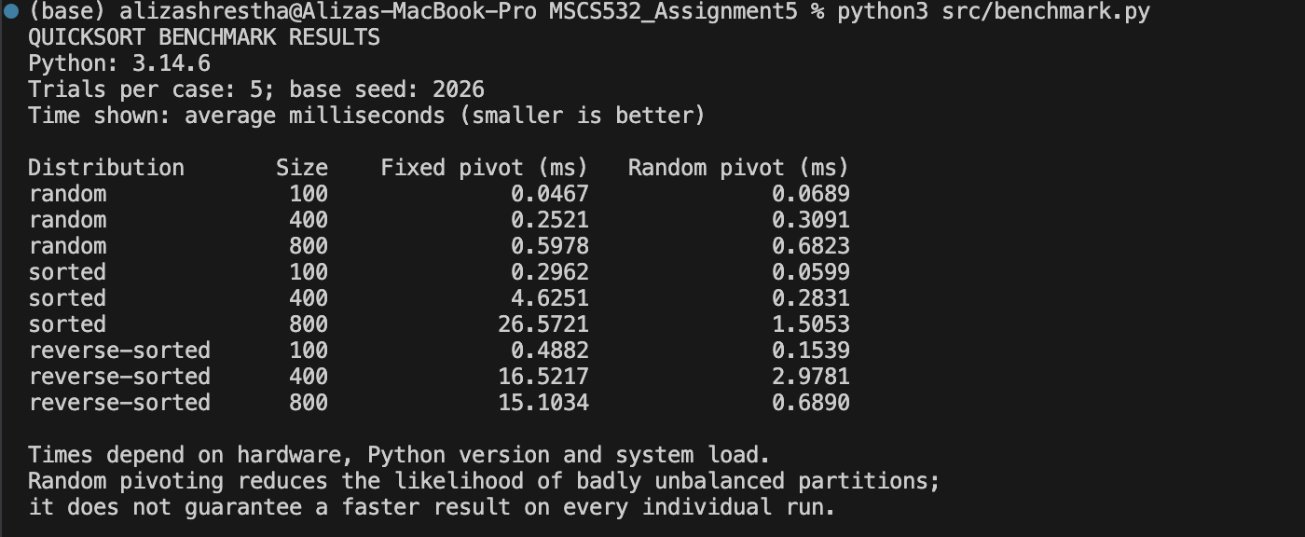

Conclusion
Both implementations correctly sort the tested data and preserve the original input. Their main distinction is the pivot-selection rule: the fixed last-element pivot is simple but sensitive to ordered input, while randomized pivot selection substantially reduced running time for sorted and reverse-sorted inputs in these experiments. The results agree with the expected O(n log n) behavior of randomized Quicksort and the O(n²) worst-case behavior of deterministic last-pivot Quicksort. The project demonstrates how a small design decision can affect practical algorithm performance.

References
Cormen, T. H., Leiserson, C. E., Rivest, R. L., & Stein, C. (2022). Introduction to algorithms (4th ed.). MIT Press.
Python Software Foundation. (n.d.). time — Time access and conversions. Python documentation. https://docs.python.org/3/library/time.html#time.perf_counter

