Selection Algorithms and Elementary Data Structures: Implementation and Analysis
Aliza Shrestha
University of the Cumberlands
MSCS-532: Algorithms and Data Structures
Dr. Michael Solomon
November 1, 2026

Selection Algorithms and Elementary Data Structures: Implementation and Analysis
Selecting a ranked element and storing collections are closely related design problems: both require balancing computational work, memory, and predictability. This project implements two selection algorithms and five basic data-structure abstractions in Python without relying on external packages. The selection benchmark and automated tests are included in the repository so the reported outcomes can be checked independently.

Part 1: Selection Algorithms
Both selection functions accept a sequence and a zero-based index k. Thus, k = 0 means the minimum, and k = n // 2 gives the upper median for even-sized inputs. They first reject empty data and out-of-range indices. Neither modifies the caller’s collection. Their three-way partitioning separates values smaller than, equal to, and greater than the pivot, so repeated values are treated as a single equal block.
Median of Medians divides the current items into groups of at most five, sorts these small groups, selects the median of their medians recursively, and partitions around that pivot. Because a constant fraction of values can be excluded after partitioning, the recurrence is T(n) ≤ T(n/5) + T(7n/10 + O(1)) + O(n), giving O(n) worst-case time (Cormen et al., 2022). Fixed group sorting and extra recursive processing add constants, however, so the guarantee does not imply that each measured run is faster.
Randomized Quickselect instead chooses a pivot uniformly from the current subproblem. It retains only the partition containing rank k and repeats. Its expected work is O(n), but unfortunate pivots on successive passes may produce O(n²) work. A seeded local random generator makes each experiment repeatable. Both versions in this project create new partition lists: they therefore use O(n) auxiliary space rather than the O(1) partition workspace possible in an in-place Quickselect implementation. The deterministic recursion also adds O(log n) stack depth with a balanced pivot guarantee; temporary partition allocations dominate storage.

Benchmark Method and Empirical Findings
The benchmark uses Python’s perf_counter_ns() and reports the median of seven timed repetitions in milliseconds for each combination. Input sizes were 100, 500, 1,000, and 3,000; datasets were random, sorted, reversed, and duplicate-heavy. The user executed python3 benchmark.py --repeats 7 --seed 2026 on a Mac, and the output confirmed that results/benchmark.csv was saved. The four n = 3,000 comparisons appear in Table 1; Appendix Figure 4 shows the terminal output with all measured cases.
Table 1
Observed median runtime at n = 3,000 (milliseconds)
Input pattern | Median of Medians | Randomized Quickselect
Random | 1.02438 | 0.28563
Sorted | 0.83813 | 0.32683
Reversed | 0.83621 | 0.34796
Duplicates | 0.38100 | 0.24054
Note. Numbers are transcribed from the supplied terminal benchmark screenshot (seven repeats, seed 2026), in milliseconds; lower is faster. The benchmark wrote results/benchmark.csv on the user’s Mac. All four patterns were measured at n = 100, 500, 1,000, and 3,000 (32 algorithm/pattern/size combinations).
On the user’s Mac, randomized Quickselect finished sooner for every n = 3,000 distribution. For random inputs it took 0.28563 ms versus 1.02438 ms for Median of Medians (about 3.59 times faster). On sorted and reversed inputs the randomized approach took 0.32683 ms and 0.34796 ms, compared with 0.83813 ms and 0.83621 ms. The duplicate-heavy case narrowed the gap to 0.24054 ms versus 0.38100 ms. These are empirical results from one machine and benchmark run, not universal speed guarantees. Deterministic selection retains its worst-case linear-time advantage despite greater pivot-selection overhead.

Execution and Correctness Validation
Terminal execution of selection.py returned 5 for both deterministic and randomized selection on [7, 2, 9, 2, 5, 1] with k = 3. The output of structures.py demonstrated dynamic-array insertion, a 2 × 2 matrix update, stack pop, queue dequeue, and linked-list traversal. Running python3 -m unittest discover -s tests -v completed eight tests in 0.012 seconds with OK. The tests covered edge inputs, invalid indices, non-mutation, array and matrix updates, queue wrap-around and growth, linked-list operations, and stack behavior. These observations support correctness for the tested cases, though automated tests do not establish a formal proof for every possible input. Figures 1–3 in the Appendix document these results.

Part 2: Elementary Data Structures
The DynamicArray manages its own capacity and doubles the backing storage when full. It supports O(1) indexed access and amortized O(1) append, while middle insertion or deletion requires shifting up to n values and therefore costs O(n). The Matrix keeps rows of equal width and supports O(1) cell lookup and replacement, with O(rows × columns) possible reorganization cost for row or column updates. Explicit shape checks protect rectangular structure.
ArrayStack stores items at the end of its backing array, giving last-in-first-out operations. ArrayQueue uses a circular buffer and head index rather than removing the first list element; this avoids copying all remaining values on every dequeue. Both give O(1) amortized insertion and O(1) removal, aside from occasional capacity growth. The singly linked list retains head and tail references. Prepending and appending are O(1); reaching or removing a general index is O(n) because each predecessor must be followed in order. Compared with an array-backed queue, a linked-list queue can avoid resizing but requires per-node references and allocation (Cormen et al., 2022).
These differences guide real usage. Arrays suit image matrices and indexed measurements; stacks support undo and depth-first traversal; queues support print jobs or breadth-first search; and linked lists work well for frequent insertions near an already-known node. Linked lists do not automatically outperform arrays: for indexing, iteration locality, and memory overhead, arrays are often preferable. Automated tests check resizing, queue wraparound, linked-list edge deletions, duplicate selections, and invalid inputs. Eight unit-test methods passed in this execution. In summary, the best choice depends on whether guaranteed latency, expected speed, indexed access, or inexpensive updates matter most.

References
Cormen, T. H., Leiserson, C. E., Rivest, R. L., & Stein, C. (2022). Introduction to algorithms (4th ed.). MIT Press.
Python Software Foundation. (n.d.). time — Time access and conversions. https://docs.python.org/3/library/time.html
Python Software Foundation. (n.d.). unittest — Unit testing framework. https://docs.python.org/3/library/unittest.html

Appendix: Terminal Verification Screenshots
Figure 1
Selection algorithms: both implementations return the same fourth-smallest value (zero-based k = 3).
Figure 2
Elementary data structure demonstration: dynamic array, matrix, stack, queue, and linked list.
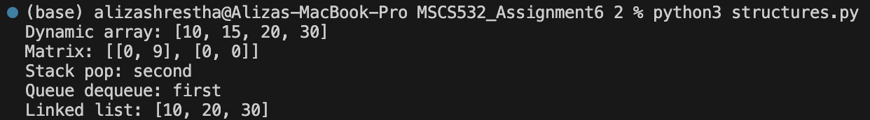
Figure 3
Automated verification: eight unit tests passed in 0.012 seconds.
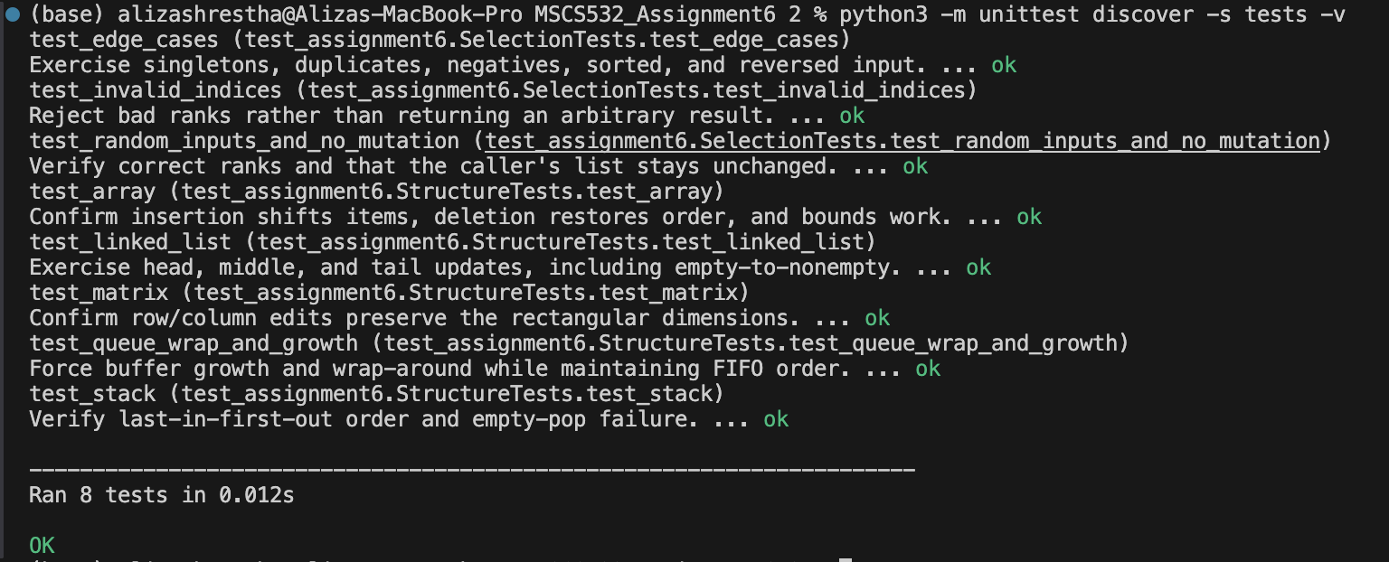
Figure 4
Benchmark execution on the user’s Mac: 32 results across four distributions and four sizes, with CSV saved.


