Employee Weekly Shift Scheduler
Programming Languages: Python and JavaScript
Student: Aliza Shrestha
Course: MSCS 632-M30
Submission date: Oct 18th, 2026

GitHub Repository
Public repository URL: https://github.com/aliza57606/MSCS632_Assignment4.git

Project Overview
This project implements a seven-day employee shift scheduler in Python and JavaScript. Each program loads or collects employee names and ranked daily shift preferences, creates assignments, resolves preference conflicts by considering alternate shifts, and prints a weekly schedule. Both programs enforce two employees per shift, at most one shift per employee per day, and no more than five working days per employee per week.

Validation
The sample input contains 12 employees. The scheduler must cover 42 weekly assignments (7 days × 3 shifts × 2 employees). The submitted programs include automated tests and display a final validation confirmation after successful scheduling.

Python Schedule Output
Figure: Actual captured output from the Python implementation.
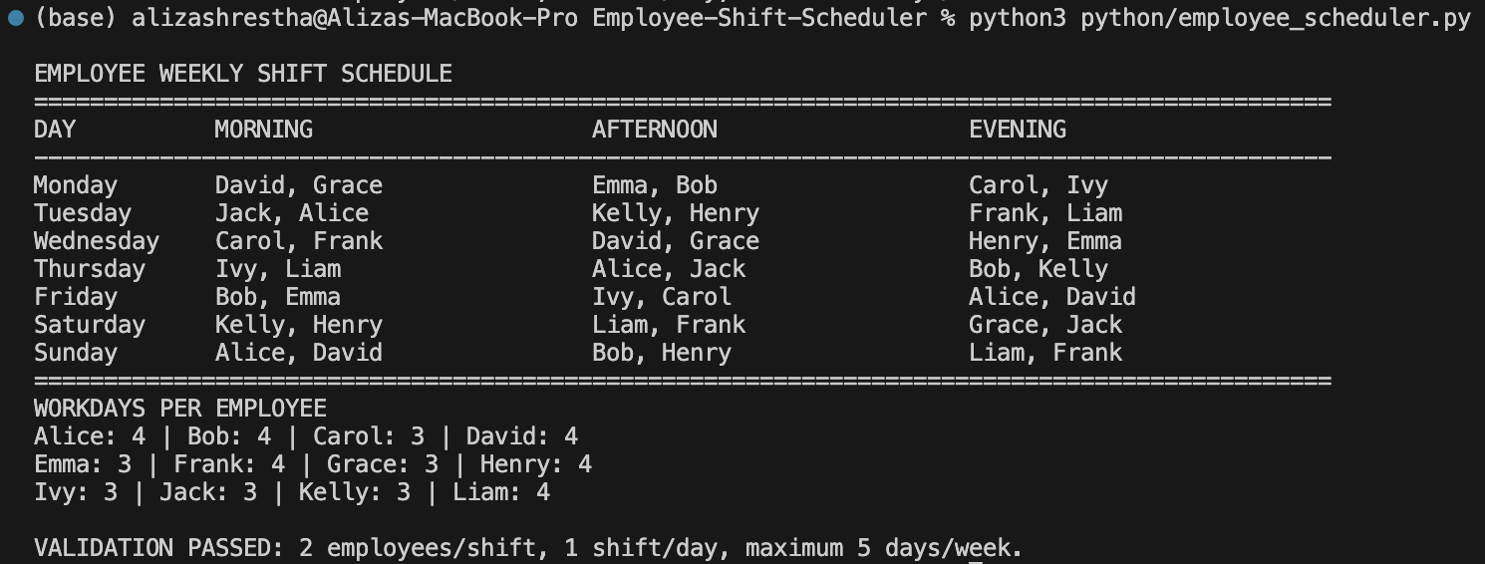

Javascript Schedule Output
Figure: Actual captured output from the Javascript implementation.
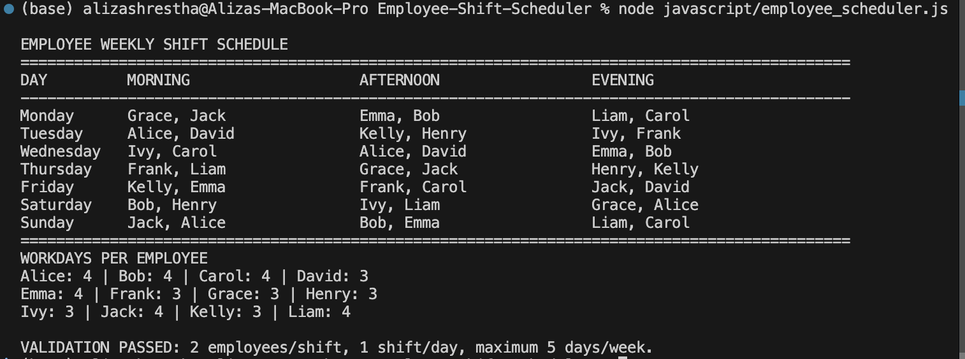

How to Run
Python: python3 python/employee_scheduler.py
JavaScript: node javascript/employee_scheduler.js
More instructions and tests: README.md.

