Credit Card Fraud Detection Using a PyOD AutoEncoder
Aliza Shrestha
University of the Cumberlands
MSCS -633-A01: Advanced Artificial Intelligence
Dr. Ulrich Vouama
October 11, 2026

Credit Card Fraud Detection Using a PyOD AutoEncoder

Introduction
Credit card fraud detection is an anomaly detection problem because fraudulent transactions are rare compared with legitimate activity. This experiment used an AutoEncoder from the Python Outlier Detection (PyOD) library to learn patterns from legitimate transactions and identify suspicious transactions through reconstruction-based anomaly scores. The objective was to implement the model, evaluate its predictions against known fraud labels, and document the results using reproducible Python code and experiment screenshots.

Dataset and Initial Exploration
The Kaggle credit card dataset contained 284,807 transactions and 31 columns: 30 input features and the Class target. Of these transactions, 284,315 (99.83%) were legitimate (Class = 0), and 492 (0.17%) were fraudulent (Class = 1). No missing values were found. The extreme class imbalance makes overall classification accuracy an unreliable standalone indicator of fraud detection quality.
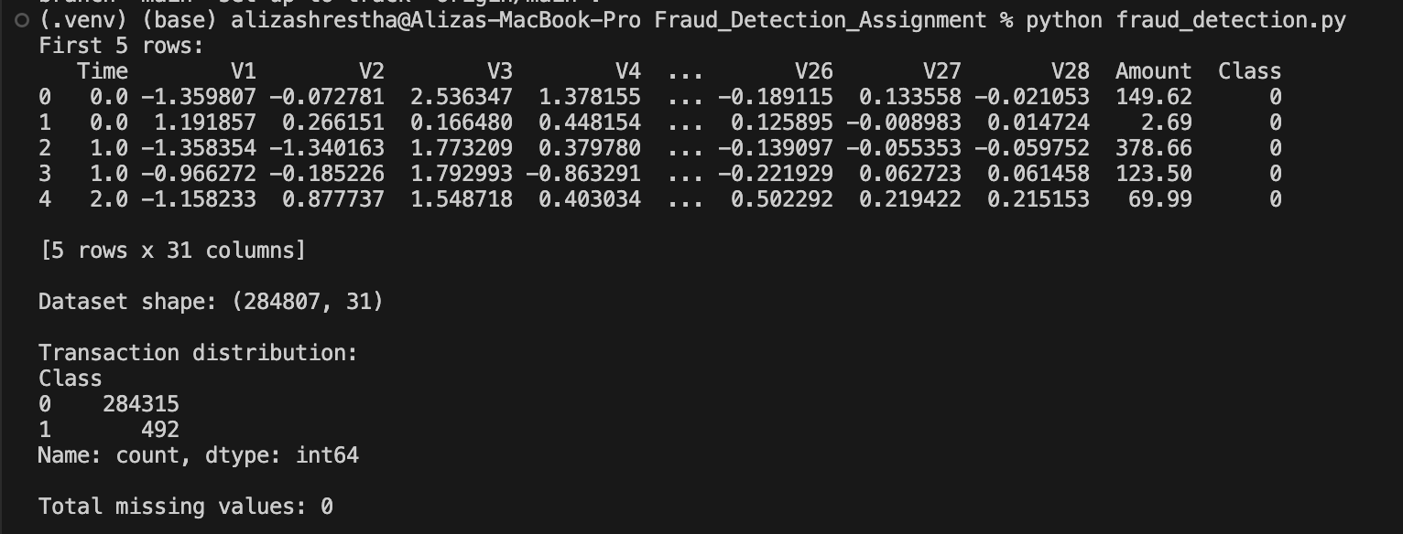
Figure 1. Dataset preview, class distribution, and missing-value check.

Data Preparation and Model Training
The dataset was divided into an 80% training partition and a 20% test partition using stratification to preserve the rare fraud proportion. Only the 227,451 legitimate training records were used to fit the AutoEncoder. The test partition contained 56,962 records, including 98 known fraud cases. A StandardScaler was fitted on legitimate training inputs and then applied to both training and test inputs, preventing information leakage from the test set.
The AutoEncoder used hidden layer sizes of [32, 16, 8, 16, 32], a learning rate of 0.001, a batch size of 256, and 10 epochs. The PyOD contamination parameter was set to 0.00173, with PyOD internal preprocessing disabled because features were already standardized. A random state of 42 supported reproducibility. Training completed in 39.08 seconds in the final screenshot run; training duration varies across runs.
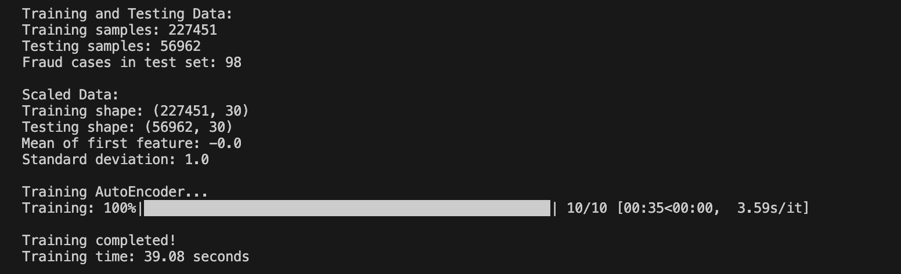
Figure 2. Training and testing sizes, feature standardization, and completed 10-epoch training.

Results
The evaluation used a classification report, confusion matrix, and receiver operating characteristic area under the curve (ROC-AUC). For fraud, precision was 0.26, recall was 0.33, and F1-score was 0.29. ROC-AUC was 0.9542, indicating that anomaly scores generally ranked fraudulent cases above legitimate ones, even though the fixed classification threshold did not recover most fraud cases.
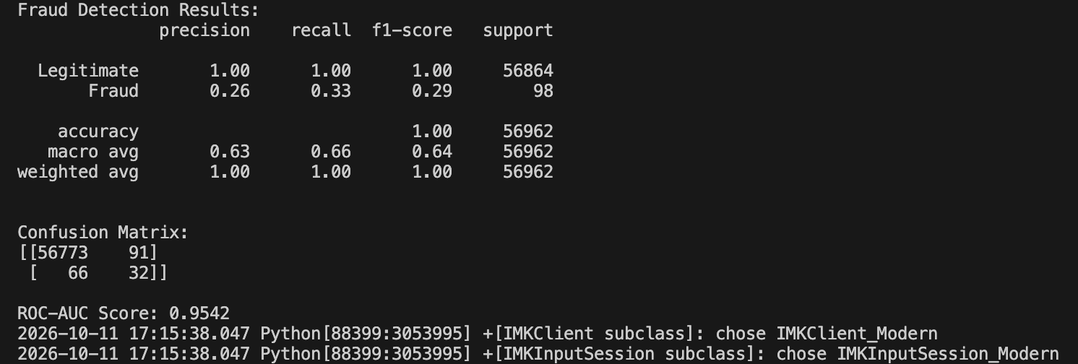
Figure 3. Terminal evaluation output: precision, recall, F1-score, confusion matrix, and ROC-AUC.
The confusion matrix showed 56,773 true negatives, 91 false positives, 66 false negatives, and 32 true positives. Thus, the model detected 32 of the 98 fraudulent transactions (32.65%) while missing 66 (67.35%). Of 123 flagged transactions, 32 were actually fraudulent (26.02%). Although rounded accuracy appeared as 1.00, this mainly reflected the large majority of legitimate transactions.
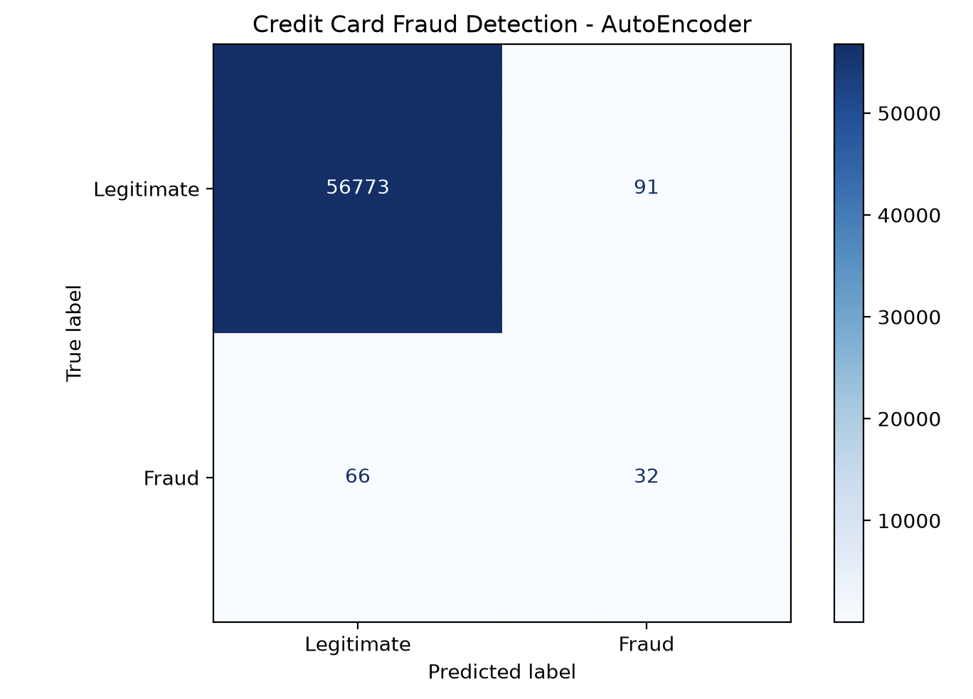
Figure 4. Confusion matrix for legitimate and fraudulent test transactions.

Discussion and Limitations
The results show a meaningful difference between anomaly ranking performance and the decision threshold used to classify fraud. The high ROC-AUC suggests that the model can distinguish many unusual transactions, but recall of 0.33 would be insufficient for a production fraud detection system without further work. Raising sensitivity could recover more fraudulent transactions, but would likely increase false alarms. Threshold selection should therefore be evaluated using a separate validation set, with attention to precision-recall trade-offs and the relative cost of missed fraud.
This experiment used one stratified split, one architecture, and 10 training epochs. It did not include a separate validation partition, cross-validation, cost-sensitive evaluation, or comparison with baseline models. The reported metrics describe this specific experiment and should not be interpreted as evidence of deployment readiness.

Conclusion
The PyOD AutoEncoder successfully trained on legitimate credit card transactions and generated anomaly scores for fraud detection. Its ROC-AUC of 0.9542 was encouraging, but the model identified only 32 of 98 fraud cases at the selected threshold. Future experiments should evaluate thresholds on validation data, examine precision-recall curves, and compare alternative anomaly detection methods. The project source code and dependency manifest are provided in the linked GitHub repository.

Code Repository
https://github.com/aliza57606/MSCS633_Assignment4

References
Packt Publishing. (n.d.). PyOD AutoEncoder example notebook [Jupyter notebook]. GitHub. https://github.com/PacktPublishing/Deep-Learning-and-XAI-Techniques-for-Anomaly-Detection/blob/main/Chapter1/PyOD_autoencoder/chapter1_pyod_autoencoder.ipynb
PyOD contributors. (n.d.). PyOD: A Python library for outlier detection [Computer software]. GitHub. https://github.com/yzhao062/pyod
Whenamancodes. (n.d.). Fraud detection [Data set]. Kaggle. https://www.kaggle.com/datasets/whenamancodes/fraud-detection

