Sir my project is about the detection of aircraft landing speed and detection of tail number during touchdown.

For that I used with HDCVI PTZ camera.

First I tried to interface it with the computer card through a PCI capture card, but it did not give good results then I went for the second approach that was using an XVR.

Composite output vide was connected to XVR through a Rg6 cable and a BNC connector from XVR I connected the cat6 cable to the PC and in PC there is a software that I have installed that is smart PSS software. So, in this way camera was interfaced with the PC to record the videos and for real time purpose as well. XVR has an internal storage of 500 GB and it has very less video lag.

Now coming towards the software part,

Sir I will be using tensorflow object detection API for speed estimation of the aircraft and OCR for tail number detection.

## Question : what is your complete approach towards the project ? like how will you do it ? how will you calculate the speed and how will you detect the tail number at the same time ?

The complete approach is as follows:

1. Airplane detection using an object detection model
2. Speed calculation by difference in positions with respect to frames and depth of the object
3. OCR to detect the tail number

We will achieve this by first using a Tensorflow model to detect the airplane and but a bounding box on it. After that we will find out the relative position of the bounding box in each of the frames in the video with which we can compare and find out the speed of the airplane

Once the airplane is detected and a bounding box is set, we will save the cropped picture and run an OCR on it to find the tail number of the airplane

## Question : if we are doing data training. Then how are you going to do that ?

Initially we will not be needing to train any data at all as we have pretrained object detection model available

Furthermore, if we do need a model for ourselves we will need around 10,000 pictures of airplanes and a tensorflow model made from scratch just for object detection.

## Question : why are you using tensorflow API and why not any other framework ?

This is a personal choice rather than a technical one. Pytorch can be used and achieve the same task but tensorflow is chosen by me as it has a most vast community for help

## Question : why have used deep learning and machine learning or any other approach?

Deep Learning is used for the airplane detection and for OCR for tail detection.

## Question : How have you prepared data like what have you done for classification, detection, and segmentation ?

No, we have not, we have used a pretrained object detection model

## Question : which deep learning model are you using with how many layers ?

We are using the Mobile Net SSD. It has 7 layers.

## Question : how will you achieve good accuracy ?

We are currently using a pretrained model that has an accuracy of 90-95% for airplane detection which is a pretty good accuracy.

## Question : what are the hyperparameters of your model i.e. input size of the image ?

The input size is for our model is 300x300 and in output we get the detected object

[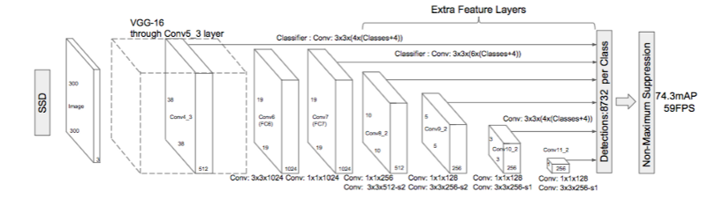](https://user-images.githubusercontent.com/22610163/41813283-79528968-773b-11e8-8069-0494cd59a813.png)

## Question : how image pixel manipulation and calculation is done ?

After the bounding box is set by our model, we get the absolute as well as relative position of the airplane detected. Using this information and the relative position compared to the coming frames, we find out the speed by which the airplane moves across pixels per frame, which in turns tells us the estimated speed of the aircraft

## Question : what is KNN machine learning algorithm ?

K-Nearest Neighbor is a supervised machine learning which is a simple algorithm used for classification and regression problems. It is not being used in this project

## Question : We must update this with a model that can detect aircraft instead of cars and it will be done when we will collect the videos. How will you do that ?

This can be done now but can only be verified once we have some aircraft landing videos

## Question : what kind of changes will be done for the speed calculation and tail number detection of aircraft ?

The only change will be of the model to recognize aircrafts, the rest is the same

## Question : what will you do with the videos once you will record them ?

We will put them in the folder of our project and run the project with that file

## Question : will your code work for the real time purpose ?

Yes, it will give the camera being used is attached to the device

## Question : speed of the aircraft will be quite fast. How will you tackle that ?

We will have a big horizon in the camera while recording the video also we will know how far the aircraft is from the camera which will help us in the calculation of the speed

## Question : why have you kept your camera static and not moving ?

Camera is kept static for the speed prediction formula we are using, which is based on the relative position of the aircraft as compared to other frames

## Question : is there anything to do with height of the camera or angle of the camera etc. ?

Yes, there is, we should know the distance of the camera from the landing strip and should have it set at a single angle to get the most accurate speed of the aircraft.