Practical 5: -

Code:

#include<windows.h>

#include<GL/glu.h>

#include<GL/glut.h>

GLfloat xMin = -0.5, xMax = 0.5, yMin = -0.5, yMax = 0.5;

GLfloat x1 = -0.8, y1 = -0.6, x2 = 0.7, y2 = 0.4;

int Left = 1, Right = 2, Bot = 4, Top = 8;

int C1, C2;

int Clip_Flag = 0, Flag = 1;

int Get_Code(GLfloat x, GLfloat y) {

int Code = 0;

if (x < xMin) Code = Code | Left;

if (x > xMax) Code = Code | Right;

if (y < yMin) Code = Code | Bot;

if (y > yMax) Code = Code | Top;

return Code;

}

void Clip() {

int C;

GLfloat x, y;

if (C1) C = C1;

else C = C2;

if (C & Left) {

x = xMin;

y = y1 + (y2 - y1) * ((xMin - x1) / (x2 - x1));

}

if (C & Right) {

x = xMax;

y = y1 + (y2 - y1) * ((xMax - x1) / (x2 - x1));

}

if (C & Bot) {

y = yMin;

x = x1 + (x2 - x1) * ((yMin - y1) / (y2 - y1));

}

if (C & Top) {

y = yMax;

x = x1 + (x2 - x1) * ((yMax - y1) / (y2 - y1));

}

if (C == C1) {

x1 = x; // Update x1

y1 = y; // Update y1

}

else {

x2 = x; // Update x2

y2 = y; // Update y2

}

}

void Draw() {

glClear(GL_COLOR_BUFFER_BIT);

glColor3f(1, 1, 1);

glBegin(GL_LINE_LOOP);

glVertex2f(xMin, yMin);

glVertex2f(xMax, yMin);

glVertex2f(xMax, yMax);

glVertex2f(xMin, yMax);

glEnd();

glColor3f(1, 0, 0);

if (Flag == 1) {

glBegin(GL_LINES);

glVertex2f(x1, y1);

glVertex2f(x2, y2);

glEnd();

}

while (Clip_Flag == 1) {

C1 = Get_Code(x1, y1);

C2 = Get_Code(x2, y2);

if ((C1 & C2) == 0) {

break;

}

else if ((C1 & C2) != 0) {

Flag = 0;

break;

}

else {

Clip();

}

}

glFlush();

}

void Key(unsigned char ch, int x, int y) {

Clip_Flag = 1;

glutPostRedisplay();

}

int main(int argc, char *argv[]) {

glutInit(&argc, argv);

glutInitWindowSize(500, 500);

glutInitWindowPosition(100, 100);

glutInitDisplayMode(GLUT_RGB | GLUT_SINGLE);

glutCreateWindow("Cohen-Sutherland Algorithm");

glutDisplayFunc(Draw);

glutKeyboardFunc(Key);

glutMainLoop();

return 0;

}

Output:

1.

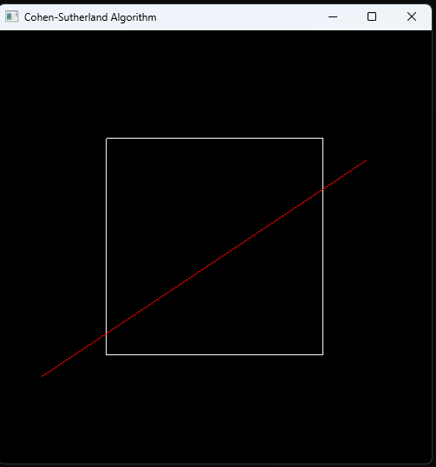

Press Enter

2.

