Practical 6: -

Code:

#include <stdio.h>

#include <math.h>

#include <iostream>

#include <vector>

#include <GL/glut.h>

using namespace std;

int pntX1, pntY1, choice = 0, edges;

vector<int> pntX;

vector<int> pntY;

int transX, transY;

double scaleX, scaleY;

double angle, angleRad;

char reflectionAxis, shearingAxis;

int shearingX, shearingY;

double round(double d) {

return floor(d + 0.5);

}

void drawPolygon() {

glBegin(GL_POLYGON);

glColor3f(1.0, 0.0, 0.0);

for (int i = 0; i < edges; i++) {

glVertex2i(pntX[i], pntY[i]);

}

glEnd();

}

void drawPolygonTrans(int x, int y) {

glBegin(GL_POLYGON);

glColor3f(0.0, 1.0, 0.0);

for (int i = 0; i < edges; i++) {

glVertex2i(pntX[i] + x, pntY[i] + y);

}

glEnd();

}

void drawPolygonScale(double x, double y) {

glBegin(GL_POLYGON);

glColor3f(0.0, 0.0, 1.0);

for (int i = 0; i < edges; i++) {

glVertex2i(round(pntX[i] * x), round(pntY[i] * y));

}

glEnd();

}

void drawPolygonRotation(double angleRad) {

glBegin(GL_POLYGON);

glColor3f(0.0, 0.0, 1.0);

for (int i = 0; i < edges; i++) {

glVertex2i(round((pntX[i] * cos(angleRad)) - (pntY[i] * sin(angleRad))),

round((pntX[i] * sin(angleRad)) + (pntY[i] * cos(angleRad))));

}

glEnd();

}

void drawPolygonMirrorReflection(char reflectionAxis) {

glBegin(GL_POLYGON);

glColor3f(0.0, 0.0, 1.0);

if (reflectionAxis == 'x' || reflectionAxis == 'X') {

for (int i = 0; i < edges; i++) {

glVertex2i(round(pntX[i]), round(pntY[i] * -1));

}

} else if (reflectionAxis == 'y' || reflectionAxis == 'Y') {

for (int i = 0; i < edges; i++) {

glVertex2i(round(pntX[i] * -1), round(pntY[i]));

}

}

glEnd();

}

void drawPolygonShearing() {

glBegin(GL_POLYGON);

glColor3f(0.0, 0.0, 1.0);

if (shearingAxis == 'x' || shearingAxis == 'X') {

glVertex2i(pntX[0], pntY[0]);

glVertex2i(pntX[1] + shearingX, pntY[1]);

glVertex2i(pntX[2] + shearingX, pntY[2]);

glVertex2i(pntX[3], pntY[3]);

} else if (shearingAxis == 'y' || shearingAxis == 'Y') {

glVertex2i(pntX[0], pntY[0]);

glVertex2i(pntX[1], pntY[1]);

glVertex2i(pntX[2], pntY[2] + shearingY);

glVertex2i(pntX[3], pntY[3] + shearingY);

}

glEnd();

}

void myInit(void) {

glClearColor(1.0, 1.0, 1.0, 0.0);

glColor3f(0.0f, 0.0f, 0.0f);

glPointSize(4.0);

glMatrixMode(GL_PROJECTION);

glLoadIdentity();

gluOrtho2D(-640.0, 640.0, -480.0, 480.0);

}

void myDisplay(void) {

glClear(GL_COLOR_BUFFER_BIT);

glColor3f(0.0, 0.0, 0.0);

if (choice == 1) {

drawPolygon();

drawPolygonTrans(transX, transY);

} else if (choice == 2) {

drawPolygon();

drawPolygonScale(scaleX, scaleY);

} else if (choice == 3) {

drawPolygon();

drawPolygonRotation(angleRad);

} else if (choice == 4) {

drawPolygon();

drawPolygonMirrorReflection(reflectionAxis);

} else if (choice == 5) {

drawPolygon();

drawPolygonShearing();

}

glFlush();

}

int main(int argc, char** argv) {

cout << "Enter Choice\n\n" << endl;

cout << "1. Translation" << endl;

cout << "2. Scaling" << endl;

cout << "3. Rotation" << endl;

cout << "4. Mirror Reflection" << endl;

cout << "5. Shearing" << endl;

cout << "6. Exit" << endl;

cin >> choice;

if (choice == 6) {

return choice;

}

cout << "\n\nFor Polygon:\n" << endl;

cout << "Enter no. of edges: ";

cin >> edges;

for (int i = 0; i < edges; i++) {

cout << "Enter co-ordinates for vertex " << i + 1 << ": ";

cin >> pntX1 >> pntY1;

pntX.push_back(pntX1);

pntY.push_back(pntY1);

}

if (choice == 1) {

cout << "Enter the Translation factor for X and Y: ";

cin >> transX >> transY;

} else if (choice == 2) {

cout << "Enter the scaling factor for X and Y: ";

cin >> scaleX >> scaleY;

} else if (choice == 3) {

cout << "Enter the angle for rotation: ";

cin >> angle;

angleRad = angle * 3.1416 / 180;

} else if (choice == 4) {

cout << "Enter reflection axis (x or y): ";

cin >> reflectionAxis;

} else if (choice == 5) {

cout << "Enter shearing axis (x or y): ";

cin >> shearingAxis;

if (shearingAxis == 'x' || shearingAxis == 'X') {

cout << "Enter the shearing factor for X: ";

cin >> shearingX;

} else {

cout << "Enter the shearing factor for Y: ";

cin >> shearingY;

}

}

glutInit(&argc, argv);

glutInitDisplayMode(GLUT_SINGLE | GLUT_RGB);

glutInitWindowSize(640, 480);

glutInitWindowPosition(100, 150);

glutCreateWindow("Extended Basic Transformations");

glutDisplayFunc(myDisplay);

myInit();

glutMainLoop();

}

Output:

1. Translation

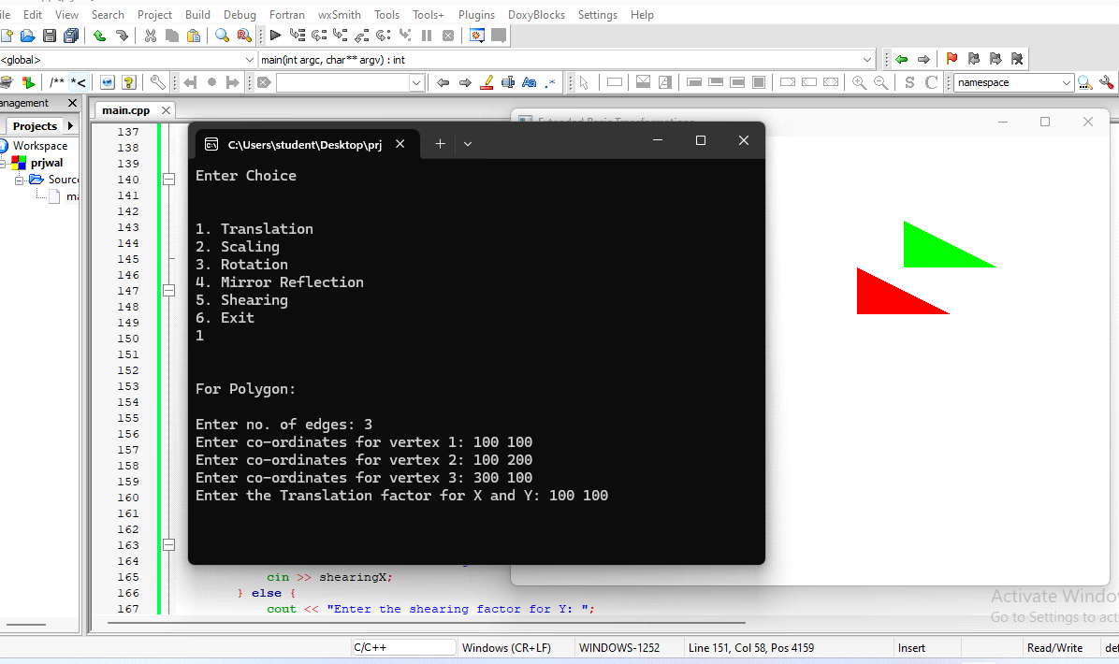

2. Scaling

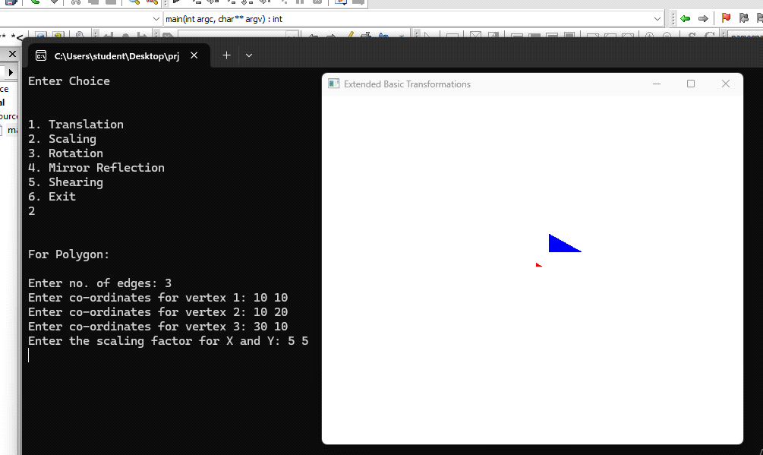

3. Rotation

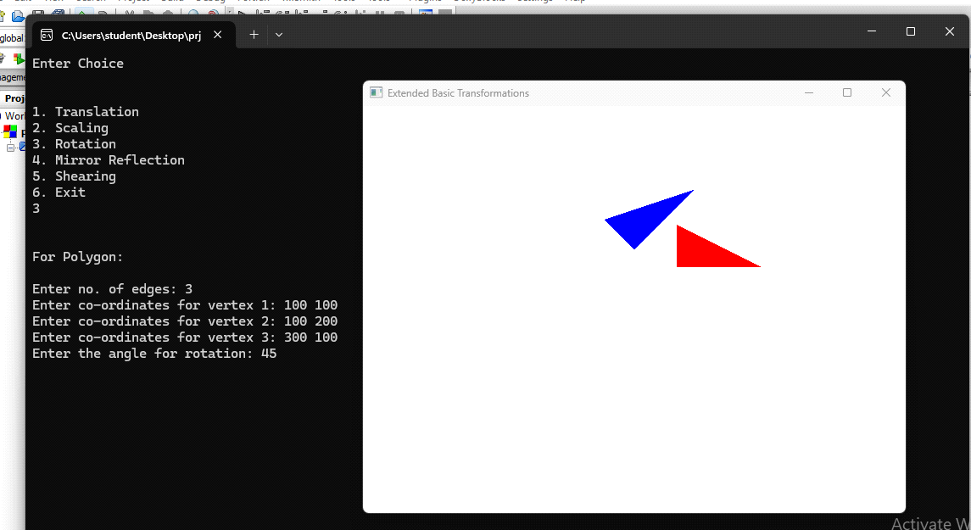

4. Mirror Reflection

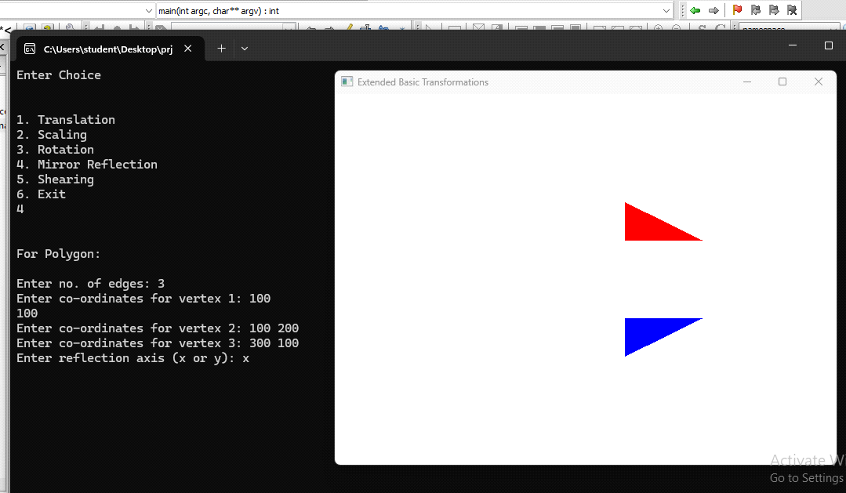

5. Shearing

