## Practical 4:

Code:

#include <iostream>

#include <math.h>

#include <time.h>

#include <GL/glut.h>

using namespace std;

void delay(float ms) {

clock_t goal = ms + clock();

while(goal > clock());

}

void init() {

glClearColor(1.0, 1.0, 1.0, 0.0);

glMatrixMode(GL_PROJECTION);

gluOrtho2D(0, 640, 0, 480);

}

void bound_it(int x, int y, float* fillColor, float* bc) {

float color[3];

glReadPixels(x, y, 1.0, 1.0, GL_RGB, GL_FLOAT, color);

if ((color[0] != bc[0] || color[1] != bc[1] || color[2] != bc[2]) &&

(color[0] != fillColor[0] || color[1] != fillColor[1] || color[2] != fillColor[2])) {

glColor3f(fillColor[0], fillColor[1], fillColor[2]);

glBegin(GL_POINTS);

glVertex2i(x, y);

glEnd();

glFlush();

bound_it(x + 1, y, fillColor, bc);

bound_it(x - 1, y, fillColor, bc);

bound_it(x, y + 1, fillColor, bc);

bound_it(x, y - 1, fillColor, bc);

}

}

void mouse(int btn, int state, int x, int y) {

y = 480 - y;

if (btn == GLUT_LEFT_BUTTON) {

if (state == GLUT_DOWN) {

float bCol[] = {1, 0, 0};

float color[] = {0, 0, 1};

bound_it(x, y, color, bCol);

}

}

}

void world() {

glLineWidth(3);

glPointSize(2);

glClear(GL_COLOR_BUFFER_BIT);

glColor3f(1, 0, 0);

glBegin(GL_LINE_LOOP);

glVertex2i(150, 100);

glVertex2i(300, 300);

glVertex2i(450, 100);

glEnd();

glFlush();

}

int main(int argc, char **argv) {

glutInit(&argc, argv);

glutInitDisplayMode(GLUT_SINGLE | GLUT_RGB);

glutInitWindowSize(640, 480);

glutInitWindowPosition(200, 200);

glutCreateWindow("Polygon Boundary Fill");

glutDisplayFunc(world);

glutMouseFunc(mouse);

init();

glutMainLoop();

return 0;

}

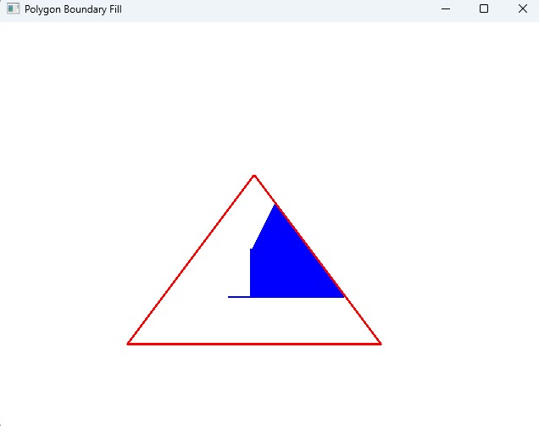Output: