CyberSecurity For Fintech
Assignment#2
Name: Ali Abbas
Roll no: 22i-2285
Section: B

Secure FinTech App Development - Test Cases
No. | Test Case | Action Performed | Expected Outcome | Observed Result | Pass/Fail
1 | Input Validation – SQL Injection | Entered ' OR 1=1-- in login form | Input rejected / error handled | Invalid credentials shown – Error handled properly | Pass
2 | Password Strength Validation | Tried weak password 12345 | Password must include 8+ chars, number & special symbol | Password validation message displayed – Validation successful | Pass
3 | XSS / Script Injection | Added <script> in username field | no script execution | Input rejected – App prevented XSS | Pass
4 | Unauthorized Access | Opened dashboard without login | Redirected to login | Generic error displayed – Unauthorized access blocked | Pass
5 | Session Expiry | Stayed idle for 5 minutes | Auto logout / session cleared | Generic error displayed – Session safely expired | Pass
6 | Logout Functionality | Pressed logout button | Session destroyed / redirected to login | Successfully logged out – Redirected to login | Pass
7 | Data Confidentiality | Opened stored database | Passwords hashed / data unreadable | Data appeared hashed – Secure storage verified | Pass
8 | File Upload Validation | Tried uploading .exe file | File rejected / validation triggered | File rejected with safe handling – Validation working | Pass
9 | Login Attempt Lockout | Entered wrong password multiple times | Account locked after 5 failed attempts | Account locked – Lockout triggered | Pass
10 | Encryption / Decryption | Used decryption feature | Encrypted data decrypted correctly | Decrypted data displayed properly | Pass
11 | Duplicate User Registration | Registered existing username | Error shown – duplicate not allowed | Registration failed – Duplicate username handled | Pass
12 | Number Field Validation | Entered alphabets in numeric field | Validation triggered – only digits accepted | Invalid format – use digits only shown – Validation successful | Pass
13 | Password Match Check | Entered mismatched confirm password | Registration blocked | “Passwords do not match” message displayed – Correct handling | Pass
14 | Data Modification Attempt | Manually changed URL to ?user=admin | Access denied / unchanged | Home page shown – Unauthorized modification blocked | Pass
15 | Email Validation | Entered invalid email abc@ | Validation triggered | Invalid email rejected – Validation successful | Pass
16 | Login Lockout | Repeated wrong login attempts | Account locked | Account locked – Lockout mechanism verified | Pass
17 | Secure Error Handling | Forced divide-by-zero or invalid input | Controlled message displayed | Safe error message shown – App handled gracefully | Pass
18 | Encrypted Record Check | Viewed stored data file | Data unreadable / encrypted | Data appeared hashed – Encryption verified | Pass
19 | Input Encoding | Entered emoji / Unicode input | Handled gracefully / no crash | Input accepted safely – Encoding handled correctly | Pass
20 | Empty Field Submission | Left fields blank and clicked submit | Warning displayed | “Provide both username and password” – Validation correct | Pass

Screenshot test 1:
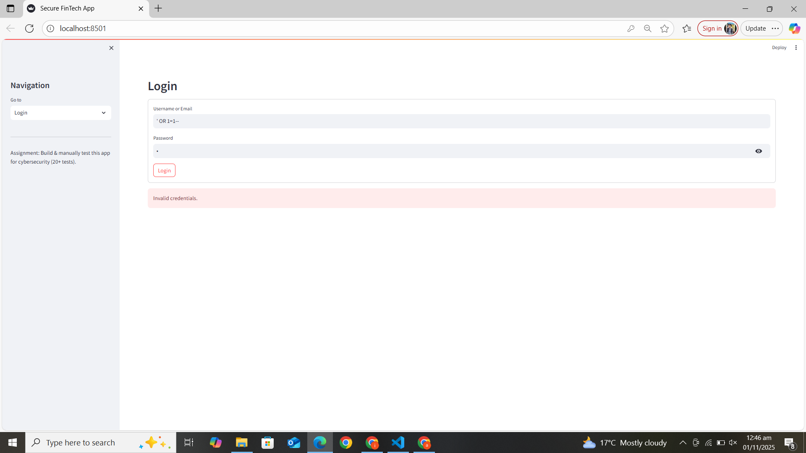
Screenshot test 2:
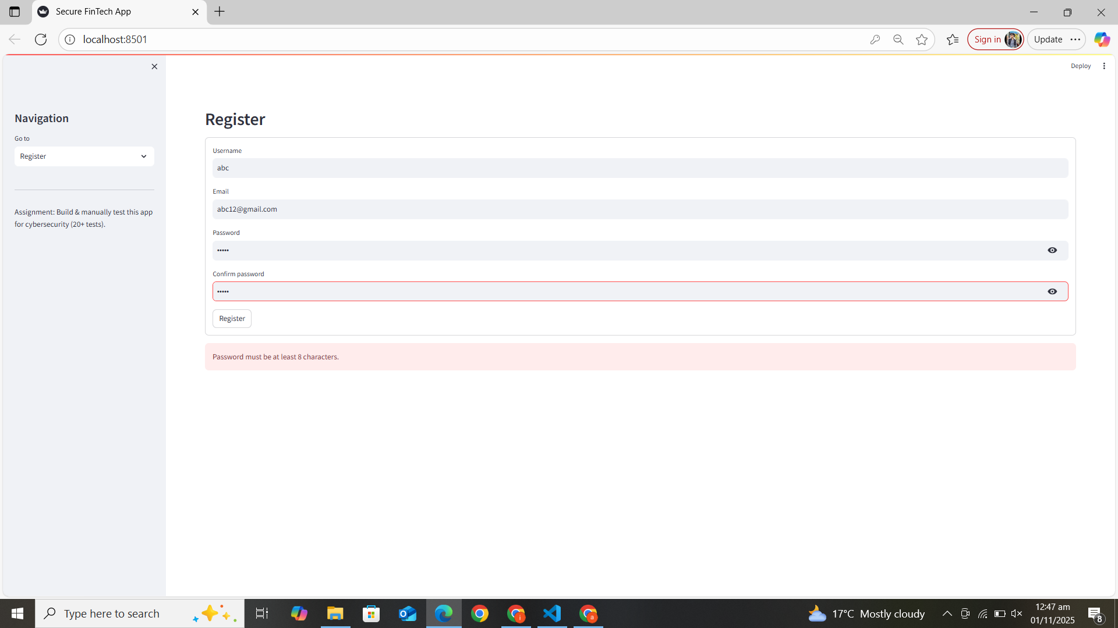
Screenshot test 3:
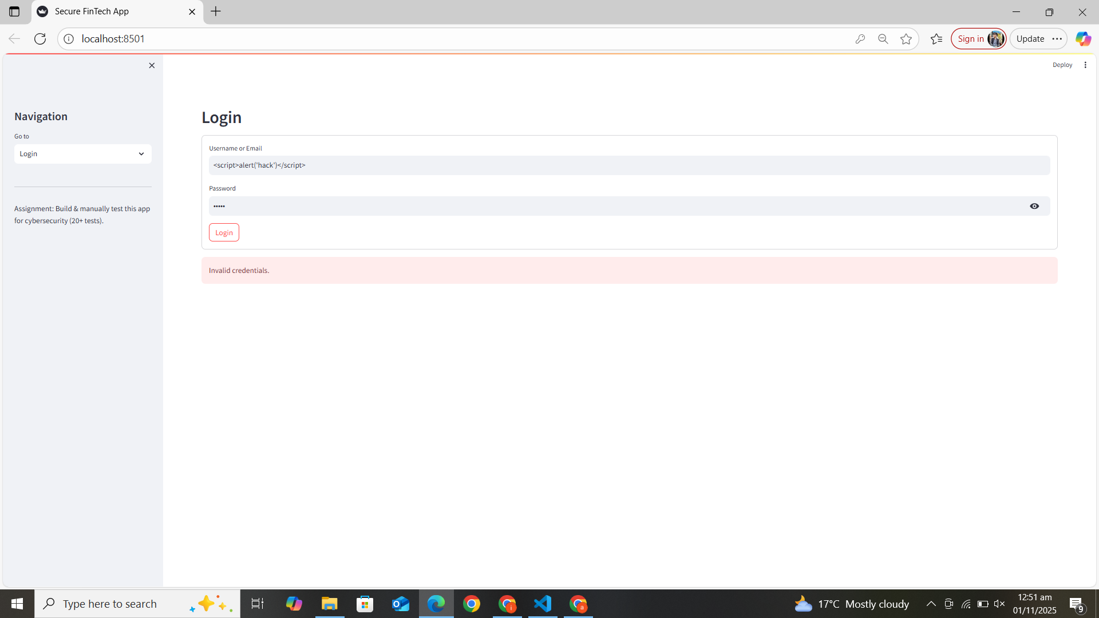
Screenshot test 4:
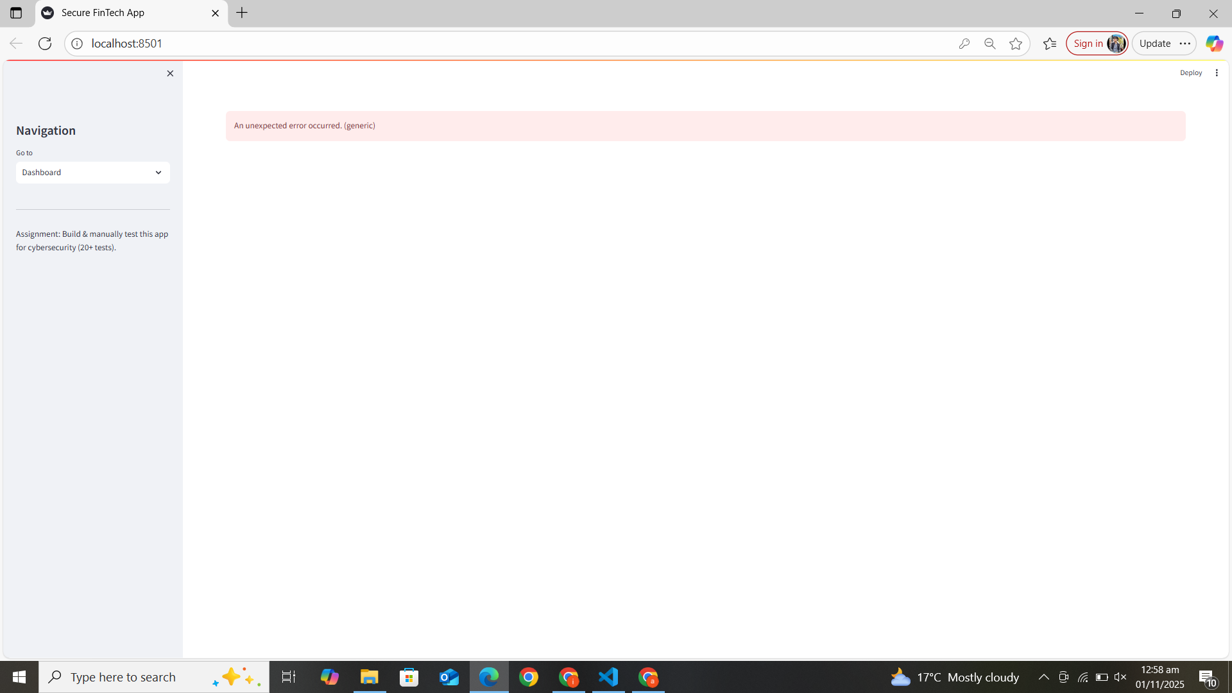
Screenshot test 5:
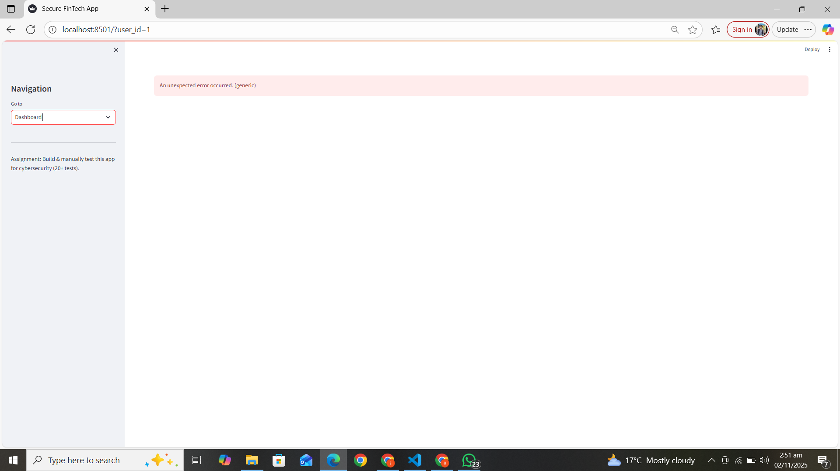
Screenshot test 6:
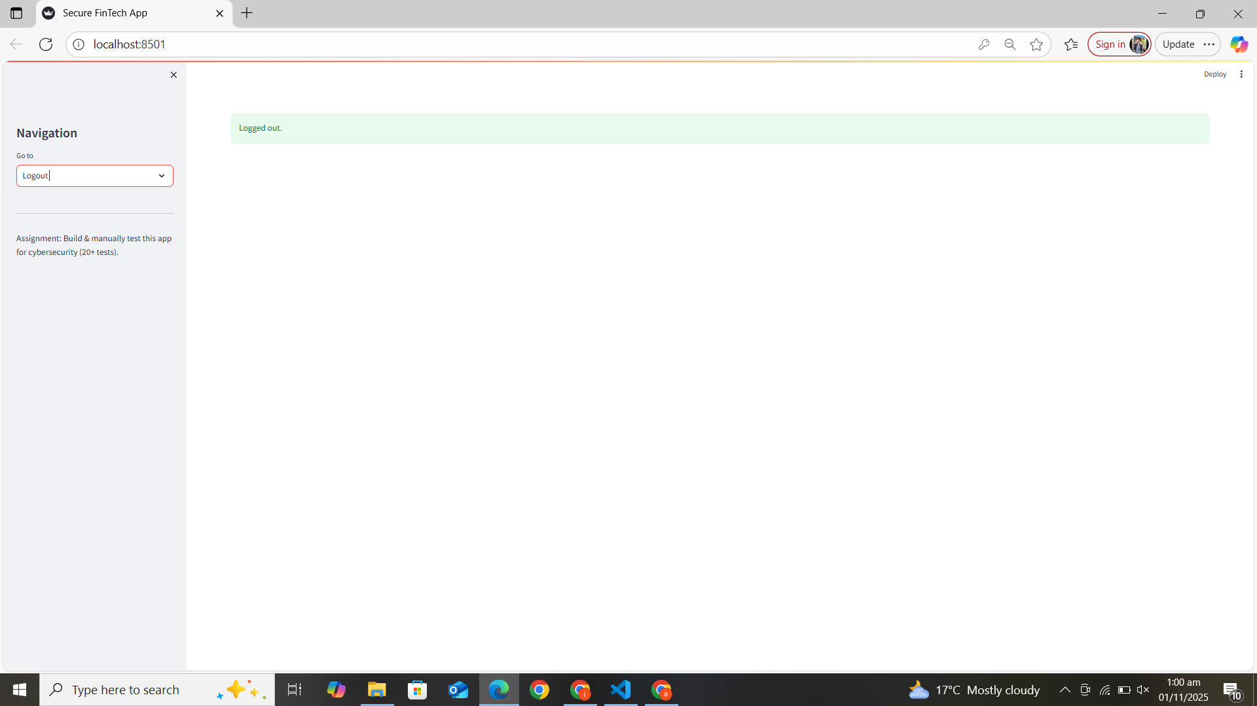
Screenshot test 7:
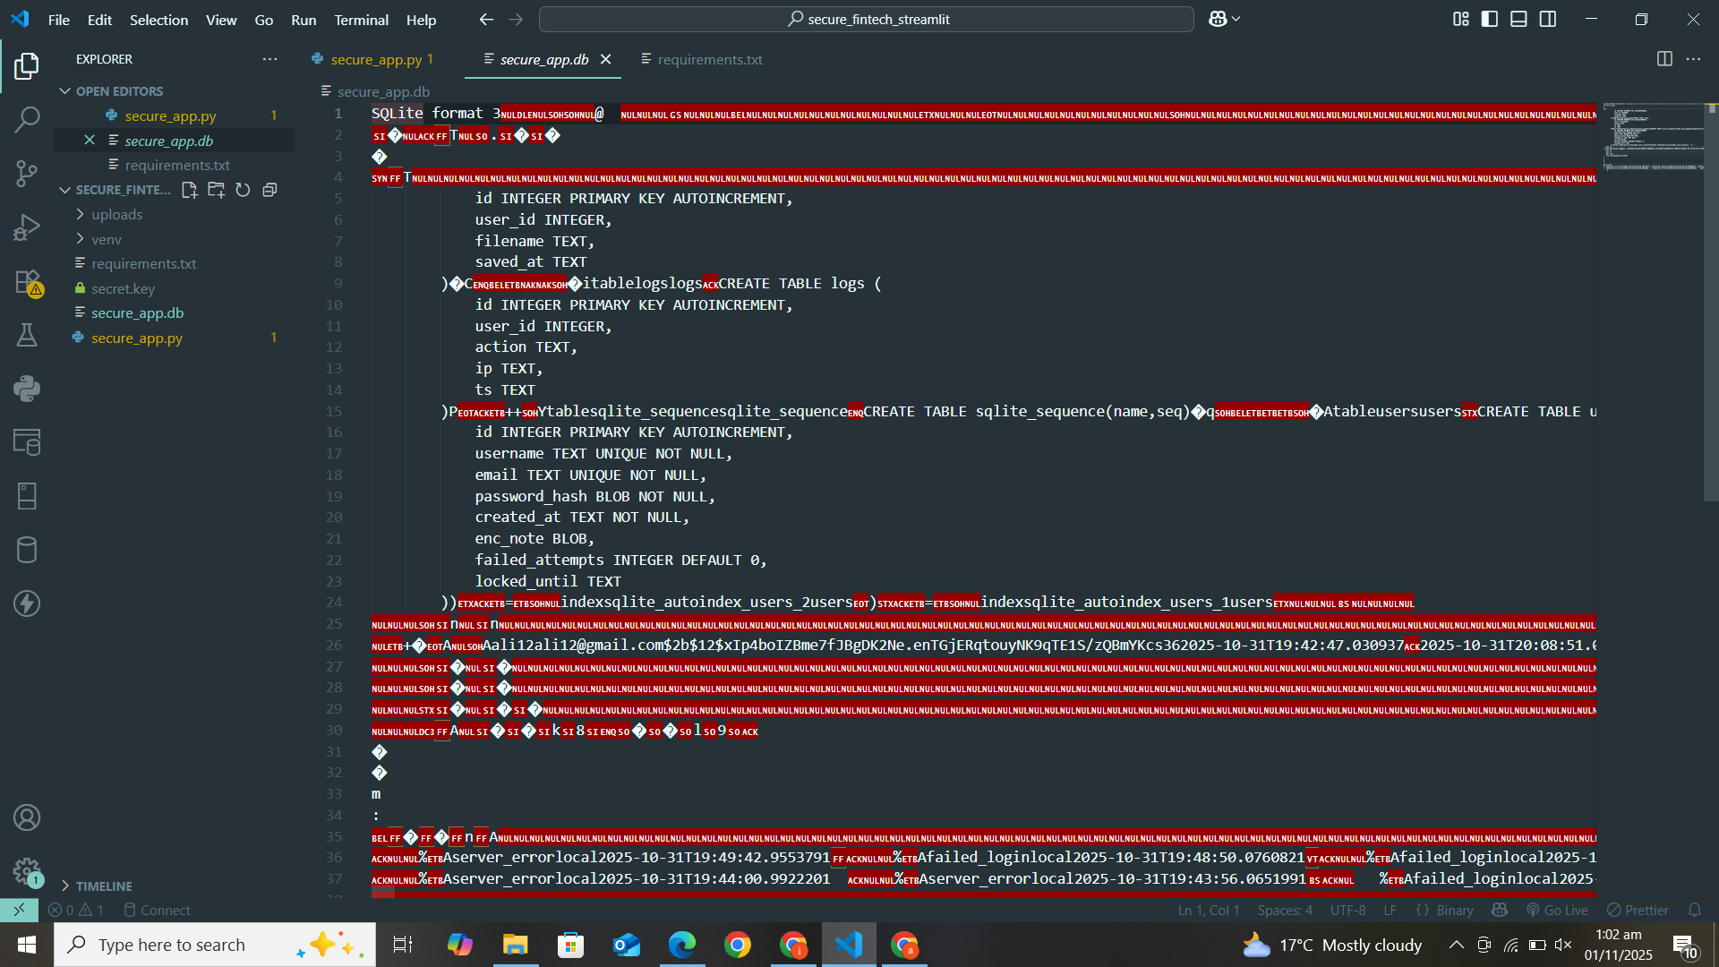
Screenshot test 8:
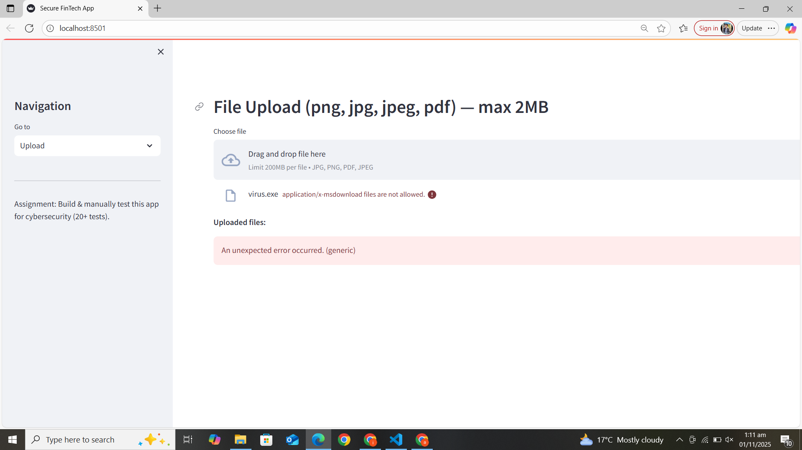
Screenshot test 9:
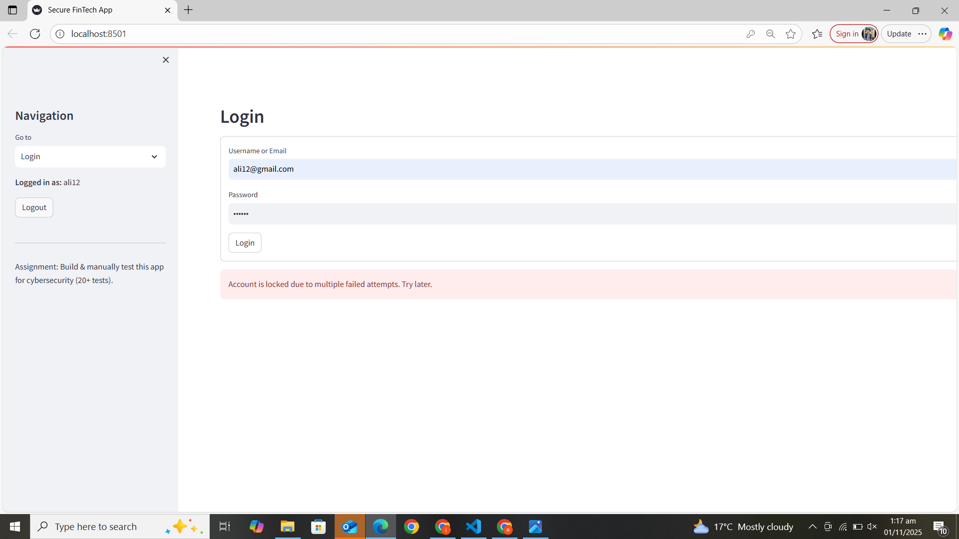
Screenshot test 10:
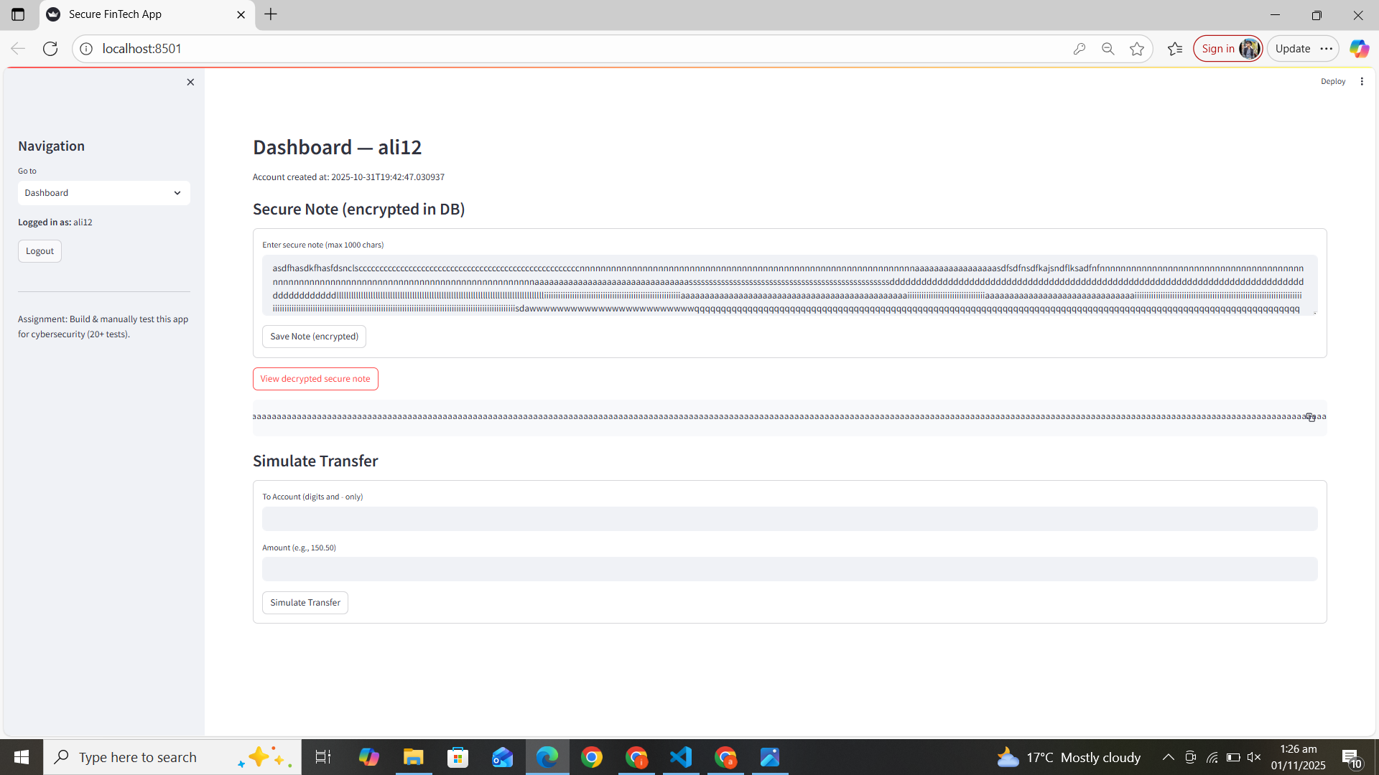
Screenshot test 11:
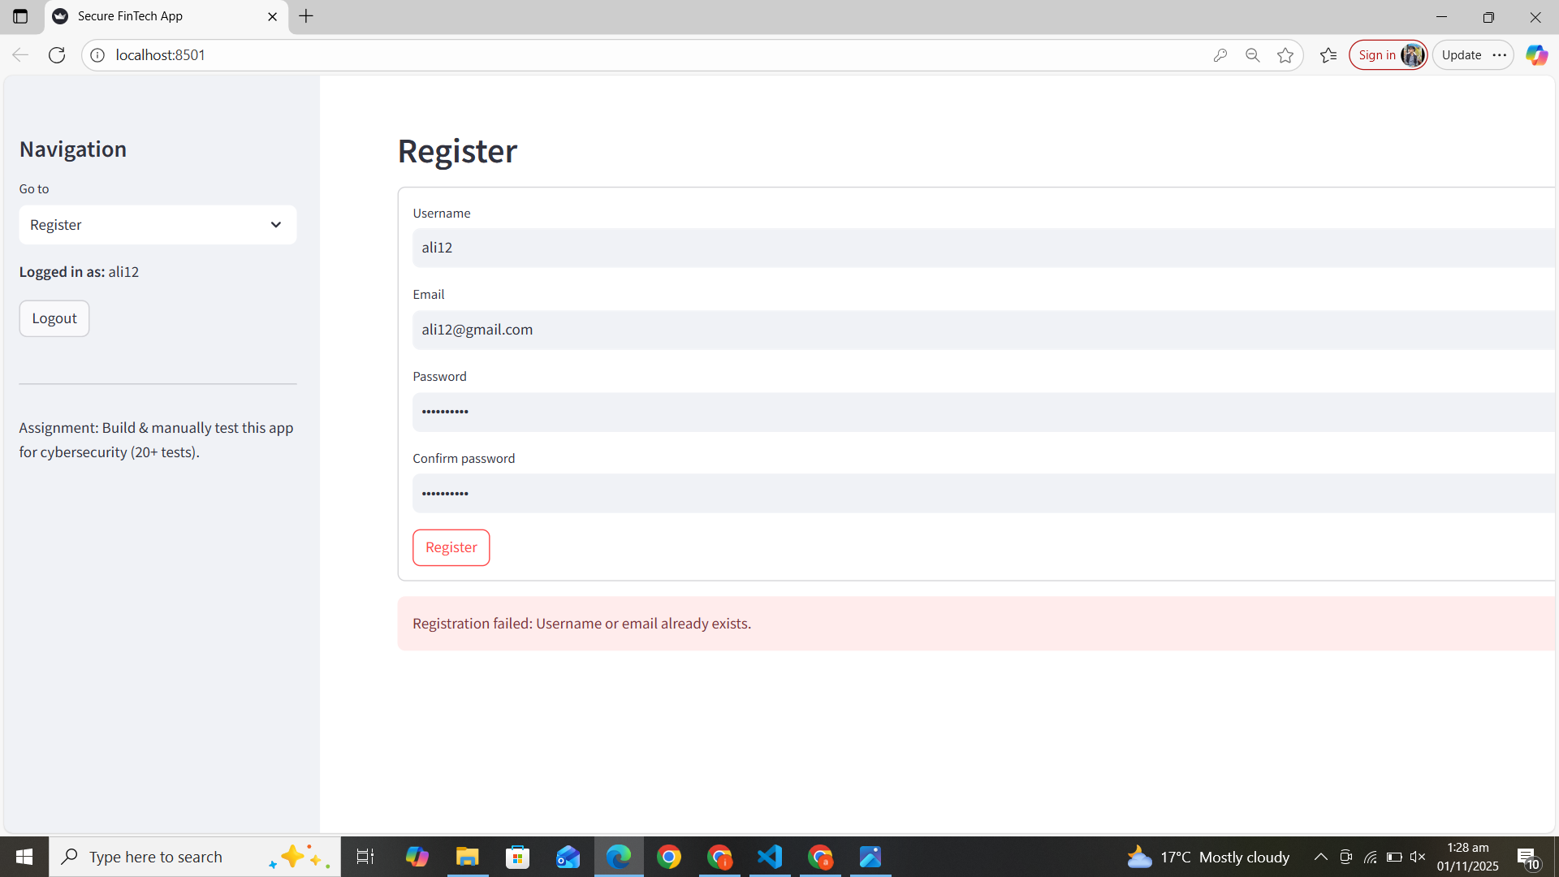
Screenshot test 12:
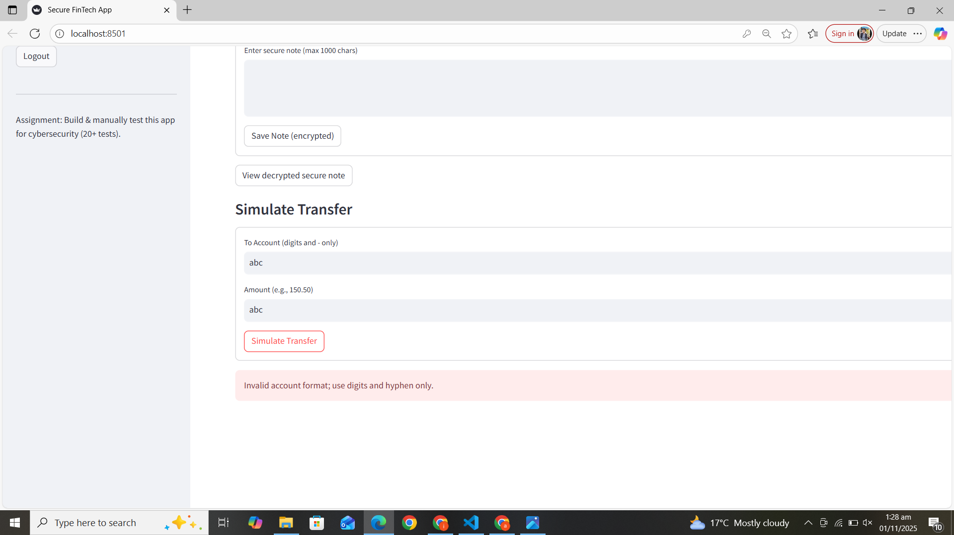
Screenshot test 13:
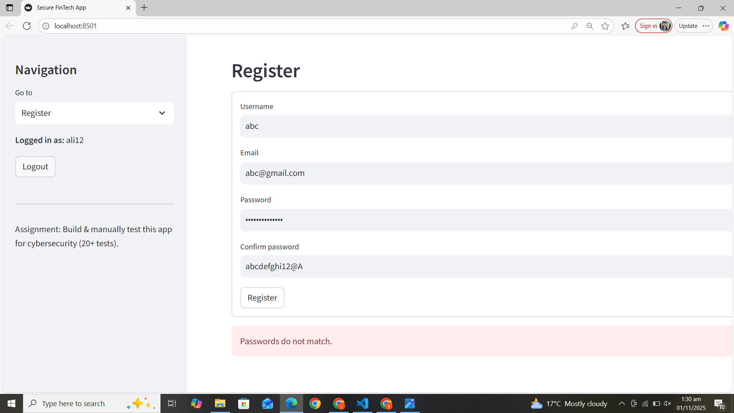
Screenshot test14:
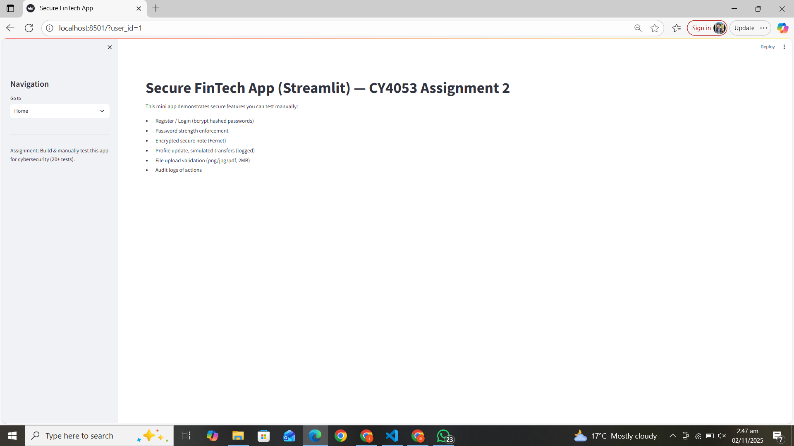
Screenshot test 15:
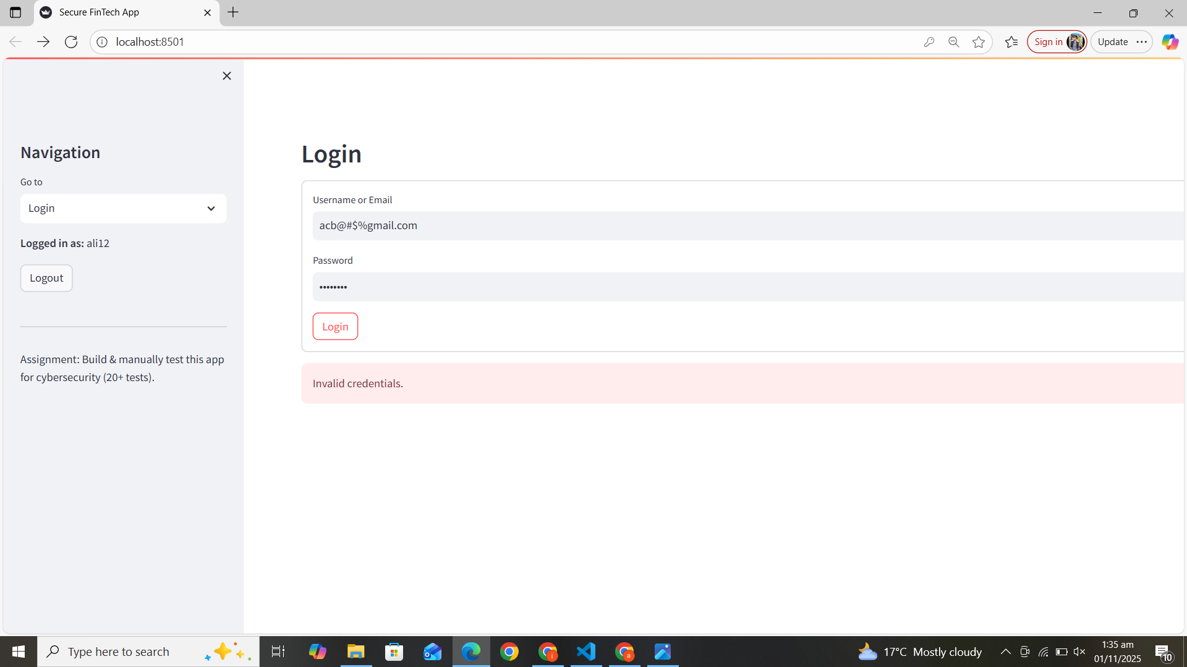
Screenshot test 16:
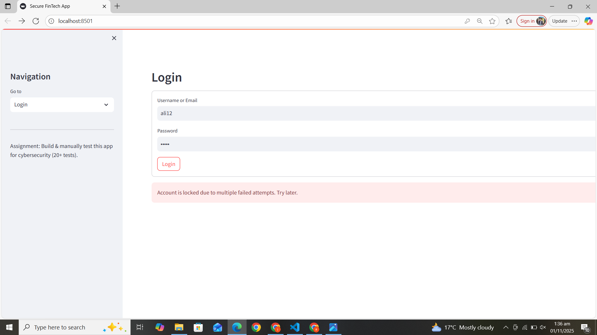
Screenshot test 17:
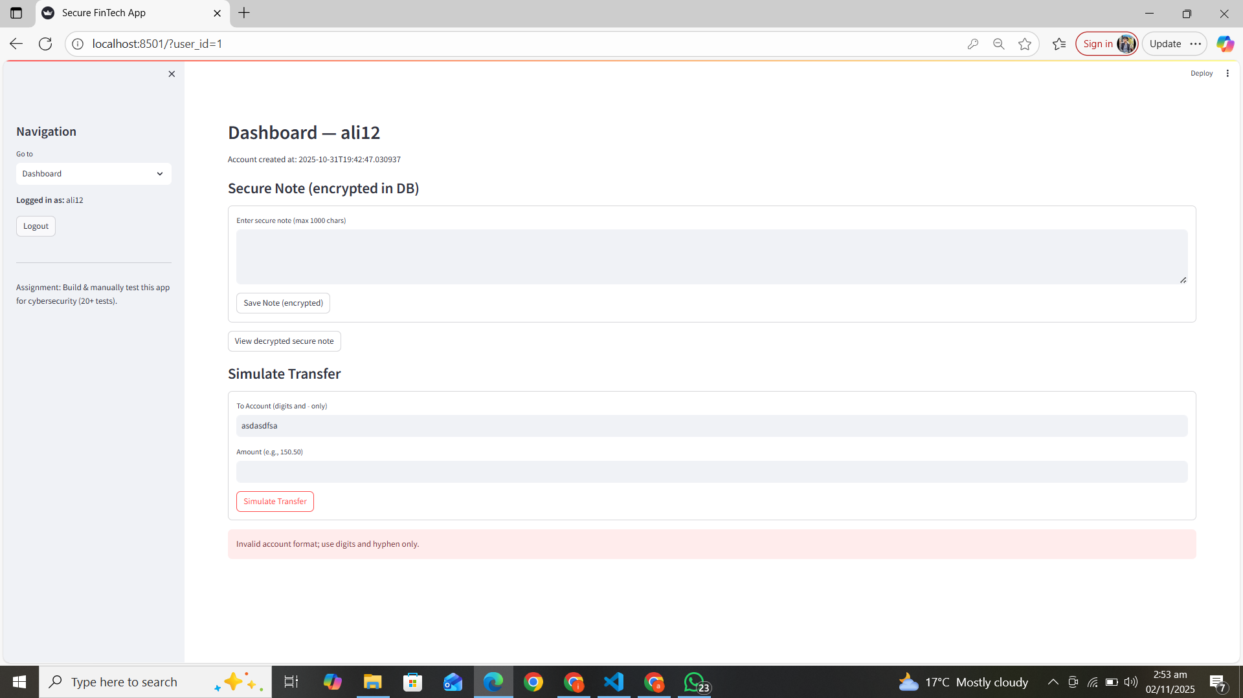
Screenshot test 18:
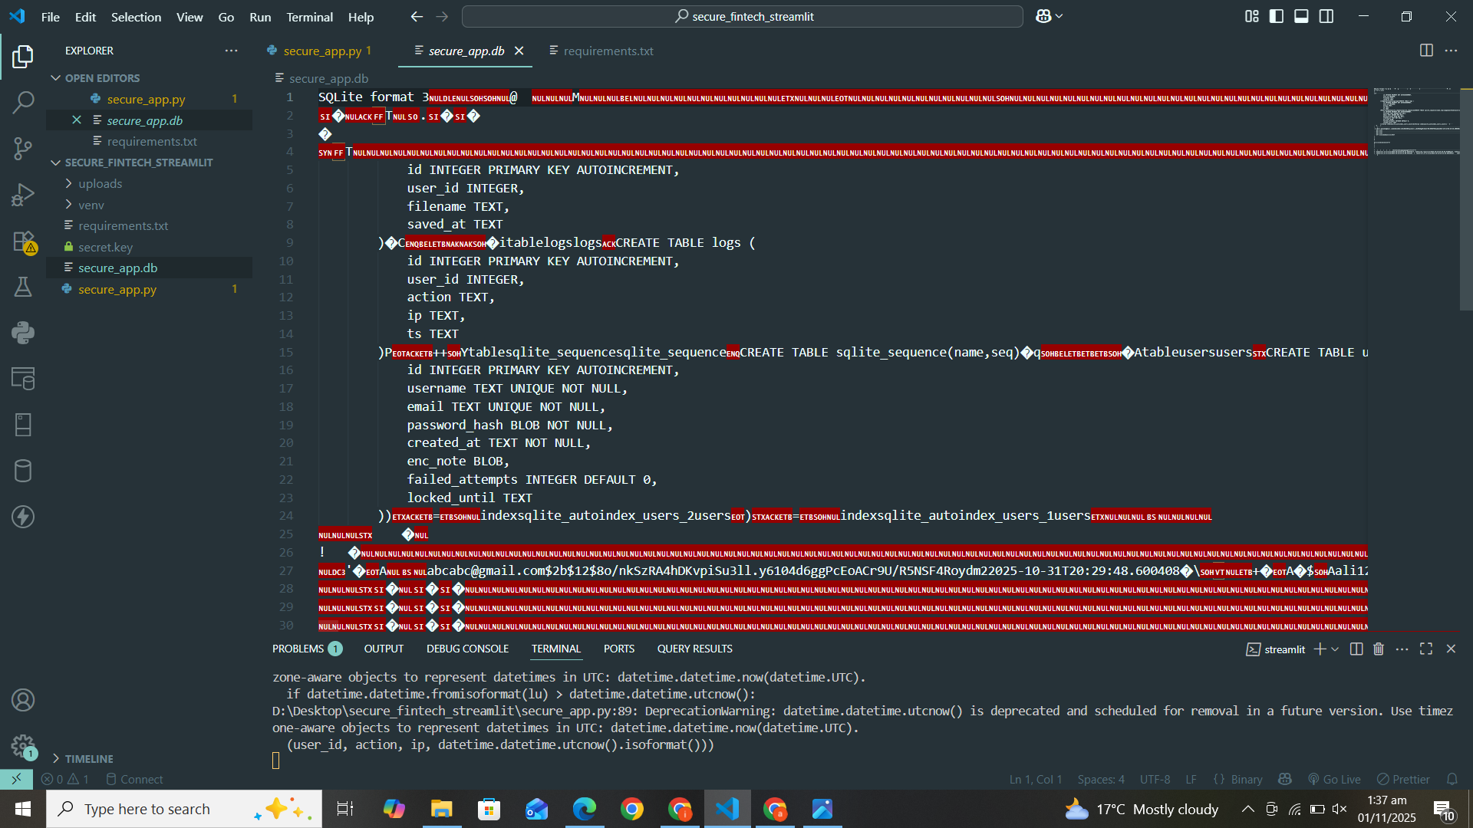
Screenshot test 19:
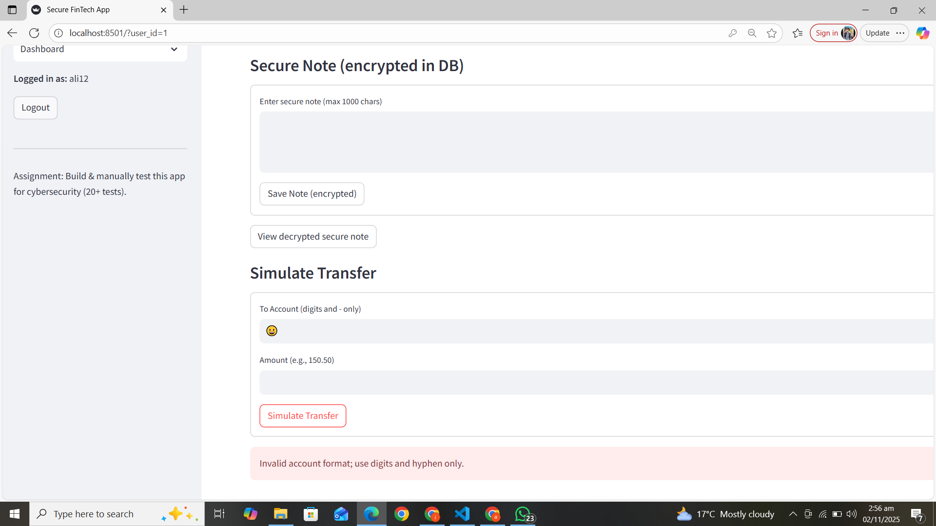
Screenshot test 20:
