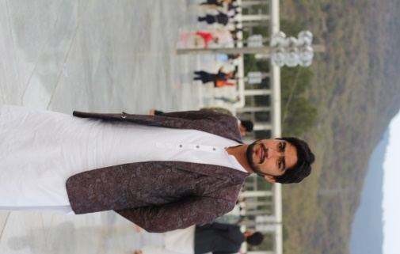

ALI ZAIN

**S/O AKHTAR HUSSAIN**

**CONTACT**

🖂

zali8371@gmail.com

+92 306 8976305

🕿

Momen Abad Khokher Isra Thal P/O Qasban Balochan District layyah Tehsil karor [www.ziibay.com](http://www.ziibay.com/)

🌍

🏠

**SKILL**

Python

25 25 25 25

ABOUT ME

**About**

To work in an environment where honesty takes place all around.

It will help me to do the work with honesty and keen interest. Because it is the only way, which can make someone successful in all kinds

of work situations whether it is challenging, complex or so simple to perform.

**PERSONAL INFORMATIONS:**

**CNIC:** 32202-0413361-7

**D.O.B: 0**1-03-1998

**Domicile:** Layyah, Punjab

**Marital Status:** Single

Dejango

MS Oﬃce 0

Web Developer 0

Management 0

Motivation 0

Communication 0

Freelancing Leadership

0

0

25 50

25 50

25 50

25 25 25

25 50

25 50

25 50

25 50

75 100

75 100

75 100

75 100

75 100

75 100

**QUALIFICATION:**ATION

|  |  |  |  |  |
| --- | --- | --- | --- | --- |
| **Degree** | **Year** | **Marks/**  **CGPA** | **Division** | **Name of Institution** |
| Matric | 2014 | 882/1100 | 1st | B.I.S.E D.G Khan |
| FSc | 2016 | 781/1100 | 1st | B.I.S.E D.G Khan |
| BS(Computer Science) | 2017-21 | 3.62/4.00 | 1st | GCUF LAYYAH CAMPUS |

**LANGUAGES**

English Urdu

WORK EXPERIENCE

**Work Experience**

* **6 Months Experience of Web Development at Ziibay Software House.**
* **12 Months Experience of Freelancing.**

Punjabi Saraiki

0 25

0 25

50 75

50 75

100

100

* **5 Moths Experience of Python with Framework DEJANGO**
* **2 Years Experience of Teaching at Creative School Layyah.**

# HOBBEI S

# Cricket

# Book Reading

RECENT WORK

# Some of my recent work in Web Development.

* **crsabers.ca**
* **toddsandkids.com**
* **oneﬁx.store**
* **sement.ae**
* **favorbuddies.com**