|  |
| --- |
| DATA STRUCTURES |
| **Employee & Customer Management System** |
| |  |  | | --- | --- | | **Submitted To** | **Sir ifran/Adnan ahmed** | | **Students** |  | | Aliza Khani | 45895 | | Fariha Hanif |  | | Syed Ahsan Zaidi |  | | Syed Abbas Raza |  | |

|  |
| --- |
| Department of Computer Science  **Bahria University Karachi Campus**  13 National Stadium Road |

**Table of Contents**

01 ABSTRACT…………………………………………………………………………………………….. 02

02 KEYWORDS………………………………………………………………………………………….. 02

03 INTRODUCTION……………………………………………………………………………………. 02

04 BACKGROUND…………………………………………………………………………….. 03

05 NOVELTY OF

PROJECT …………… ……………………………………………………………………….. 03

06 OPERATIONS ………………………………………………………………………………. 04

07 TESTING …………………………………………………………………………………….. 05

08 SCREENSHOTS ……………………………………………………………………………. 06

* Add employee ………………………………………………………………………. 06
* Add after an employee ……………………………………………………………… 06
* Add at last …………………………………………………………………………….. 07
* Delete employee ………………………………………………………………………… 07
* Add customer details …………………………………………………………………….. 08
* Selection menu ……………………………………………………………………………. 08
* Login page ……………………………………………………………………………………. 08

09 Data structure …………………………………………………………………………………….. 08

10 CONCLUSION …………………………………………………………. 09

# **ABSTRACT**

Every organization, whether big or small, has human resource challenges to overcome. Every organization has different employee management needs; therefore we design exclusive employee management systems that are adapted to your managerial requirements. This is designed to assist in strategic planning, and will help you ensure that your organization is equipped with the right level of human resources for your future goals. Also, for those busy executive who are always on the go, our systems come with remote access features, which will allow you to manage your workforce anytime, at all times. These systems will ultimately allow you to better manage resources. One of the main features in employee management system is time tracking for employees. Effective time tracking mechanism saves both time and money for the organization.

# **02 Keywords:**

Switches, if-else, functions, pointers,

# **03 Introduction:**

Employee & Customer Management System is a distributed application, developed to maintain the details of employees and Customer relating the organization. It maintains the information about the personal details of their employees, also the details about the payroll system which enable to generate the payslip. It is simple to understand and can be used by anyone who is not even familiar with simple employees system. It is user friendly and just asks the user to follow step by step operations by giving him few options. It is fast and can perform many operations of a company.

# **04 Background:**

Every organization needs an upto date record of their employees and as well as their customers therefore we design exclusive employee management systems that are adapted to your managerial requirements. This is designed to assist in strategic planning, and will help you ensure that your organization is equipped with the right level of human resources for your future goals. Also, for those busy executive who are always on the go, our systems come with remote access features, which will allow you to manage your workforce anytime, at all times. These systems will ultimately allow you to better manage resources. You can easily search, add, delete and update the record of your employees and customer.

# **05 Novelty of project:**

Searching, deletion, updation and adition on employee record get easier by using this system it is a novel method to replace manual work, This management system works better for employee management by using the employee record to wish them on their birthday for their better engagement with the job.

# **06 Operations:**

**Admin Operations**

* Add New Employee
* Update Employee’s information
* Delete Employee
* Search Employee
* Add new account of customer
* Update customer information
* Delete customer Information

# **07** **Testing:**

The number of test cases used to determine errors in the program should be minimum. There are two fundamental goals of a practical testing activity:-

• maximize the number of errors detected and

. • minimize the number of test cases.

**08 Screenshots:**

**a) Add employee:**

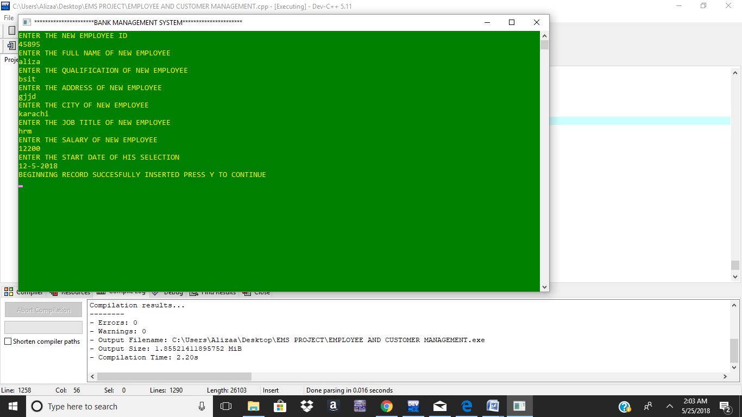

**b) Add after an employee_Id:**

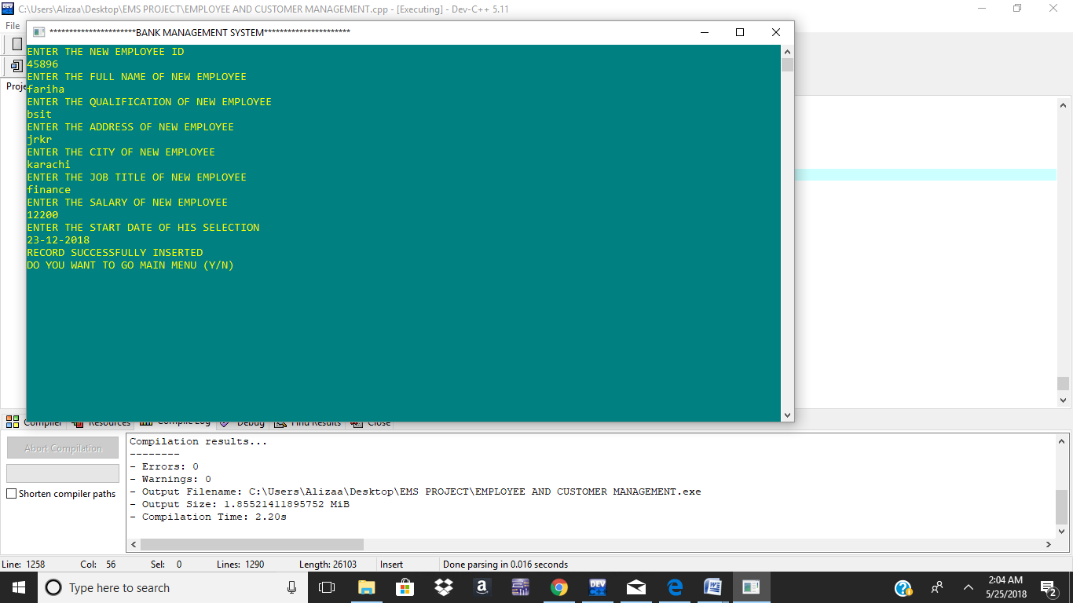

**c) Add employee At last:**

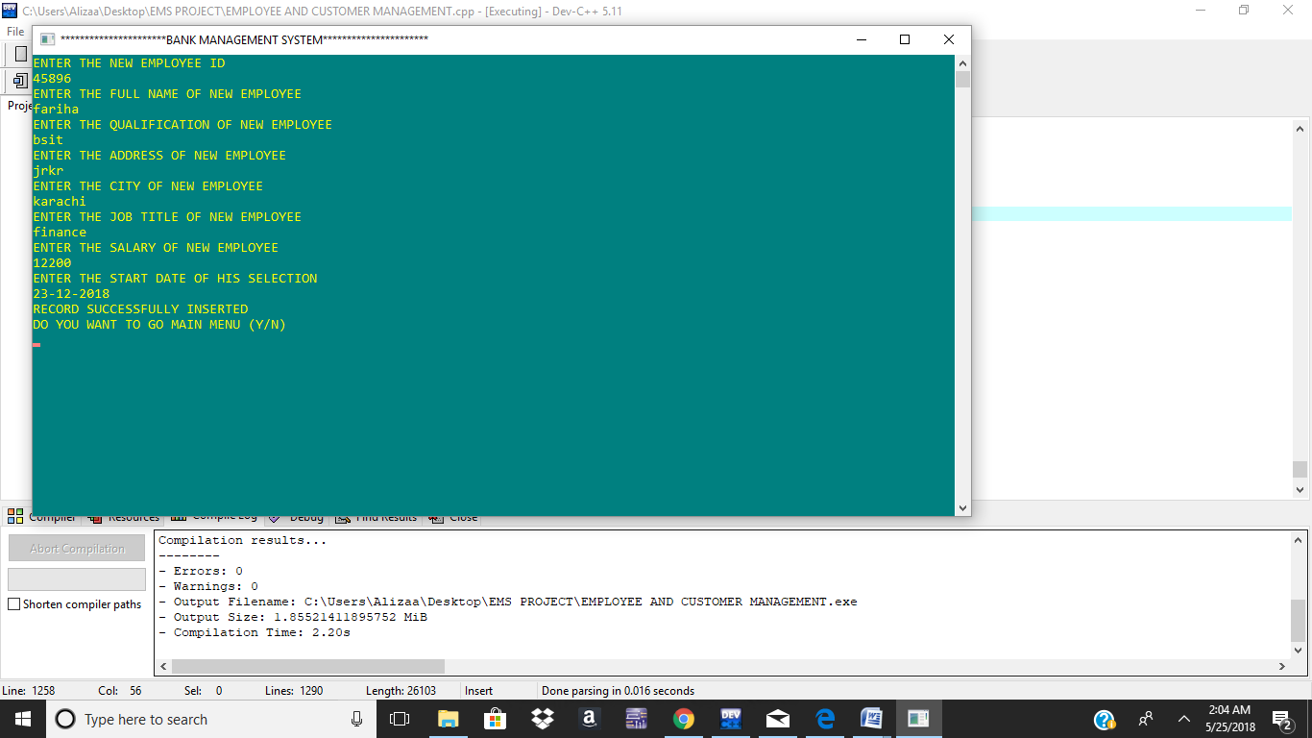

**d) To display all employees:**

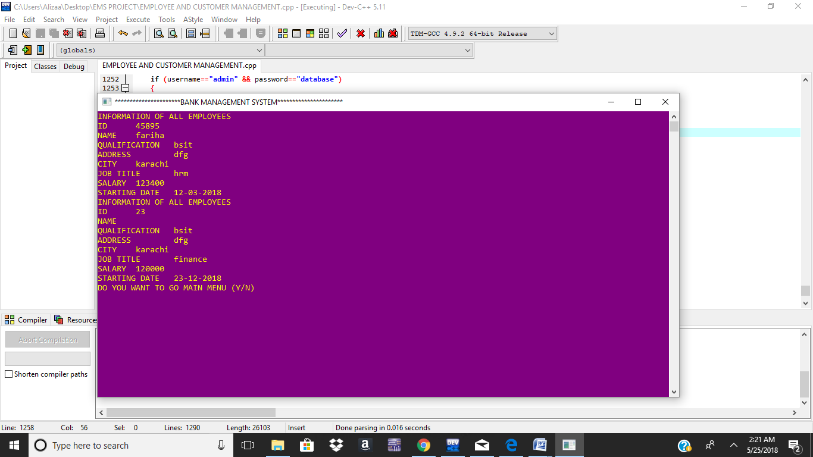

**e) Add Customer details:**

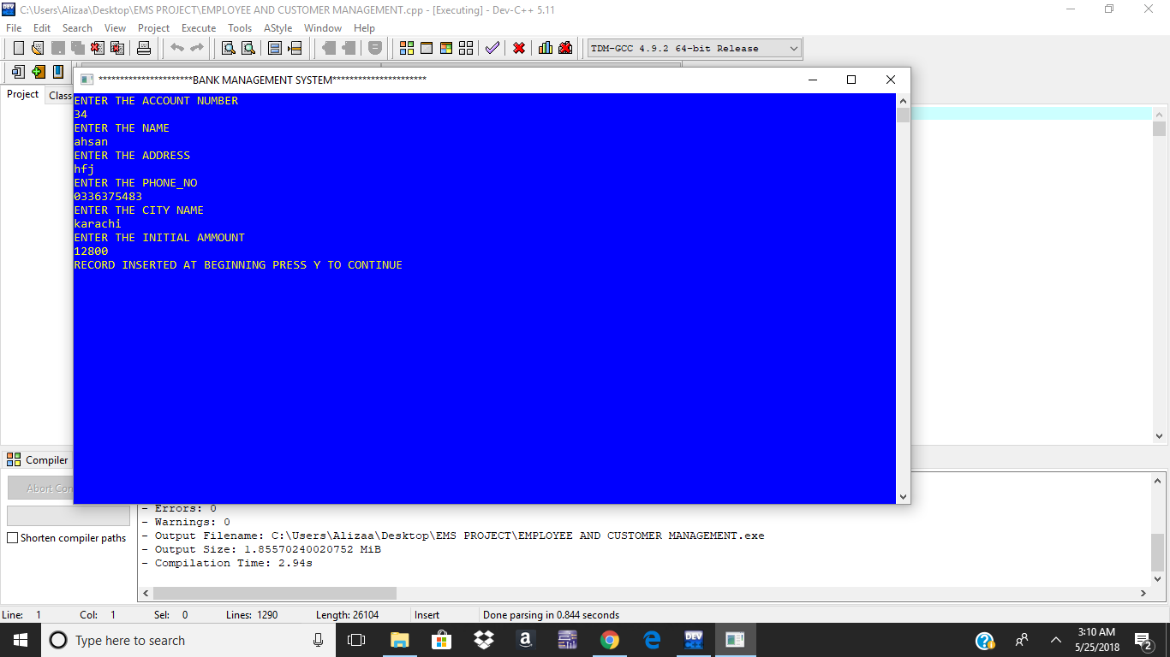

**f) Selection menu:**

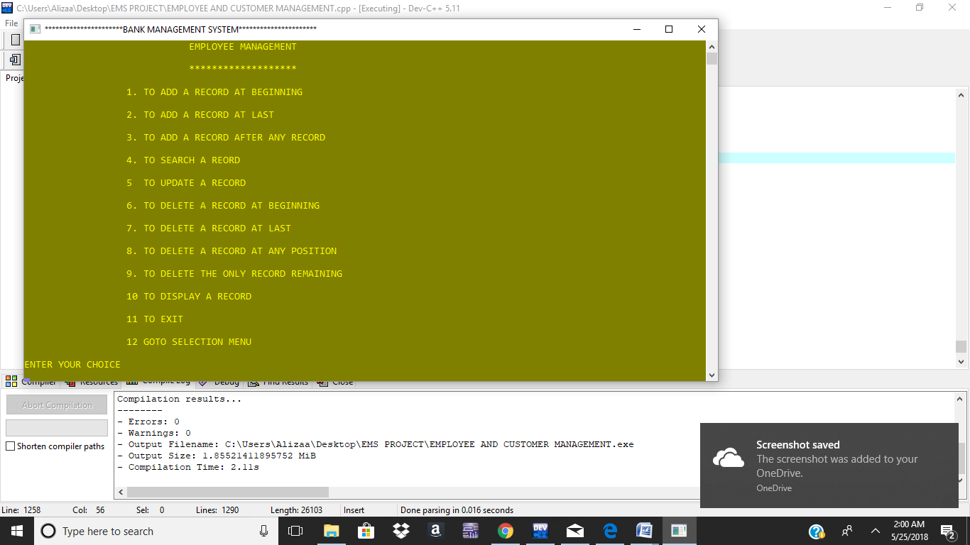

**g) Login page:**

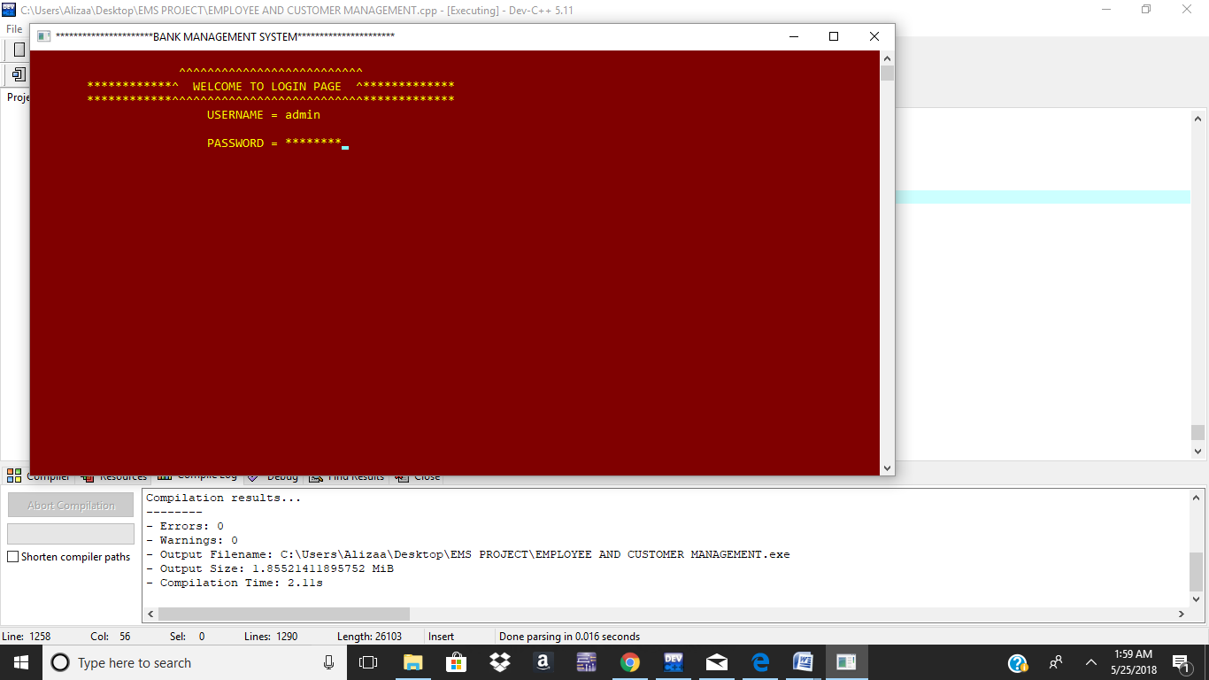

**9 Data Structures:**

Doubly linked list.

# **10 Conclusion**

Since this project has been designed exclusively as a project, certain complexities that do faced by any real life manual problem like total no. of employee, address redundancy etc. are considered in this project. But enhancement to the project can easily be made without changing the current design and programming structure.