Web Architecture & Technology Stacks
AWT Course — Complete Study Guide
Comprehensive Reference | All Topics Covered

Chapter 1: Web Architecture & Technology Stacks

Definition of Web Architecture
Web Architecture is the overall structure and design of a web application that defines how different components (Client, Server, and Database) communicate with each other to process requests and provide services to users.
In simple words: Web Architecture tells us how a website works behind the scenes and how data moves between users, servers, and databases.

Example: Facebook Login Flow
When you login to Facebook: • You enter email and password. • Browser sends request to server. • Server checks database. • Database returns result. • Server sends response. • Facebook homepage opens. This complete flow is called Web Architecture.

Full Stack Application

Definition
A Full Stack Application is an application that contains all three major layers:
- Frontend
- Backend
- Database
A developer who can work on all three layers is called a Full Stack Developer.

Layers of Full Stack Application

1. Frontend (Presentation Layer)
Definition
Frontend is the part of the application that users can see and interact with directly.
Responsibilities
- Display data
- Take user input
- Show buttons, forms, images
- Send requests to backend
Technologies
- HTML
- CSS
- JavaScript
- React
- Angular
- Vue
Example — YouTube
- Search bar
- Video player
- Like button
- Comment section
All are Frontend components.

2. Backend (Business Logic Layer)
Definition
Backend is the server-side part of the application that processes requests and performs business logic.
Responsibilities
- Authentication
- Authorization
- Data processing
- API creation
- Communication with database
Technologies
- Node.js
- Express.js
- Django
- Spring Boot
- ASP.NET
Example — Login Flow
When user clicks Login, the backend:
- Receives credentials
- Verifies them
- Generates token
- Sends response

3. Database (Data Layer)
Definition
A Database is a structured collection of data used to store and manage application information permanently.
Responsibilities
- Store records
- Retrieve data
- Update data
- Delete data
Technologies
- MongoDB
- MySQL
- PostgreSQL
- SQL Server
Example — Instagram Database stores
- Users
- Posts
- Comments
- Followers
- Messages

Full Stack Application Lifecycle
Definition
The Full Stack Application Lifecycle describes the complete journey of a request from the user to the database and back to the user.
Example: Student Registration

Step | Action | Layer
Step 1 | Student fills form (Name: Ali, Email: ali@gmail.com) | Frontend
Step 2 | Frontend sends POST /register request | Frontend → Backend
Step 3 | Backend receives the request | Backend
Step 4 | Backend validates the information | Backend
Step 5 | Backend stores data in database | Backend → Database
Step 6 | Database confirms save operation | Database
Step 7 | Backend sends success response | Backend → Frontend
Step 8 | Frontend displays: Registration Successful | Frontend

Client-Server Communication Architecture
Definition
Client-Server Architecture is a computing model in which clients send requests and servers process those requests and return responses.

Client
Definition
A Client is a software application that requests services from a server.
Examples
- Chrome
- Firefox
- Edge
- Mobile Apps
Client's job
- Send requests
- Display responses

Server
Definition
A Server is a software or machine that receives requests, processes them, and sends responses back to clients.
Server's job
- Handle requests
- Execute business logic
- Access database
- Return responses

Architecture Diagram
Client (Browser)
|
| Request
↓
Server (Node.js)
|
| Query
↓
Database (MongoDB)
|
| Data
↑
Server
|
| Response
↑
Client

Database Integration
Definition
Database Integration is the process of connecting an application with a database so that data can be stored, retrieved, updated, and deleted.
Why Database Integration is Important?
Without database: ❌ Data disappears after application closes
With database: ✅ Data remains permanently stored ✅ Easy retrieval ✅ Secure management
Example — E-Commerce Order

Order ID | Customer | Product
101 | Ali | Laptop

Later the order can be retrieved anytime.

Technology Stack
Definition
A Technology Stack is a collection of technologies used together to build a complete web application. It usually includes:
- Frontend Technology
- Backend Technology
- Database Technology

MEAN Stack
Definition
MEAN is a Full Stack JavaScript technology stack consisting of:

Letter | Technology | Role
M | MongoDB | Database — stores data
E | Express.js | Backend — handles APIs and routing
A | Angular | Frontend — builds user interface
N | Node.js | Server — runs JavaScript on server

MERN Stack
Definition
MERN is a Full Stack JavaScript technology stack consisting of:

Letter | Technology | Role
M | MongoDB | Stores application data
E | Express.js | Creates APIs
R | React | Creates interactive user interfaces
N | Node.js | Runs backend code

MEAN vs MERN — Comparison

Feature | MEAN | MERN
Frontend | Angular | React
Type | Framework | Library
Learning Curve | Difficult | Easier
Flexibility | Moderate | High
Development Speed | Medium | Fast
Enterprise Systems | Excellent | Good
Community Support | Large | Very Large

Real-World Scenario: Enterprise Management System
Requirements
- Employee Management
- Attendance
- Payroll
- Reports
- Inventory
- Authentication

Option 1: MERN Stack
Advantages
- Fast development
- Flexible UI
- Large community
Disadvantages
- Less structured for very large teams

Option 2: MEAN Stack
Advantages
- Better project structure
- TypeScript support
- Easier maintenance
- Suitable for enterprise applications
Disadvantages
- More complex
- Steeper learning curve

Structural Justification (Exam Answer)
Scenario: A large university wants an Enterprise Management System to manage students, faculty, attendance, fee records, and reports. Selected Stack: MEAN Stack Justification: • Angular provides a structured architecture. • TypeScript reduces programming errors. • Large teams can manage code more efficiently. • Better maintainability for long-term projects. • MongoDB handles large amounts of data efficiently. • Node.js and Express.js provide fast backend services. Conclusion: The MEAN Stack is the most suitable choice for a large Enterprise Management System.

One-Line Exam Definitions

Term | Definition
Web Architecture | The structure that defines how clients, servers, and databases interact in a web application.
Full Stack Application | An application containing frontend, backend, and database layers.
Client | A software application that requests services from a server.
Server | A system that processes client requests and returns responses.
Database Integration | The process of connecting an application with a database for data storage and retrieval.
Technology Stack | A combination of technologies used to build a complete web application.
MEAN Stack | MongoDB, Express.js, Angular, and Node.js.
MERN Stack | MongoDB, Express.js, React, and Node.js.

Chapter 2: JavaScript Runtime Environment & Async Programming

Introduction
JavaScript is a single-threaded programming language, meaning it can execute only one instruction at a time. However, modern web applications perform many tasks simultaneously, such as:
- Fetching data from APIs
- Reading files
- Waiting for user clicks
- Running timers
JavaScript handles these operations using its Runtime Environment, which includes the Call Stack, Web APIs, Event Loop, Callback Queue, and Microtask Queue.
This allows JavaScript to perform asynchronous programming without blocking the execution of the program.

1. Single-Threaded Execution
Definition
JavaScript is a single-threaded language, meaning it has only one Call Stack and executes code one line at a time. At any moment, only one operation can be executed.
Example
console.log("A");
console.log("B");
console.log("C");
Output
A
B
C
Explanation: JavaScript executes statements sequentially — A first, B second, C third.

2. Synchronous Programming
Definition
Synchronous programming means each statement waits for the previous statement to finish before executing.
Example
console.log("Start");

function greet() {
console.log("Hello");
}

greet();

console.log("End");
Output
Start
Hello
End
Explanation: The program executes line by line and waits for each instruction to finish.

3. Asynchronous Programming
Definition
Asynchronous programming allows JavaScript to start a task and continue executing other code without waiting for the task to complete. This prevents the application from becoming slow or unresponsive.
Example
console.log("Start");

setTimeout(() => {
console.log("Timer Finished");
}, 2000);

console.log("End");
Output
Start
End
Timer Finished
Explanation
The timer takes 2 seconds. Instead of waiting:
- JavaScript starts timer.
- Continues executing next line.
- Prints "End".
- After 2 seconds prints "Timer Finished".

4. Non-Blocking I/O
Definition
Non-Blocking I/O means JavaScript does not stop execution while waiting for operations such as:
- API requests
- Database queries
- File reading
- Timers
It continues executing other instructions.
Why Non-Blocking I/O is Important
Without non-blocking I/O: Application becomes slow | User interface freezes | Server performance decreases
Example
console.log("Start");

setTimeout(() => {
console.log("File Read Complete");
}, 3000);

console.log("Processing Other Tasks");
Output
Start
Processing Other Tasks
File Read Complete
JavaScript continues running while waiting.

5. JavaScript Runtime Environment Components

Component | Role
Call Stack | Stores and tracks function calls
Web APIs | Browser-provided features for async operations
Callback Queue | Stores callbacks from completed async operations
Microtask Queue | Stores higher-priority async tasks (Promises)
Event Loop | Bridges Call Stack and Queues; manages execution order

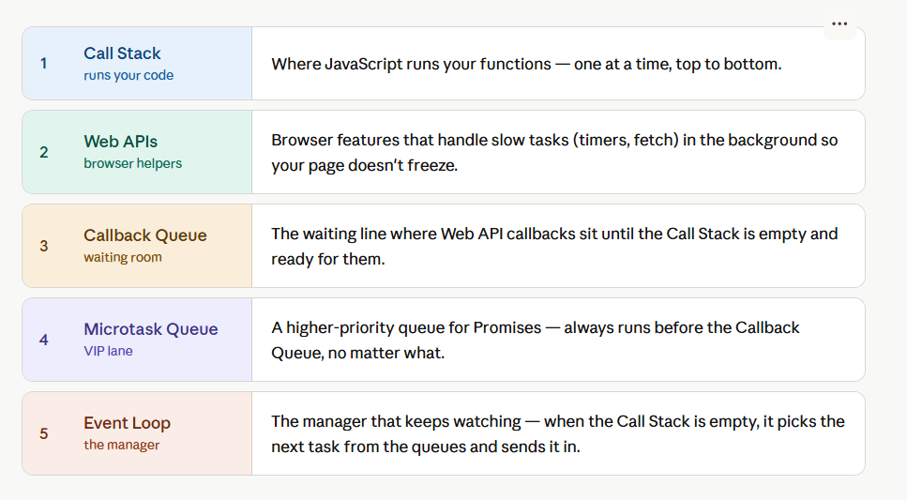

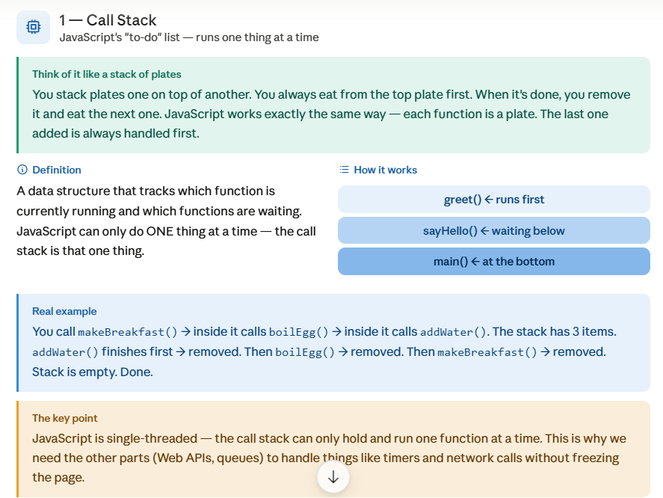

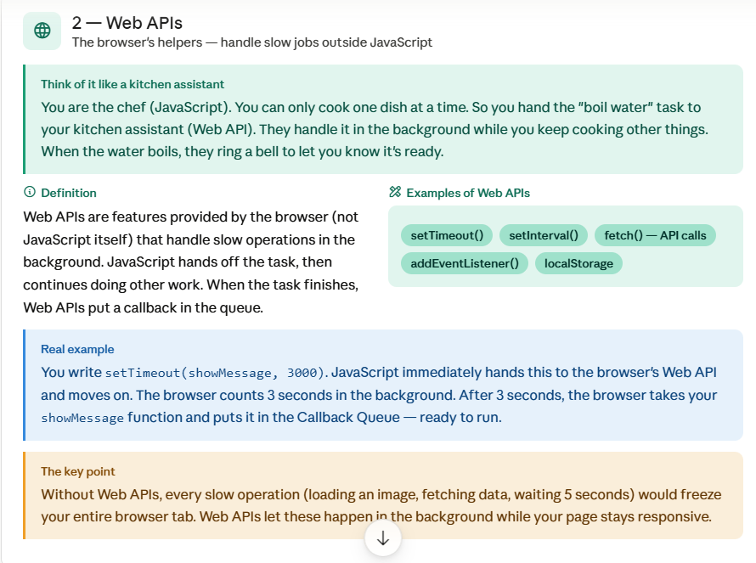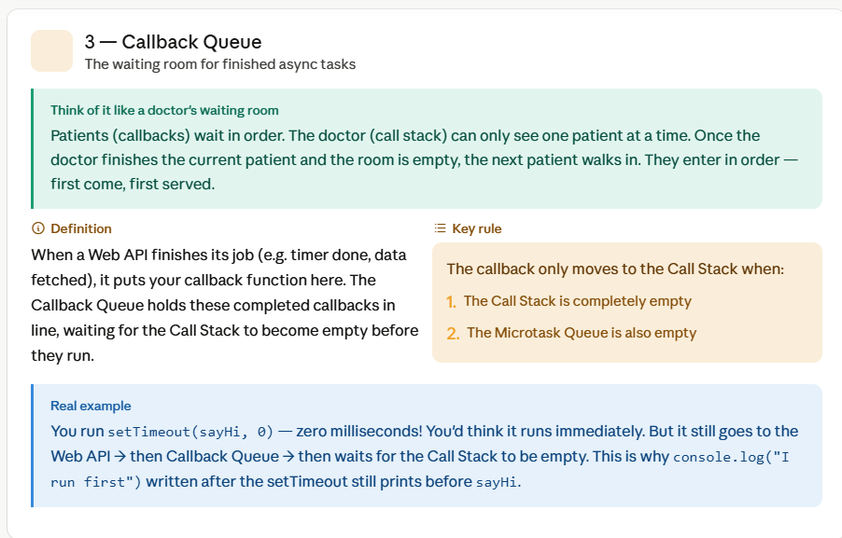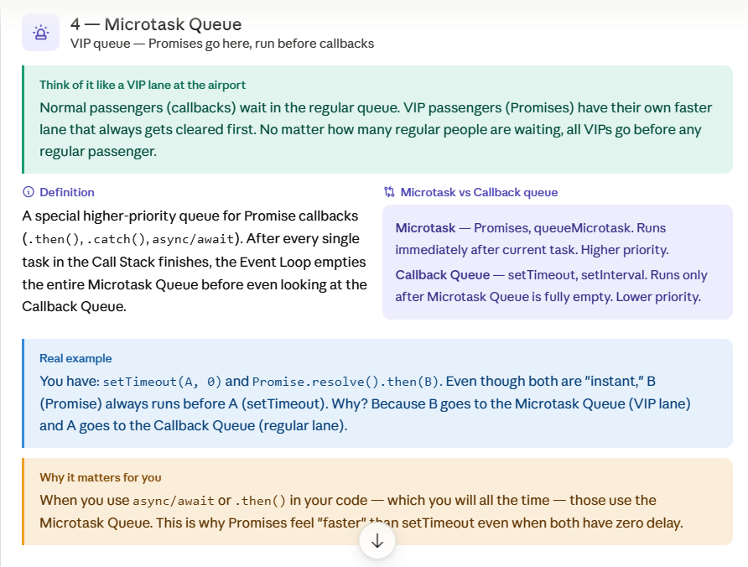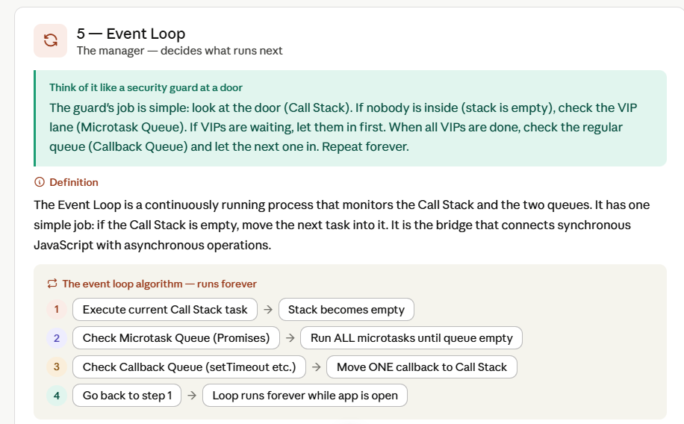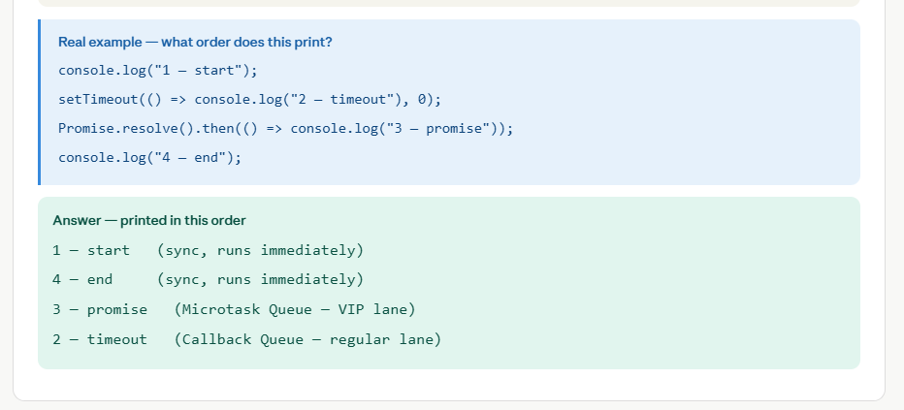

6. Call Stack
Definition
The Call Stack is a data structure that stores function calls and keeps track of program execution. Functions enter the stack when called and leave the stack when completed.
Example
function first() {
console.log("First");
}

function second() {
console.log("Second");
}

first();
second();
Stack Operation
Push first() → Execute first() → Pop first()
Push second() → Execute second() → Pop second()
Output
First
Second

7. Web APIs
Definition
Web APIs are browser-provided features that handle asynchronous operations such as timers, HTTP requests, DOM events, and geolocation outside the JavaScript engine.
Examples
- setTimeout()
- fetch()
- DOM Events
- Geolocation
Example
setTimeout(() => {
console.log("Hello");
}, 2000);
The timer is handled by Web APIs, not by the Call Stack.

8. Callback Queue
Definition
Callback Queue is a queue that stores callback functions from asynchronous operations like setTimeout() and DOM events after they are completed and waiting for execution.
Examples
- setTimeout()
- setInterval()
- Event Handlers
Example
setTimeout(() => {
console.log("Timer");
}, 0);
After timer completion, callback enters Callback Queue.

9. Microtask Queue
Definition
The Microtask Queue is the VIP waiting room. Promises (.then(), async/await) go here instead. The rule is: after every single task finishes, the entire Microtask Queue must be emptied before even one item from the Callback Queue gets to run.
The Microtask Queue stores higher-priority asynchronous tasks.
Examples
- Promise.then()
- catch()
- finally()
- queueMicrotask()

Important Rule
Microtask Queue always executes BEFORE Callback Queue.

Example
Promise.resolve().then(() => {
console.log("Promise");
});
This callback goes to Microtask Queue.

10. Event Loop
Definition
The Event Loop continuously checks: Is the Call Stack empty? If yes, move tasks from queues to the Call Stack. It acts as a bridge between the Call Stack and Queues.
Event Loop is a mechanism that continuously monitors the Call Stack and queues. When the Call Stack becomes empty, it moves tasks from the Microtask Queue first, then from the Callback Queue, to the Call Stack for execution.
Event Loop Diagram
Call Stack
↑
Event Loop
↑
--------------------
Microtask Queue (higher priority)
Callback Queue (lower priority)

Execution Order Rule
1. Synchronous Code (runs first) 2. Microtask Queue (Promises — runs second) 3. Callback Queue (setTimeout/setInterval — runs last)

Example 1 — setTimeout with 0ms
console.log("A");

setTimeout(() => {
console.log("B");
}, 0);

console.log("C");
Output
A
C
B
Explanation
Step 1: Execute synchronous code → prints A, C.
Step 2: Call Stack becomes empty.
Step 3: Event Loop picks callback from queue → prints B.

Example 2 — Promise vs Timer
console.log("Start");

setTimeout(() => {
console.log("Timer");
}, 0);

Promise.resolve().then(() => {
console.log("Promise");
});

console.log("End");

Phase | Output
Synchronous Code | Start, End
Microtask Queue | Promise
Callback Queue | Timer
Final Output | Start → End → Promise → Timer

Example 3 — 0ms vs 10ms setTimeout
console.log("One");

setTimeout(() => {
console.log("Two");
}, 10);

setTimeout(() => {
console.log("Three");
}, 0);

console.log("Four");
Final Output
One
Four
Three
Two

Practice Challenge
console.log("1");

setTimeout(() => { console.log("2"); }, 0);

Promise.resolve().then(() => { console.log("3"); });

console.log("4");

setTimeout(() => { console.log("5"); }, 10);

Promise.resolve().then(() => { console.log("6"); });

console.log("7");

Phase | Output
Synchronous Code | 1, 4, 7
Microtask Queue | 3, 6
Callback Queue | 2, 5
Final Output | 1 → 4 → 7 → 3 → 6 → 2 → 5

Exam Conclusion
JavaScript is a single-threaded language that uses the Runtime Environment to perform asynchronous operations. • Call Stack — executes synchronous code • Web APIs — handle async tasks • Microtask Queue — stores Promise callbacks (higher priority) • Callback Queue — stores timer callbacks (lower priority) • Event Loop — manages execution order Execution Order: Synchronous Code → Microtask Queue → Callback Queue This mechanism allows JavaScript to remain fast, efficient, and non-blocking.

Chapter 3: Server-Side Frameworks — Express.js

Introduction
Express.js is the most popular server-side framework for Node.js. It provides a simple and efficient way to build web servers and REST APIs. Without Express, creating routes, handling requests, and managing responses in Node.js requires a lot of code. Express simplifies these tasks by providing built-in methods and middleware.
Express is widely used in MERN Stack applications because it makes backend development fast, scalable, and easy to manage.

What is Express.js?
Definition
Express.js is a lightweight, flexible, and minimal web application framework built on top of Node.js.
It helps developers to
- Create web servers
- Build REST APIs
- Handle HTTP requests and responses
- Manage routes
- Use middleware
- Connect with databases

Why Use Express.js?
Advantages
- Simple syntax
- Fast development
- Easy routing
- Middleware support
- REST API development
- Works well with MongoDB and React

Node.js Runtime Environment
Definition
Node.js is a runtime environment that allows JavaScript to run outside the browser. Normally JavaScript runs in browsers like Chrome, but Node.js allows JavaScript to run on the server.
Example
console.log("Server Running");
This JavaScript code can run on the server using Node.js.

Creating an Express Application

Step 1: Install Express
npm install express

Step 2: Import Express
const express = require('express');
Explanation: require() imports the Express package. Now Express functionality can be used.

Step 3: Create Express App Instance
const app = express();
This creates an Express application object. The app object controls Routes, Middleware, and Server settings.

Built-in Middleware

What is Middleware?
Definition
Middleware is a function that executes between receiving a request and sending a response.
Middleware has access to
- Request object (req)
- Response object (res)
- Next middleware (next)
Middleware can perform
- Authentication
- Validation
- Logging
- Error handling
- JSON parsing

express.json()
Definition
express.json() is built-in middleware that converts incoming JSON data into JavaScript objects.
app.use(express.json());
Why Needed?
Suppose client sends:
{ "name": "Ali", "age": 22 }

Situation | req.body Result
Without express.json() | undefined
With express.json() | req.body.name → "Ali"

Starting the Server — app.listen()
Definition
app.listen() starts the Express server and makes it listen for incoming requests.
app.listen(3000, () => {
console.log("Server Running");
});
Explanation
- 3000 = Port Number
- Callback runs when server starts

Express Routing
Definition
Routing determines how an application responds to a client request for a particular URL.
Basic Route
app.get('/', (req, res) => {
res.send("Welcome");
});
When user visits http://localhost:3000/, server responds with "Welcome".

GET Endpoint
Definition
GET method is used to retrieve data from the server.
Example
let students = [
{id:1, name:"Ali"},
{id:2, name:"Sara"}
];

app.get('/students', (req,res)=>{
res.json(students);
});
Output
[ { "id":1, "name":"Ali" }, { "id":2, "name":"Sara" } ]

POST Endpoint
Definition
POST method is used to create or add new data.
Example
app.post('/students',(req,res)=>{
const student = req.body;
students.push(student);
res.json({ message:"Student Added", data:student });
});

Client Sends | Server Response
{ "id":3, "name":"Ahmed" } | { "message":"Student Added", "data":{ "id":3, "name":"Ahmed" } }

Request Object (req) — Key Properties

Property | Description | Example
req.body | Contains JSON data sent from client (requires express.json()) | req.body.name → "Ali"
req.params | Values extracted from the URL path | GET /students/5 → req.params.id = 5
req.params Example
app.get('/students/:id',(req,res)=>{
res.send(req.params.id);
});
URL: /students/5 → Output: 5

Response Object (res) — Key Methods

Method | Use | Example
res.send() | Simple text or HTML response | res.send("Hello")
res.json() | JSON response | res.json({ message:"Success" })

Memory Array Example
Instead of database, data can be stored temporarily in an array.
let students = [];

// Add student:
students.push({ id:1, name:"Ali" });

// Retrieve:
res.json(students);

Complete Express Server Example
const express = require('express');
const app = express();
app.use(express.json());

let students = [];

app.get('/',(req,res)=>{
res.send("Welcome to Express");
});

app.get('/students',(req,res)=>{
res.json(students);
});

app.post('/students',(req,res)=>{
const student = req.body;
students.push(student);
res.json({ message:"Student Added", data:student });
});

app.listen(3000,()=>{
console.log("Server Running");
});

Express Request-Response Cycle
Client
↓ HTTP Request
Express Server
↓ Middleware (express.json, auth, etc.)
Route Handler
↓ Data Processing
Response
↓ JSON / HTML
Client

Real-Life Analogy
Restaurant Analogy: Customer → Request | Waiter → Express Server | Kitchen → Processing | Food → Response Similarly in Express: Client → HTTP Request | Server → Processing | Response → Client

Chapter 4: RESTful API Design Architecture

Definition

RESTful API Architecture is a way of designing web services where resources are accessed using standard HTTP methods (GET, POST, PUT, DELETE) through unique URLs. REST stands for Representational State Transfer.
RESTful API Design is a way of designing APIs using REST principles, where data is treated as resources and accessed using standard HTTP methods.
REST stands for Representational State Transfer.

1. REST Constraints

Constraint | Description
Client-Server | Frontend and backend are separate.
Stateless | Server does not remember previous requests. Each request must contain complete information.
Uniform Interface | API endpoints should be clear and standard.
Resource-Based | Everything is treated as a resource (e.g., /books, /students, /products, /orders).

2. Resource-Oriented Design
In REST, endpoints should use nouns, not verbs.

❌ Wrong (Verb-based) | ✅ Correct (Resource-based)
/getBooks | GET /books
/addBook | POST /books
/deleteBook | DELETE /books/1
Because books is a resource — not an action.

3. HTTP Methods and CRUD Mapping

CRUD Operation | HTTP Method | Example Endpoint | Meaning
Create | POST | /books | Add new book
Read (All) | GET | /books | Get all books
Read (One) | GET | /books/1 | Get one book
Update | PUT | /books/1 | Update book
Delete | DELETE | /books/1 | Delete book

4. Professional URI Pattern — Library System

Resource | Endpoints
Books | /books | /books/:id
Members | /members | /members/:id
Loans | /loans | /loans/:id

5. HTTP Status Codes

Success Codes (2xx)

Code | Meaning | Use
200 | OK | Data fetched or updated
201 | Created | New resource created
204 | No Content | Deleted successfully

Client Error Codes (4xx)
Code | Meaning | Use
400 | Bad Request | Invalid input
401 | Unauthorized | User not logged in
403 | Forbidden | User has no permission
404 | Not Found | Resource not found

Server Error Codes (5xx)
Code | Meaning | Use
500 | Server Error | Backend crash or database error

Practice Challenge: Library API Design

Entity: Books

Action | Method | Endpoint | Success Code | Error Code
Add book | POST | /books | 201 Created | 400 Bad Request
Get all books | GET | /books | 200 OK | 500 Server Error
Get book by ID | GET | /books/:id | 200 OK | 404 Not Found
Update book | PUT | /books/:id | 200 OK | 400 / 404
Delete book | DELETE | /books/:id | 204 No Content | 404 Not Found

Example Responses

POST /books — Add New Book
Request
{ "title": "Clean Code", "author": "Robert Martin" }
Success Response (201 Created)
{ "message": "Book created successfully" }

GET /books/10 — Get One Book
If Found (200 OK)
{ "id": 10, "title": "Clean Code" }
If Not Found (404 Not Found)
{ "message": "Book not found" }

PUT /books/10 — Update Book
Success (200 OK)
{ "message": "Book updated successfully" }
Invalid Data (400 Bad Request)
{ "message": "Title is required" }

DELETE /books/10 — Delete Book
Success
Status: 204 No Content
Not Found
{ "message": "Book not found" }
Status: 404 Not Found

REST API Flow Diagram
Client
↓ HTTP Request (GET/POST/PUT/DELETE)
REST API Endpoint
↓ Route Matching
Server Processing
↓ Business Logic
Database / Resource
↓ Data
HTTP Status Code + Response Body
↓
Client

Chapter 5: Type Systems in Modern Web Development — TypeScript

What is TypeScript?
TypeScript is a programming language built on top of JavaScript. It adds types to JavaScript, helping catch errors before running the program.
JavaScript + Types = TypeScript

1. Static Typing vs Dynamic Typing

Feature | JavaScript (Dynamic) | TypeScript (Static)
Type Checking | At runtime | At compile time (before execution)
Error Detection | Late — after running | Early — while writing code
Example | let age = 22; age = "twenty"; // allowed | let age: number = 22; age = "twenty"; // Error!

2. Compile-Time Checking
Definition
Compile-time checking means TypeScript checks code errors before the code runs.
Example
let marks: number = 90;
marks = "A grade"; // Error: Type 'string' is not assignable to type 'number'

3. Type Safety
Definition
Type safety means variables, functions, and objects must use the correct data type. It helps prevent wrong data from entering the program.
Example
function add(a: number, b: number) {
return a + b;
}

add(5, 10); // ✅ correct
add("5", 10); // ❌ error

4. Interface in TypeScript
Definition
An interface defines the structure of an object. It tells TypeScript which fields the object should have, their data types, and which are required or optional.
Example
interface Student {
id: number;
name: string;
email: string;
age: number;
}
Correct Object
const student1: Student = {
id: 1,
name: "Ali",
email: "ali@gmail.com",
age: 22
};
Wrong Object — Error
const student2: Student = {
id: 2,
name: "Sara",
email: "sara@gmail.com",
age: "twenty" // ❌ Error: age must be number
};

5. Optional Properties
Sometimes a field may not be required. We use ? to mark it optional.
interface Student {
id: number;
name: string;
phone?: string; // optional
}
Both are valid
const s1: Student = { id: 1, name: "Ali" }; // ✅ no phone needed
const s2: Student = { id: 2, name: "Sara", phone: "03001234567" }; // ✅ phone provided

6. Literal Types
Definition
Literal types allow a variable to have only specific fixed values.
let role: "admin" = "admin";
role = "student"; // ❌ Error — only "admin" is allowed

7. Union Types
Definition
Union type allows a value to be one of multiple fixed types or values.
let role: "admin" | "teacher" | "student";

role = "admin"; // ✅ correct
role = "student"; // ✅ correct
role = "manager"; // ❌ error

8. Type Intersection
Definition
Intersection combines multiple types into one. The object must contain all fields from all combined types.
type PersonalInfo = {
name: string;
email: string;
};

type AcademicInfo = {
department: string;
semester: number;
};

type StudentProfile = PersonalInfo & AcademicInfo;

const profile: StudentProfile = {
name: "Ali",
email: "ali@gmail.com",
department: "CS",
semester: 6
};

9. Practice Challenge — Complex Object: Course Enrollment
Interface Definition
interface CourseEnrollment {
id: number;
studentName: string;
email: string;
semester: number;
category: "web" | "mobile" | "ai" | "database";
role: "student" | "teacher" | "admin";
status: "active" | "pending" | "completed";
marks?: number;
}
Correct Object
const enroll1: CourseEnrollment = {
id: 1,
studentName: "Ali",
email: "ali@gmail.com",
semester: 6,
category: "web",
role: "student",
status: "active",
marks: 85
};
Invalid Object — Errors
const enroll2: CourseEnrollment = {
...
category: "networking", // ❌ Error: must be web | mobile | ai | database
role: "manager", // ❌ Error: must be student | teacher | admin
status: "running" // ❌ Error: must be active | pending | completed
};

10. TypeScript Flow Diagram
TypeScript Code (.ts file)
↓ Type Checking
Errors Found Before Running
↓ tsc compile
Safe JavaScript Output (.js file)
↓ Runs in Node.js / Browser

TypeScript Summary — Key Concepts
• Static Typing — types checked at compile time, not runtime • Compile-Time Checking — errors caught before execution • Type Safety — prevents wrong data types in variables/functions • Interface — defines object structure with required/optional fields • Optional Properties — use ? for fields that may be absent • Literal Types — restrict a variable to specific fixed values • Union Types — allow one of multiple allowed types • Type Intersection — combine multiple types with &

End of AWT Study Guide

Chapter 6: Component-Based Architecture & Directives — Angular

Definition

Angular is a frontend framework used to build dynamic web applications. It follows component-based architecture, where the UI is divided into small reusable parts called components.

1. Modular Frontend Architecture

Angular application is divided into:

Module → Component → Template → Service

Simple Meaning
- Module organizes the app
- Component controls one part of UI
- Template is HTML view
- Service handles data / business logic

2. Angular CLI

Definition
Angular CLI is a command-line tool used to create and manage Angular projects quickly.

Important Commands

Create new Angular project
ng new my-app

Move into project folder
cd my-app

Run project locally
ng serve

Create student component
ng generate component student

# Short form:
ng g c student

Create student service
ng generate service student

# Short form:
ng g s student

Command | Short Form | Purpose
ng new my-app | — | Create new Angular project
ng serve | — | Run project locally on browser
ng generate component student | ng g c student | Create a new component
ng generate service student | ng g s student | Create a new service

3. Component in Angular

Definition
A component is a reusable UI block in Angular.
Each component has:
- TypeScript file (.ts) — logic
- HTML template (.html) — view
- CSS file (.css) — styling

Example
student.component.ts
student.component.html
student.component.css

4. Data Binding in Angular

Definition
Data binding connects component data with HTML template.

Types of Data Binding

1. Interpolation
Interpolation is used to display data from the component (TypeScript) in the template (HTML) using {{ }}.
<h1>{{ studentName }}</h1>

Component:
studentName = "Ali";

Output:
Ali

2. Property Binding
Property Binding is used to bind a component value to an HTML element property using [ ].
<img [src]="imageUrl">

Component:
imageUrl = "profile.png";

3. Event Binding
Event Binding is used to respond to user actions such as clicks, key presses, and mouse events using ( ).
<button (click)="showMessage()">Click</button>

Component:
showMessage() {
alert("Button clicked");
}

Type | Syntax | Direction | Use
Interpolation | {{ value }} | TypeScript → HTML | Display data
Property Binding | [property]="value" | TypeScript → HTML | Bind element property
Event Binding | (event)="handler()" | HTML → TypeScript | Handle user action

5. Structural Directives

Definition
Structural directives change the structure of DOM. They can:
- Add elements
- Remove elements
- Repeat elements

1. *ngIf — Conditional Display
Definition:
*ngIf is a structural directive used to show or hide an element based on a condition.

Example
<p *ngIf="isLoggedIn">Welcome User</p>

Component
isLoggedIn = true;

What happens?
- If isLoggedIn is true, the paragraph is displayed.
- If isLoggedIn is false, the paragraph is removed from the DOM.

Output (when true)
Welcome User
Purpose: Display content only when a specific condition is met.

2. *ngFor — Loop Over a List
Definition:
*ngFor is a structural directive used to repeat an element for each item in a collection or array.

Example
<ul>
<li *ngFor="let student of students">
{{ student.name }}
</li>
</ul>

Component
students = [
{ name: "Ali" },
{ name: "Sara" },
{ name: "Ahmed" }
];

What happens?
- Angular takes each student from the array one by one.
- A new <li> element is created for each student.

Output
Ali
Sara
Ahmed

Directive | Use | Example
*ngIf | Conditional display | *ngIf="isLoggedIn"
*ngFor | Loop and repeat elements | *ngFor="let item of items"

6. Attribute Directives

Definition
Attribute directives change the appearance or behavior of an existing element (without adding or removing it).

Examples
<p [ngClass]="className">Hello</p>

<p [ngStyle]="{'color':'red'}">Hello</p>

Directive | Use
[ngClass] | Dynamically apply CSS class
[ngStyle] | Dynamically apply inline CSS style

Feature | Structural Directives | Attribute Directives
Effect on DOM | Add / Remove elements | Change appearance only
Symbol | Prefix * | Square brackets [ ]
Examples | *ngIf, *ngFor | [ngClass], [ngStyle]

7. Angular Service

Definition
A service is used to store logic and fetch data. It is commonly used to share data between components.

Service Example
export class StudentService {
getStudents() {
return [
{ id: 1, name: "Ali" },
{ id: 2, name: "Sara" }
];
}
}

8. Component Using Service

A component can inject and use a service using Angular's dependency injection system.
export class StudentComponent {
students: any[] = [];

constructor(private studentService: StudentService) {}

ngOnInit() {
this.students = this.studentService.getStudents();
}
}

9. Template Binding with *ngFor

Display the list in HTML using *ngFor:
<h2>Student List</h2>

<ul>
<li *ngFor="let student of students">
{{ student.id }} - {{ student.name }}
</li>
</ul>

10. Practice Challenge Flow

Angular Service to Template Flow

Service
↓ Returns Data
Component TypeScript
↓ Stores Data in Array
HTML Template
↓ *ngFor Displays Data

Complete Diagram
StudentService
↓
getStudents()
↓
StudentComponent.ts
↓
students array
↓
student.component.html
↓
*ngFor loop
↓
Display student list

Chapter 6 Summary — Angular Key Concepts
• Component-Based Architecture — UI divided into small reusable components
• Angular CLI — command-line tool to manage Angular projects
• Component — reusable UI block with .ts / .html / .css files
• Interpolation — {{ value }} displays TypeScript data in HTML
• Property Binding — [property]='value' binds element properties
• Event Binding — (event)='handler()' handles user actions
• *ngIf — structural directive for conditional display
• *ngFor — structural directive to loop over lists
• Attribute Directives — [ngClass], [ngStyle] change appearance
• Service — shared logic/data provider across components

Chapter 7: State Management, Props & Component Validation — React

1. What is React?

React is a JavaScript library used to build user interfaces.
It creates UI using small reusable parts called components.

2. Virtual DOM

Definition
Virtual DOM is a lightweight copy of the real DOM.
When data changes:
- React updates Virtual DOM first
- Compares old and new Virtual DOM
- Updates only the changed part in real DOM
This makes React fast.

State changes
↓
React updates Virtual DOM
↓
Diff with previous Virtual DOM
↓
Only changed parts updated in Real DOM
↓
UI is fast and efficient

3. Declarative UI

Declarative UI means we describe what the user interface should look like, and React automatically updates the UI when data changes.
👉 We tell React what to display, not how to update it step by step.

Example
<h1>Hello {name}</h1>
If:
const name = "Ali";

Output
Hello Ali
If name changes to:
const name = "Sara";
React automatically updates the screen to:
Hello Sara

Approach | How it works | Example
Declarative (React) | Tell what the UI should look like | <h1>{name}</h1>
Imperative (Vanilla JS) | Tell how to change UI step by step | document.getElementById('h1').innerText = name

4. Single-Direction Data Flow

Definition
In React, data flows only in one direction, from the Parent Component to the Child Component through props.
Parent Component
↓ props
Child Component

Example

Parent Component
function Parent() {
return <Child name="Ali" />;
}

Child Component
function Child(props) {
return <h1>{props.name}</h1>;
}

Output
Ali

How it Works?
- Parent sends data using props.
- Child receives data through props.
- Child displays the data.
- Child cannot directly change the parent's data.

Why Single-Direction Data Flow?
- Easier to understand.
- Easier to debug.
- Better control of data.
- Predictable application behavior.

5. Props in React

Definition
Props are used to pass data from one component to another.
Props are read-only — meaning child component should not change them.

Example
function Student(props) {
return <h2>{props.name}</h2>;
}

function App() {
return <Student name="Ali" />;
}

Output
Ali

Feature | Props | State
Who sets it? | Parent component | Component itself
Read-only? | Yes — cannot be changed | No — can be updated
When to use? | Pass data to child | Store changing local data

6. useState Hook

Definition
useState() is a React Hook used to manage local component state.
State is data that can change inside a component.

Syntax
const [value, setValue] = useState(initialValue);

Example — Counter
import { useState } from "react";

function Counter() {
const [count, setCount] = useState(0);

return (
<div>
<h2>Count: {count}</h2>
<button onClick={() => setCount(count + 1)}>
Increase
</button>
</div>
);
}

Explanation
- count stores the current value
- setCount() updates the value
- When state changes, React re-renders the UI

7. Handling User Events

Definition
React handles events using camelCase names.

HTML Event | React Event
onclick | onClick
onchange | onChange
onsubmit | onSubmit

Example
<button onClick={handleClick}>Click</button>

8. JSX Syntax Rules

JSX is a syntax extension of JavaScript used in React to write HTML-like code.

Rule 1 — Component names must start with capital letter
✅ Correct | ❌ Wrong
function Student() {} | function student() {}

Rule 2 — Use className instead of class
✅ Correct | ❌ Wrong
<div className="box"></div> | <div class="box"></div>

Rule 3 — Return one parent wrapper
Correct
return (
<div>
<h1>Hello</h1>
<p>Welcome</p>
</div>
);

Wrong
return (
<h1>Hello</h1>
<p>Welcome</p>
); // ❌ Error — multiple root elements

Rule 4 — Use {} for JavaScript expressions
<h1>{studentName}</h1>

Practice Challenge

HTML Code (Original)
<div class="card">
<h2>Ali</h2>
<button>Show</button>
</div>

React Component (Improved)
function StudentCard(props) {
const [show, setShow] = useState(false);

return (
<div className="card">
<h2>{props.name}</h2>

<button onClick={() => setShow(!show)}>
Show
</button>

{show && <p>Student details displayed</p>}
</div>
);
}

// Usage:
<StudentCard name="Ali" />

Common JSX Mistakes

❌ Wrong | ✅ Correct | Reason
class | className | class is a reserved keyword in JavaScript
onclick | onClick | React uses camelCase event names
for | htmlFor | for is reserved in JavaScript
Multiple parent tags | One parent wrapper (<div> or <>) | JSX must return one root element
Lowercase component | Uppercase component | React treats lowercase as HTML tags

React Data Flow Diagram

Parent Component
↓
Props (read-only data)
↓
Child Component
↓
useState() (local state)
↓
UI Re-renders on state change

Chapter 7 Summary — React Key Concepts
• React — JavaScript library for building component-based UIs
• Virtual DOM — lightweight copy; updates only changed real DOM parts
• Declarative UI — describe what UI looks like, React handles updates
• Data Flow — one-directional: Parent → Child via props
• Props — read-only data passed from parent to child
• useState() — Hook to store and update local component state
• Events — camelCase: onClick, onChange, onSubmit
• JSX Rules — className, one root, capital component names, {} for JS

