Functional Requirements Document
OF
Java Development Assignment

Version | Description of Change | Author | Date
1.0 | Java Assignment | Nazneen Shaikh | 1-Oct-2020

INTRODUCTION
Design and implement a Java application.
1.1 Purpose
Test
1.2 Requirements

URL: https://a511e938-a640-4868-939e-6eef06127ca1.mock.pstmn.io/handsets/list,
you will find a JSON file with a sample “Mobile handset” database. The data in this JSON is static, I.e it doesn’t get updated.

Create a Spring Boot application exposing a search API (GET /mobile/search?) that will allow the caller to retrieve one or more mobile handset record based on the passed
search criteria.

The criteria can be any field in the handset data along with any value. Examples:

• /search?priceEur=200. Will return 10 devices.
• /search?sim=eSim. Will return 18 devices.
• /search?announceDate=1999&price=200. Will return 2 devices.

Data Flow Diagrams
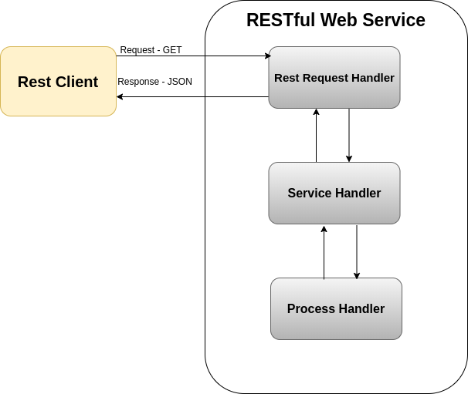

Logical Data Model/Data Dictionary
NA

Functional Requirements
NA

Error Handling
[Describe system error handling.

