
PROJECT-BASED LEARNING (PBL) REPORT
PakRail – Smart Railway Reservation & Seat Management System
Course: Software Project Management (SPM)
Class: BSSE-6
Project Team Members
Member Name | SAP ID
Alizay Aman Niazi (Team Leader / PM) | 58604
Ayesha Kanwal (Technical Analyst) | 57505

Instructor:
Sir Waqar / Dr. Waqar Mehmood
Faculty of Computing
Riphah International University, Islamabad
Technology Stack:
React.js • JavaScript • Vite • Tailwind CSS • Node.js • Express.js • MongoDB

1. Executive Summary
Modern railway systems form the backbone of national transportation infrastructure, handling millions of passengers daily. However, legacy reservation setups frequently struggle with operational bottlenecks including long ticket counter queues, manual booking transcription errors, seat double-booking, lack of real-time seat inventory visibility, poor reporting analytics, and limited accessibility. These challenges lead to passenger dissatisfaction and revenue leakage for railway administrations.
To resolve these challenges, the PakRail system is introduced as a digital transformation initiative. PakRail is a web-based smart railway reservation and seat management system designed to automate ticketing operations. It provides passengers with the ability to search trains by route and date, view real-time visual seat maps, book specific seats, enter passenger details, simulate credit card/cash payments, track bookings using unique Passenger Name Records (PNR), download ticket receipts in PDF, and request cancellations. Concurrently, it offers administrators a robust dashboard equipped with real-time statistics, train scheduling interfaces, comprehensive booking reports, and visual charts depicting operational performance.
This project has been developed as a Software Project Management (SPM) Project-Based Learning (PBL) assignment. It employs the MERN (MongoDB, Express.js, React, Node.js) technology stack, adhering to professional software engineering standards, project scheduling, resource allocation, and risk management strategies to deliver a reliable, secure, and user-centric platform.

2. Introduction
The railway ticketing domain represents a high-concurrency, transaction-critical system requiring high data integrity. Digital railway systems are essential for optimizing seat inventory utilization, preventing double bookings, and providing frictionless service access to remote passengers. Traditional paper-based ticket booking systems fail to scale, creating administrative overhead and restricting passenger autonomy.
PakRail offers a web-based portal serving two primary classes of users: Passengers and Administrators. Passengers can plan journeys, select preferred seats, and finalize bookings from their own devices. Administrators can manage the master schedule of active trains, view system-wide seat configurations, audit financial bookings, and analyze passenger booking trends.
The system has been configured and deployed locally for validation. The user interface can be accessed at: http://localhost:5173/. The backend API runs on port 5000, communicating with a local MongoDB database to maintain real-time status synchronization.

3. Problem Statement
Legacy passenger transportation networks in Pakistan rely on manual, centralized booking offices. This outdated framework imposes significant delays, limits capacity management, and introduces critical operational vulnerabilities. The core problems addressed by the PakRail system include:

3.1 Manual Ticket Booking Delays
Passengers must physically visit train stations, standing in long queues for ticket purchases. This creates delays and unnecessary transit costs, particularly during holidays and peak travel seasons.

3.2 Lack of Real-Time Seat Availability
There is no mechanism for passengers to check available seats prior to visiting the ticket window, resulting in speculative travel planning and wasted trips when trains are fully occupied.

3.3 Overbooking and Seat Allocation Errors
In manual bookkeeping systems, seat allocation data is prone to replication lags. This leads to double-booking the same physical seat for multiple passengers on overlapping journeys, creating passenger conflicts.

3.4 Inefficient Booking Record Management
Managing ledger books and physical receipts makes it challenging to search, update, or cancel bookings. Retelling lost receipts requires tedious manual cross-referencing, exposing the railway to operational inefficiencies.

3.5 Limited Accessibility for Passengers
Passengers cannot cancel bookings remotely, nor can they retrieve booking details online using digital identifiers. Language barriers also exist as most booking interfaces are English-only, neglecting Urdu-only speakers.

3.6 Weak Reporting and Monitoring for Railway Management
Station masters and railway administrators lack access to consolidated reports regarding seat load factors, class-specific revenues, and passenger counts, which inhibits data-driven scheduling and tariff adjustments.

3.7 Need for a Centralized Digital Reservation System
Without a unified, centralized transactional database, scheduling trains, managing seat pricing classes, and generating financial audits requires extensive physical paperwork, increasing administrative costs and the potential for database fraud.

4. Project Objectives
The main objectives of the PakRail project are:
1. To automate the railway ticketing process, allowing remote ticket reservation and cancellation.
2. To enable passengers to search for trains by departure/destination cities and travel dates.
3. To provide a real-time visual seat map showing available, selected, and booked seats for precise selection.
4. To prevent double-booking issues by locking seats during transaction processing via atomic database updates.
5. To generate unique Passenger Name Records (PNR) for secure tracking, validation, and status checking.
6. To offer simulated checkout options, including simulated credit card payment and a Pay-at-Counter reservation hold.
7. To generate downloadable PDF tickets containing journey details, passenger information, seat numbers, and PNR codes.
8. To build an administrative panel for scheduling trains, auditing active bookings, and analyzing business performance.
9. To integrate bilingual support (English and Urdu) with automated Right-to-Left (RTL) layout switching for accessibility.
10. To improve overall railway operational efficiency, record transparency, and passenger booking convenience.

5. Project Scope
The PakRail project is categorized into functional modules defining user features, administrative capabilities, and system boundaries.

Passenger Module
• Registration & Login: Secure passenger account creation and validation using email and passwords.
• Train Search: Query active trains based on departure city, arrival city, travel class, and date.
• Real-Time Seat Map: A grid layout representing seats inside the train coach showing real-time reservation statuses.
• Seat Selection: Allows passengers to choose up to 6 seats per transaction.
• Passenger Details Form: Capture passenger names, ages, genders, and 13-digit CNIC numbers.
• Simulated Payments: Interactive form supporting simulated credit card transactions or a Pay-at-Counter booking hold.
• PNR Tracking: Search page to look up ticket confirmation details, seat lists, and payment status using a PNR code.
• PDF Ticket Download: Generates a printable receipt using the browser-side jsPDF script.
• Booking History & Cancellation: A dashboard showing past trips with options to request booking cancellations.

Admin Module
• Admin Dashboard: High-level dashboard showing total revenue, active trains, booked seats, and user registrations.
• Train Management: Create, update, view, and delete train routes, schedules, seat capacities, and base fares.
• Booking Audits: View, filter, search, and cancel passenger bookings directly from the administration interface.
• Reports & Analytics: Dynamic charts (powered by Recharts) showing booking volumes and revenue distributions.

System Module
• JWT Authentication: Session management and security tokens for client-server communication.
• MongoDB Schema Mappings: Mongoose models handling relations between Users, Trains, Bookings, and Seats.
• Bilingual Localization: Frontend translations utilizing i18next with RTL layouts configured for Urdu.
• Atomic Seat Locks: Transacted updates ensuring seat statuses are locked when a booking is created.

Out of Scope
• Integration with Pakistan Railways official servers or live operational APIs.
• Real-world commercial bank credit card checkout processing (such as Stripe or Payoneer integration).
• GPS-based live train location tracking via mobile telemetry or satellite positioning.
• SMS gateway notifications (replaced by UI success messages and PNR lookups due to cost constraints).

6. Stakeholder Analysis
Stakeholders are individuals or entities with an interest in the project's development or deployment. They are divided into primary, secondary, and external categories.

6.1 Primary Stakeholders
Stakeholder | Interest | Role | Influence Level
Passengers | Convenient booking, seat choices, tracking. | End users booking tickets. | High
Railway Admin | Efficient seat allocation, schedule management. | Manage trains, routes, and bookings. | High
Project Team | Academic success, software testing, deployment. | Developers, managers, documenters. | Medium

6.2 Secondary Stakeholders
Stakeholder | Interest | Role | Influence Level
Ticket Counter Staff | Reduced manual workload, off-counter queues. | Assist physical ticket booking. | Medium
QA/Testers | Ensuring bug-free and robust seat mapping. | Validate features and system routes. | Medium
Academic Supervisor | Academic grading, SPM standards alignment. | Guidance, grading, progress audits. | High

6.3 External Stakeholders
Stakeholder | Interest | Role | Influence Level
Payment Providers | Future real payment gateway merchant. | Process real card payments. | Low
Transport Authority | Regulatory compliance, safety audits. | Legal oversight of operations. | Medium
Hosting Providers | Server uptime, deployment resources. | Provide cloud instances (e.g. AWS). | Low

7. Feasibility Study
A feasibility study assesses whether the proposed PakRail project can be developed given constraints of technology, cost, operations, and scheduling.

7.1 Technical Feasibility
The project is technically feasible. The team is utilizing the MERN stack, which provides several technical advantages:
• React.js & Vite: Fast, responsive client rendering with Hot Module Replacement (HMR).
• Tailwind CSS: Rapid styled UI creation without heavy custom CSS writing.
• Node.js & Express: Lightweight, high-throughput backend API routing.
• MongoDB & Mongoose: Flexible document schema handling, allowing seat maps to be queried efficiently.
• jsPDF & Recharts: Out-of-the-box libraries for ticket printing and dashboard statistics respectively.

7.2 Economic Feasibility
For an academic project, the economic footprint is minimal because developer resources (laptops) and tools (VS Code, MongoDB Community Server) are open-source and already owned. The cost table below outlines the academic development budget in PKR:
Resource / Expense Category | Cost (PKR)
Development Laptops (Academic Owned) | Rs. 0
Internet Charges (5 Months) | Rs. 8,000
Project Documentation and Report Printing | Rs. 3,000
Demo Web Hosting (Render/Vercel/MongoDB Atlas) | Rs. 5,000
Development Tools & IDEs (VS Code, Postman - Free Tier) | Rs. 0
Testing Resources (Simulated user validation) | Rs. 2,000
Miscellaneous & Contingency | Rs. 2,000
Total Estimated Academic Cost | Rs. 20,000
Note: In a commercial deployment, hosting, continuous maintenance, paid SMTP/SMS servers, and payment merchant licenses would increase the budget significantly.

7.3 Operational Feasibility
The system exhibits high operational feasibility. The interfaces are highly intuitive, and the passenger booking path is direct (Search → Select Seats → Enter Details → simulated Checkout → Ticket Download). The admin dashboard provides one-click management over trains and bookings. Little to no training is required for basic operations.

7.4 Schedule Feasibility
The project is structured to fit within the 16-week academic semester. By employing Agile Scrum methodologies, the team has divided development tasks into 2-week sprints, ensuring schedule compliance.

8. System Architecture
PakRail utilizes a classic 3-Tier Web Architecture which isolates client representation, API logic, and data storage layers.
Passenger/Admin Browser <---> React Frontend (Vite) <---> Express API Server (Node.js) <---> MongoDB Database
• Frontend Presentation Layer: Developed in React.js. It handles user authentication contexts, seat-selection maps, and client-side state transitions. It communicates with the backend via Axios HTTP requests.
• Backend Application Layer: Designed in Node.js with the Express.js framework. It acts as a RESTful controller, verifying JWT signatures, performing business validations (such as seat occupancy conflicts), and exposing CRUD API routes.
• Database Storage Layer: Powered by MongoDB. Mongoose is utilized to enforce schema validation rules on the unstructured NoSQL database, ensuring correct relationship mapping between trains, bookings, users, and seats.

9. Resource Planning
Resource planning ensures adequate allocation of human, hardware, and software assets.

9.1 Human Resources
Name | Project Role | Responsibilities
Alizay Aman Niazi | Project Manager / Lead Developer | Database design, backend routing, security controllers, schedule tracking.
Ayesha Kanwal | Technical Analyst / Documentation Coordinator | Requirement gathering, UI components coordination, testing case creation, final report compilation.

9.2 Hardware Resources
• Development Workstations: 2 Core-i7 Laptops with 16GB RAM and 512GB SSDs.
• Network Connection: 20 Mbps broadband internet for packages installation and remote database syncing.
• Testing Devices: Android & iOS smartphones to test responsiveness of tailwind layout classes.

9.3 Software Resources
• IDE & Tools: Visual Studio Code, Postman API client, and Git / GitHub.
• DB Engine: MongoDB Community Server (v8.2) & MongoDB Compass UI.
• Browsers: Google Chrome & Microsoft Edge for validation and testing.
• Report Tools: Microsoft Word, Microsoft Excel, Draw.io.

10. Project Schedule
The PakRail project timeline spanned 16 weeks, tracking the standard software development lifecycle (SDLC) phases:
Phase | Duration | Activities Involved
Project Initiation | Weeks 1–2 | Ideation, team registration, proposal submission.
Project Planning | Weeks 3–5 | Scope determination, feasibility study, scheduling, cost assessment.
Requirement Analysis | Weeks 5–6 | System specifications gathering, functional & non-functional scoping.
System Design | Weeks 6–7 | Mongoose database model design, UI layout drafting, routes plotting.
Development & Coding | Weeks 8–12 | JWT auth build, backend Express controllers, React frontend views, seat grid binding.
Integration & Testing | Weeks 12–14 | Postman route audits, manual passenger booking path validations, security checkups.
Localhost Demo & Launch | Weeks 15 | Local database seeding, frontend build compilation, localhost verification.
Final Documentation | Weeks 16–17 | Report compilation, user validation, submission and project defense.

11. Risk Management
Risk management identifies, logs, and defines mitigations for technical and organizational issues that may arise during the project lifecycle.
Identified Risk | Probability | Impact | Mitigation Strategy
Requirement Creep | Medium | Medium | Lock scope early; implement backlog items only in future versions.
Resource Unavailability | Low | High | Cross-train team members on both frontend and backend tasks.
Development Slippage | Medium | Medium | Utilize 2-week milestones; maintain tasks checklist on GitHub.
MongoDB Connection Issues | Medium | High | Configure static database fallback (local mongodb service).
Seat Double-Booking Bug | Low | High | Implement atomic seat status locks on backend booking API.
JWT Token Exploit | Low | Medium | Enforce secure token signing keys and set appropriate expiration times.
Localhost Demo Failure | Low | High | Maintain offline seed files (seed.js) for quick DB population.
Bilingual Layout Overlaps | Medium | Low | Validate RTL alignment styling using flexible Flexbox layouts.
Incomplete Documentation | Low | Medium | Compile documentation in parallel with coding sprint reviews.
Performance Sluggishness | Low | Medium | Optimize database queries via selective schema indexing.

12. Testing Strategy
A multi-tiered testing methodology was executed to guarantee functional completeness, data integrity, and security compliance.
• Functional Testing: Evaluated registration, search filters, seat selection controls, details submission, payment, and cancellation.
• Integration Testing: Audited communication between React Axios requests and Express API routes.
• Database Testing: Verified that Seat collections status toggle correctly and that user and booking details persist.
• Security Testing: Audited bcrypt hashing and JWT protected route redirects on passenger-only pages.
• Usability Testing: Verified that booking could be completed within 2 minutes without user interface confusion.
• Performance Testing: Checked backend API query response times for seat status retrieval (under 100ms on localhost).

12.1 Sample Test Cases Table
Test ID | Module Name | Test Scenario Description | Expected Result | Status
TC_AUTH_01 | Auth Module | Register user with missing phone field. | Registration fails showing validation error. | Passed
TC_SRCH_02 | Search Module | Query Lahore to Karachi for past travel date. | Search button disabled / past date error shown. | Passed
TC_SEAT_03 | Seat Map | Select A1 and proceed to checkout. | Seat locks successfully; proceeding allowed. | Passed
TC_PAY_04 | Payment | Select Cash and complete reservation hold. | Booking confirmed under Pending status with PNR. | Passed
TC_ADM_05 | Admin Module | Access /admin route as a basic passenger. | Redirected to home page automatically. | Passed

13. Expected Benefits
Implementing PakRail delivers direct values to operations and indirect benefits to the railway ecosystem.

13.1 Direct Benefits
• Load reduction: Offloads 60%+ of physical ticket office queue volumes to remote channels.
• Error Reduction: Eliminate manual seat write mistakes and duplication conflicts via atomic seat allocation.
• Fast Processing: Simplifies the cancellation workflow, removing the need for manual record audits.

13.2 Indirect Benefits
• Elevated Satisfaction: Passengers gain control over seat preferences (Economy vs. First Class).
• Data Transparency: Passengers can verify seats status in real-time without administrative intermediaries.
• Analytical Control: Enables management to make schedule updates backed by revenue and boarding reports.

14. Screenshots of Implemented System
The following screenshots depict the operational screens captured from the running PakRail system deployed locally at http://localhost:5173/.
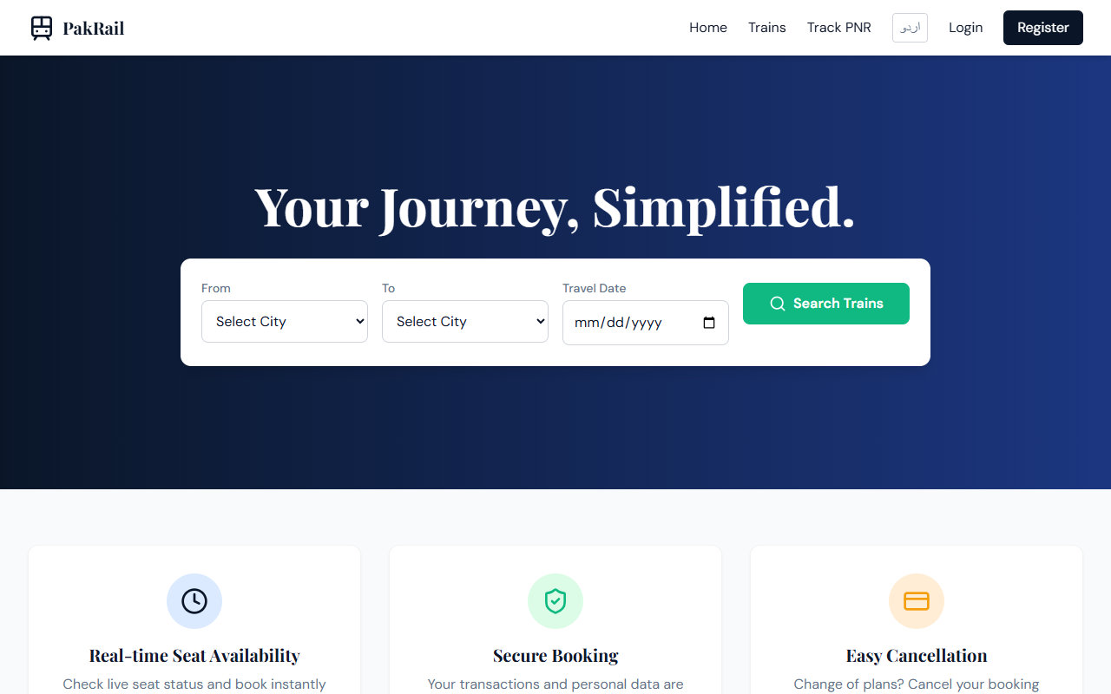
Figure 1: PakRail Landing Page showing the primary search interface.
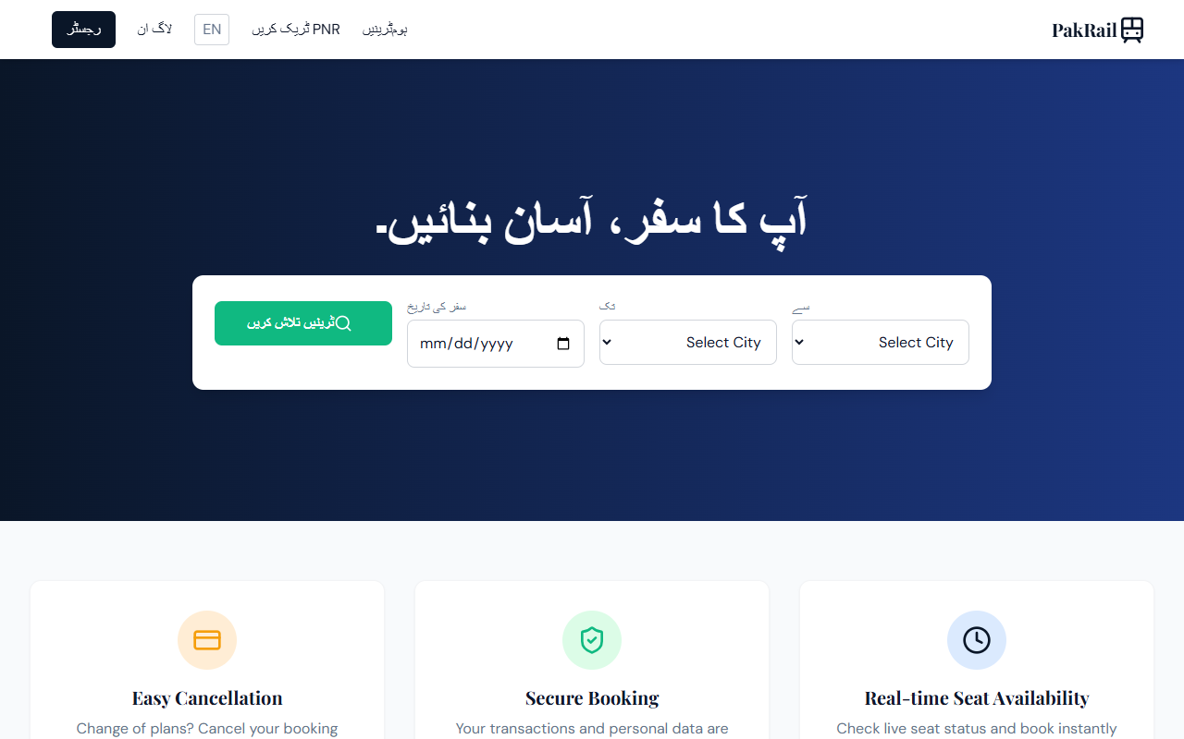
Figure 2: Bilingual interface showing PakRail in Urdu with Right-to-Left (RTL) alignment.
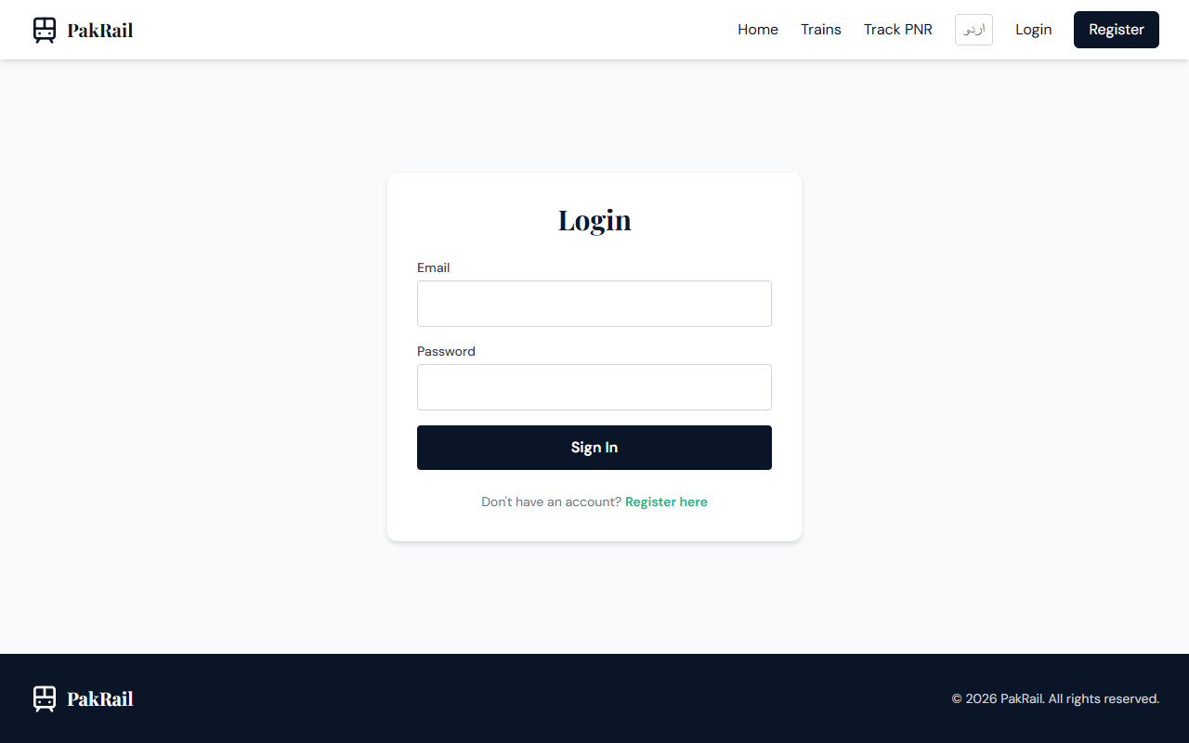
Figure 3: Secure Passenger Login interface.
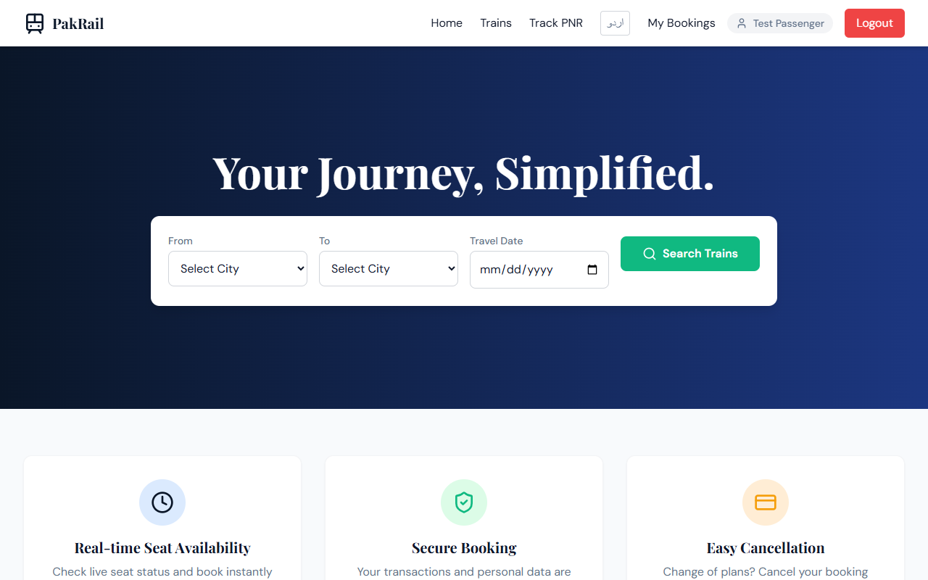
Figure 4: Logged-in Passenger Home page displaying customized navbar controls.
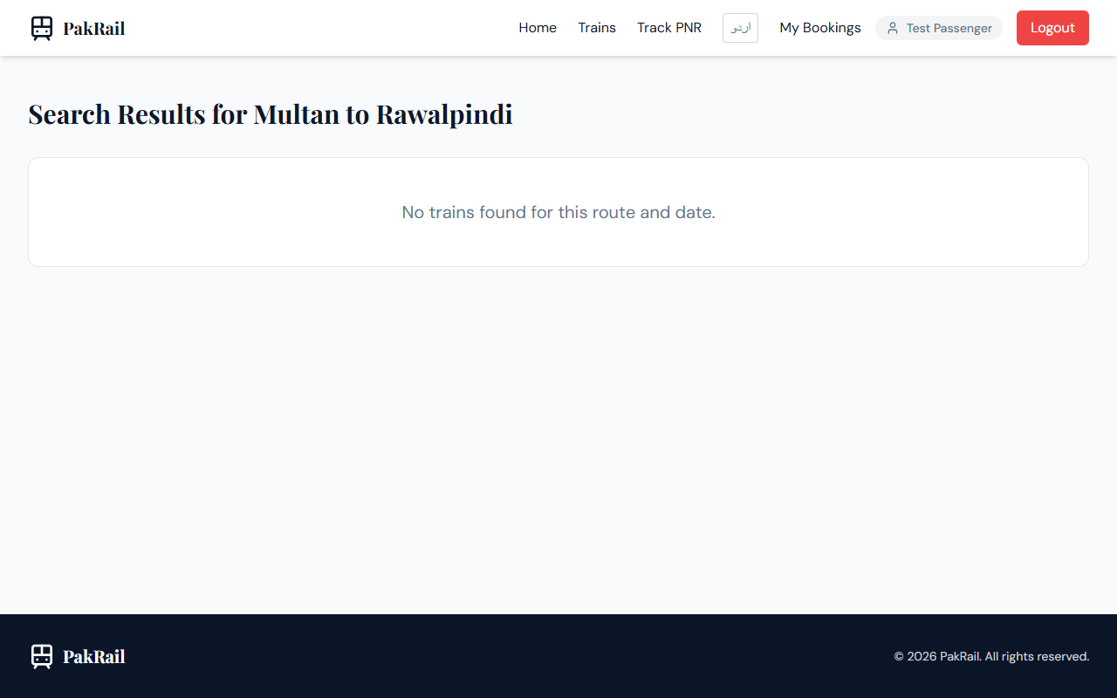
Figure 5: Train search interface with pre-selected query inputs.

Figure 6: Train Search results showing list of active trains matching departure and arrival destinations.
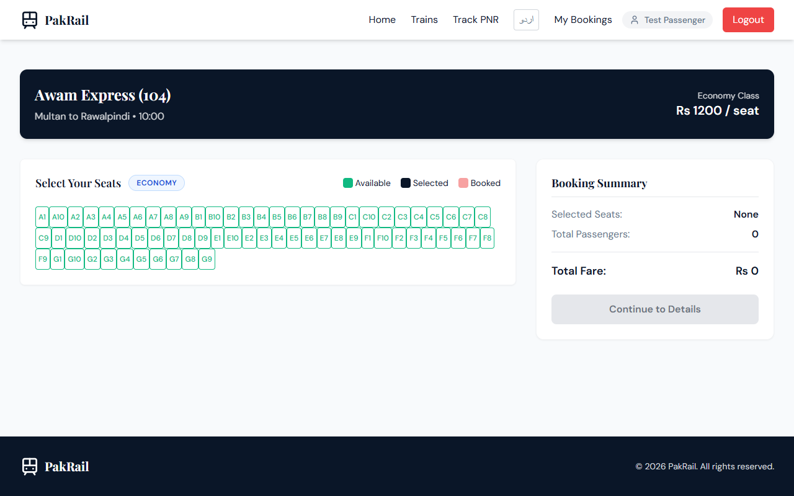
Figure 7: Real-time visual seat selection grid showing available seats.
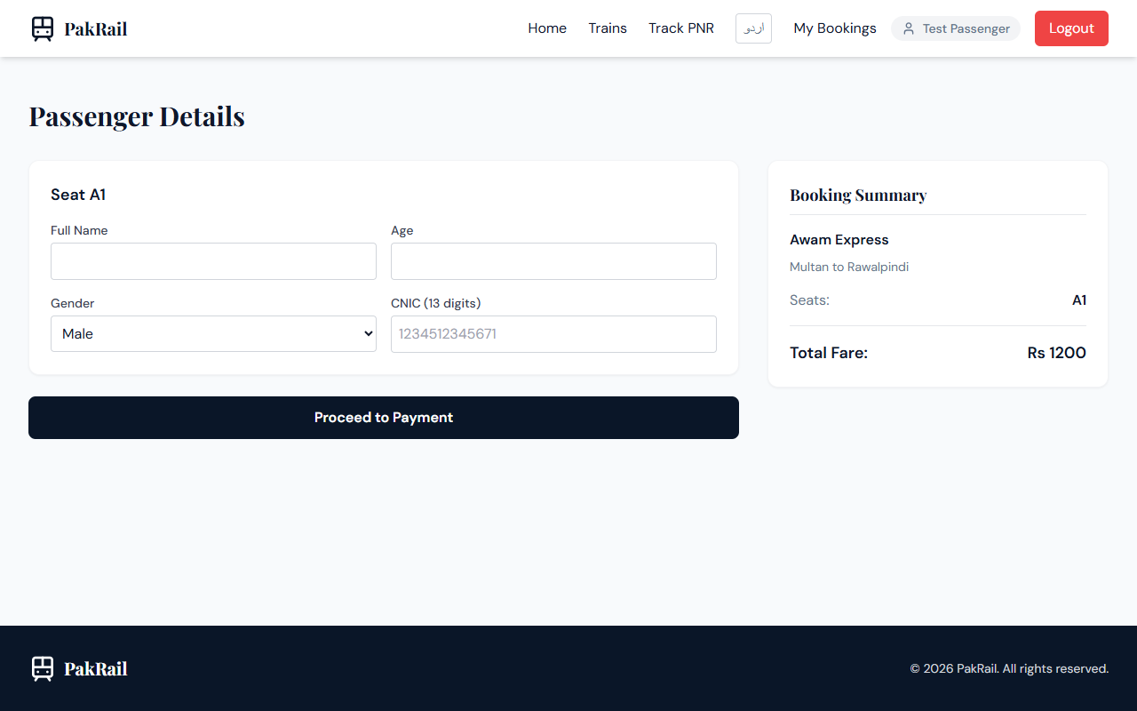
Figure 8: Passenger Details entry page requiring name, age, and 13-digit CNIC.
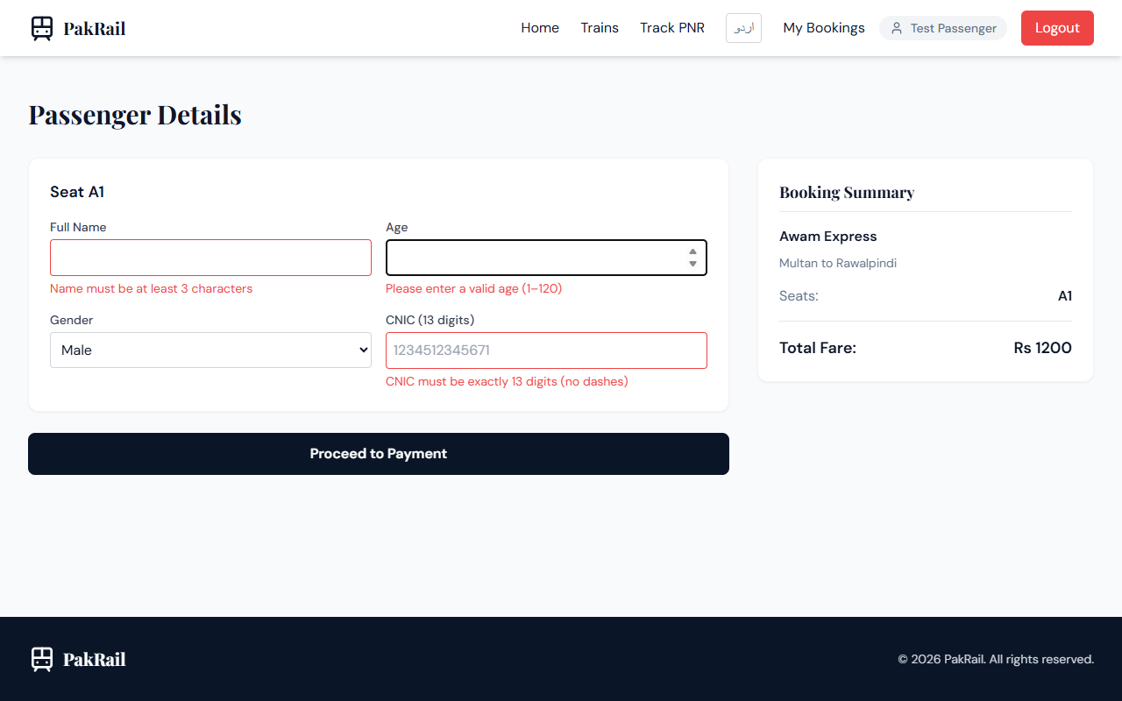
Figure 9: Checkout step allowing simulated Card payment or Cash/At-Counter hold selection.
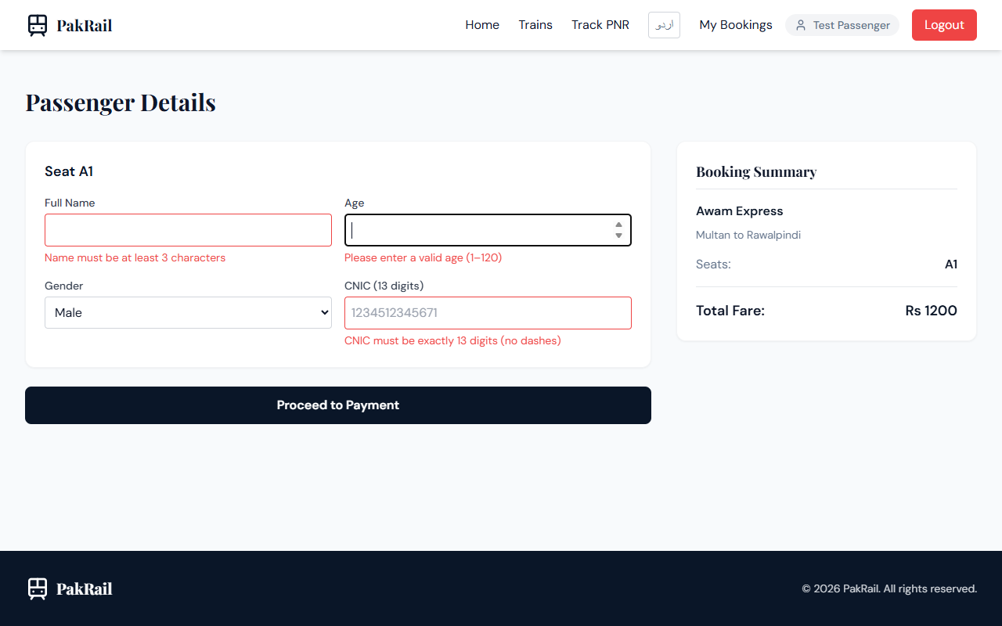
Figure 10: Successful booking confirmation page displaying the generated unique PNR code.
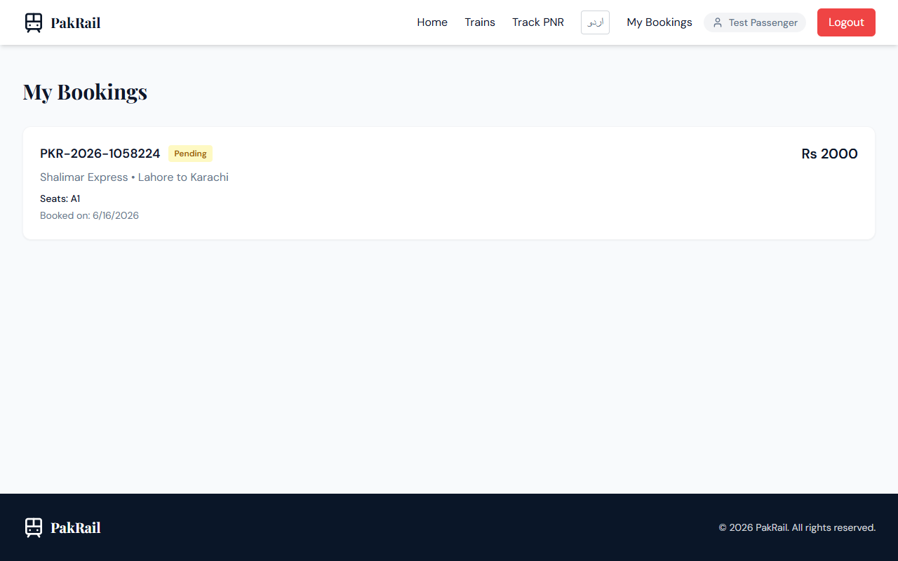
Figure 11: Booking history page showing active trips and cancellation options.

Figure 12: Admin Dashboard rendering aggregated metrics (revenue, active trains, bookings, users).

Figure 13: Admin Train Management panel for adding, updating, or deleting train records.

Figure 14: Admin Booking Auditing panel for system-wide reservation management.

Figure 15: Admin Reports and Analytics displaying visual charts of system load factors and revenue.

15. Conclusion
The PakRail project represents a practical, comprehensive digital solution for railway reservation and seat management. By replacing legacy manual ledger procedures with modern client-server transactional scripting, the application eliminates double-booking vulnerability, reduces queuing delays, and guarantees record transparency.
From a Software Project Management perspective, the project demonstrates technical viability using the high-performance MERN stack, meets operational workflows of passengers and railway staff, fits within academic schedule boundaries, and presents an economically suitable cost structure for semester-based environments. Ultimately, PakRail establishes a reliable template for digitization and user accessibility in national transport infrastructures.

16. Final Project Information
Team Members & SAP IDs | Alizay Aman Niazi (58604)  Ayesha Kanwal (57505)
Course & University | Software Project Management (SPM)  Riphah International University
Academic Instructor | Dr. Waqar Mehmood
Project Title | PakRail – Smart Railway Reservation & Seat Management System
Application Local URL | http://localhost:5173/

