Understanding Garden gross profit and choosing an action
Stories Coffee | January to June 2026 | Integrated report and final validation
Garden’s recorded gross margin is 46.91%, compared with 64.96% at Harbour and 62.63% at Uptown. Garden also earns less gross profit per transaction. Recorded unit costs explain the largest accounting component of those differences; prices materially amplify or offset it, while basket composition contributes relatively little.
Recommendation. Validate the recorded cost premium with comparable invoices, product specifications and allocation records, then test the feasible action with the highest positive benefit after expenses and adverse volume outcomes. An avoidable purchasing premium would justify a limited cost trial. Harbour price matching remains a competing option: the analysis does not establish 25% cost-gap closure as the financial winner.
For illustration, at 95% of observed quantities and $1,000 of additional six-month expenses, Harbour price matching adds $1,396.85 against observed Garden gross profit; 25% Harbour cost-gap closure adds $442.10. These are hypothetical stress outcomes. Supplier feasibility and customer responses remain unmeasured.

Observed branch performance
Metric | Garden | Harbour | Uptown
Transactions | 11,163 | 16,334 | 6,390
Units sold | 17,833 | 26,093 | 10,161
Revenue | $99,748.55 | $150,483.58 | $55,693.01
Recorded costs | $52,954.06 | $52,729.64 | $20,810.95
Gross profit | $46,794.49 | $97,753.94 | $34,882.06
Gross margin | 46.91% | 64.96% | 62.63%
Gross profit per transaction | $4.19 | $5.98 | $5.46

Questions answered in this report
1. Are the financial comparisons reliable, and which data limitations remain?
2. How much of the profit-per-transaction gap is associated with recorded costs, prices, discounts, basket size and mix? How does volume affect total profit?
3. Does the disadvantage persist for comparable baskets, periods and order types?
4. What explains the cost pattern, and what evidence would distinguish the plausible causes?
5. Which action remains worthwhile after implementation expenses and adverse outcomes, and what would make Stories choose differently?

1 Reliability of financial comparisons
The primary analysis retains all 51,177 supplied product lines across 33,887 distinct transactions from 1 January to 30 June 2026. A basket is a distinct transaction ID; units are summed quantities. Revenue and gross profit preserve supplied line amounts. Every gross-profit line reconciles exactly to revenue less quantity times recorded unit cost; no reconstructed revenue differs by more than half a cent per line.
Transaction metadata are internally consistent and required financial fields are complete. Customer IDs are missing on 18,691 lines belonging to 12,353 transactions. This limits complete customer-level retention or repeat-purchase analysis. Volume sensitivity therefore scales quantities, not identified customers.
The duplicate audit finds 132 exact repeated-row pairs: 264 participating rows, including 132 excess copies. It also finds 34 nonidentical repeated-item pairs. All are retained in the primary comparison because repeated items may be valid. Keeping one copy of each exact repeat is a sensitivity check; it reduces Garden’s cost premiums by approximately 0.23% and leaves the cost rules unchanged.

The recorded cost schedule
All 45 products satisfy Garden cost = Harbour cost × 1.43 rounded to cents, and Uptown cost = Harbour cost × 0.96 rounded to cents, with zero exceptions. Prices and costs remain fixed within all 135 branch-product combinations across the six months. A single direct Garden-to-Uptown multiplier does not reproduce every rounded cent, although both Harbour-based rules do.
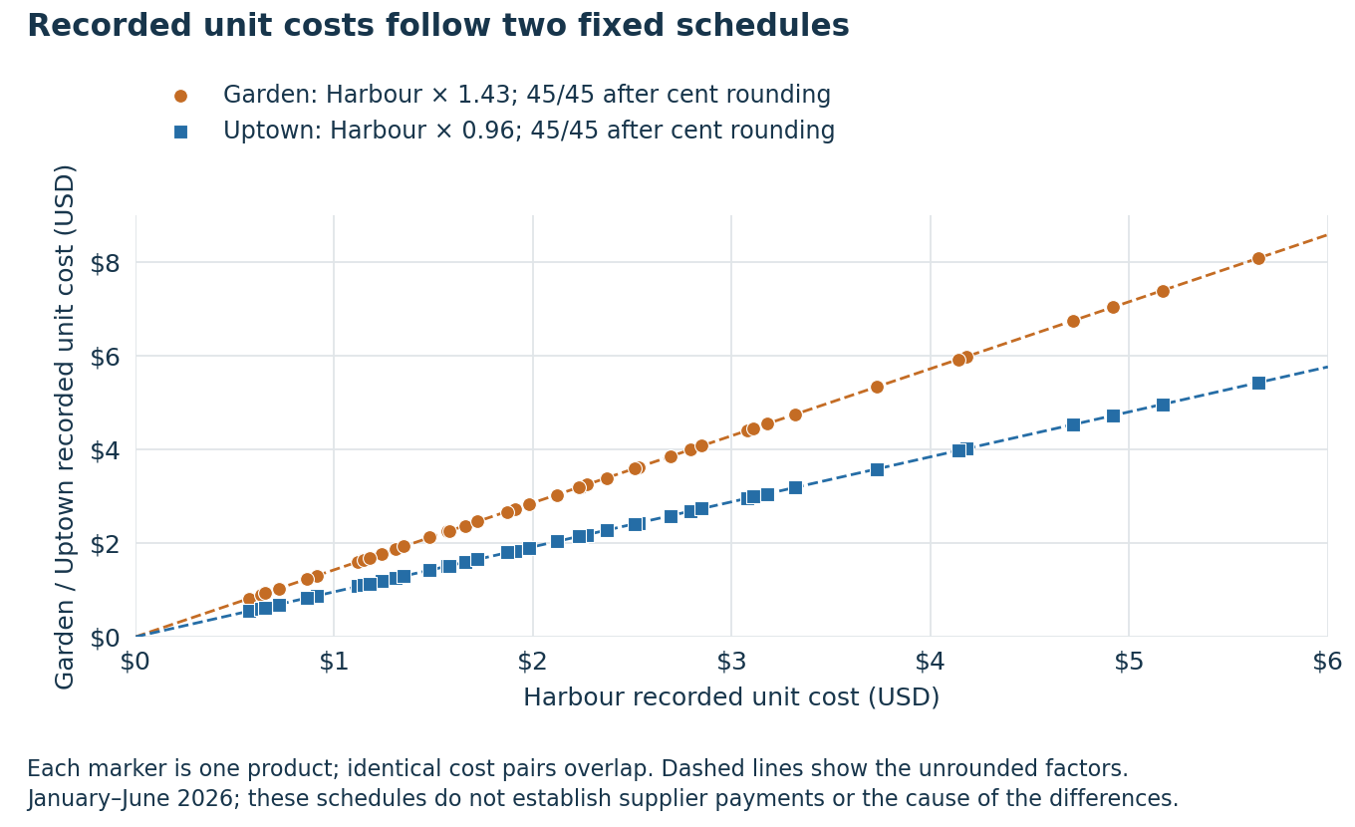
Figure 1. One point per product comparison; coincident cost pairs overlap. Repeated sales reuse fixed schedules and do not provide independent observations of supplier prices.
These checks validate the recorded accounting pattern. Matching product names and fixed schedules do not establish equivalent recipes, portions, quality, supplier terms or actual payments. Those require source documents and operating evidence.

2 Components of the gross profit gap
Garden earns $4.1919 gross profit per transaction, compared with $5.9847 at Harbour and $5.4589 at Uptown. The observed gaps are $1.7928 and $1.2669. We replace Garden’s factors in the declared order: recorded costs, list prices, realized discounts, units per basket, then product mix. A positive component raises the comparison branch above Garden; a negative component works in Garden’s favour.
The accounting identity is units per basket multiplied by the product-mix-weighted sum of list price after realized discount less unit cost. Product discount rates are quantity-weighted. The rounding residual is below $0.0001 per transaction and is retained in the reconciliation.
USD per transaction | Harbour minus Garden | Uptown minus Garden
Recorded unit costs | +1.4265 | +1.5596
List prices | +0.4466 | -0.3588
Realized discounts | -0.0311 | -0.0017
Units per basket | -0.0002 | -0.0249
Product mix | -0.0490 | +0.0928
Recorded line rounding | -0.0001 | -0.0000
Observed gap | 1.7928 | 1.2669

Against Harbour, costs contribute $1.43, or 79.57% of the observed gap, and higher list prices contribute $0.45, or 24.91%. Garden’s product mix and smaller realized discount effect offset part of that difference. Against Uptown, costs contribute $1.56, or 123.10%, while Garden’s higher list prices offset $0.36. Shares can exceed 100% because other components offset them.

Order sensitivity
Cost contribution in USD per transaction | Harbour | Uptown
Declared order | 1.4265 | 1.5596
Reverse order | 1.3880 | 1.5956
Average of all 120 orders | 1.4072 | 1.5776

Component sizes depend on the decomposition method. Recorded costs remain the largest component under the declared order, the reverse order and the average across all 120 orders. These are accounting attributions; they do not estimate the causal effect of changing a supplier or menu.

Transaction volume and total profit
Total gross profit equals transaction count times gross profit per transaction. Garden serves 74.69% more transactions than Uptown, so its total gross profit is higher despite its lower profit per transaction: $46,794.49 versus $34,882.06. Harbour has both more transactions and higher profit per transaction, producing $97,753.94. The per-transaction and total-profit questions must remain separate.

How the accounting components reconcile
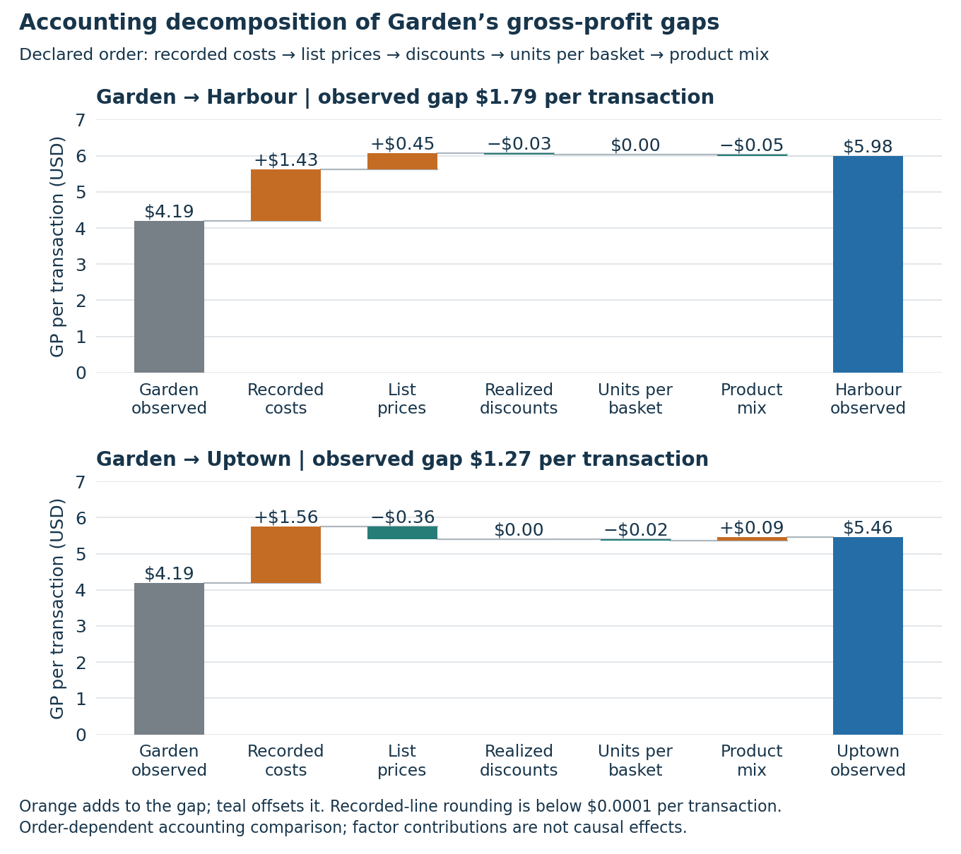
Figure 2. The same declared-order decomposition shown graphically. Each bar is an accounting component; values are displayed to cents, while full-precision calculations retain the rounding residual.

Consistency across subsets
Garden’s observed gross profit per basket is lower in each of the six months and in both dine-in and takeaway orders. Recomputing the decomposition by month, order type and exact-repeat sensitivity preserves recorded cost as its largest component. These checks show that the finding is not confined to one month or service channel; they do not remove the common dependence on the same fixed recorded schedules.

3 Comparable purchases and buying patterns
Garden’s basket sizes, spend and order-type proportions are broadly similar to the other branches. To compare buying patterns alone, we value every branch’s observed quantities using one common product price-and-cost list and remove discounts. The common list uses quantity-weighted chain averages for each product, applied identically to all branches.
Metric | Garden | Harbour | Uptown
Distinct baskets | 11,163 | 16,334 | 6,390
Units per basket | 1.60 | 1.60 | 1.59
Revenue per basket | $8.94 | $9.21 | $8.72
Dine-in share of transactions | 58.69% | 58.96% | 60.25%
Baskets containing a dessert | 16.2% | 11.5% | 10.2%
Actual GP per basket | $4.19 | $5.98 | $5.46
GP at common price and cost list | $5.36 | $5.33 | $5.43

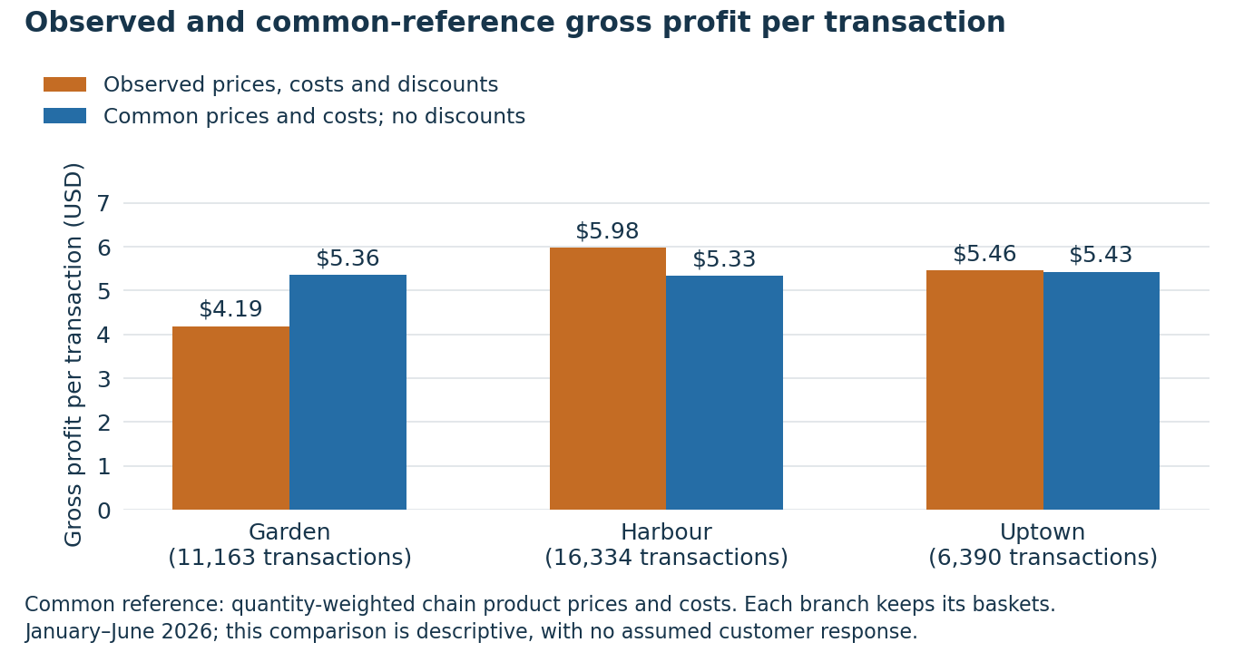
Figure 3. The same observed baskets valued at a common quantity-weighted product schedule, with discounts removed. The difference reflects units and mix under that reference, not an estimated response to a price change.
At the chain reference, Garden has a $0.0285 advantage over Harbour and a $0.0720 disadvantage versus Uptown. Across the chain, Garden, Harbour and Uptown reference lists, Garden’s advantage over Harbour ranges from $0.008 to $0.053; its disadvantage versus Uptown ranges from $0.039 to $0.078. Direction matters: a blanket statement that buying patterns explain 0–6% of both gaps would conceal Garden’s small advantage against Harbour.

Matched baskets and concentration of the cost gap
Exact basket signatures contain the same products and summed quantities. The comparison branch’s signature profits are weighted to Garden’s matched-signature counts; unmatched transactions are excluded. Discounts remain as observed. Garden is lower on every matched signature in each comparison.
Exact-basket comparison | Harbour | Uptown
Matched signatures | 1,170 | 932
Matched Garden transactions | 10,293 | 9,806
Share of Garden transactions | 92.21% | 87.84%
GP disadvantage per matched basket | $1.69 | $1.07

The disadvantage also holds in the ten most common category-line basket types, each month and both order types, and under exact-repeat removal and undiscounted-only variants. Category-line types count category occurrences in source rows; they are distinct from exact product-and-quantity signatures.
Garden has the highest dessert-basket share in all six months: 14.33–17.20%, versus Harbour’s 10.70–12.49% and Uptown’s 8.97–10.91%. This is a descriptive association and does not establish that a dessert bundle would increase sales.
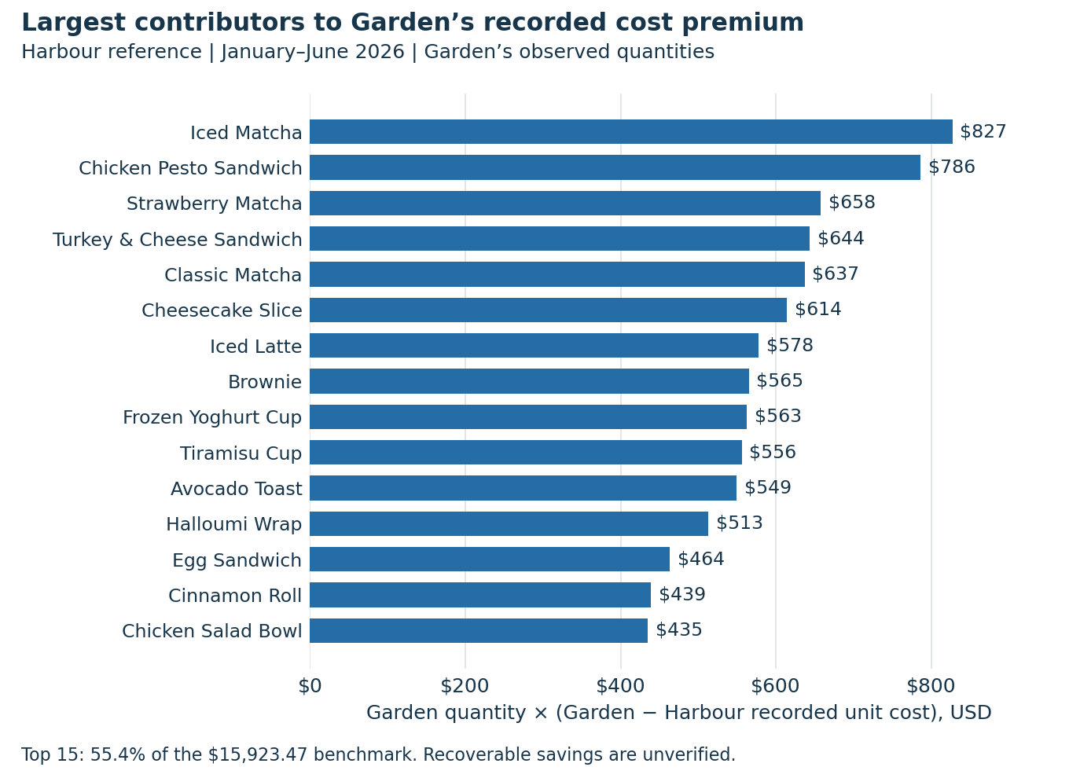
Figure 4. Recorded premium at Garden’s actual quantities. Iced Matcha contributes the most; the top five contribute 22.30% of the Harbour gap and 22.31% of the Uptown gap. The premium extends across the menu.

4 Explanations and evidence needed
At Garden’s observed quantities, the recorded cost premium is $15,923.47 against Harbour and $17,409.78 against Uptown. These are fixed-quantity comparison benchmarks, not verified recoverable savings. Replacing Garden costs with Harbour costs gives a 62.88% gross margin at unchanged revenue, still below Harbour’s observed 64.96%; costs therefore do not account for the entire margin difference.
The uniform schedule is compatible with supplier terms, portion or ingredient differences, cost allocation, standard waste allowances, persistent entry or mapping errors, and quantity-dependent supplier discounts. The transactions do not distinguish among them. Source constancy alone rules out none of these explanations.
Avoidable purchasing premium confirmed. Obtain like-for-like supplier terms at Garden’s actual purchase volumes, including freight, rebates, credit, minimum orders and service. Trial the quoted offer and count invoice-backed savings after additional expenses.
Allocation difference confirmed. Correct branch performance comparisons and identify the expenses allocated to each branch. Count financial savings only where Stories’ underlying expenses actually fall; do not recommend a supplier change from an allocation correction.
Quality or portion differences confirmed. Compare equivalent ingredients, recipes, yields and portion sizes. Evaluate like-for-like offers and customer quality acceptance before recommending cost reduction. Retain the premium if its value outweighs verified alternatives.
Cause unresolved. A supplier-change recommendation is blocked by uncertainty over whether the recorded premium is a comparable and avoidable purchase cost. Obtain invoices, allocation rules and product specifications before proceeding.

Additional checks before an operating change
Reconcile costing rules and supplier invoices to the ledger and inventory. Inspect standard waste allowances and expiry or yield logs. If a costing or mapping error is confirmed, correct the records and rerun the comparison; a ledger correction is not itself cash saving. If supplier price tiers require larger orders, include delivery, storage, financing and extra waste in the evaluation of actual available terms.
The original implication that the schedule proves one supplier problem is unsupported. Likewise, waste data provide no 25–50% ceiling on attainable closure. Net profitability cannot be established from this file because operating expenses are absent.

5 Choosing an action after expenses and adverse outcomes
Compare only feasible actions supported by equivalent product specifications and available terms. For each, use evidence-supported conservative volume, unit economics and all additional expenses; choose the largest positive benefit. Keep current operations when no action clears that test. Harbour price matching must remain in the choice set, because its fixed-quantity gain exceeds both 25% cost-closure benchmarks.

Decision calculation
Let Gₛ be scenario gross profit at Garden’s observed quantities and G₀ = $46,794.49. Let v scale quantities while product mix and scenario unit economics remain fixed. Let K be all additional implementation expenses over the same six months. This is a proportional accounting stress test; it estimates no demand curve or customer response.
$Incremental benefit = vG_{s} − G_{0} − K$
$v_{break-even} = \frac{G_{0} + K}{G_{s}}$
$K_{max} = vG_{s} − G_{0}$
These formulas apply because every Gₛ in the comparison is positive. A break-even v above 1 requires volume growth. A negative Kmax means the action loses against observed profit even with no implementation expense. Strictly positive benefit requires v above break-even, or K below Kmax.

What 25 percent closure means
Garden’s recorded costs total $52,954.06. Repricing its quantities at Harbour’s recorded unit costs gives $37,030.59, a $15,923.47 gap. Recovering one quarter of that gap saves $3,980.87, or 7.52% of Garden’s costs, and leaves $48,973.19 of costs. It does not mean cutting Garden costs by 25%. At 95% volume, 0.95 × $50,775.3575 − $46,794.49 = $1,442.10 before K.

Consolidated scenario comparison
All values cover the same six months. Dollar columns below are rounded to whole dollars for readability; supporting tables retain precision. H means Harbour and U means Uptown. Closure percentages refer to the reference cost gap. Garden’s observed discount rates are retained except in the final row.
Action | Garden cost reduction | Gₛ  USD | Benefit  v 100%  K $0 | Benefit  v 95%  K $1,000
Do nothing | 0.00% | 46,794 | 0 | —
H prices only | 0.00% | 51,780 | 4,986 | 1,397
U prices only | 0.00% | 42,789 | −4,006 | −7,145
H gap 25% · Garden prices | 7.52% | 50,775 | 3,981 | 442
H gap 50% · Garden prices | 15.04% | 54,756 | 7,962 | 4,224
H gap 100% · Garden prices | 30.07% | 62,718 | 15,923 | 11,788
U gap 25% · Garden prices | 8.22% | 51,147 | 4,352 | 795
U gap 50% · Garden prices | 16.44% | 55,499 | 8,705 | 4,930
U gap 100% · Garden prices | 32.88% | 64,204 | 17,410 | 13,200
H gap 25% · H prices | 7.52% | 55,761 | 8,967 | 5,179
H gap 50% · H prices | 15.04% | 59,742 | 12,948 | 8,960
H gap 100% · H prices | 30.07% | 67,704 | 20,909 | 16,524
U gap 25% · U prices | 8.22% | 47,141 | 347 | −3,010
U gap 50% · U prices | 16.44% | 51,494 | 4,699 | 1,124
U gap 100% · U prices | 32.88% | 60,199 | 13,404 | 9,394
Remove recorded discounts | 0.00% | 47,350 | 556 | −2,812

Do nothing is the observed comparator: v = 1, K = $0 and benefit = $0. Applying different v or K to its coefficients is a baseline stress calculation, not a separate action; therefore its adverse-action cell is left blank.
At the same v and K, Harbour price matching exceeds 25% Harbour cost closure by $1,005.00 at unchanged volume, and by $954.75 at 95% volume. Uptown 25% cost closure also exceeds Harbour 25% closure by $371.58 at unchanged volume. The choice of cost benchmark must therefore depend on attainable, comparable supplier terms.
The $555.90 discount-removal gain is a fixed-quantity benchmark. Sales, retention and product mix may change if discounts are removed; that response is unknown. It is not a proven recoverable cash amount or a universal ceiling on potential gains.

Break even volume and expense sensitivity
Minimum quantities as a percentage of observed Garden volume. Equality means zero incremental benefit; a worthwhile action must exceed the threshold. Expense levels are explicitly hypothetical six-month totals, not budgets quoted by suppliers or estimated customer responses.
Action | K $0 | K $1,000 | K $2,500 | K $5,000
H prices only | 90.37% | 92.30% | 95.20% | 100.03%
U prices only | 109.36% | 111.70% | 115.20% | 121.05%
H gap 25% · Garden prices | 92.16% | 94.13% | 97.08% | 102.01%
H gap 50% · Garden prices | 85.46% | 87.29% | 90.03% | 94.59%
H gap 100% · Garden prices | 74.61% | 76.21% | 78.60% | 82.58%
U gap 25% · Garden prices | 91.49% | 93.45% | 96.38% | 101.27%
U gap 50% · Garden prices | 84.32% | 86.12% | 88.82% | 93.32%
U gap 100% · Garden prices | 72.88% | 74.44% | 76.78% | 80.67%
H gap 25% · H prices | 83.92% | 85.71% | 88.40% | 92.89%
H gap 50% · H prices | 78.33% | 80.00% | 82.51% | 86.70%
H gap 100% · H prices | 69.12% | 70.59% | 72.81% | 76.50%
U gap 25% · U prices | 99.26% | 101.39% | 104.57% | 109.87%
U gap 50% · U prices | 90.87% | 92.82% | 95.73% | 100.58%
U gap 100% · U prices | 77.73% | 79.39% | 81.89% | 86.04%
Remove recorded discounts | 98.83% | 100.94% | 104.11% | 109.39%

Harbour 25 percent cost closure stress test
Incremental benefit in USD. These volume levels are hypothetical quantities, with mix and unit economics fixed. Every cell uses the same Gₛ = $50,775.3575.
Volume v | K $0 | K $1,000 | K $2,500 | K $5,000
85.00% | −3,635 | −4,635 | −6,135 | −8,635
90.00% | −1,097 | −2,097 | −3,597 | −6,097
95.00% | 1,442 | 442 | −1,058 | −3,558
100.00% | 3,981 | 2,981 | 1,481 | −1,019
105.00% | 6,520 | 5,520 | 4,020 | 1,520
110.00% | 9,058 | 8,058 | 6,558 | 4,058

At v = 95%, Kmax is $1,442.10. Raising K from $1,000 to $2,500 changes the result from +$442.10 to −$1,057.90. At v = 90%, the result is already −$1,096.67 before any implementation expenses.

Assumptions register
Assumption or evidence | Decision consequence
Observed baseline | Garden revenue $99,748.55, recorded costs $52,954.06 and GP $46,794.49 cover January–June 2026. They are historical observations, not a future no-action forecast.
Comparable products | All 45 product names match, and branch/product prices and costs are constant in the file. Names alone do not establish equivalent recipes, portions, quality, service or supplier terms. Verify these before selecting a reference.
Cash avoidability | Cost closure is hypothetical. Count savings only where procurement, waste or another expense actually falls. A lower allocated charge alone changes reported branch performance, not Stories’ total cash expenses.
Closure mechanism | For each product, new cost equals Garden cost less α times its gap to the reference. The same α applies across products. If only some products change, aggregate their actual savings and recompute Gₛ.
Volume and mix | v scales units sold, not customer or transaction counts. Product mix, discounts and scenario unit margins stay fixed. No elasticity is estimated. Recompute product-level profit if mix, terms, waste or unit costs change.
Prices and discounts | Price matching changes list prices to the reference and preserves Garden discount rates. Removing discounts restores recorded discount dollars at fixed quantity. Neither customer response nor future promotion effectiveness is observed.
Implementation expenses | K includes setup, training, testing, switching, delivery, minimum-order effects and six-month recurring expenses beyond scenario costs. Include additional waste or refunds once only; avoid double-counting amounts already in unit costs or net revenue.
Sensitivity levels | v = 85%, 90%, 95%, 100%, 105% and 110%; K = $0, $1,000, $2,500 and $5,000. These are illustrative stress levels, not forecasts, probability bounds or estimated customer responses.
Profit and timing | Results are gross-profit changes less additional expenses, not a full forecast of net profit. Existing fixed overhead is unchanged. Ramp-up delays and affected sales coverage must reduce projected benefits. A short trial cannot establish realized six-month benefit.
Rounding and inference | Repricing adds modeled price changes to recorded revenue, preserving its $0.755 aggregate rounding residual. Full precision is kept until display. Repeated transactions at fixed prices and costs do not identify demand response or the cause of the cost gap.

Scope of uncertainty. The missing evidence is supplier invoices and contracts, allocation rules, recipe and portion specifications, inventory and waste records, and a controlled sales response. Until these are resolved, the scenarios quantify conditional opportunities rather than validated actions.

What would make Stories choose a different action
The action with the greatest fixed-quantity gain need not have the greatest realized benefit. The following switching conditions make the decision explicit. They use the historical six-month baseline and remain conditional on comparable quality, actual cash avoidability and the specified quantity assumptions.

Numerical conditions that reverse the decision
Harbour 25% cost closure: with K = $1,000, retain more than 94.13% of observed quantities. At v = 95%, keep K below $1,442.10. At v = 95% and K = $1,000, actual Harbour-gap closure must exceed 22.08%; at K = $2,500 it must exceed 31.99%.
Choose Harbour price-only over Harbour 25% cost-only if, at equal expenses, price-only retains more than 98.06% while cost-only retains 100%, or more than 93.16% while cost-only retains 95%. If price-only costs $1,000 more and cost-only retains 100%, price-only must retain more than 99.99%. Independently require positive benefit versus baseline.
Choose Uptown 25% cost closure over Harbour 25% if equally comparable and feasible: at v = 95%, Uptown can incur only $353.00 more expense before losing its advantage. With equal v and K, Harbour cost closure must exceed 31.31% of its gap to outperform Harbour price-only.
Test the combined Harbour 25% cost closure and Harbour prices after both levers pass: at v = 95%, K = $1,000 it yields $5,178.67. Choose it only if the joint result survives actual demand, quality and expense measurements.
Uptown price-only needs more than 9.36% volume growth at K = $0 or 11.70% at K = $1,000 merely to beat observed GP. Discount removal tolerates only 1.17% volume loss at K = $0. These thresholds require measured evidence before adoption.

Limits of the declared stress grid
Across the hypothetical grid of 85–110% volume and $0–$5,000 expenses, only full Harbour cost closure at Garden prices, full Uptown cost closure at Garden prices, and full Harbour cost closure with Harbour prices remain positive in every cell. At v = 85% and K = $5,000, their benefits are $1,515.78, $2,779.14 and $5,753.76 respectively.
Their full cost recoverability has not been verified. The grid’s lowest volume is not an established lower bound, and $5,000 is not an established expense ceiling. These results identify the evidence needed to choose an action; they do not justify an unconditional supplier or price change.

Practical validation plan
Proposed trial design. Use two weeks of baseline measurement followed by four weeks of a limited trial, covering at least two replenishment cycles. Before starting, record products, supplier terms, unchanged recipe/portion specifications, matched untreated products or alternating comparable periods, cost coverage, expense cap and stopping rules. This duration and the tolerances below are proposed management choices; the dataset does not establish them.
Purchasing trial: hold prices and promotions stable and test one cost change. Measure contemporaneous untreated products or periods to separate demand and seasonality from the change. Then, if warranted, test Harbour prices with cost and quality held stable. Use matched weekdays, order types and product groups; record spillovers and stockouts. A combined trial follows only if the separate tests justify it.
Set minimum exposure from baseline daily variation before launch. Predeclare a one-sided 95% lower confidence bound on matched-day recurring incremental contribution. Project it only across verified coverage and rollout time, then deduct all six-month expenses once. Four weeks does not guarantee sufficient precision; an inconclusive result does not support rollout.

Measures and financial reconciliation
Purchase costs. Reconcile receipts, invoices, freight, rebates and usable yield per comparable unit. Track units purchased, consumed, sold and held in inventory. Separate purchase timing from actual expense reduction.
Implementation expenses. Log setup, staff time, testing, transport, minimum-order commitments and recurring expenses. Maintain trial expenses and complete six-month K. Reduce projected savings for delayed rollout; do not also count those missed savings in K.
Waste and quality. Weigh waste by product and reason; track waste cost, portion compliance, specification checks, blind quality scores, complaints and refunds. Reconcile waste with cost of sales to count it only once.
Sales and realized benefit. Track quantities, mix, net revenue, discounts and returns daily. Calculate trial GP from actual net sales less actual consumed costs, then subtract a matched-control estimate of no-change GP and incremental expenses. Report the measured trial result separately from any six-month projection.

Predeclared success and stop conditions
Economic success. For the illustrative Harbour 25% plan, require verified comparable savings equivalent to at least 25% of the weighted gap, total six-month K no greater than $1,000, and a conservative quantity assumption of at least 95%. These imply at least $442.10 under the model. Recalculate for actual coverage and ramp-up; do not award full savings to a partial rollout. Require a positive conservative six-month benefit bound. Report trial net benefit after all trial expenses even if upfront costs make it negative; this is a six-month decision, not a four-week payback rule.
Operating success. Require every delivered trial batch to meet agreed ingredient and portion specifications. Predeclare no more than a 0.5 percentage-point increase in waste weight as a share of material handled, no more than a 1 percentage-point increase in orders with complaints or refunds, and no more than a 0.25-point drop in blind quality rating on a five-point scale. These are proposed tolerances, not estimated outcomes; fix them before data collection.
Stop or hold. Stop on a specification failure or an operating tolerance breached at two consecutive weekly reviews. Hold expansion if K is forecast to exceed $1,000, conservative six-month benefit is zero or negative, or a volume/savings floor fails. At four weeks, incomplete invoices or an inconclusive six-month bound mean no rollout. Extend only within a budget and duration agreed before seeing the results. Reconcile actual benefit at six months before calling the projected saving realized.

Final evaluation and validation
Evaluation outcome. The integrated report is internally consistent and its reported financial comparisons reconcile to the supplied dataset. It supports a conditional choice and a prospective test. It does not establish that recorded cost premiums are recoverable cash savings or that customers will respond as assumed.
Validation area | Result and practical meaning
Source and baseline | 32 independent numerical/data checks passed. All source rows are preserved; financial fields reconcile and transaction metadata are consistent.
Cost evidence | 215 reconciliation checks passed in the repaired shared-baseline pipeline. Both 45-product cost rules and the duplicate sensitivity reproduce.
Comparison methods | Declared/reverse/all-order decomposition, common references and exact-basket comparisons reproduce. Harbour and Uptown matched coverage are reported separately.
Action model | 16 scenarios and 384 hypothetical volume/expense combinations pass baseline, decomposition, break-even and sensitivity identity checks.
Interpretation | Supplier-causality, universal cost-option superiority and exclusive reversal claims were removed. Recorded amounts, hypotheses and proposed test choices are distinguished.
Field validation | Still required: invoices and equivalent specifications, avoidable expenses, waste/yield, quality, actual sales response and a credible no-change comparator.

Why the trial needs a comparator
The requested vGₛ − G₀ − K sensitivity compares with historical G₀. A prospective trial also needs a matched-control estimate of no-change gross profit. If both action and no-action quantities fall 5%, Harbour 25% closure saves $3,781.82 before expenses against that declining comparator, while its historical-baseline benefit is $1,442.10. Report both. A confidence bound does not remove confounding; check pre-trial trends, comparable exposure, spillovers and stockouts before attributing a difference to the action.

Corrections incorporated in the shared report
The incomplete eight-row scenario table is replaced by all 16 alternatives and six-month expense thresholds. Duplicate cost sections are consolidated. Matched-basket coverage is corrected to 92.21% against Harbour and 87.84% against Uptown. Common-reference differences retain their signs; dessert and order-type shares are stated precisely. The conclusion now includes supplier feasibility, actual expenses, volume response and alternative actions as reasons to change course.

Sources and reproducibility
Primary source: stories_transactions.csv, January–June 2026. The supplied shared report provides the original analysis structure; its findings were independently checked against the transaction data. Audited source tables and claim reviews are saved under outputs/final_review; the full action and sensitivity tables are under outputs/decision. All four figures were regenerated from the same source data.
Reproducible checks: validate_final_report.py performs the independent audit; build_cost_evidence.py uses shared_baseline.py and the unresolved-explanation ledger; consolidated.py generates the action model. The analysis preserves reported revenue and GP. Repricing carries forward Garden’s $0.755 aggregate line-rounding residual. Full precision is retained before display.
Source SHA-256: f1672e728c28295b2b802d878fd38a158ba039827b429355e8438ee0463237a1

