Assignment 01

Git, Gitea, GitHub, Git LFS, and GitHub Pages

Student Information
Student Name | Alizeh Anwar
Registration No. | FA24B1-SE-038
Section | B
Program / Semester | BS (Software Engineering) - V
Course | Cloud Computing (BSE-410)
Assignment | Assignment 01: Git, Gitea, GitHub, Git LFS, and GitHub Pages
GitHub Username | alizeh-anwar
Submission Date | October 10, 2026

Task 1: Install Gitea and Push a Repository from the Ubuntu Server

Step 1.1: Install and Run Gitea
Commands used
sudo apt update -y && sudo apt install -y docker.io curl cd ~/Gitea && docker compose up -d docker compose ps
curl -sS -o /dev/null -w "Gitea HTTP status: %{http_code}\n" http://127.0.0.1:3000/
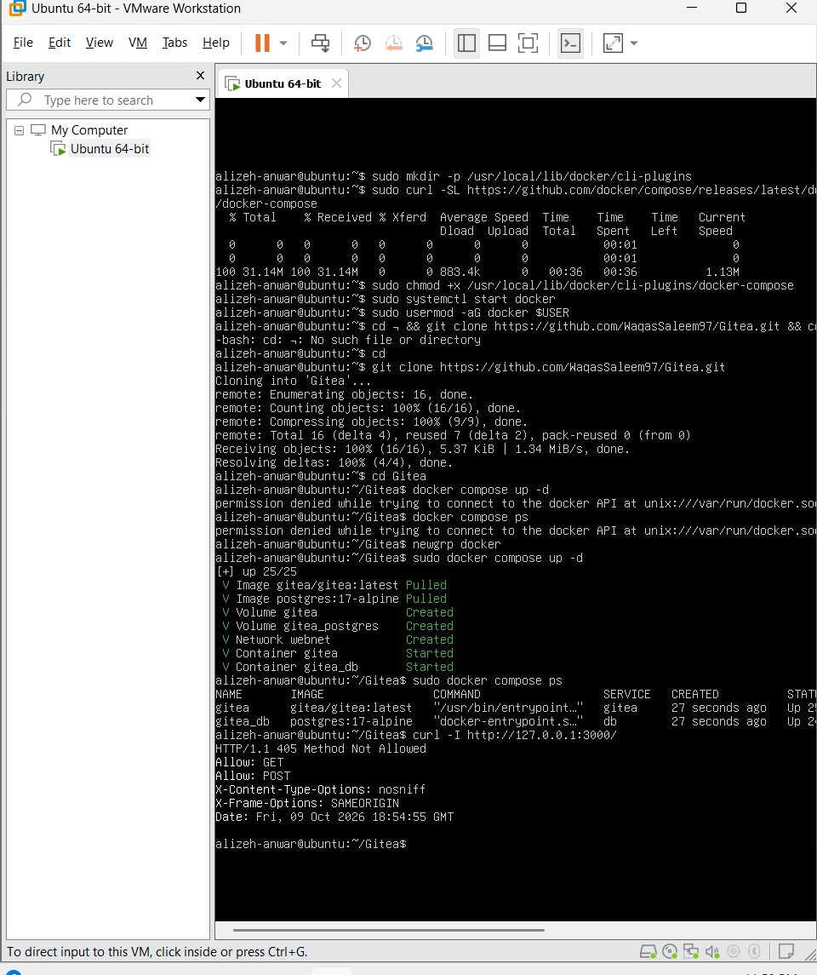
Screenshot

Figure 1: task1_gitea_running.png

Step 1.2: Create and Push the Initial Repository
Commands used
cd ~/Assignment01 && git init && git branch -M main git add README.md && git commit -m "Add student information" git remote add gitea http://<gitea-username>@127.0.0.1:3000/<giteausername>/Assignment01.git git remote -v git push -u gitea main
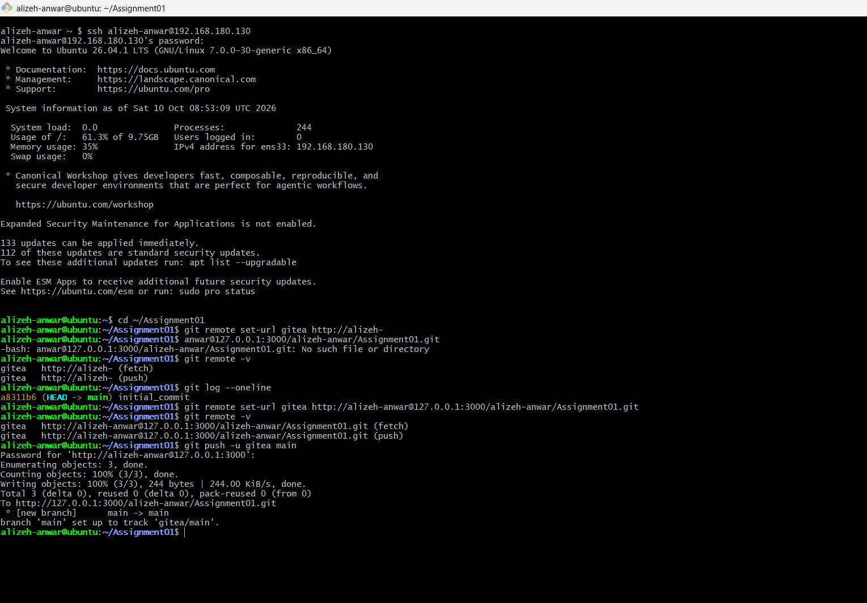
Screenshot

Figure 2: task1_gitea_push.png

Step 1.3: Verify the Gitea Repository
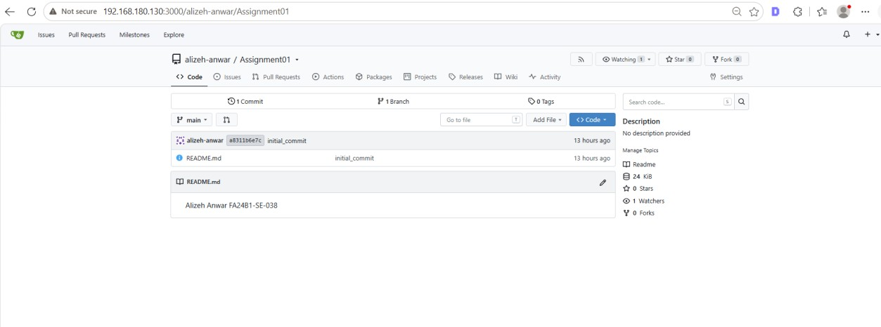
Screenshot

Figure 3: task1_gitea_repository.png

Task 2: Push the Same Repository to GitHub

Step 2.1: Add GitHub Remote and Verify Both Remotes
Commands used
cd ~/Assignment01
git remote add github https://github.com/<your-github-username>/Assignment01.git git remote -v
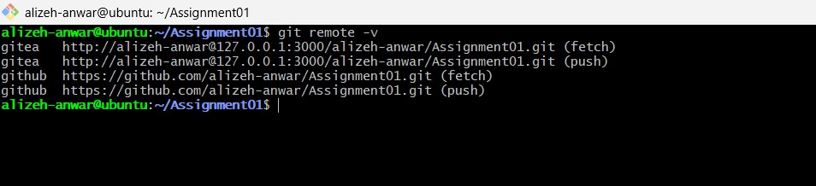
Screenshot

Figure 4: task2_remotes.png

Step 2.2: Push to GitHub
Command used
git push -u github main
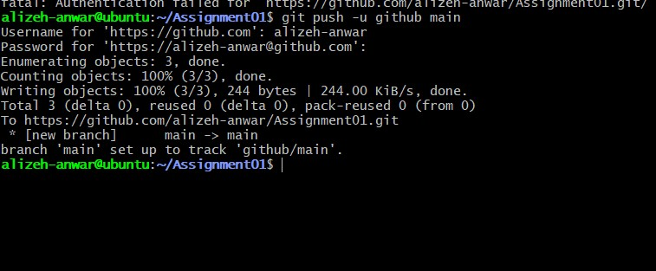
Screenshot

Figure 5: task2_github_push.png

Step 2.3: Verify the GitHub Repository
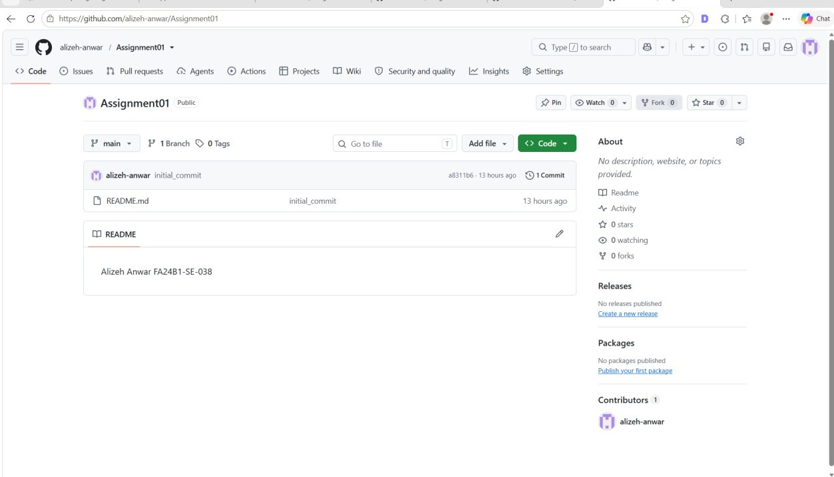
Screenshot

Figure 6: task2_github_repository.png

Task 3: Track Three Large Files with Git LFS

Step 3.1: Configure Git LFS
Commands used
cd ~/Assignment01 git lfs install git lfs version git lfs track "*.bin" cat .gitattributes
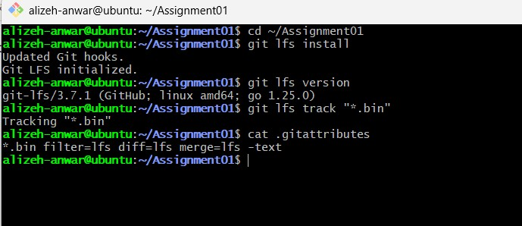
Screenshot

Figure 7: task3_lfs_setup.png

Step 3.2: Create and Verify Three LFS Files
Commands used
truncate -s 101M large-file-1.bin truncate -s 102M large-file-2.bin truncate -s 103M large-file-3.bin
git add .gitattributes large-file-1.bin large-file-2.bin large-file-3.bin git lfs ls-files --size
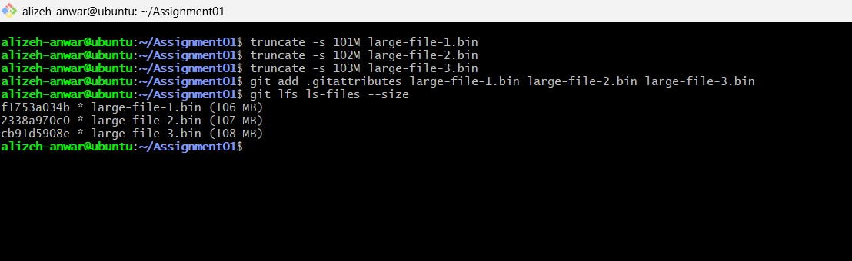
Screenshot

Figure 8: task3_lfs_files.png

Step 3.3: Commit and Push the LFS Files
Commands used
git commit -m "Add three files using Git LFS" git push github main
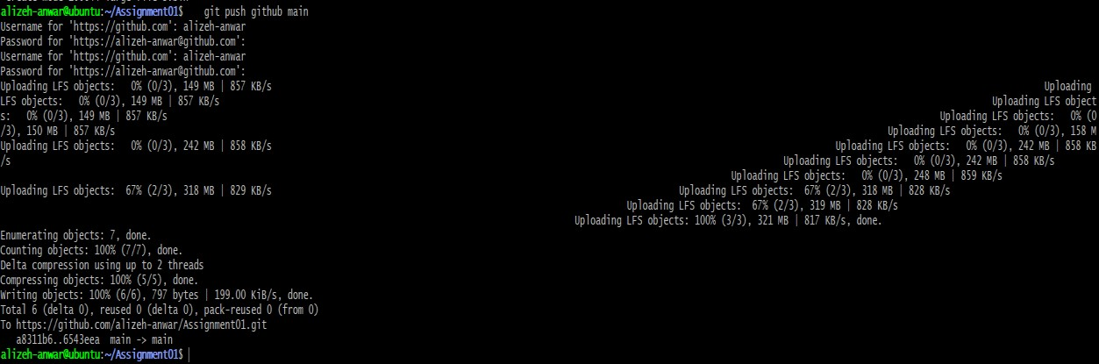
Screenshot

Figure 9: task3_lfs_push.png

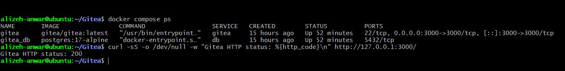

Task 4: Create a Portfolio or CV with GitHub Pages

Step 4.1: Create and Push the Portfolio Repository
Repository name: <your-github-username>.github.io Required files: index.html, styles.css
Required sections: About Me, Education, Skills, Projects
Screenshot
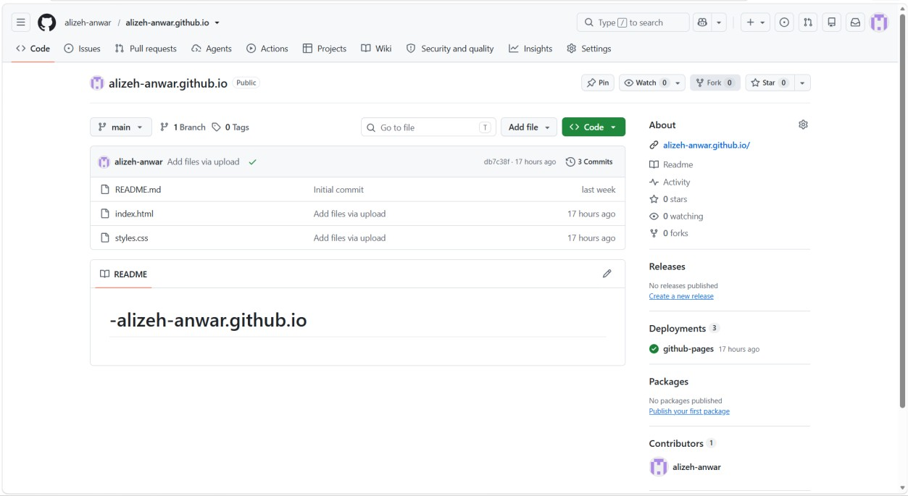

Figure 10: task4_pages_repository.png

Step 4.2: Publish with GitHub Pages
Settings > Pages > Deploy from a branch > main > / (root) > Save

Screenshot
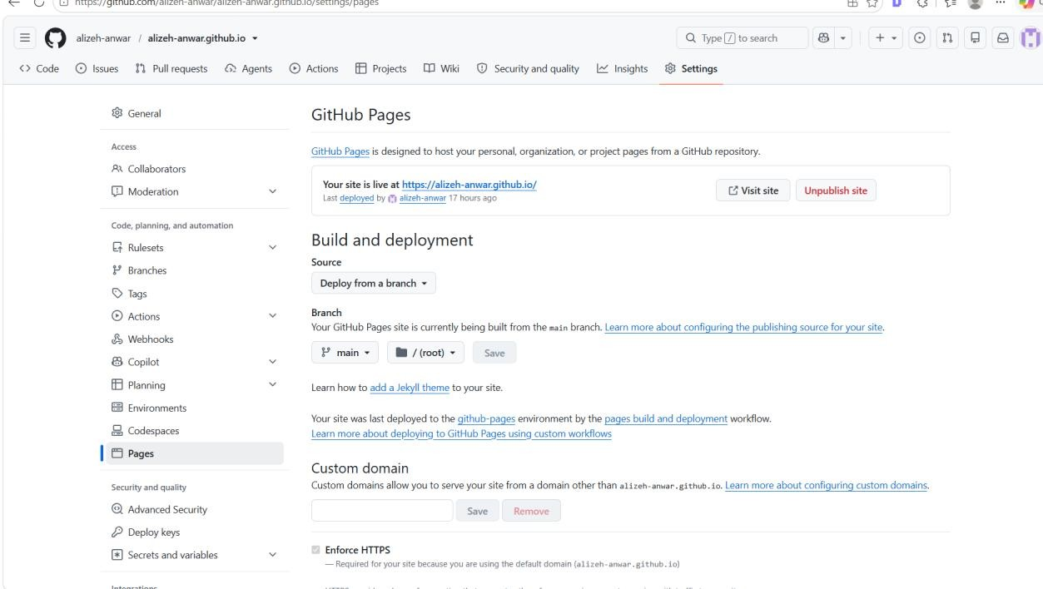

Figure 11: task4_pages_deployment.png

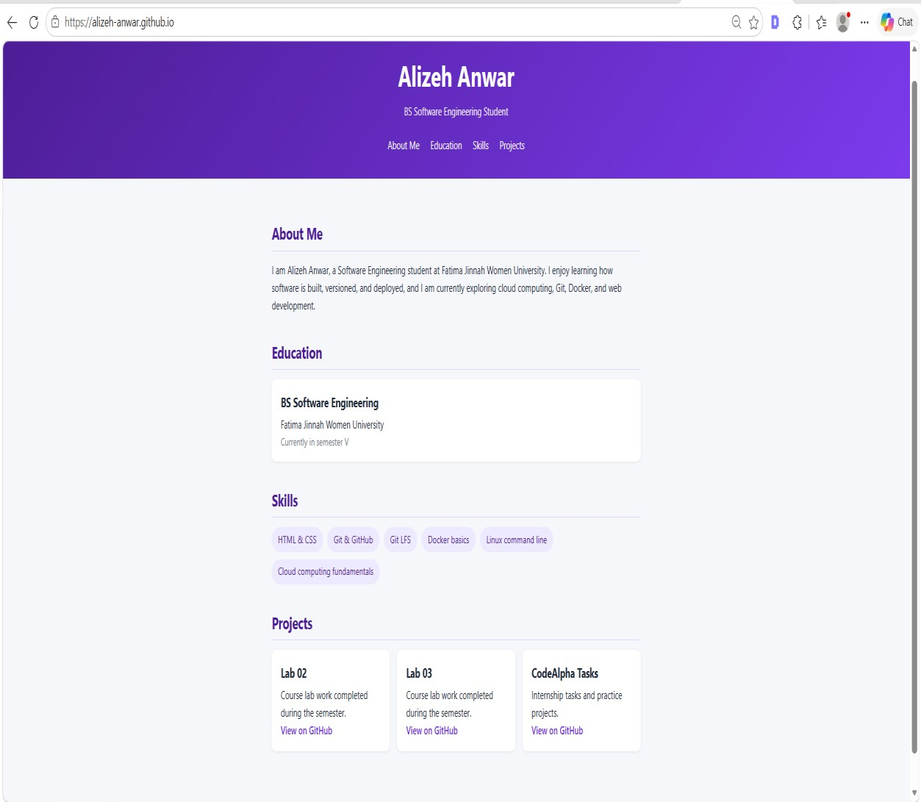
Step 4.3: Verify the Live Portfolio

Screenshot

Figure 12: task4_portfolio_live.png
Page

Assignment Summary

- Installed and ran Gitea on the Ubuntu server using Docker Compose.
- Created a local Git repository on the server and pushed it to Gitea and GitHub using two remotes.
- Authenticated with personal access tokens entered at the password prompt, never inside a URL.
- Configured Git LFS and pushed three files larger than 100 MiB.
- Published a portfolio with GitHub Pages.
______________________________________________________________________________

Page

