**Colors:**

Background Color: #21262d

Font Color: #c9ced0

Color: #238636

**Images:**

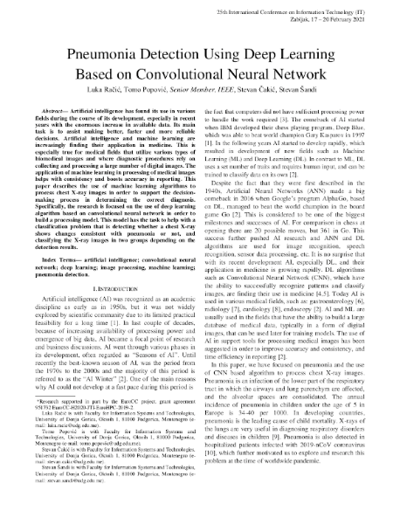

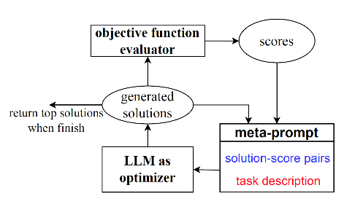

**Fonts:**

Font_1:Roboto

Font_2: