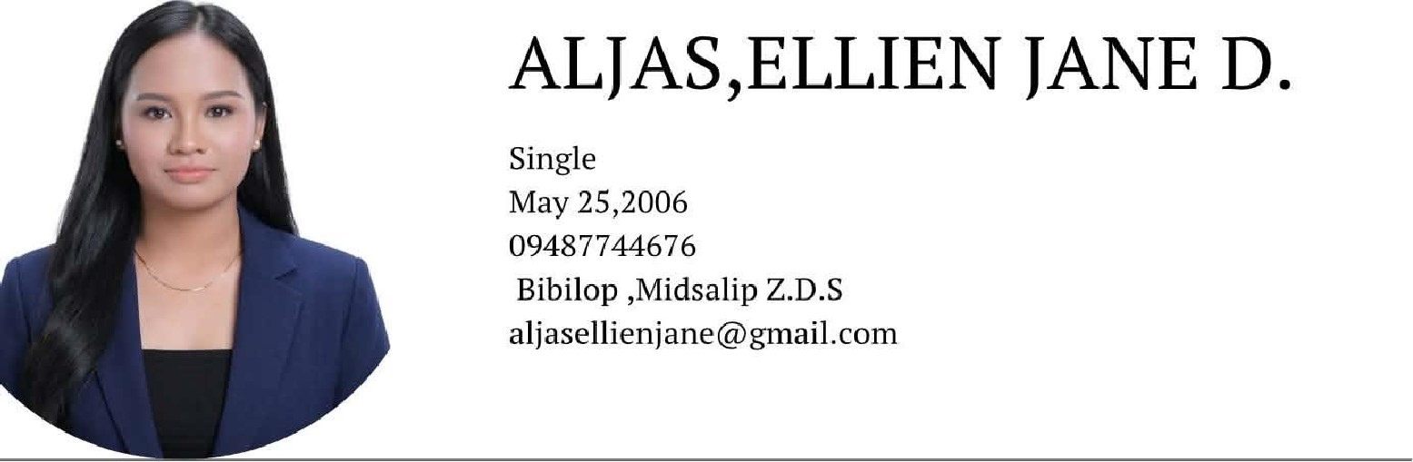
Educational Background
EDUCATION
2025-2026
-Associate in Computer Technology major in Applications Development -ZDSPGC-midsalip Campus
2021-2022
-Senior High School-Diploma
-Midsalip National High School

Special Skills:
•Java,JavaScript,HTML,python
•Problem solvinge-skills
•Flexible/Multitasking
•Creative
•Google sheet,drives
•Encoding and record keeping
•Microsoft word(document formatting, typing
ALIAS ELLIEN JANE D.
APPLICANT

