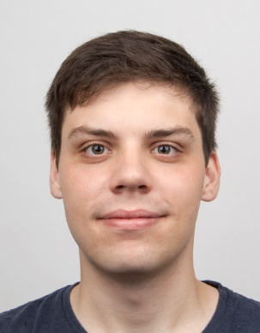**Aljaž Frančič**

Ješenca 6d

2327 Rače

+386 51 410 170

[aljaz.francic@um.si](mailto:aljaz.francic@um.si)

CV

Born on 1st of March 1993.

**Education**

* Primary school Rače
  + Finished all the grades with a 5/5 mark
  + Tested and recognized as a talented student on general intelectual, learning and creative fields
  + Awards (mathematics, physics, logic, english, etc.)
    - 15 bronze
    - 8 silver
    - Frkolin award for an exceptional literary work
  + Extracurricular activities
    - Mathemathics club
    - Physics club
    - Astronomy club
    - Happy school club
* II. gymnasium Maribor
  + General gymnasium programme
  + Zois scholarship
  + Status of pupil – researcher/competitor
  + Awards
    - 2nd place in the state RoboCup Junior competition (gold award)
    - 2 silver and 1 bronze award in the state computer knowledge competition (ACM, IJS)
    - Mathematics award
    - Bronze key award
    - Illustrations and text in the book Ideas for teaching psychology with film
  + Extracurricular activites
    - Computer club
    - Programming club (later as a mentor)
* University of Maribor, Faculty of Electrical Engineering and Computer Science
  + Bachelor’s degree in Computer Science
  + Master’s degree in Computer Science
  + Tutor for first year students
  + Tutor for Erasmus+ students
  + Erasmus Student Nerwork buddy and member
* Tampere University of Technology, Finland
  + Erasmus+ exchange in the first semester of Master’s studies
* Certificates
  + English C2 (CEFR)
  + Driver’s licence category B

**Programming languages**

* Python
* C#
* C/C++
* Java
* Matlab
* MySQL
* JavaScript
* PHP
* HTML
* CSS

**Technologies/knowledge**

* Oculus Rift
* Kinect
* Myo
* Git
* WPF
* Unity
* OpenCV
* Regex
* Adobe Photoshop
* Microsoft Office

**Projects/work experience**

* Young researcher (SSL, FEECS, UM)
* Demonstrator (SSL, FEECS, UM)
* PKP: Guide2Music (Android augmented reality application)
* PKP: Electric bike (R & D)
* Bingo game (EDIT)
* Iwashere (web portal)
* Nakit & Ure (online shop)

**Free time**

* Sport (swimming, runing)
* Board games (Catan, Magic the Gathering, Dungeons & Dragons)

**Other**

* I like acquiring new skills
* I like challenges
* Accurate
* Conscientious
* Self-initiative
* Creative