How a Website Project Evolved Into My First SOC Home Lab
  - What started as a simple website became a platform for learning networking, threat detection, incident response, and security operations.
Journey at a glance: Website → Azure home lab → Custom telemetry → Analytics rules → Incidents → Workbooks → SOAR exploration

Why I Started This Project
When I started this project, I thought I was simply building a website.
As part of our training, we were tasked to create and host a web application to help us understand concepts such as DNS, FQDNs, Apache web servers, Linux administration, and networking fundamentals.
What I didn't realize at the time was that this simple requirement would eventually lead me to build my first SOC home lab and completely change how I understood cybersecurity.

The Idea
Instead of creating a generic website, I decided to build a phishing-awareness simulation.

Scenario
The scenario centered on a company assessing employee awareness of phishing and social engineering risks.
Users would:
Visit a training portal
Register their information
Download a training resource
Experience a harmless awareness prank
The downloadable file was not malware. It was a harmless batch-file simulation that displayed an awareness message, demonstrating the risk of downloading and running files from untrusted sources.
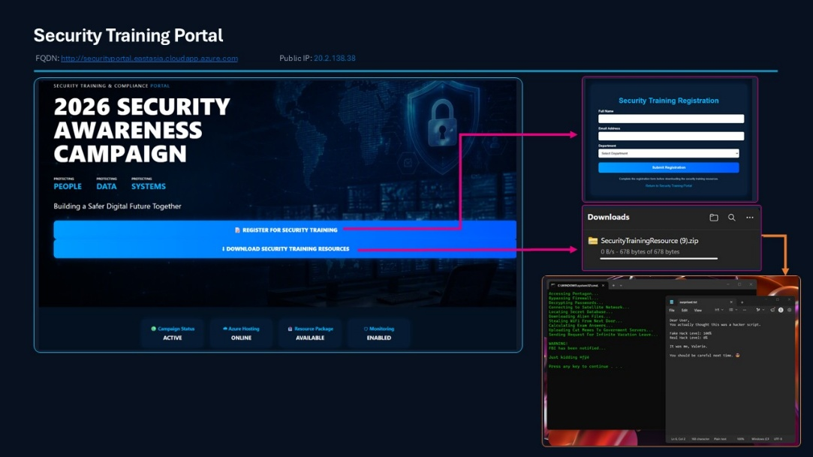
Figure 1. Security awareness portal and simulated training-resource workflow.
At the time, I believed I was simply creating a website with a cybersecurity theme.
Looking back, this decision became the foundation of everything that followed.

Building My Home Lab
As the project progressed, I started asking different questions.
- How does a user actually reach the website?
- How does DNS work?
- How does an FQDN point to a server?
- Where does website activity get recorded?
- Can activity be monitored?
- Can suspicious behavior be detected?
Those questions gradually expanded the scope of the project.
To understand both attacker and defender perspectives, I expanded the project into a small Azure-based home lab.

Infrastructure

WEB01
- Security Training & Compliance Portal
- Admin Login Portal
- Apache Web Server

ATTACK01
- Attack Simulation Machine
- Reconnaissance Testing
- Brute Force Testing

Security Operations Components
- Microsoft Sentinel
- Microsoft Defender
- Log Analytics Workspace
- Custom Log Collection
- Analytics Rules
- Workbooks
- Playbooks
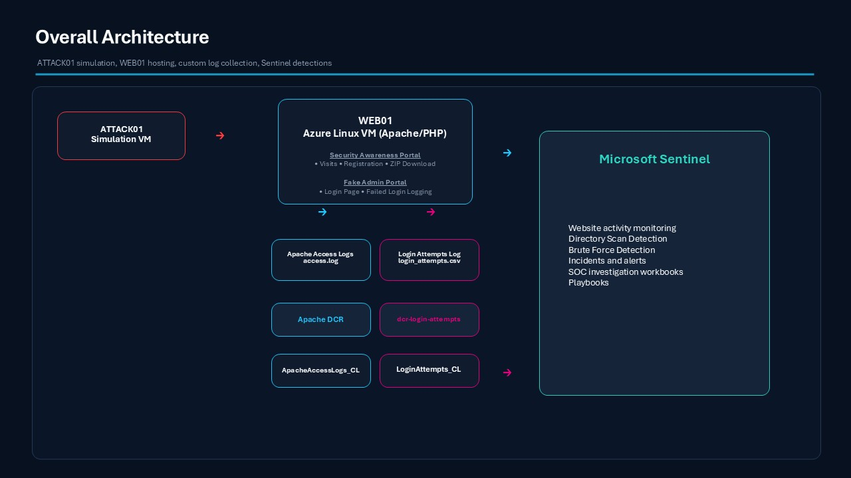
Figure 2. Overall Azure lab architecture: ATTACK01, WEB01, custom telemetry, and Microsoft Sentinel.
At this point, I realized I was no longer simply building a website.
I was building an environment where I could generate activity, collect telemetry, investigate alerts, and understand how security operations work from end to end.

Website Activity
- Security Training Portal
↓
- Apache Access Logs
↓
- ApacheAccessLogs_CL

Captured activities included:
Website visits
User registrations
Training resource downloads
Reconnaissance and directory scanning attempts
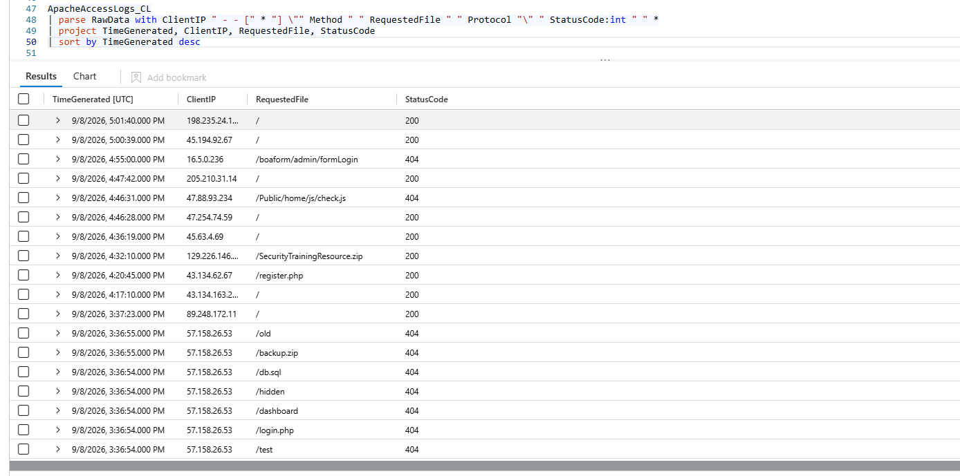
Figure 3. Website requests parsed from ApacheAccessLogs_CL.
Website activity collected through Apache access logs and ingested into Microsoft Sentinel. The logs provide visibility into legitimate user activity, training resource downloads, and reconnaissance attempts against the environment.
Looking at the logs for the first time was one of the moments where the project started to feel more like a security monitoring environment than a website. Activities that seemed simple from a user's perspective, such as opening a page or downloading a file, were now visible as telemetry that could be monitored, analyzed, and investigated.

Authentication Activity
To expand the project beyond website monitoring, I created a mock Administration Portal that served as a controlled target for authentication testing.
The portal does not authenticate users or store submitted passwords. Each submission generates a simulated failed-authentication event, while only the timestamp, source IP address, attempted username, result, and user agent are recorded for monitoring.
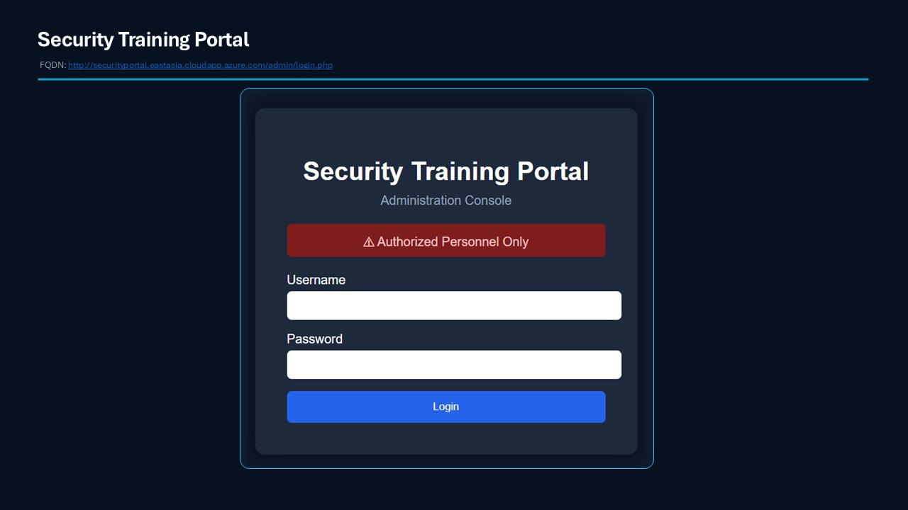
Figure 4. Simulated Administration Portal used for authentication testing.
- Admin Login Portal
↓
- login_attempts.csv
↓
- Data Collection Rule
↓
- LoginAttempts_CL

Captured information included:
Timestamp of the login attempt
Source IP address
Username entered
Login result
User agent
This separate telemetry source allowed me to monitor authentication activity and create a detection for repeated failed login attempts from the same source IP.

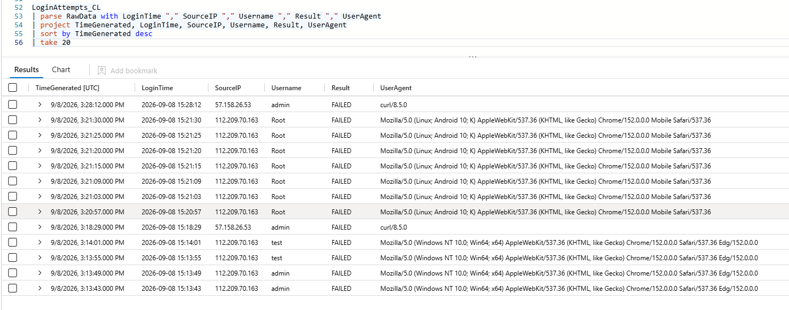
Figure 5. Failed-authentication telemetry parsed from LoginAttempts_CL.
Authentication telemetry collected from the simulated Administration Portal and ingested into LoginAttempts_CL. The repeated failed attempts from the same source IP provided the data needed to develop and test the brute-force detection rule.

Separating website activity and authentication activity into dedicated custom tables made the data easier to understand and query. ApacheAccessLogs_CL provided visibility into web requests and reconnaissance, while LoginAttempts_CL provided visibility into failed authentication attempts.
Once both telemetry sources were available, the next question became clear:
Could I turn these logs into security detections?

Building Security Detections
Once both telemetry sources were available, the next question became clear:
Could I turn these logs into meaningful security detections?
Using Microsoft Sentinel analytics rules, I developed several custom detections designed to monitor both user activity and simulated attack activity within the environment.
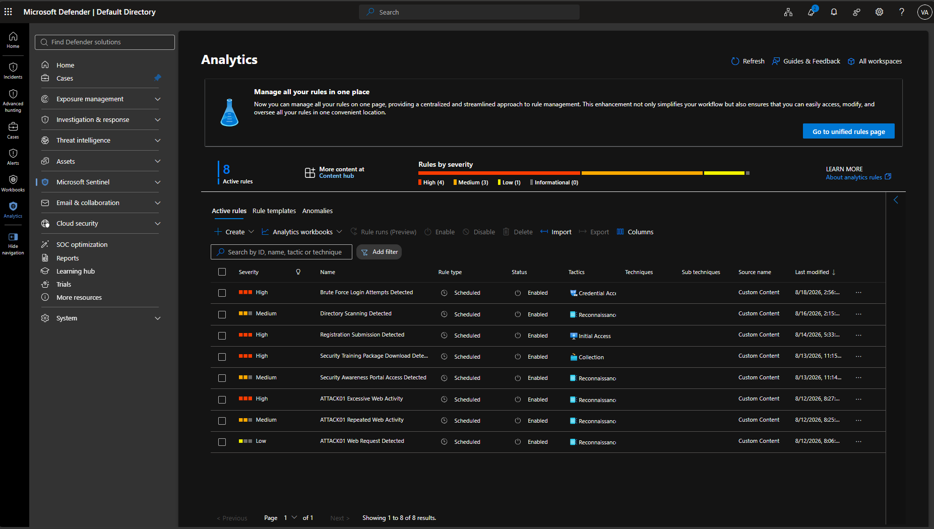
Figure 6. Custom analytics rules created for portal activity and attack simulations.

User Activity Monitoring
To support the phishing-awareness simulation, I created analytics rules that monitored normal user behavior throughout the Security Training Portal lifecycle:
Security Awareness Portal Access Detected
Tracks visitors accessing the portal homepage.
Registration Submission Detected
Monitors successful registration submissions through the portal.
Security Training Package Download Detected
Identifies downloads of the simulated training resource package.
These detections provided visibility into how users interacted with the awareness platform and allowed activities to be tracked through Microsoft Sentinel.

Attack Simulation Monitoring
To better understand how activities appear from a defender's perspective, I also created detections specifically for ATTACK01, the attack simulation machine.
ATTACK01 Web Request Detected
Detects web requests originating from ATTACK01.
ATTACK01 Repeated Web Activity
Triggers when multiple requests are generated within a short time window.
ATTACK01 Excessive Web Activity
Identifies unusually high levels of web activity from ATTACK01.
These detections helped validate the telemetry pipeline and provided visibility into simulated attacker behavior.

Simulating Security Threats
While all analytics rules contributed to the environment, two detections became the foundation of my security monitoring workflow:
- Directory Scanning Detected
- Brute Force Login Attempts Detected
These represented two common attack phases:
- Reconnaissance
↓
- Credential Access
Instead of relying on sample datasets, I generated the activity myself from ATTACK01, validated the telemetry, and confirmed that the detection logic behaved as expected.

Directory Scanning Detection
The first detection focused on reconnaissance activity.
Using ATTACK01, I generated requests against common directories and files frequently targeted during web enumeration, including:
- /.env
- /.git
- /phpmyadmin
- /wp-admin
- /config.php
- /backup.zip
The analytics rule monitored repeated requests to suspicious locations and generated a security incident once the configured threshold was exceeded.
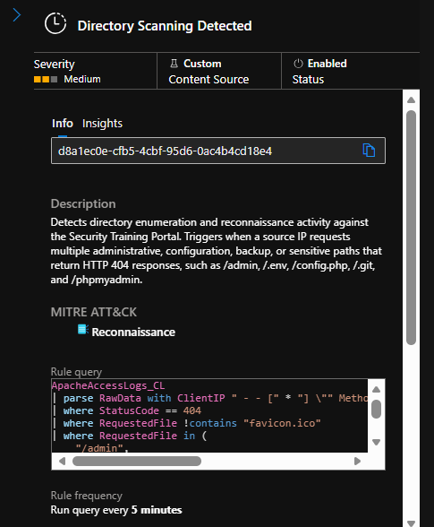
Figure 7. Directory Scanning Detected analytics rule.
Directory Scanning Detected
Simulated reconnaissance activity generated from ATTACK01. Requests targeting common administrative and sensitive paths were successfully detected by Microsoft Sentinel and converted into a security incident.
For the first time, I was able to generate attack activity, observe the telemetry, validate the detection logic, and watch the incident appear inside Sentinel.

Brute Force Login Detection
The second detection focused on authentication attacks.
Using ATTACK01, I generated multiple failed login attempts against the Administration Portal.
The authentication telemetry collected in LoginAttempts_CL was analyzed by a custom Sentinel analytics rule designed to identify repeated failed login attempts from the same source IP address within a defined time window.
Once the configured threshold was reached, Microsoft Sentinel generated a brute-force incident.
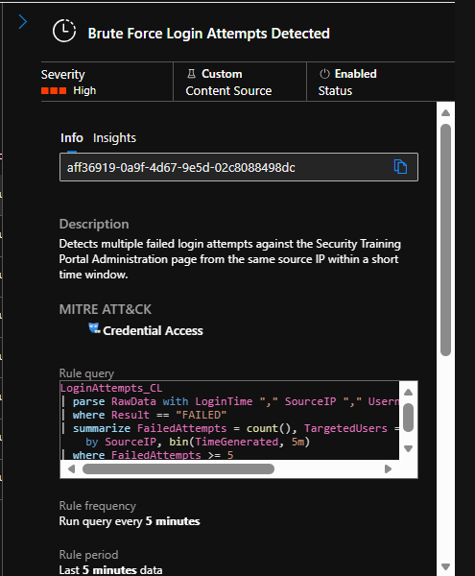
Figure 8. Brute Force Login Attempts Detected analytics rule.
Brute Force Login Attempts Detected
Repeated failed authentication attempts generated from ATTACK01. Authentication telemetry collected through LoginAttempts_CL successfully triggered a Microsoft Sentinel brute-force incident.
This became one of the most rewarding parts of the project because it connected multiple concepts together:
- Simulated Attack
↓
- Logs
↓
- Custom Tables
↓
- Analytics Rules
↓
- Alerts
↓
- Incidents
What started as a website was now producing meaningful security detections that could be investigated from a defender's perspective.

Investigating Through Microsoft Sentinel and Microsoft Defender
Building detections was only part of the learning experience.
Once alerts started triggering, I needed a way to investigate and understand what was happening inside the environment.
This was where Microsoft Sentinel and Microsoft Defender began to play a significant role in the project.
Rather than simply generating logs and alerts, I could now follow activities through the investigation process and view them from a defender's perspective.
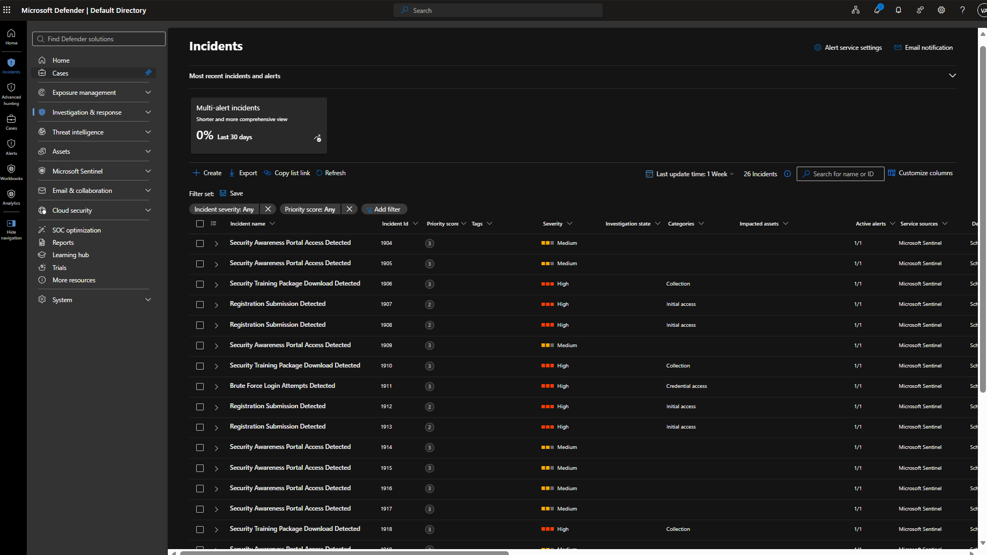
Figure 9. Incident queue in Microsoft Defender.

From Alert to Incident
When my custom analytics rules detected suspicious activity, Microsoft Sentinel automatically generated incidents that could be investigated further.
Some of the incidents generated throughout the project included:
Directory Scanning Detected
Brute Force Login Attempts Detected
Registration Submission Detected
Security Training Package Download Detected
Each incident provided context that helped me understand:
- What happened
- When it happened
- Which source IP generated the activity
- Which detection triggered the alert
For the first time, I was no longer looking only at logs.
I was looking at security incidents.
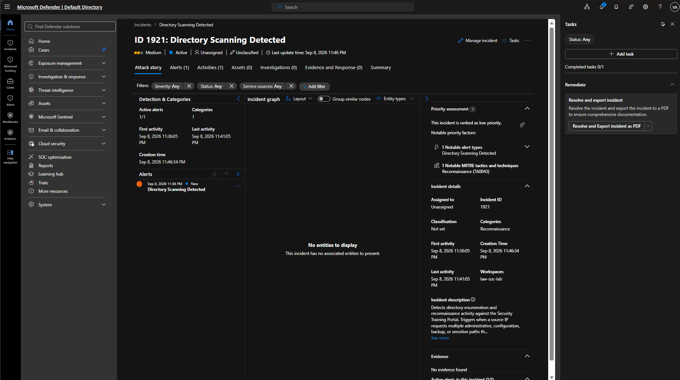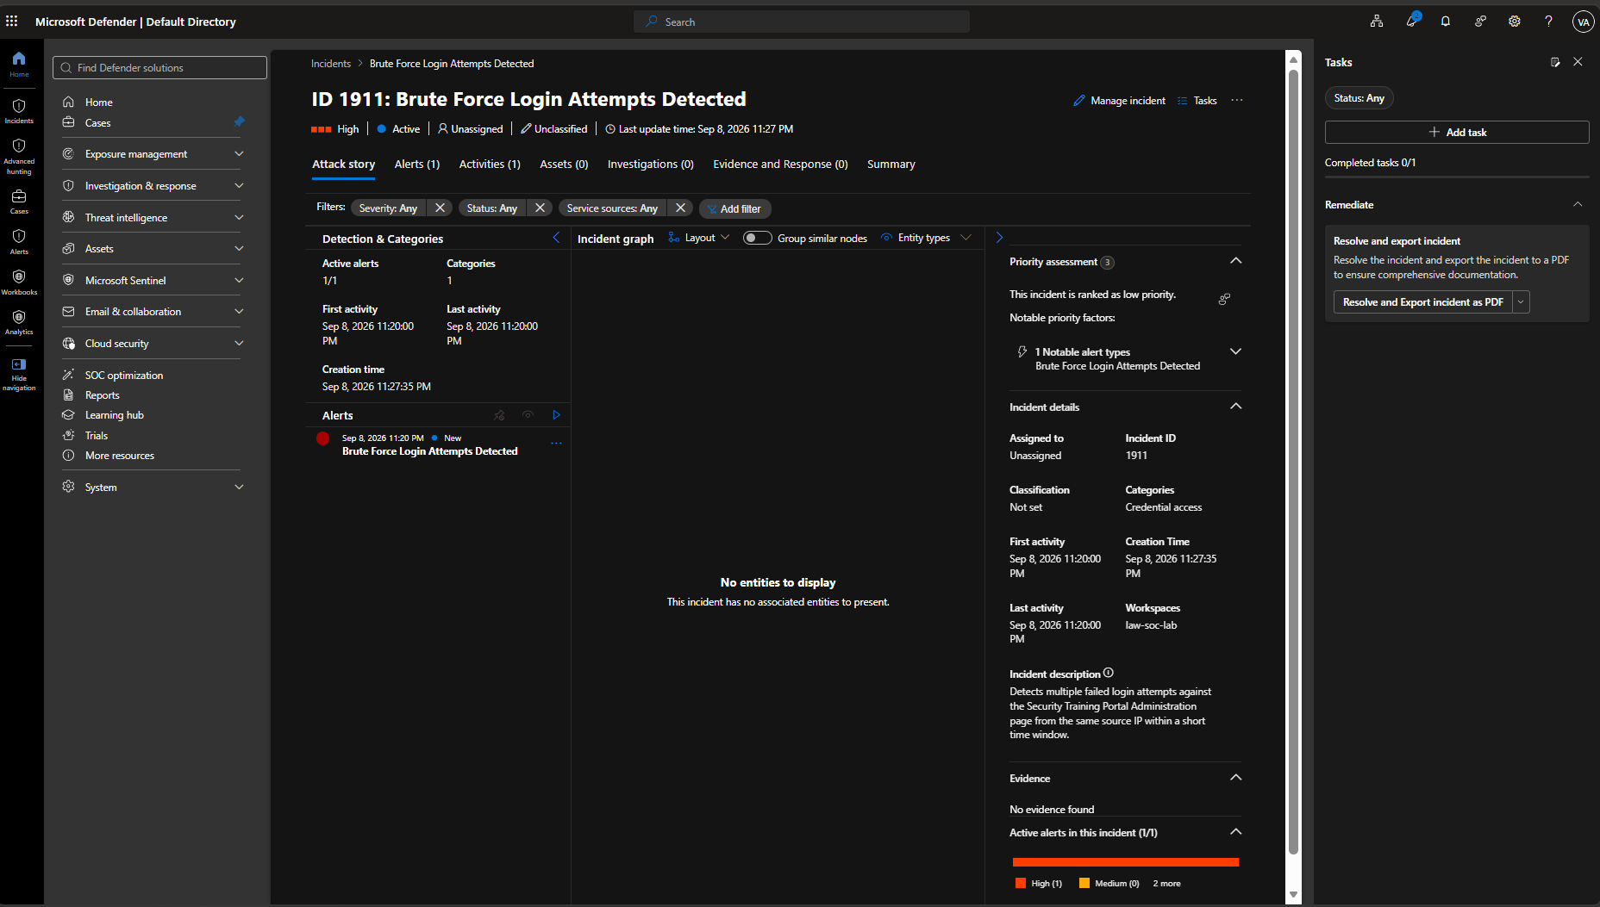
Figure 10. Directory Scanning Detected incident investigation view.

Viewing the Environment Through Microsoft Defender
As telemetry and incidents accumulated, Microsoft Defender provided another way to view and investigate activity occurring within the environment.
Using Defender, I could view:
Alerts
Incidents
Investigation data
Security events
Correlated activities
This helped me understand how security teams can move beyond raw logs and focus on meaningful security events.
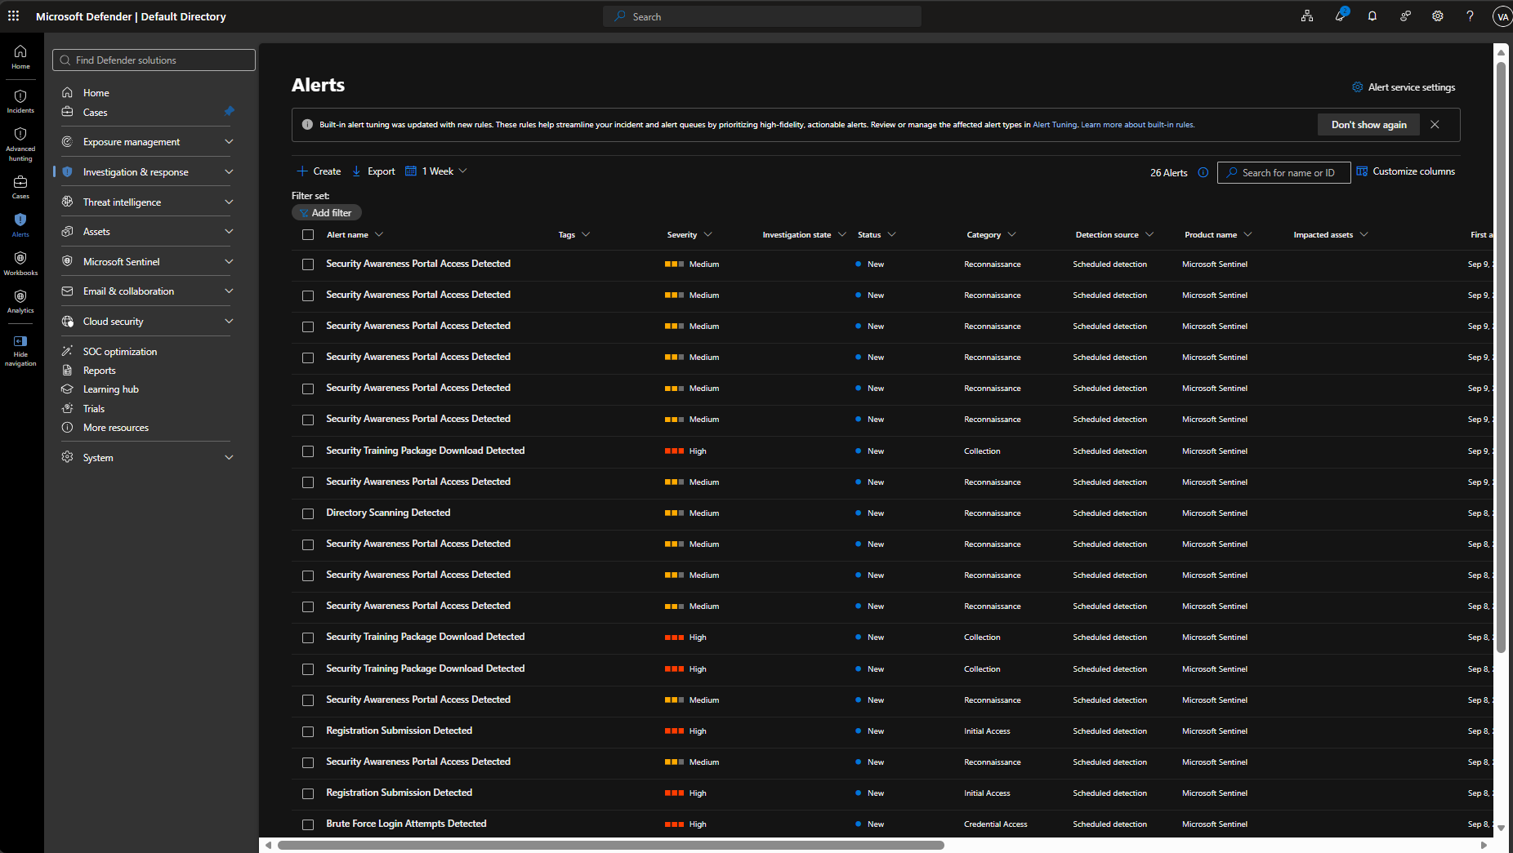
Figure 11. Brute Force Login Attempts Detected incident investigation view.

Visualizing the Data
Collecting logs and generating incidents provided valuable visibility, but I wanted a faster way to understand what was happening inside the environment.
To accomplish this, I developed custom Microsoft Sentinel workbooks that transformed raw telemetry into visual dashboards.
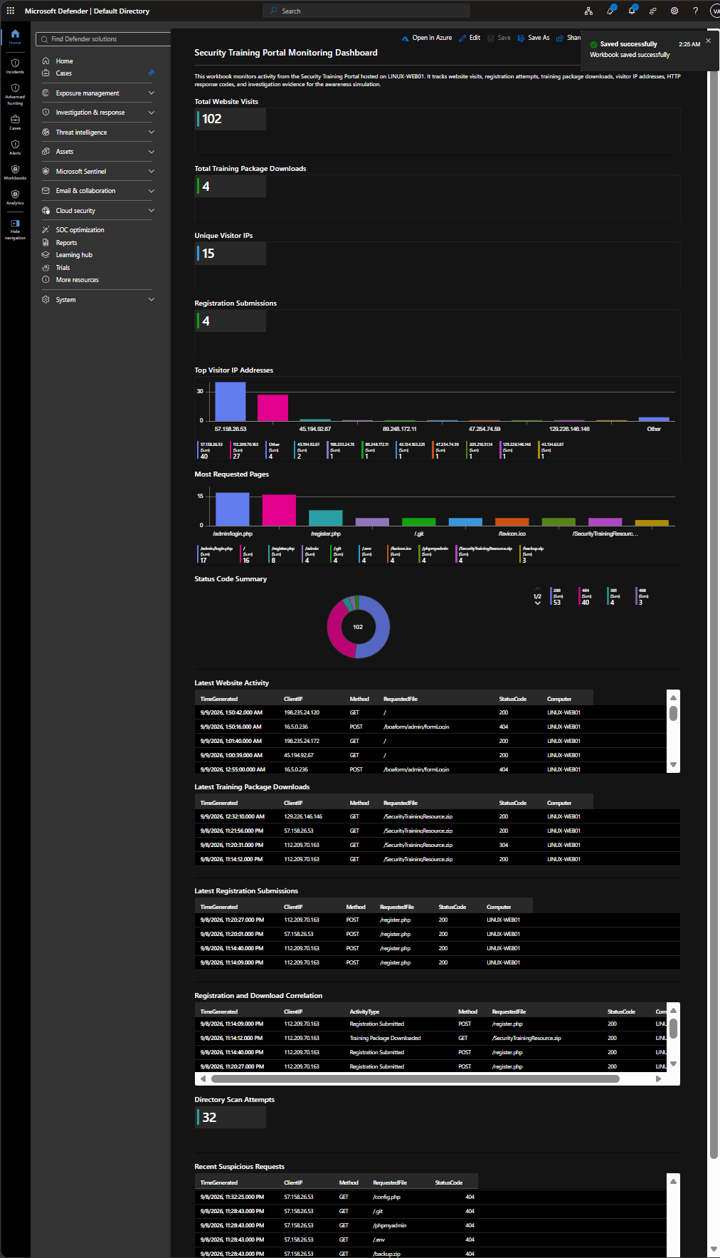
Figure 12. Alerts view in Microsoft Defender.

Security Awareness Monitoring Dashboard
This workbook provided visibility into:
Website traffic
User registrations
Training resource downloads
User activity trends
Instead of reviewing logs one at a time, I could immediately see how users interacted with the Security Training Portal.

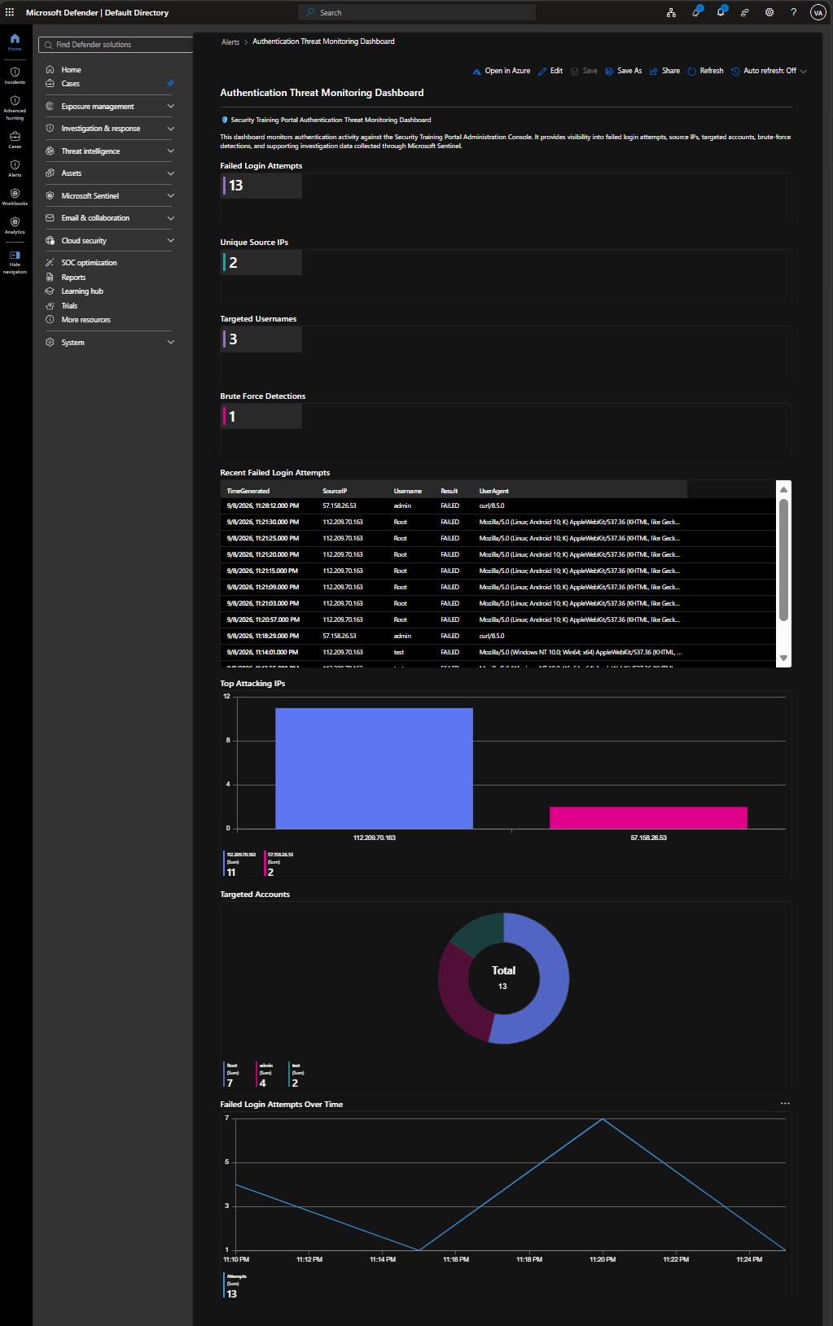
Figure 13. Security Awareness Monitoring workbook.

Authentication Threat Monitoring Dashboard
The second workbook focused on authentication telemetry collected from the Administration Portal.
The dashboard provided visibility into:
Failed login attempts
Source IP addresses
Targeted usernames
Authentication trends
Suspected brute-force activity
One of the biggest lessons I learned was that collecting data is only part of the process.
Dashboards help transform large amounts of telemetry into information that can be understood and investigated more effectively.

Exploring Security Automation
As the project continued to grow, I became curious about another area of security operations: automation.
Up until this point, I had focused on generating telemetry, building detections, creating incidents, and investigating alerts. The next question I asked myself was:
Could part of the investigation process be automated?
To explore this concept, I created my first Microsoft Sentinel playbook using Azure Logic Apps.
The playbook was designed to run in response to a brute-force incident.
Using a Microsoft Sentinel incident trigger, the playbook is designed to add investigation guidance directly to the incident.
The workflow is simple:
- Microsoft Sentinel Incident
↓
- Add Comment to Incident
The automated comment provides investigation guidance such as:
Review LoginAttempts_CL
Validate the source IP address
Review targeted usernames
Correlate authentication activity
Review authentication monitoring dashboards
This was my first exposure to Security Orchestration, Automation, and Response (SOAR) concepts and helped me understand how automation can assist analysts during incident investigations.

What I Learned About Automation
Although the playbook was relatively simple, it demonstrated an important concept:
Security operations are not only about detecting threats. They are also about making investigations more consistent and efficient.
By automating repetitive tasks, analysts can spend less time gathering information and more time focusing on analysis and decision-making.
For me, this was the moment where the project expanded beyond detection and investigation into automation.

The Challenges Along the Way
Looking back, the most valuable lessons didn't always come from successfully building something.
Most of them came from figuring out why something wasn't working.
Throughout the project, I found myself constantly moving between different areas of technology:
- Networking
- Linux Administration
- Web Hosting
- Log Collection
- KQL
- Detection Engineering
- Security Monitoring
What started as a website assignment quickly became a series of questions:
How does DNS actually work?
Why isn't the log reaching Sentinel?
Why didn't my detection trigger?
How do incidents get created?
How can I automate investigations?
Every question led to another lesson, another troubleshooting session, and another opportunity to learn.
One of the most rewarding moments came when I generated attack activity from ATTACK01, followed the telemetry through custom tables, validated the detection logic, and finally watched the incident appear inside Microsoft Sentinel.
That was the moment I realized I wasn't simply building a lab.
I was learning how security operations work from start to finish.

What Surprised Me Most
Before this project, I viewed many technologies as separate topics.
DNS was one topic.
Web servers were another.
Logs were another.
Microsoft Sentinel was another.
Building this environment showed me something different.
Everything was connected.
- User Activity
↓
- Website
↓
- Logs
↓
- Telemetry
↓
- Detection
↓
- Incident
↓
- Investigation
↓
- Automation
For the first time, I was not learning concepts in isolation.
I was seeing how they worked together.

Advice to Other Learners
If you're currently learning cybersecurity, my biggest advice is simple:
Build something.
It doesn't have to be perfect.
It doesn't have to be enterprise-grade.
It doesn't even have to be complicated.
Just build something that allows you to ask questions.
Every time I asked:
"How does this work?"
I ended up learning a new technology, troubleshooting a new problem, or discovering a new security concept.
Some of my biggest lessons didn't come from completing the project.
They came from figuring out why something wasn't working.
Looking back, the project taught me far more than the final result ever could.

Final Thoughts
Looking back, this became one of the most memorable projects of my training journey.
I thought I was learning web hosting.
Instead, I learned networking, Linux administration, log collection, security monitoring, threat detection, incident investigation, dashboard creation, and security automation.
More importantly, I learned that the best way to understand something is to build it yourself.
What started as a website eventually became the foundation of my first SOC home lab.
And somewhere between a phishing-awareness simulation, a Sentinel alert, a Defender investigation, and a security incident, I realized I was no longer just studying cybersecurity.
I was practicing it.

