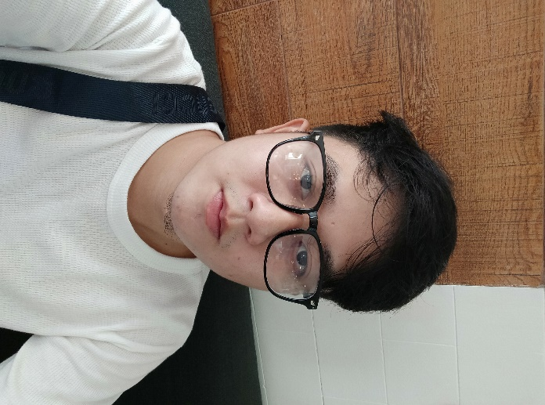

Contact

**Address:**

Santo Nino, Paombong,

Bulacan, 3001

**Phone:**

+639276343461

**Email:**

aljersulit12@gmail.com

ALDRIN JEROME SULIT

About Me

An individual who seeks career challenge in an engaging atmosphere where I will be continuously growing, learning, and improving myself becoming very passionate to be the best, dedicating my time and effort for the continuous growth and prosperity of the client’s businesses

Skill Highlights

|  |  |
| --- | --- |
| * Strong decision maker * Problem solver * Attention to Detail   Languages:  Python  HTML  CSS | * Creative design * Innovative * Service-focused |

Education

Bachelor of Industrial Technology: **Mechatronics** - 2018

**Bulacan State University**, Malolos

Work Experience

**Steak and Wine Grill and Restaurant**

**2019 – 2020**

Commissary Coordinator and Dining Staff

Tools

MS Word

MS Excel

Canva