https://restcountries.com/v3.1/all
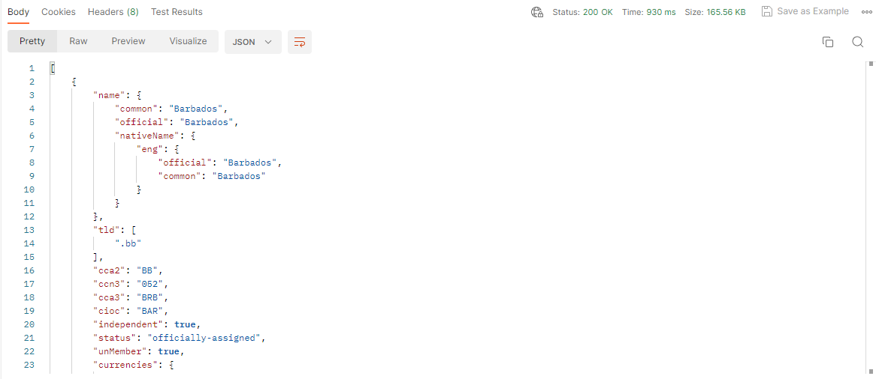

https://restcountries.com/v3.1/name/spain

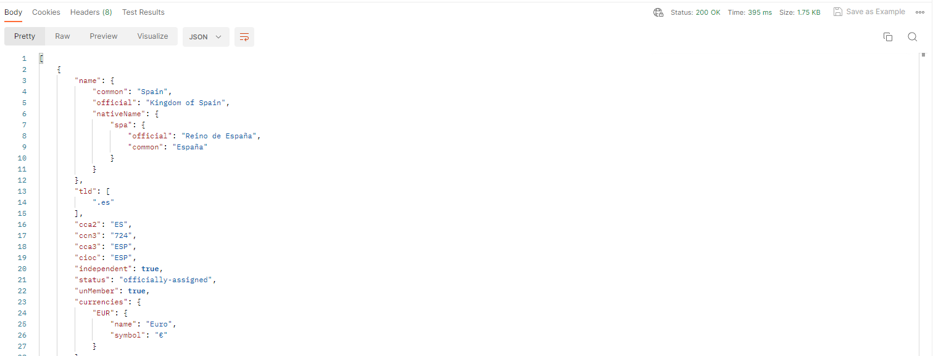

https://restcountries.com/v3.1/name/russia?fullText=true

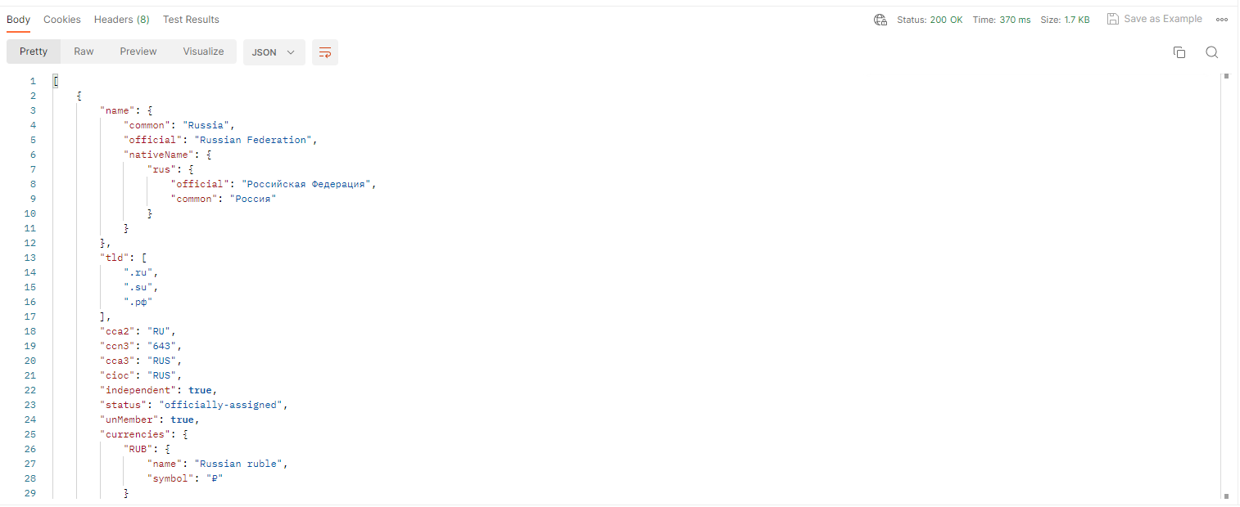

https://restcountries.com/v3.1/currency/eur

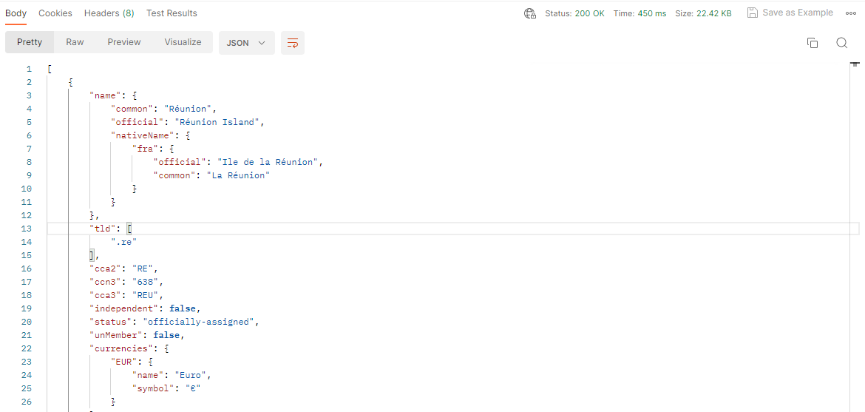

https://restcountries.com/v3.1/lang/eng

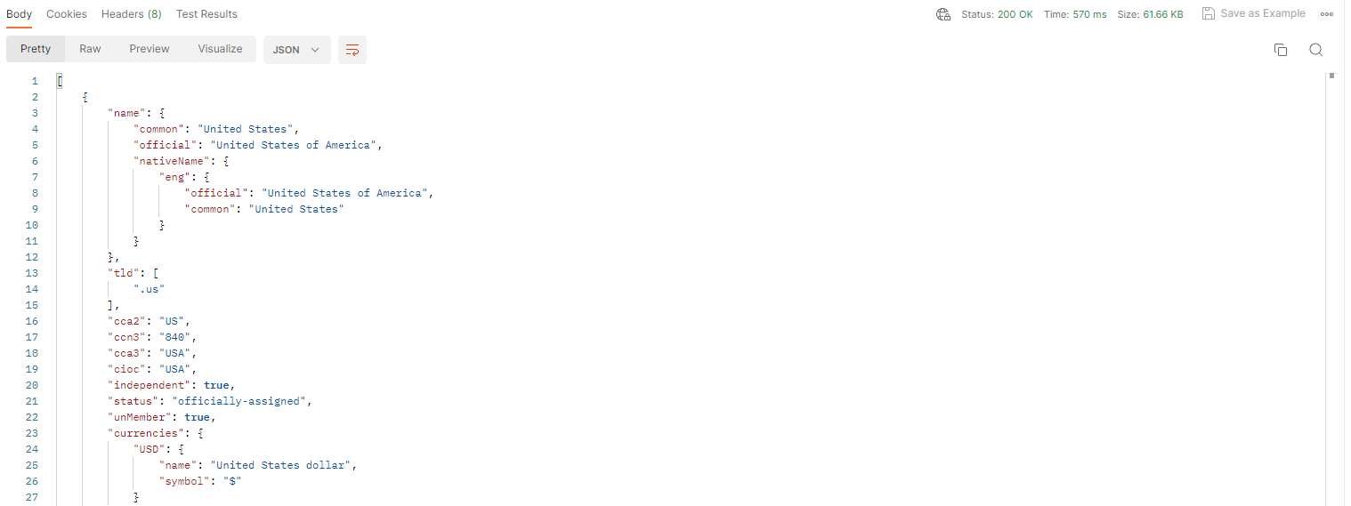

https://restcountries.com/v3.1/capital/Rabat

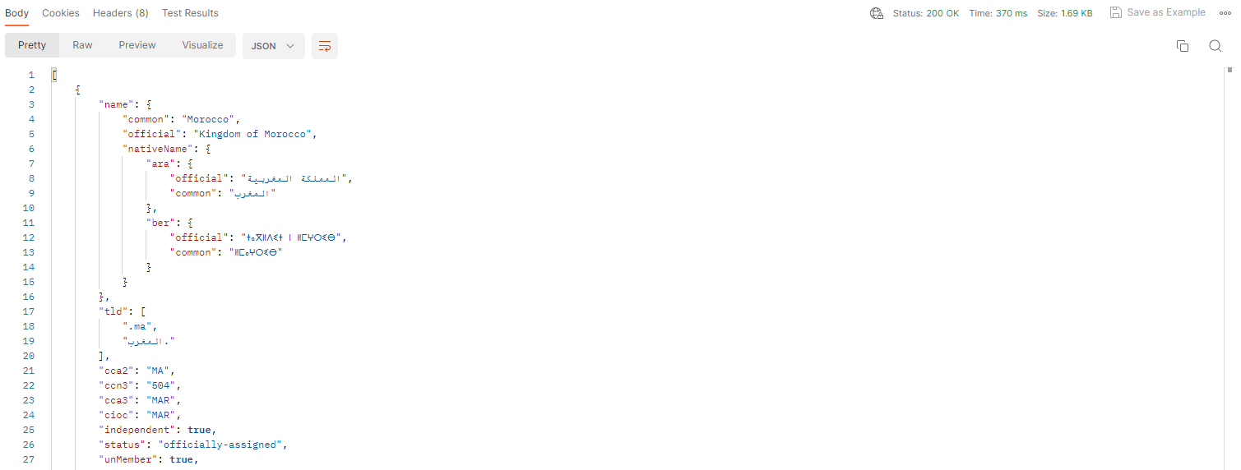
https://restcountries.com/v3.1/region/Oceania

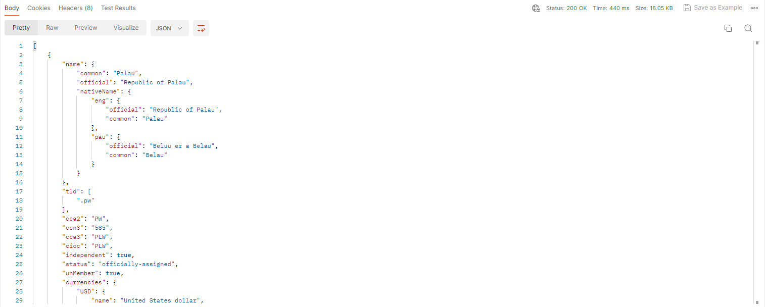

https://restcountries.com/v3.1/subregion/Central America
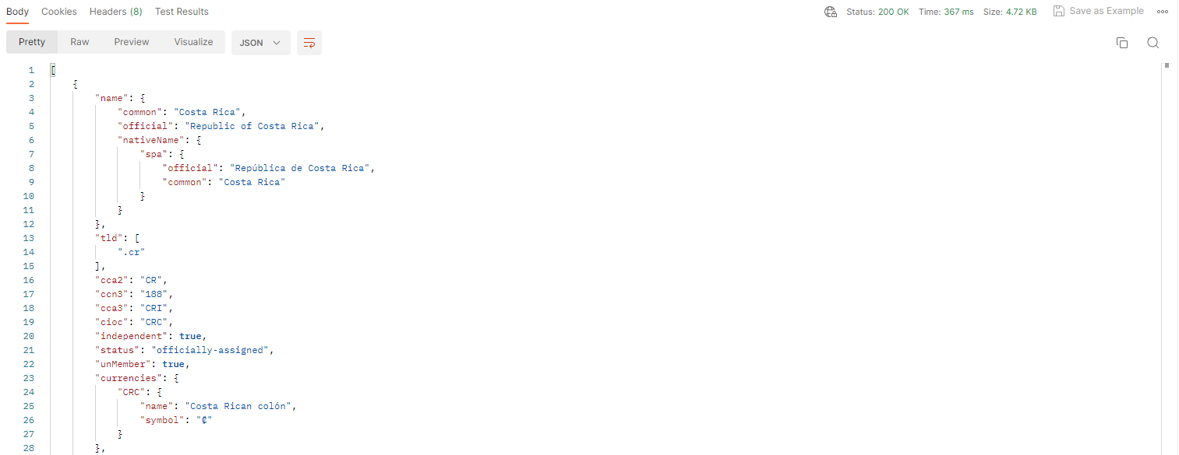

https://restcountries.com/v3.1/alpha?codes=170,no,est,pe

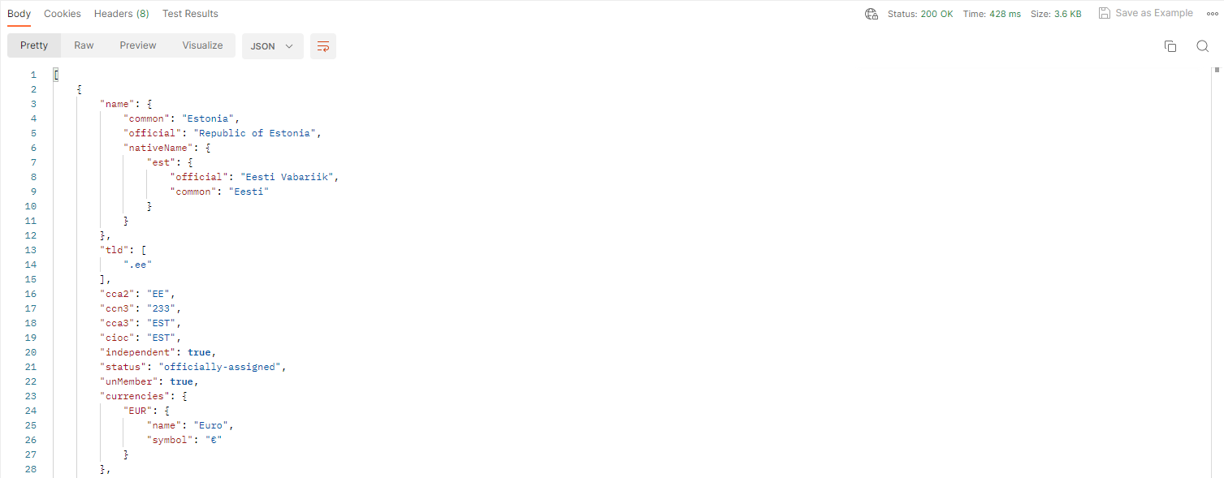

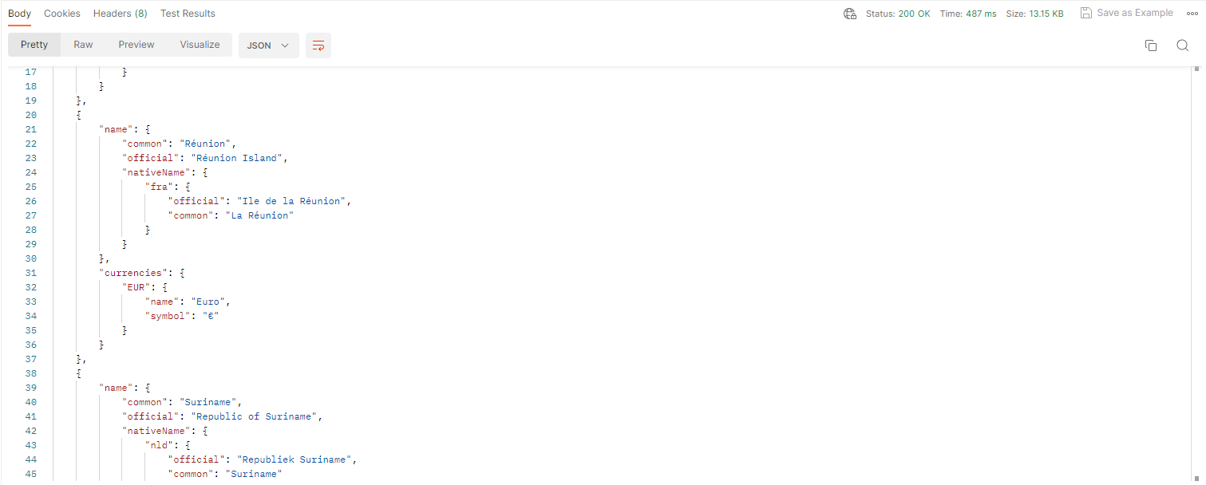
https://restcountries.com/v3.1/all?fields=name,capitals,currencies

https://restcountries.com/v3.1/alpha/170

