FINAL PROJECT | UNIT 3

Disney World
Wait Times 2018
  - Data Exploration and Dashboard Development

This report explores hourly ride wait times, compares posted and actual waits, and presents a Streamlit dashboard for filtering the results.
The strongest finding is the large difference in average posted waits between rides. Actual wait comparisons are more limited because most actual values are missing.

Prepared by
Aljoharh mohammed Alnjm

Project scope
66,492 hourly records
14 rides across 4 parks
January to December 2018

26 October 2026

Table of Contents
This report presents the dataset, cleaning steps, analysis, dashboard, and main findings.
Section | Page
Introduction | 3
Data Exploration | 4
Data Cleaning | 5
Exploratory Data Analysis | 6
Time and Season Comparisons | 7
Posted and Actual Wait Comparisons | 8
Dashboard Overview | 9
Insights and Conclusion | 10
References | 11

How to read the results
All wait times are measured in minutes. Unless stated otherwise, averages refer to available hourly records. They are not weighted by the number of visitors or the number of measurements behind each hourly average.
Figures 1 to 6 show the main analysis. Figure 7 is a screenshot of the running dashboard. Table values are rounded for readability; calculations use the original numeric precision.

Introduction

Dataset and source
The dataset is touringplans_2018 from the touringplans repository by Lucy D’Agostino McGowan. It contains hourly average posted and actual waits for selected Disney World rides, together with information about the rides and parks [1, 2]. The source data was curated by TouringPlans.com [3].
The original file uses the R data format. It was read using pyreadr and exported to CSV so that it could be analyzed with Pandas. The dataset covers 1 January to 31 December 2018, with 66,492 records and 17 original variables.

Why this dataset was selected
Wait times are easy to understand and useful for comparing visitor experiences. This dataset supports numerical and categorical analysis through its ride names, parks, hours, dates, ticket seasons, and wait measurements.

Problem definition
The aim is to identify differences in observed wait times and assess how closely posted waits match actual waits when both are available. The analysis describes patterns rather than proving their causes.

Research questions
- Which rides have the highest and lowest average posted waits?
- How do posted waits differ across hours and days of the week?
- How do posted wait distributions differ between ticket seasons?
- How do posted and actual wait times compare in records with both values?

Expected insights
The analysis looks for differences between rides, time patterns, seasonal variation, and possible overstatement or understatement of wait times. These expectations were checked against the data rather than assumed to be results.

Data Exploration
The notebook uses head, shape, info, describe, isnull, and duplicated to examine the data before cleaning. The first five rows and full summaries are included in the notebook.
Item | Observed value
Original records | 66,492
Original variables | 17
Rides and parks | 14 rides and 4 parks
Exact duplicate rows | 0
Missing posted waits | 54
Missing actual waits before cleaning | 56,794

Ride names, park names, and seasons are categorical text. The hour is numeric. Waits are numeric averages and may contain decimals. The date was converted to a Pandas datetime value. Missing actual waits are the main data quality issue.

Posted wait statistics
Valid records | Mean | Median | Minimum | Maximum
66,438 | 53.8 | 45.0 | 0.0 | 306.8

Top five rides by mean posted wait
Ride | Records | Mean | Median
Avatar Flight of Passage | 5,144 | 126.2 | 120.0
Seven Dwarfs Mine Train | 5,620 | 84.5 | 81.7
Slinky Dog Dash | 2,687 | 72.6 | 69.4
Na'vi River Journey | 5,070 | 70.2 | 72.2
Rock 'n' Roller Coaster | 5,061 | 60.6 | 56.7

Record counts vary by ride. A higher count means more hourly observations, not more visitors. This difference in coverage should be considered when comparing ride averages.

Data Cleaning

Cleaning decisions
Preserve the source. A copy of the original table was used for cleaning. Exact duplicates were checked and the removal step was included; no exact duplicate rows were found.
Use clearer names. Important fields were renamed to Date, Hour, Ride, Park, PostedWait, ActualWait, and Season. The date was converted to datetime, and wait fields were converted to numeric values.
Handle invalid waits. Negative waits or waits above 1,440 minutes were marked as missing. Two actual values, 4,338 and 45,231.5 minutes, exceeded this threshold. No posted values were flagged. Other high values were retained.
Keep missing waits missing. Actual waits were not filled with a mean or median because the missing share is very large. Filling them would create unobserved values and could distort the comparison.
Field | Missing before | Missing after
PostedWait | 54 | 54
ActualWait | 56,794 | 56,796

After cleaning, 85.4% of actual waits are missing. The number of rows remains 66,492 because invalid wait values were replaced rather than entire records being deleted.

Derived variables and export
Day and Month were extracted from Date. WaitDifference was calculated as PostedWait minus ActualWait. A missing input produces a missing difference. The paired analysis keeps only rows with both waits available, leaving 9,642 records.
clean.to_csv("clean_data.csv", index=False)
The cleaned CSV is used by the Streamlit application. The cleaning steps and the missing percentage calculation are also included in the notebook.

Exploratory Data Analysis
The first comparison examines one numeric variable on its own, followed by the relationship between ride and average posted wait.
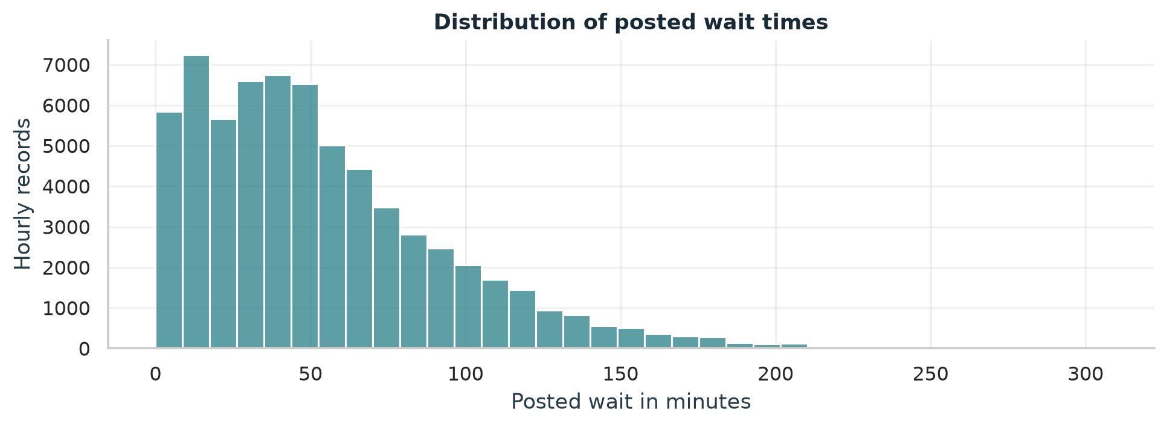
Figure 1. Distribution of available posted waits (n = 66,438). The right tail shows that a smaller number of hourly records have much longer waits.
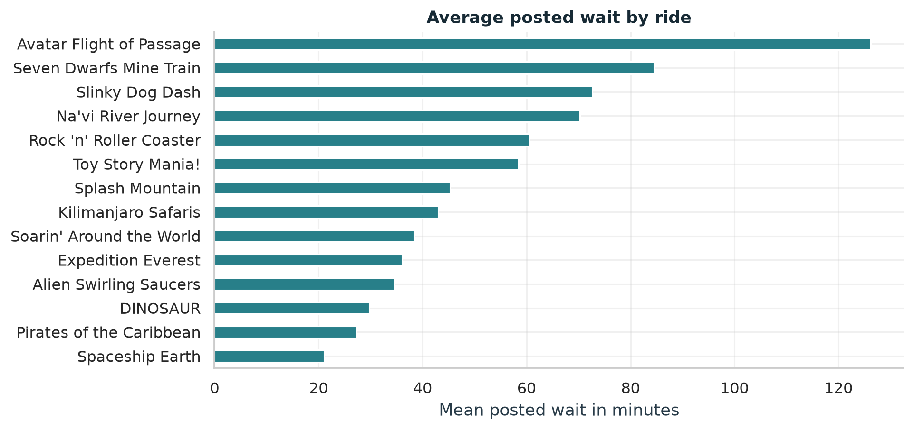
Figure 2. Mean posted waits by ride. Long ride names are shortened for display. Avatar Flight of Passage has the highest mean at 126.2 minutes; Spaceship Earth has the lowest at 21.1 minutes.
The overall median of 45.0 minutes is below the mean of 53.8 minutes, which is consistent with the right skew in Figure 1. Ride averages should be interpreted alongside their different observation counts.

Time and Season Comparisons
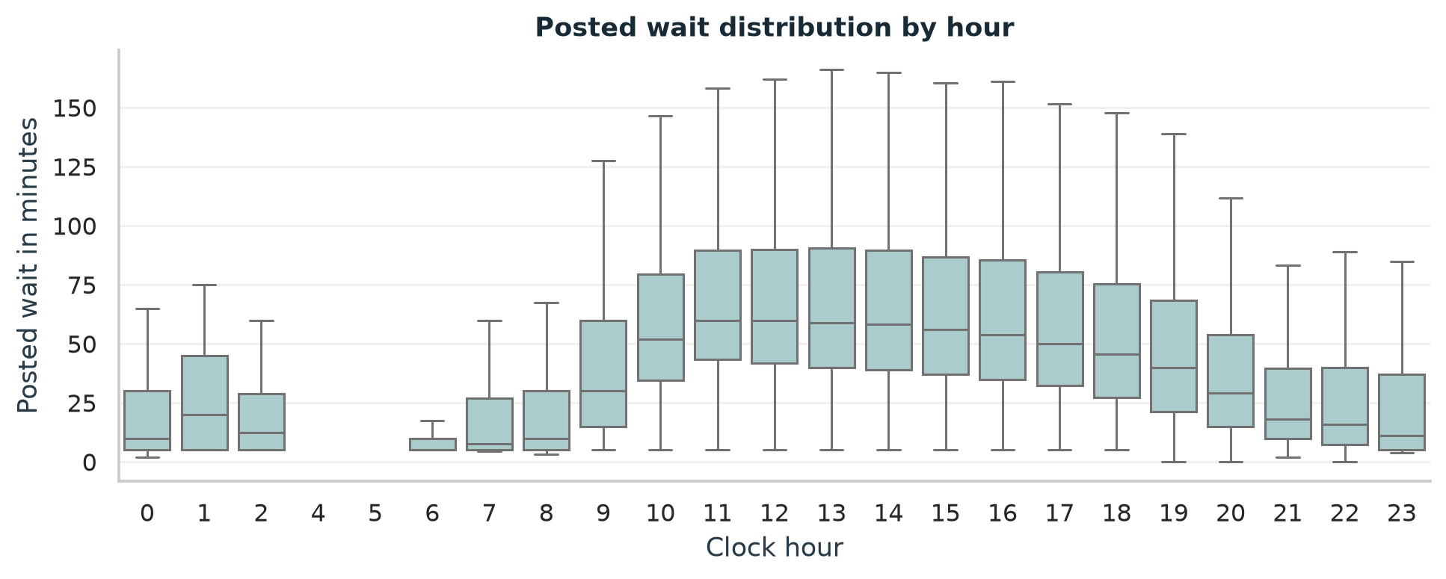
Figure 3. Hourly distributions of posted waits. Boxes show the middle 50% and the line inside each box is the median. Outlier points are hidden in this figure only; they remain in the data.
The highest observed hourly mean is at 11:00, at 70.5 minutes. This is a dataset result rather than a general rule. Different ride coverage and operating hours can influence the comparison. Hour 0 represents midnight; the date refers to the park operating day.
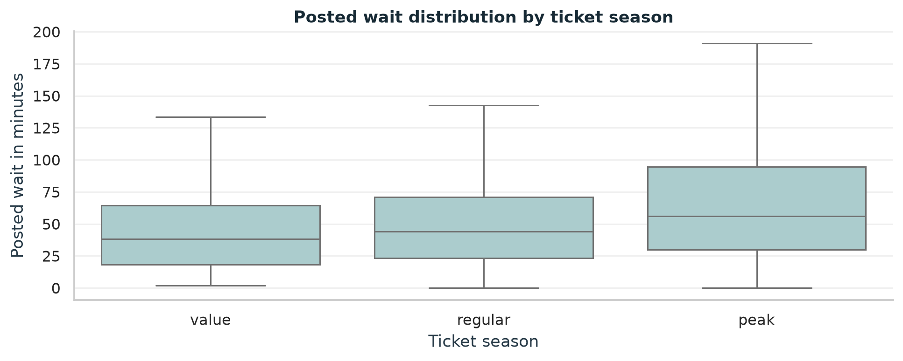
Figure 4. Posted waits by ticket season. Mean waits are 47.2 minutes in value season, 51.3 in regular season, and 65.8 in peak season. Outlier points are hidden only for readability.
Saturday has the highest observed weekday mean (57.9 minutes), compared with 52.5 on Sunday. These are descriptive differences. No claim of statistical significance is made because repeated ride and date observations are related.

Posted and Actual Wait Comparisons
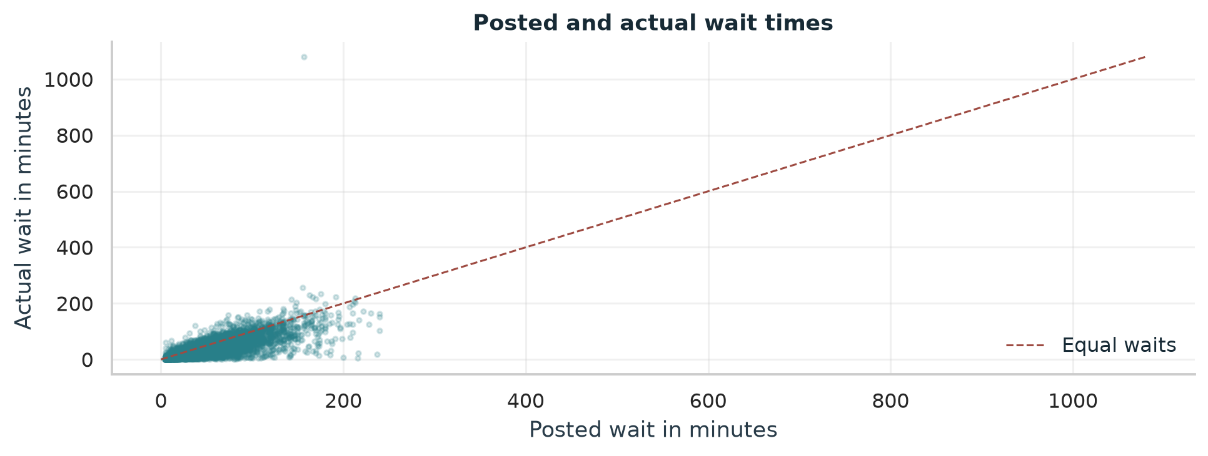
Figure 5. Posted and actual waits for 9,642 paired records. The dashed line marks equal waits. One retained high actual value stretches the vertical scale; high values below the cleaning threshold were not automatically removed.
The mean posted-minus-actual difference is 12.4 minutes and the median is 9.5 minutes. The middle 50% of differences lie between 2.6 and 19.0 minutes. The full range is -922.8 to 218.0 minutes, so the mean alone does not describe every observation.
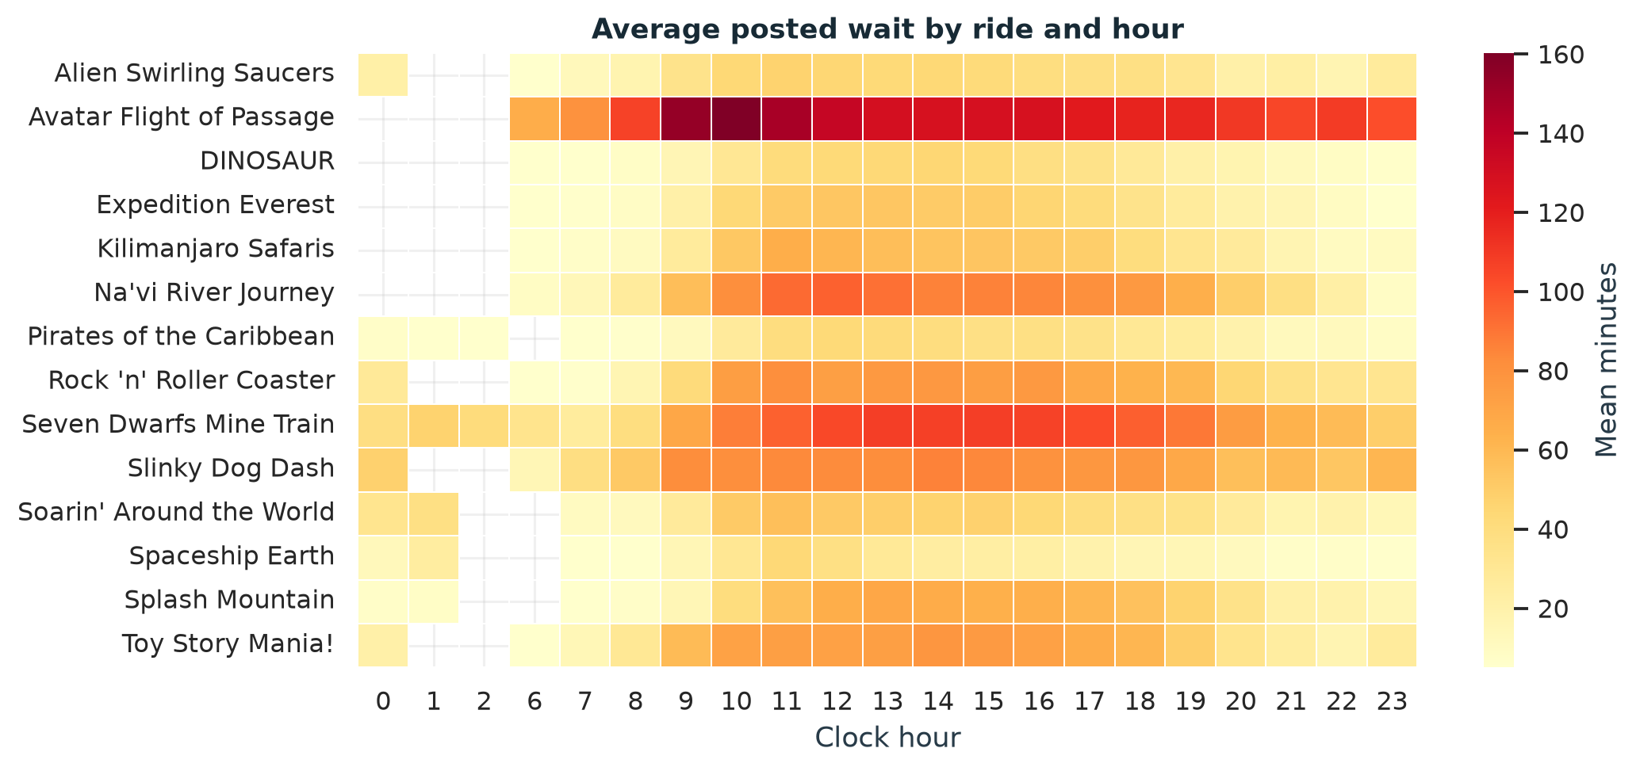
Figure 6. Mean posted wait by ride and clock hour. Darker cells indicate longer waits, and blank cells indicate missing coverage. The heatmap reveals differences hidden by the overall hourly average.
The paired comparison covers about 14.5% of all records. Its positive average difference suggests higher posted waits in this available sample, but it cannot be assumed to describe hours with missing actual waits.

Dashboard Overview
The Streamlit application reads clean_data.csv and provides an interactive way to explore the cleaned data. The sidebar includes a dataset description and filters for park, ride, ticket season, and hour range.
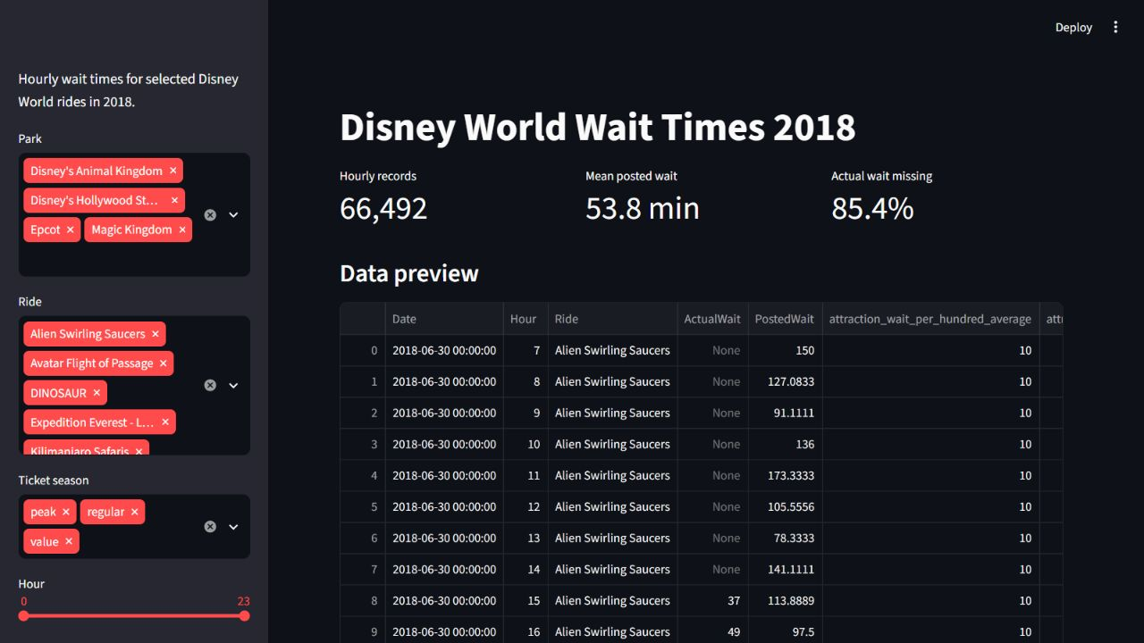
Figure 7. Running Streamlit dashboard showing the sidebar filters, full-data indicators, and data preview. The initial view contains all 66,492 hourly records.

Main dashboard features
- Indicators for record count, mean posted wait, and the percentage of missing actual waits.
- A data preview and descriptive statistics for posted waits, actual waits, and their difference.
- Charts comparing mean posted waits by ride and hour.
- Insights recalculated for the selected records, including the paired mean and median difference.
- A download button for the filtered dataset and a message when filters return no records.

Using the application
Select a park or ride, adjust the season or hour range, and compare the updated results. The application runs locally using streamlit run app.py. The analysis and dashboard use the same cleaned CSV to keep the results consistent.

Insights and Conclusion

Main findings
Finding | Result
Highest mean posted wait | Avatar Flight of Passage 126.2 min
Lowest mean posted wait | Spaceship Earth 21.1 min
Peak observed hour | 11:00 with mean 70.5 min
Highest observed weekday mean | Saturday 57.9 min
Paired mean and median difference | 12.4 min and 9.5 min
Actual wait missing after cleaning | 85.4%

Wait times differ substantially across rides. The overall hourly pattern peaks in late morning in the available records, and peak ticket season has a higher average posted wait. The paired sample also shows a positive posted-minus-actual difference on average.

Limitations
The dataset covers selected rides in 2018, so it does not describe all attractions or current conditions. Actual waits are missing in most records. Hourly averages have no measurement counts for visitor weighting. Unequal coverage, season, ride mix, and operating hours can affect comparisons. High values remain possible below the conservative cleaning threshold.
The analysis is descriptive. It does not establish that a day, hour, or ticket season directly causes longer waits. The available actual-wait sample may differ from the missing records.

What I learned
I learned how to read an R data file, export it to CSV, inspect missing values, clean invalid values, group records with Pandas, and create charts with Matplotlib and Seaborn. I also learned how a Streamlit dashboard can make the analysis easier to explore.

Recommendations and future work
Future analysis could use newer data, compare the same rides across matched time periods, and investigate unusual values with source information. Better coverage of actual waits would improve the posted-versus-actual comparison. A later statistical model could account for ride and date effects before drawing stronger conclusions about weekdays or seasons.

References
[1] McGowan, L. D. touringplans GitHub repository. Dataset file touringplans_2018.rda.
https://github.com/LucyMcGowan/touringplans/blob/main/data/touringplans_2018.rda
[2] McGowan, L. D. Reduced data set for Disney World attraction wait times in 2018. Variable descriptions and dataset documentation.
https://lucymcgowan.github.io/touringplans/reference/touringplans_2018.html
[3] TouringPlans.com. Disney World ride wait time datasets. Original data source credited in the touringplans documentation.
https://touringplans.com/walt-disney-world/crowd-calendar#DataSets

