**San Pedro, Alejandre Jose | IV – BS Psych | Psych 180 | 12/7/23**

**Final Project Proposal:**

**Dating App Simulator Video Game to Highlight  
Applicable Social Pschology Concepts and   
Approaches to Issues with Online Dating**

**Aspect of Life to Explore**

* Online Dating via Dating Apps

 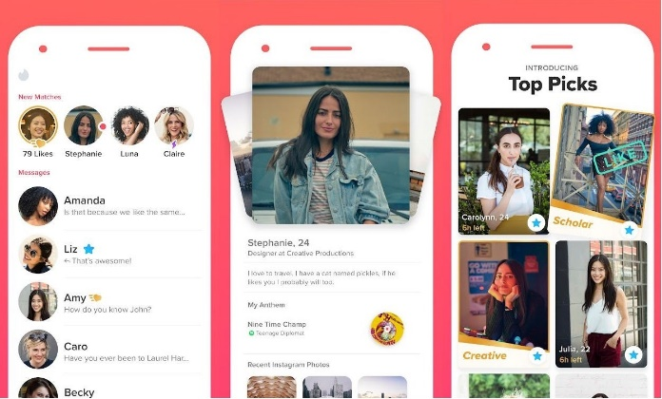

Fig. 1. Images of icons (left) and layouts (right) of dating apps.

**Relevant Social Psychology Topics**

1. Attraction and Close Relationships
   1. Attraction
      1. Interpersonal
         1. Need for affiliation
      2. Physical
         1. “Love is blind”, “what is beautiful is good”
         2. Physique & weight, red is sexy
      3. Frequency of Exposure
         1. Proximity
      4. Dis/liking others
         1. Similarity
            1. Complementarity, matching hypothesis, implicit egotism, attitude similarity
         2. Balance theory
            1. Balance, imbalance, non-balance
         3. Social comparison
            1. Consensual validation
         4. Traits present
            1. Social skills, liking us, narcissism
            2. Extraversion, agreeableness
   2. Types of Close Relationships
      1. Love
         1. Beyond sexual and romantic
         2. Types of love
            1. Passionate, companionate, unrequited
         3. Triangular model
            1. Passion + intimacy + commitment
            2. -> consummate love
      2. Friends
         1. Mature friendship formation
            1. Spend time, different situations, mutual support, self-disclosure
         2. Gender differences
            1. Women : intimacy, men : activities
         3. Similarity
            1. Actual vs. perceived
2. The Self
   1. Self-presentation
      1. Rewarded biased self-presentation
      2. Strategies
         1. Promotion, depracation, ingratiation
   2. Unrealistic optimism
      1. Social comparison
         1. Downward, upward
   3. Self-esteem
      1. Gender, experiences, perceived discrimination
   4. Self-conscious emotions
      1. Internalized socially acceptable conduct
      2. Guilt, shame, pride
3. Persuasion
   1. Factors for Success
      1. Early research model
         1. Communicator, message, audience
      2. Communicator traits
         1. Credible, attractive, liked, “not persuasive”
      3. Processing
         1. Systematic, heuristic
   2. Methods to Resist
      1. Reactance, forewarning, selective avoidance, contrary to views, individual differences, ego depletion
4. Social Perception
   1. Initial Information
      1. Speed, accuracy, updated in different contexts
      2. Impression management
         1. Self & others

**Issues Involved**

1. “Bad for mental health”
   1. Bumble has a section for “protecting your mental health”
   2. Mental Exhaustion
      1. Ego-depletion?
   3. Feelings of Rejection
      1. Self-esteem?
   4. Harmful Behavior
      1. Aggression?
2. How well do dating apps help people with finding “true love”?
   1. Rather than just “well-marketed love”?

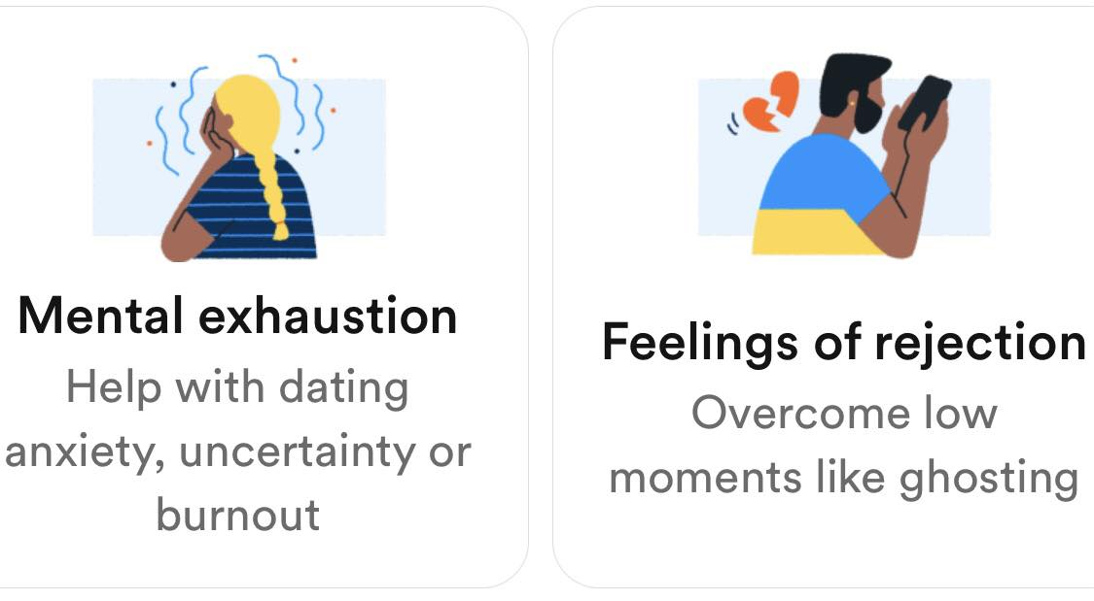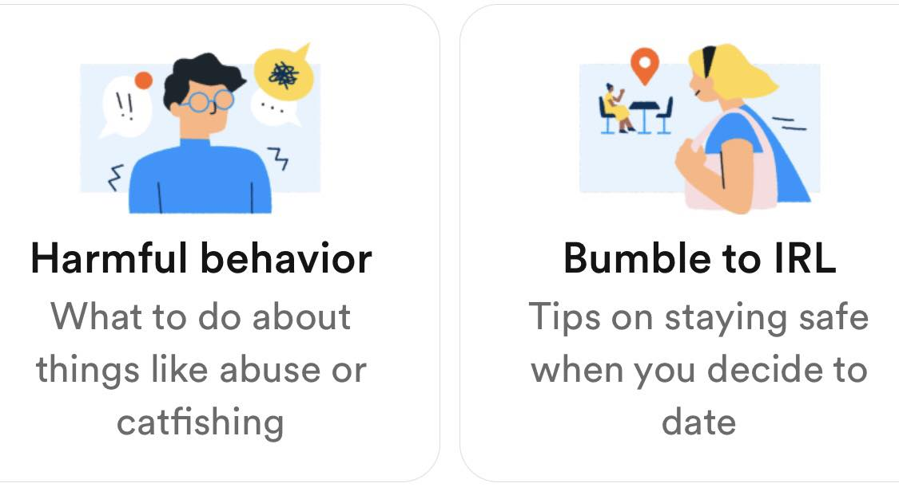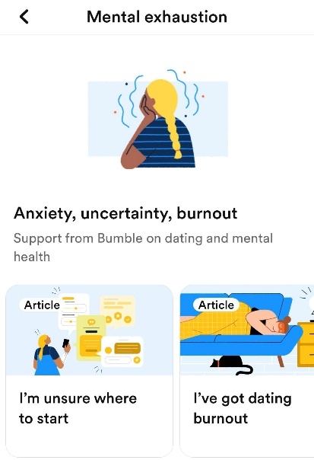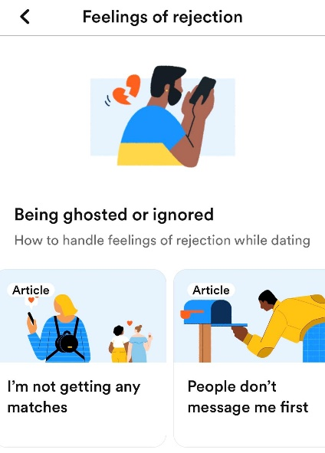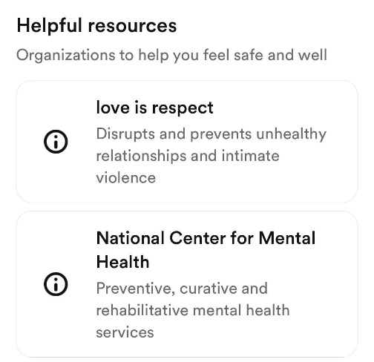

Fig. 2. Snippets of the “Wellbeing” section of Bumble.

**Format**

* Short Write-Up
  + Due to unusual medium
  + Covers relevant social psychology concepts and arguments
  + Assesses and addresses the relevant issues raised
* Video Game
  + Deliverables
    - Application executable file
    - Github page

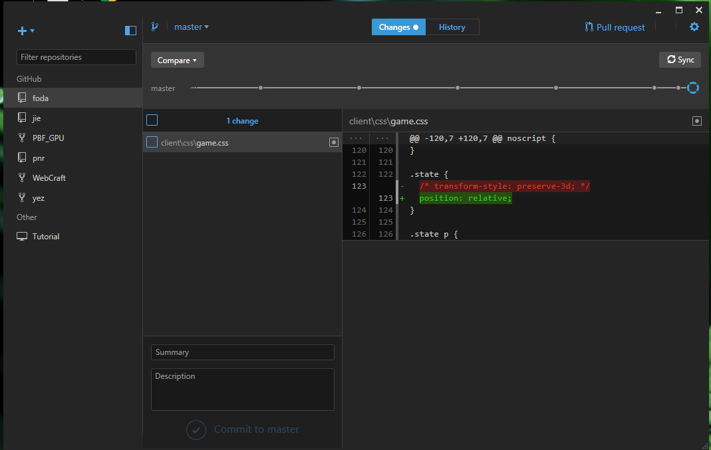

Fig. 3. GitHub for PC.

* + - [itch.io website](https://undead-engine.itch.io/a-train-from-baclaran) (sample linked)

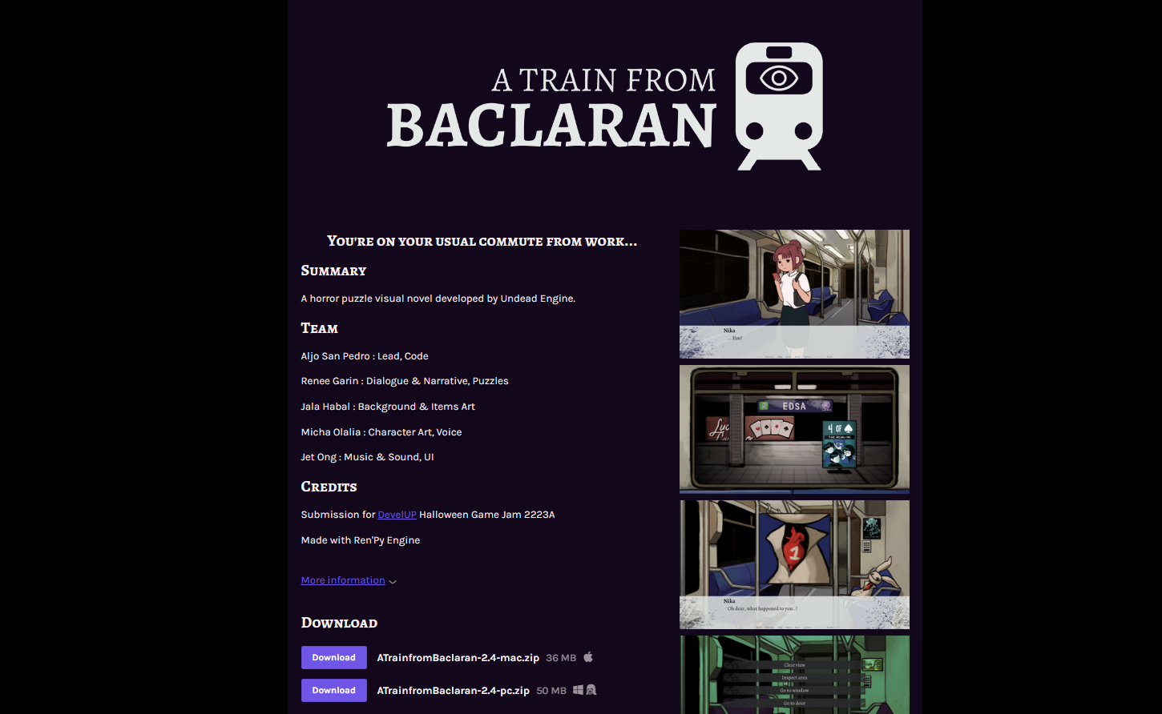

Fig. 4. Sample Itch.io website for the game to be hosted on.

* + - Social media posts (optional)
  + Components
    - Art and Sound
      * Free or very cheap resources online
    - Writing
      * Sections of a dating app
      * People profiles
      * How to present the concepts, arguments, and issues
    - Programming
      * Godot Game Engine
      * Or, in case of Visual Novel: RenPy

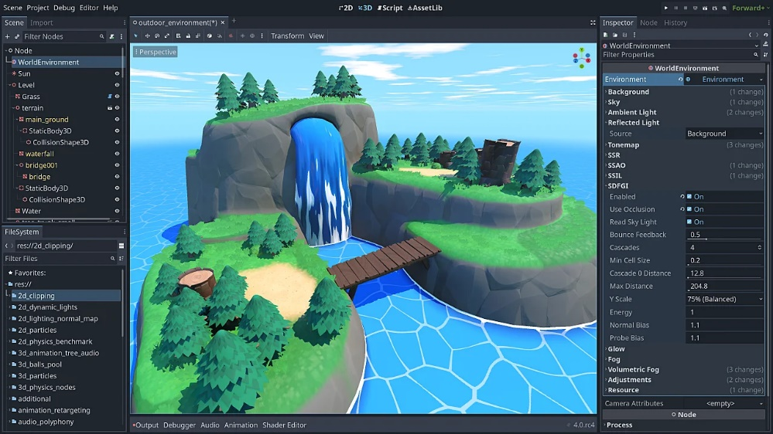

Fig. 5. Godot Game Engine.

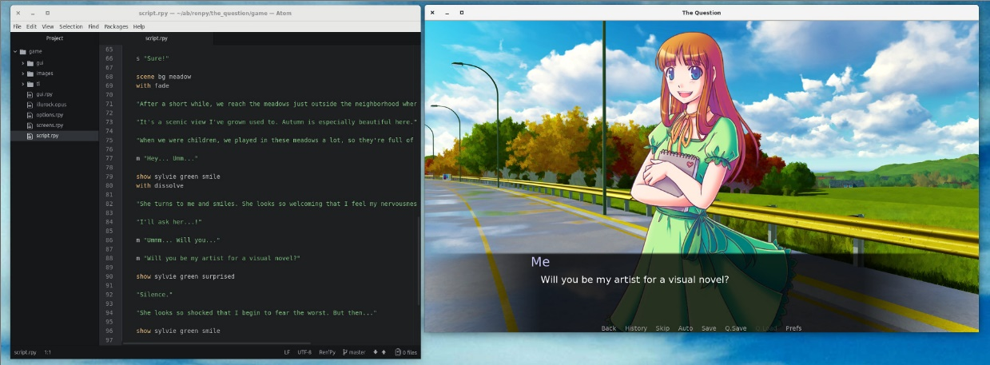

Fig 6. RenPy Library on a code editor (left) and output (right).

* + Game Design **(very much still lacking/need consult)**
    - Base Game Idea
      * Option: Pre-determined “story” that changes with choices
    - Sections
      * Main Menu
      * Profile Creation
      * Swiping Section (w/ Others’ Profiles)
    - Presentation of Concepts
      * Terms
      * Themes
      * Ideas
      * Directions
        + Recommendations, Interventions
    - Sources
      * In a credits section in the main menu
      * Along with other assets that need crediting
    - References for UI Layouts

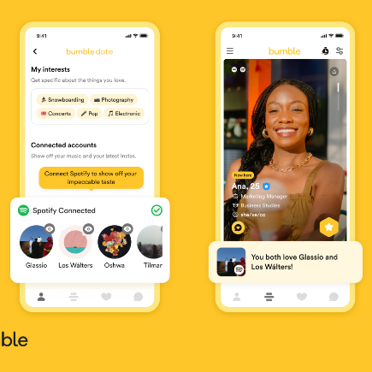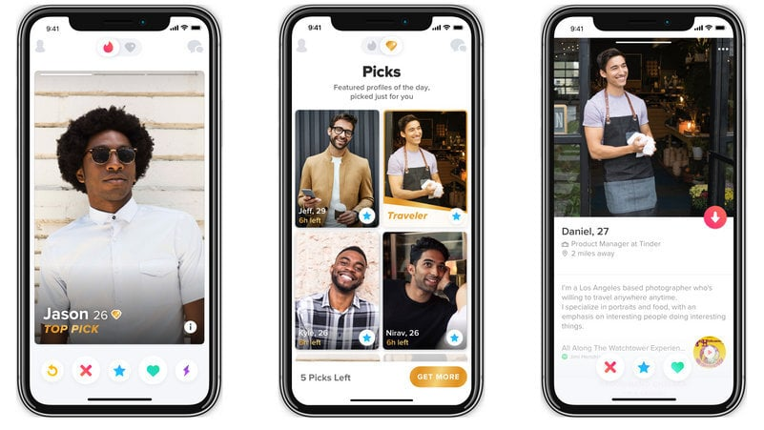

Fig. 7. Layouts of actual dating apps (Left: Bumble, Right: Tinder).

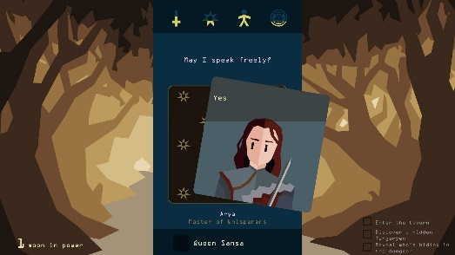 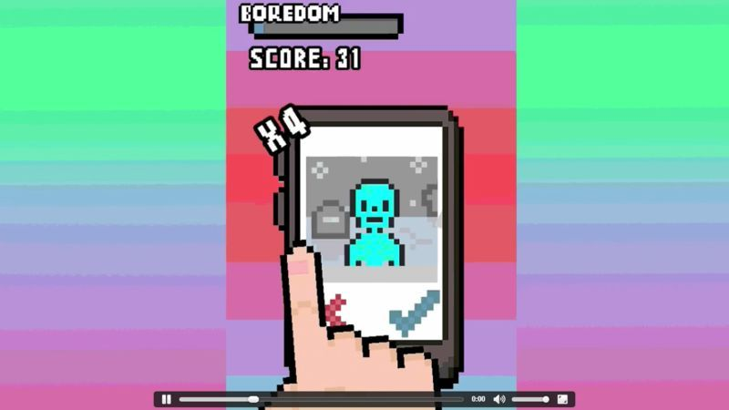

Fig. 8. Layouts of video games inspired by dating apps.

**Documentation**

* GitHub
* Itch.io logs
* Screenshots

**Personal Capability**

* Have been developing skills in making video games for 2 years
* VP for Intel in DevelUP, the UPD video game development org
* Will ensure to scope low for most chances of success

**Prospective Additional References**

Bandinelli, C., & Gandini, A. (2022). Dating apps: The uncertainty of marketised love. *Cultural Sociology*, *16*(3), 423-441. <https://doi.org/10.1177/17499755211051559>

Castro, Á., & Barrada, J. R. (2020). Dating apps and their sociodemographic and psychosocial correlates: A systematic review. *International Journal of Environmental Research and Public Health*, *17*(18), 6500. <https://doi.org/10.3390/ijerph17186500>

Chin, K., Edelstein, R. S., & Vernon, P. A. (2019). Attached to dating apps: Attachment orientations and preferences for dating apps. *Mobile Media & Communication*, *7*(1), 41-59. <https://doi.org/10.1177/2050157918770696>

Hobbs, M., Owen, S., & Gerber, L. (2017). Liquid love? Dating apps, sex, relationships and the digital transformation of intimacy. *Journal of Sociology*, *53*(2), 271-284. <https://doi.org/10.1177/1440783316662718>

Holtzhausen, N., Fitzgerald, K., Thakur, I., Ashley, J., Rolfe, M., & Pit, S. W. (2020). Swipe-based dating applications use and its association with mental health outcomes: a cross-sectional study. BMC psychology, 8(1), 1-12. <https://bmcpsychology.biomedcentral.com/articles/10.1186/s40359-020-0373-1?fd=5317710456904024|5456507360795513&lp=/dating-apps-mental-health>

Rochat, L., Bianchi-Demicheli, F., Aboujaoude, E., & Khazaal, Y. (2019). The psychology of “swiping”: A cluster analysis of the mobile dating app Tinder. Journal of Behavioral Addictions, 8(4), 804-813. https://akjournals.com/view/journals/2006/8/4/article-p804.xml

Thomas, M. F., Binder, A., & Matthes, J. (2022). The agony of partner choice: The effect of excessive partner availability on fear of being single, self-esteem, and partner choice overload. Computers in Human Behavior, 126, 106977. <https://doi.org/10.1016/j.chb.2021.106977>

Wu, S., & Trottier, D. (2022). Dating apps: a literature review. *Annals of the International Communication Association*, *46*(2), 91-115. <https://doi.org/10.1080/23808985.2022.2069046>

**Questions for Consultation**

* Should I focus on one or a few main social psychology topics to explain the phenomenon? If so, which among the ones I’ve presented would work the best?
* I’m having difficulty with determining if the issues I raised count as “valid” or “explain-able” enough with the social psychology topics I presented
* Do you have a preferred scope for at least how much content the output can provide? (ex. 5-10 minutes of gameplay, X amount of concepts explained…)
* I mostly prepared for the concepts I can use, but I have been having difficulty imagining how the game would work in a way that is both fun yet informative. Would you happen to have any initial suggestions for what direction I can take?

**Consultation Notes**