Heading

Document Name: Sprint 2 Plan

Product Name: Ride Share App

Team Name: #NOLife

Sprint Completion Date: November 4th, 2015

Goal:

To get our Ride Share App to have a searchable, editable rideshare database with accounts containing profile information.

Task listing , organized by user story:

**User Story #1:** As a user I need a way to search by destination and origin so that I end up in the right place.

Associated tasks:

* Edit JSP file for search page which will require an access to the database, and return to user a set of rides with nearby postal addresses. (8 hours)

**User Story #2:** As a user I need to be able to search by time of departure and arrival so that I can find a ride at the most convenient time.

Associated tasks:

* Edit JSP file for search page which will require an access to the database, and return to user a set of rides with closest times. (8 hours)

**User Story #3:** As a user I need to be able to search by recurring frequency so that I can decide who I want a ride with.

Associated tasks:

* Add fields to the databases for recurring frequency. (0 hours)

**User Story #4:** As a user I want to have an account with profile information so that people can see my information.

Associated tasks:

* Create a database template of a profile page, and have a login page.

**User Story #5:** As a user, I need to have a built in map so that I can see who I can pick up on my route

Associated tasks:

* Implement google maps to display the map.
* Implement a pathfinding algorithm using probabilities to display your routes and who’s on them.

**User Story #6:** As a user, I want to be able to rate other users so people can see who is reliable

Associated tasks:

* Adding star buttons for rating.

**User Story #7:** As a user, I need to know how many riders are in each ride so that I can update number of available seats

Associated tasks:

* Add a field for number of riders in the database

**User Story #8:** As a user, I want to be able to search by how many seats are available so that I can make sure there’s enough room

Associated tasks:

* Add an option to the search dropdown menu and an algorithm for searching based on the number of seats available

Team roles:

Alice Yu: Developer

Alix Feinsod: Project manager and developer

Brighton Keslin: Developer

Carol Figueroa: Developer and Scrum Master

Christopher Peck: Developer

Timothy Ma: Developer and Scrum Master

Initial task assignment:

Alix Feinsod: User story #1, 2, 3

Alice Yu: User story #4

Christopher Peck: User story #1,2, 3

Carol Figueroa: User story #4

Timothy Ma: User story #4

Brighton Keslin: User story #1, 2, 3, 4 (Brighton will be a floater)

Initial burnup chart:

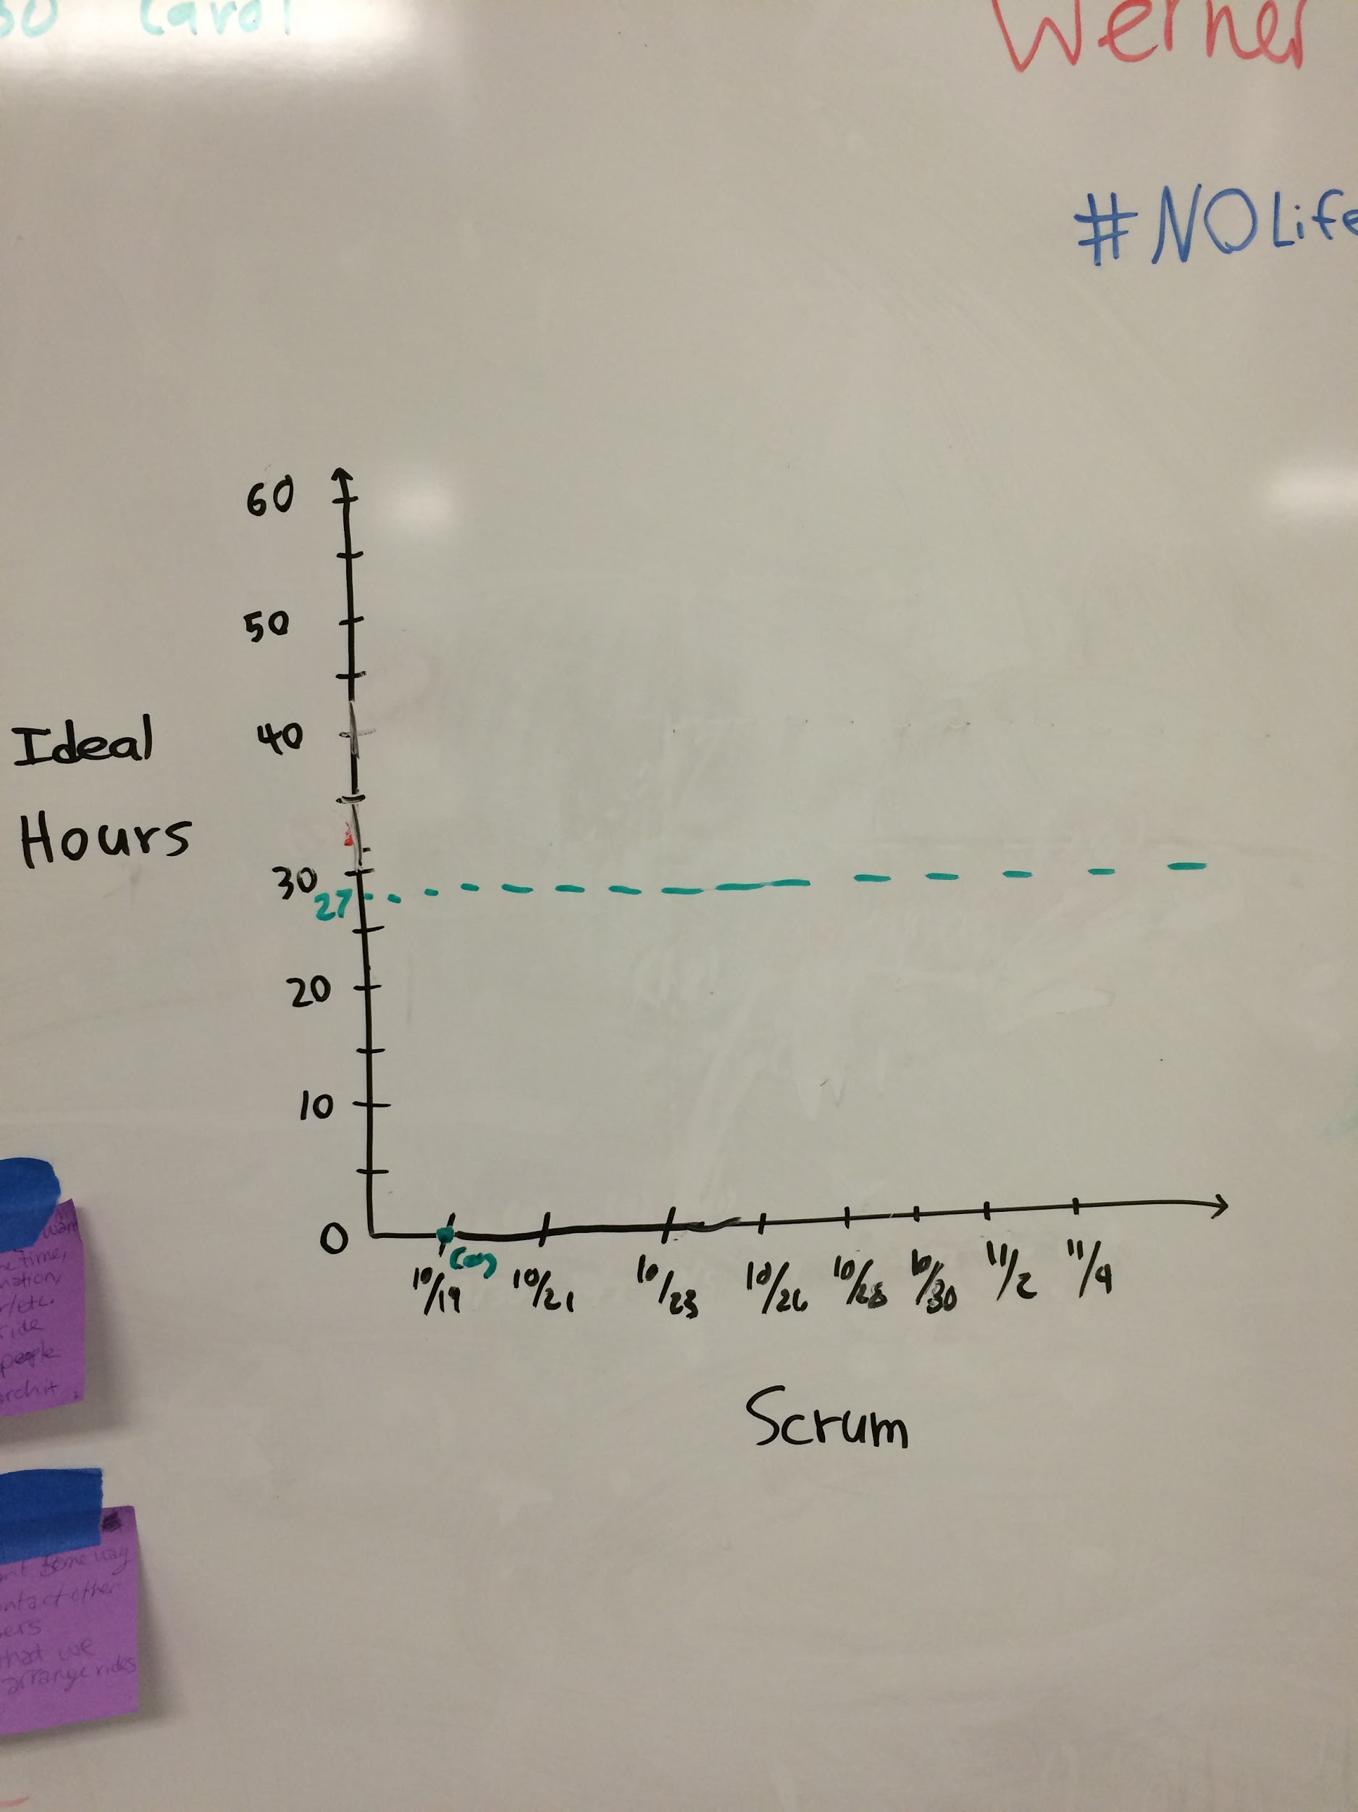

Initial scrum board:

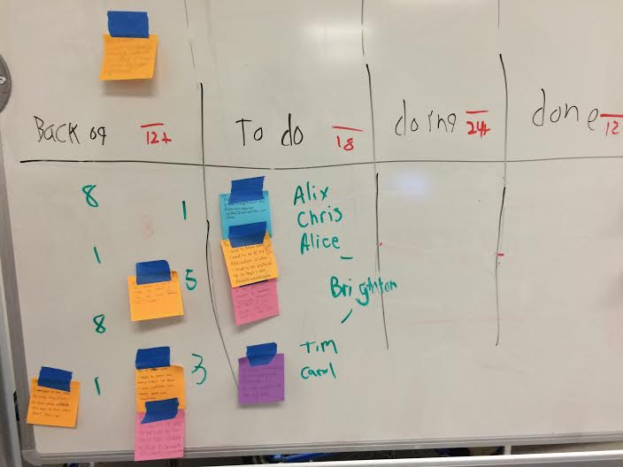

Scrum times: Monday (1:30 PM), Wednesday (7:00 PM), Friday (1 PM)