

**California State University Long Beach**  
Computer Engineering Department

CECS 497 Directed Studies Proposal

**Mesh Network Remote Underwater Image Acquisition System**

**Deliverable 1 (Feb. 03, 2015)**

Presented By: Matthew Connolly & Brent Scheneman

Under Supervision of John Tramel

Table of Contents

Summary 4

Project Specifications 5

Task Listing and Timeline 6

Implementation and Results 7

Conclusions 8

Appendix 9

Figure 1: California Spiny Lobster 4

# Identification and Significance of the Problem or Opportunity

|  |  |
| --- | --- |
| https://lh6.googleusercontent.com/lr-bYUq7vf4Xb8EMFx7VgYpGVAVKVk2XftmtYfdM0_Gc1EfkPpbbwjCx_tFWUaYRAUHjIr2MbgSPOHQlQDvHXi8r3K_4L5QgTwSZQNH1hSogqOKvJFUtndBBDks6mJr61TRAdS9J-vnIZTwr  Figure 1: California Spiny Lobster | https://lh3.googleusercontent.com/o7G8H13qrHfFSutxHF-VqK0vGeotiWv6-F6yVtSn9xQSdixfeZWIDD5Q9_LQuvmsfotWr1wvwpjOec9bfD7IkoOH7qI8ZqLgrMEOEdEntRWyff3wDn2lwr45so3wBaWHQ41iHPapBSGoFyHY  Figure 2 Hoop Net Lobster Trap |

The Panulirus Interruptus (California Spiny Lobster) is a highly sought crustacean game that has no claws and dwells within structure during the day. Once the sun starts to set, they venture out into the open ocean to scavenge for food. This is the best time to catch them and for many years, recreational lobster harvesting in California was an activity reserved largely to divers with the skills and bravado to descend into the pitch black ocean and hunt these “Bugs” with their bare hands. Yet within the past seven years, a more productive technique has gained immense popularity — hoop-netting at night. No more night dives. Just drop a baited net (see “Hoop-Netting Gear”), let it soak for 30 minutes, and then pull it up quickly to see if lobsters have crawled inside. Many modern day fishermen who utilize this hoop net approach deploy several nets simultaneously so as to maximize their returns when fishing.

The goal of this project was to create a system which allows a hoop net lobster fisherman to remotely check the contents of multiple traps, reducing unnecessary trap recovery and fuel consumption. The general concept revolves around a modular system wherein each trap is equipped with a waterproofed, infrared camera capable of transmitting data through a serial interface. The cameras are mounted at the apex of the hoop net so as to avoid interfering with the basic operation of the trap while maintaining enough proximity to be able to allow proper imaging of the trap and its contents under normal conditions.

Data from the camera is then transmitted serially to a buoy at the surface of the ocean. These buoys act as nodes in a mesh network, relaying information back to the base collector which is monitored by the user. The base station will allow the user to query one or all of the lobster traps, at their leisure, and to view their contents. In this way, the user does not waste time and energy checking empty traps.

# Phase I Technical Overview

The approach to system development will focus on first achieving function, with future phases dedicated to cost reduction and operation improvement.  Key tasks that need to be achieved to ensure proper operation of system are as follows:

## Specifications

* Depth of trap less than or equal to 100 feet.
* System operation does not interfere with normal function of trap
* System allows for tension line that allows trap to stay upright and float to be directly above trap (reduce drift in current)
* Range of 1-3 miles line of sight.
* Battery Operated Buoy
* Base Station Powered by 110V supply (Outlet)
* 1-3 Nodes

## Hardware

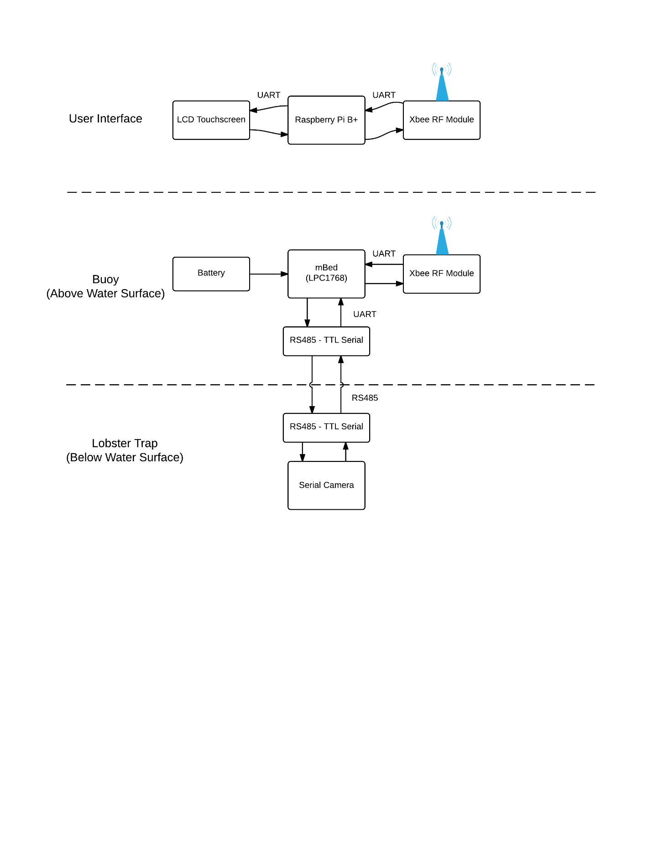

Figure 3 Hardware Block Diagram

### Receiver

### Buoy

#### Buoy Top

#### Buoy Bottom

# Task Listing and Timeline

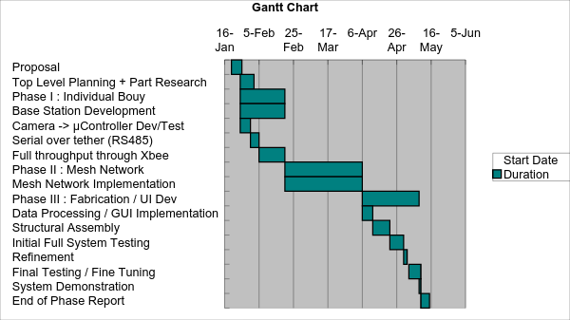

# Phase I Work Plan

## Statement of Work

Generally, this project will be broken down into three main phases; the initial phase will be dedicated to establishing an individual buoy system proof of concept.  The goal of this single node approach is to first validate the fundamental concept and to glean information about data transfer rates, and basic process flow.  This step will also help to identify any issues regarding power supplies or other electronic factors that will need to be addressed early on such as noise generated by processors interfering with RF communications.  Testing in this phase will also reveal the capabilities of low light imaging in an underwater environment, which will be a topic that will pervade the entire timeline of development and will need constant enhancement.

The second phase will target implementing multiple buoys into the system.  The development of the requisite mesh network needed to implement this approach effectively will occupy the bulk of the work throughout this project.  A wireless mesh network (WMN) is a communications network made up of radio nodes organized in a mesh topology wherein all nodes cooperate in the distribution of data in the network.  Our team’s experience with this technology is limited and will produce an excellent learning opportunity for us, as well as to enhance the challenges of development.  Due to the nature of the project, the mesh network is the most ideal for our application.

Phase 3 of our project will be dedicated to testing, UI enhancement, and system refinement as well as waterproofing and enclosure design.  Much of this phase will focus less on theory and research, and more on technical work and fabrication.

A series of deliverables will be provided to our project supervisor John Tramel.  In keeping with the phased structure of our project, the culmination of each phase will demand working deliverables of the tasks said phases were dedicated to.  As such the following deliverables will be provided:

## Schedule

## Deliverables

### Task Deliverables Responsibility Schedule

|  |  |  |  |
| --- | --- | --- | --- |
| **Task** | **Team  Member(s)  Responsible** | **Specifications / Extended Description** | **Date** |
|  | *Phase I* |  |  |
| Software Flowchart | Matt | Provide a software flowchart illustrating the conceptual activities performed by the base station and highlighting potential tools necessary to implement these tasks. | 02/03/2015 |
|  |  |  |  |
| Top Level Hardware  Block Diagram | Brent | Provide a top level hardware block diagram for the project citing specifically researched components and their implementation with relation to the project | 02/03/2015 |
|  |  |  |  |
| Serial Camera Test | Matt | Demonstrate the ability to command target camera to produce an image capture and output it into a microcontroller via serial connectivity. | 02/10/2015 |
|  |  |  |  |
| Long Distance Serial | Matt | Demonstrate the previous task, now over some form of long range serial medium (>30ft). | 02/17/2015 |
|  |  |  |  |
| Base Station | Matt | Demonstrate Base station initial framework including controller and display. | 02/24/2015 |
|  |  |  |  |
|  | *Phase II:* |  |  |
| Single Node Connectivity | Matt and Brent | Demonstrate transmission of simple text between a base and a single node using wireless data transfer methods. | 03/03/2015 |
|  |  |  |  |
| Single Node Image | Matt and Brent | Demonstrate transmission of image upon query from base station, from node to base station. | 03/10/2015 |
|  |  |  |  |
| Multiple Node Connectivity | Matt and Brent | Demonstrate transmission of simple text to and from multiple nodes across a mesh network containing a minimum of three nodes. | 03/17/2015 |
| Multiple Node Image | Matt and Brent | Demonstrate transmission of simple text to and from multiple nodes across a mesh network containing a minimum of three nodes. | 03/24/2015 |
|  |  |  |  |
|  | *Phase III:* |  |  |
| GUI | Brent | Demonstrate GUI that will be implemented in the final system.  GUI will allow user to query an individual node or the entire net, and will be able to display the images from one or more of the nodes | 04/12/2015 |
|  |  |  |  |
| Individual Complete Buoy | Matt | Present a completely functional individual buoy featuring independent power supply (batteries / solar / etc), proper buoyancy characteristics and nodal function. | 04/12/2015 |
|  |  |  |  |
|  |  |  |  |
| Project Final Demonstration | Matt and Brent | Demonstration of complete working project, including GUI implemented base station capable of querying all or individual network nodes and displaying images of the contents of the traps at each node.  Trap and buoy nodes will be self powered, trap will be submersible to 100 feet maximum depth. | 05/10/2015 |
|  |  |  |  |
| End of Phase Report | Matt and Brent | Submit Complete Documentation of project outlining all major tasks, completion and lessons learned. | 05/15/2015 |
|  |  | --- |  |

# Prototyping

In an effort to mitigate risk and to develop a proof of concept, an initial prototype model was designed and fabricated. The process followed is outlined in the following section and includes a full detailing of the lessons learned and successes achieved during the process.

## JPEG Serial Camera

Initial plans to create the camera module focused on the use of the Serial camera module ______

# Related Work

To date, our team has had sufficient success implementing related projects to this one.  We have already addressed long range serial communication using RS485 in the development of an underwater ROV, “Xeebo” during the summer of 2014.  “Xeebo” demonstrated our ability to effectively transmit data to and from a remote point utilizing RS485 in a half duplex configuration.  In addition, there was much learned regarding effective waterproofing, heat dissipation in a closed system environment, and tether design / power considerations utilizing a tethered system during this project.  Buoyancy was also addressed heavily throughout “Xeebo” which may also have implications in this project.

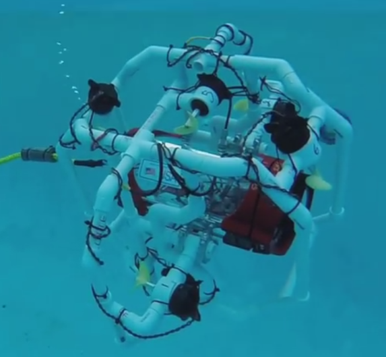

Figure 4 "Xeebo" Remote Operated ROV

Some cursory exploration into the use of RF data transmission was completed under the “OPS” heads up tactical display system conducted by the team.  This project aims to pick up where that project left off in terms of use of the Xbee RF data transmission.  “OPS” was only ever capable of data transmission between two nodes.  With this lobster trap system, the very nature of the project requires that multiple nodes be able to interact and chain their transmissions along a mesh network.  This will allow for a more dynamic implementation as well as serve to increase the maximum range of the entire system.

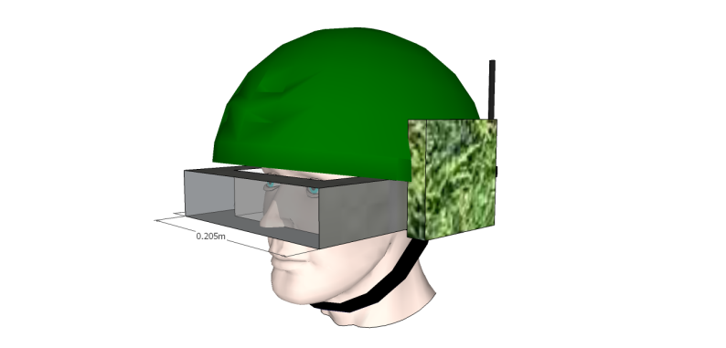

Figure 5 OPS Battlefield Awareness System

# Commercialization Strategy

In an effort to make this the foundation for a commercially viable undertaking, care will be taken to minimize cost while still not sacrificing performance.  Care in leveraging the capabilities of the mesh network, as well as thorough part selection and design will be taken in order to result in an end product that is functional and robust, while also leaving an infrastructure for future development and enhancement.  Initial proof of concept incarnations will favor simplicity of implementation in an effort to refine crucial software and electrical hardware systems.  Once those systems are complete, efforts to refine and enhance the physical design will be undertaken.

# Key Personnel

|  |  |  |
| --- | --- | --- |
| |  |  | | --- | --- | |  |  | |
| Mr. Scheneman brings to this project experience in embedded systems, electronic hardware design, complete system on chip design flow, and remote data acquisition development.    He has been part of a team of engineers who developed the next generation of inert atmosphere gloveboxes and inert gas purification systems at Vacuum Atmospheres Co. located in Hawthorne, CA. Mr. Scheneman contributed to the industrial automation and control system design on a multitude of purification systems, along with the mechanical design of innovative inert gas purification systems.    He has extensive involvement in complete embedded system development from low-level sub-system design to high-level system integration. This is made possible with his experience in embedded processor applications involving communication and control of external peripheral devices. This includes communication with wireless sensor networks using industry standard self-healing mesh network protocols. Additional experience includes System on Chip (SoC) design implemented on Field Programmable Gate Array (FPGA) utilizing hardware description languages such as Verilog and VHDL.    After joining M4 Engineering, he has contributed heavily to the design and implementation of remote rugged data acquisition systems for condition monitoring applications that require the upmost in durability and reliability. This involved top-down design of hardware systems and firmware, coupled with web-based methods for displaying and analyzing the acquired data. Mr. Scheneman has contributed to the development of high performance cloud computing systems responsible for high-speed computational fluid dynamic analysis and simulation. |

|  |  |  |
| --- | --- | --- |
| |  |  | | --- | --- | |  |  | |
| Mr. Connolly supplies the project with experience in embedded system development implementing top-down methods for hardware/software system-on-chip (SOC) co-design.  His most recent involvement with M4 saw him contribute heavily to the design and implementation of an innovative, large scale, and high throughput real-time data acquisition project designed for the NASA Langley research center in Langley VA. This work focused on creating a robust embedded system capable of high volumes of simultaneous data acquisition while also working to simplify connectivity requirements for existing systems. The scope of the project also required the validation of hardware components through experiment and analysis.  Other projects he has been involved in have focused on myriad aspects of embedded system development ranging from complete system, to task specific subsystem development. His experience includes implementing sequential logic emphasizing finite state machine design & analysis, and timing analysis of sequential logic.  Additional experience includes the use of Electronic Design Automation (EDA) tools for design, simulation, and verification of logic circuits as well as circuit board design and fabrication. He has implemented embedded systems using Field Programmable Gate Array (FPGA) and microcontroller processing architectures using complete SOC design flow from specification to working SOC. Additionally he has worked on the creation of Register Transfer Level (RTL) modules designed for reuse and integration of intellectual property (IP) for RTL and physical level IP, IC verification, and creation of self-checking test benches for designs.  His diverse skill-set and experience derived from his prior service in Special Operations Command (SOCOM) as a member of a small technical surveillance and long range reconnaissance team affords him unique insight as to real world implementation of military systems in harsh environments and end user expectations. Following his military service he attended California State University; Long Beach where he led the team responsible for pioneering the schools underwater robotics program, as well as developed experimental reality augmentation embedded systems for military applications. |

# Facilities / Equipment

Lab space provided by the CSULB Engineering department will serve as a base of operations for the lobster trap project.  Initial testing will be conducted in one of the school’s three pools through coordination with faculty.  Full system testing will be conducted out in the ocean through personal contacts and interested parties that have boat access, as well as at local public ocean access points such as La Jolla Cove / Long Beach Marina.

Traps and requisite equipment will be provided by the team as needed.

# Consultants

* John Tramel 

Mr.  John Tramel will serve as the project overseer and advisor.  The team will report all status and deliverables to him.  Additionally, his expertise in embedded system development will be sought throughout development in order to streamline production and to circumvent common pitfalls amongst inexperienced engineers.

* Bob Ward              

Mr. Ward will be consulted regarding electrical systems design and as a consulate to exterior interested parties.  His knowledge regarding underwater systems will be sought as well.

# References Bibliography

"California Lobster Battles." *Boating Magazine*. N.p., n.d. Web. 26 Jan. 2015.

"Mesh Networking." *Wikipedia*. Wikimedia Foundation, n.d. Web. 26 Jan. 2015.

"California Spiny Lobster." *Wikipedia*. Wikimedia Foundation, n.d. Web. 26 Jan. 2015.

# Implementation and Results

# Conclusions

# Appendix