

**California State University Long Beach**  
Computer Engineering Department

CECS 497 Directed Studies Proposal

**Mesh Network Remote Underwater Image Acquisition System**

Presented By: Matthew Connolly & Brent Scheneman

Under Supervision of John Tramel

Table of Contents

Identification and Significance of the Problem or Opportunity 3

Phase I Technical Overview 5

Phase I Work Plan 5

Statement of Work 5

Schedule 6

Deliverables 7

Related Work 9

Commercialization Strategy 10

Key Personnel 10

Facilities/Equipment 10

Consultants 11

References/Bibliography 12

# Identification and Significance of the Problem or Opportunity

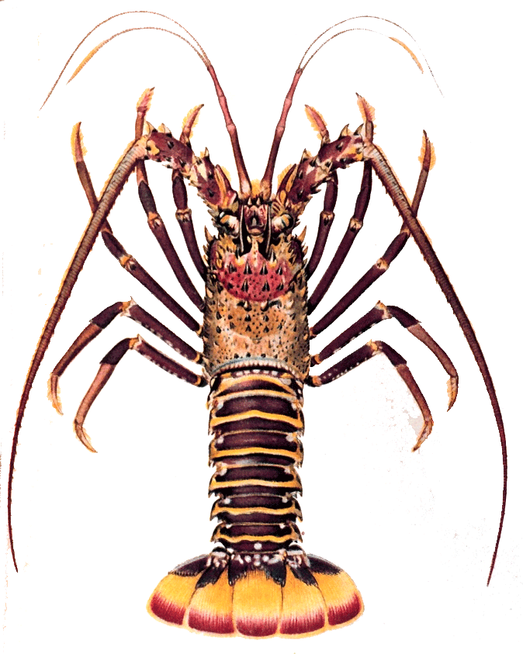

Figure : Panulirus Interruptus

The Panulirus Interruptus (California Spiny Lobster) is a highly sought crustacean game that has no claws and dwells within structure during the day. Once the sun starts to set, they venture out into the open ocean to scavenge for food. This is the best time to catch them and for many years, recreational lobster harvesting in California was an activity reserved largely to divers with the skills and bravado to descend into the pitch black ocean and hunt these “Bugs” with their bare hands. Yet within the past seven years, a more productive technique has gained immense popularity — hoop-netting at night. No more night dives. Just drop a baited net (see “Hoop-Netting Gear”), let it soak for 30 minutes, and then pull it up quickly to see if lobsters have crawled inside.

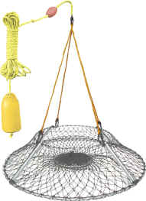

Figure : Lobster Hoop Net

The goal of our project is to create a system which allows a hoop net lobster fisherman to remotely check the contents of multiple traps, reducing unnecessary trap recovery and fuel consumption. The general concept will revolve around a modular system wherein each trap is equipped with a waterproofed, infrared camera capable of transmitting data through a serial interface. The cameras will be mounted at the apex of the hoop net so as to avoid interfering with the basic operation of the trap while maintaining enough proximity to be able to allow proper imaging of the trap and its contents under normal conditions.

Data from the camera will then need to be transmitted via a long range serial method (likely RS422 or RS 485) to a buoy at the surface of the ocean. These buoys will act as nodes in a mesh network, relaying information back to the base collector which will be operated on a boat. The base station will allow the user to query one or all of the lobster traps, at their leisure, and to view their contents. In this way, the user does not waste time and energy checking empty traps.

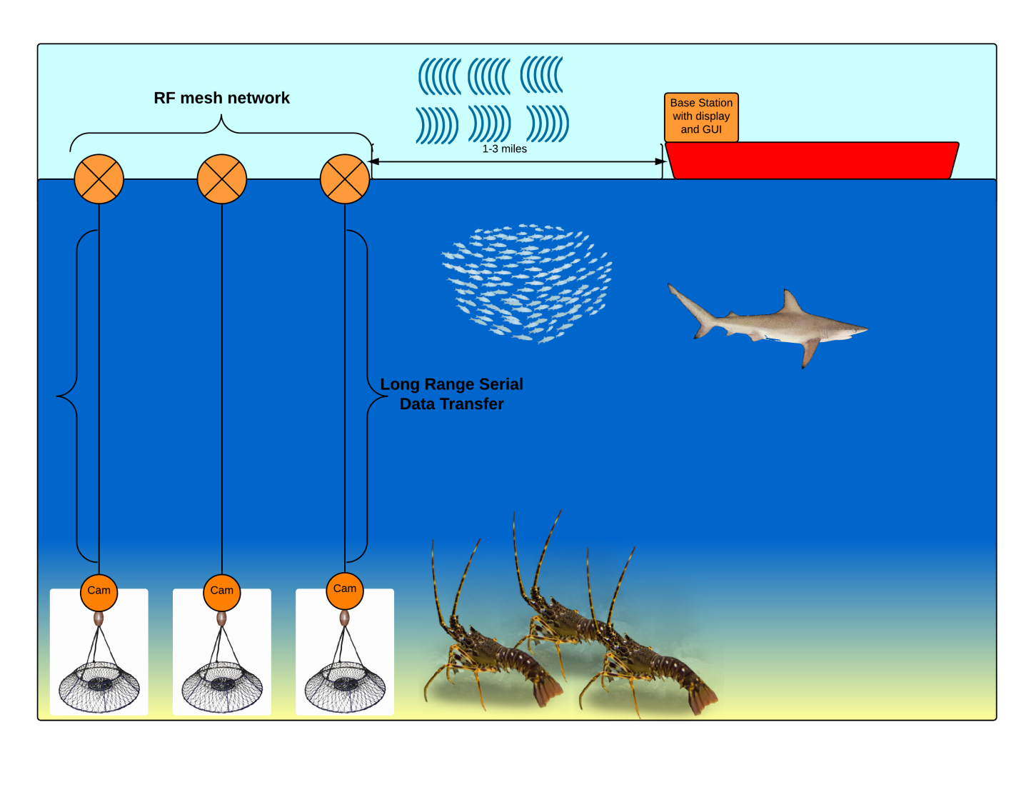

Figure : Concept Diagram

# Phase I Technical Overview

The approach to system development will focus on first achieving function, with future phases dedicated to cost reduction and operation improvement. Key tasks that need to be achieved to ensure proper operation of system are as follows:

# Phase I Work Plan

## Statement of Work

Generally, this project will be broken down into three main phases; the initial phase will be dedicated to establishing an individual buoy system proof of concept. The goal of this single node approach is to first validate the fundamental concept and to glean information about data transfer rates, and basic process flow. This step will also help to identify any issues regarding power supplies or other electronic factors that will need to be addressed early on such as noise generated by processors interfering with RF communications. Testing in this phase will also reveal the capabilities of low light imaging in an underwater environment, which will be a topic that will pervade the entire timeline of development and will need constant enhancement.

The second phase will target implementing multiple buoys into the system. The development of the requisite mesh network needed to implement this approach effectively will occupy the bulk of the work throughout this project. A wireless mesh network (WMN) is a communications network made up of radio nodes organized in a mesh topology wherein all nodes cooperate in the distribution of data in the network. Our team’s experience with this technology is limited and will produce an excellent learning opportunity for us, as well as to enhance the challenges of development. Due to the nature of the project, the mesh network is the most ideal for our application.

Phase 3 of our project will be dedicated to testing, UI enhancement, and system refinement as well as waterproofing and enclosure design. Much of this phase will focus less on theory and research, and more on technical work and fabrication.

## Schedule

1. Figure : Project Timeline

## Deliverables

A series of deliverables will be provided to our project supervisor John Tramel. In keeping with the phased structure of our project, the culmination of each phase will demand working deliverables of the tasks said phases were dedicated to. As such the following deliverables will be provided:

Task Deliverables Responsibility Schedule

|  |  |  |  |
| --- | --- | --- | --- |
| Task | Team  Member(s)  Responsible | Specifications / Extended Description | Date |
|  | Phase I |  |  |
| Software Flowchart | Matt | Provide a software flowchart illustrating the conceptual activities performed by the base station and highlighting potential tools necessary to implement these tasks. | 02/03/2015 |
|  |  |  |  |
| Top Level Hardware  Block Diagram | Brent | Provide a top level hardware block diagram for the project citing specifically researched components and their implementation with relation to the project | 02/03/2015 |
|  |  |  |  |
| Serial Camera Test | Matt | Demonstrate the ability to command target camera to produce an image capture and output it into a microcontroller via serial connectivity. | 02/10/2015 |
|  |  |  |  |
| Long Distance Serial | Matt | Demonstrate the previous task, now over some form of long range serial medium (>30ft). | 02/17/2015 |
|  |  |  |  |
| Base Station | Matt | Demonstrate Base station initial framework including controller and display. | 02/24/2015 |
|  |  |  |  |
|  | Phase II: |  |  |
| Single Node Connectivity | Matt and Brent | Demonstrate transmission of simple text between a base and a single node using wireless data transfer methods. | 03/03/2015 |
|  |  |  |  |
| Single Node Image | Matt and Brent | Demonstrate transmission of image upon query from base station, from node to base station. | 03/10/2015 |
|  |  |  |  |
| Multiple Node Connectivity | Matt and Brent | Demonstrate transmission of simple text to and from multiple nodes across a mesh network containing a minimum of three nodes. | 03/17/2015 |
| Multiple Node Image | Matt and Brent | Demonstrate transmission of simple text to and from multiple nodes across a mesh network containing a minimum of three nodes. | 03/24/2015 |
|  |  |  |  |
|  | Phase III: |  |  |
| GUI | Brent | Demonstrate GUI that will be implemented in the final system. GUI will allow user to query an individual node or the entire net, and will be able to display the images from one or more of the nodes | 04/12/2015 |
|  |  |  |  |
| Individual Complete Buoy | Matt | Present a completely functional individual buoy featuring independent power supply (batteries / solar / etc), proper buoyancy characteristics and nodal function. | 04/12/2015 |
|  |  |  |  |
|  |  |  |  |
| Project Final Demonstration | Matt and Brent | Demonstration of complete working project, including GUI implemented base station capable of querying all or individual network nodes and displaying images of the contents of the traps at each node. Trap and buoy nodes will be self powered, trap will be submersible to 100 feet maximum depth. | 05/10/2015 |
|  |  |  |  |
| End of Phase Report | Matt and Brent | Submit Complete Documentation of project outlining all major tasks, completion and lessons learned. | 05/15/2015 |
|  |  | --- |  |

# Related Work

To date, our team has had sufficient success implementing related projects to this one. We have already addressed long range serial communication using RS485 in the development of an underwater ROV, “Xeebo” during the summer of 2014. “Xeebo” demonstrated our ability to effectively transmit data to and from a remote point utilizing RS485 in a half duplex configuration. In addition, there was much learned regarding effective waterproofing, heat dissipation in a closed system environment, and tether design / power considerations utilizing a tethered system during this project. Buoyancy was also addressed heavily throughout “Xeebo” which may also have implications in this project.

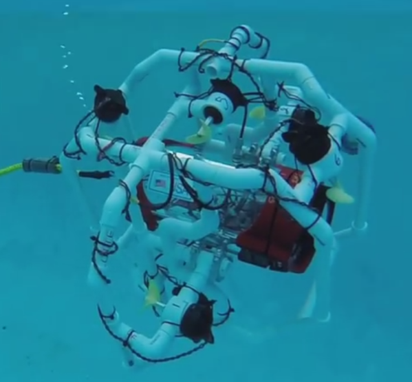

Figure : "Xeebo" Underwater ROV

Some cursory exploration into the use of RF data transmission was completed under the “OPS” heads up tactical display system conducted by the team. This project aims to pick up where that project left off in terms of use of the Xbee RF data transmission. “OPS” was only ever capable of data transmission between two nodes. With this lobster trap system, the very nature of the project requires that multiple nodes be able to interact and chain their transmissions along a mesh network. This will allow for a more dynamic implementation as well as serve to increase the maximum range of the entire system.

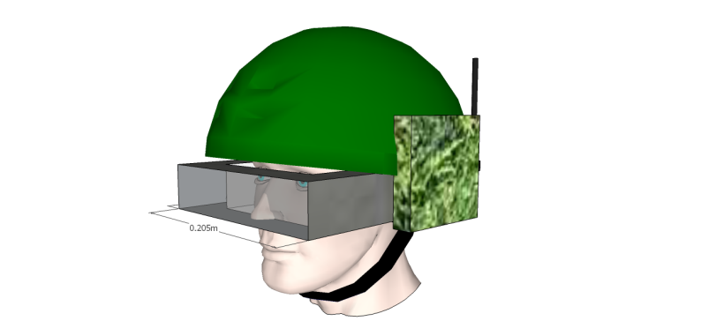

Figure : OPS Heads Up Display System

# Commercialization Strategy

In an effort to make this the foundation for a commercially viable undertaking, care will be taken to minimize cost while still not sacrificing performance. Care in leveraging the capabilities of the mesh network, as well as thorough part selection and design will be taken in order to result in an end product that is functional and robust, while also leaving an infrastructure for future development and enhancement. Initial proof of concept incarnations will favor simplicity of implementation in an effort to refine crucial software and electrical hardware systems. Once those systems are complete, efforts to refine and enhance the physical design will be undertaken.

# Key Personnel

The team responsible for developing this project is comprised of two senior level computer engineering students completing their bachelor of science in computer engineering at CSULB, Matthew Connolly and Brent Scheneman. Both share an interest in developing embedded systems and have worked together on previous projects.

|  |  |  |  |  |
| --- | --- | --- | --- | --- |
| |  |  | | --- | --- | | Matthew Connolly  Senior Level Computer Engineer Specialties:  Underwater digital systems  Software development  Team Management / Documentation |  |  |  |  | | --- | --- | | Brent Scheneman  Senior Level Computer Engineer Specialties:  Electrical Systems Design  RF data networks / protocol  Embedded Systems Design |  | |

# Facilities/Equipment

Lab space provided by the CSULB Engineering department will serve as a base of operations for the lobster trap project. Initial testing will be conducted in one of the school’s three pools through coordination with faculty. Full system testing will be conducted out in the ocean through personal contacts and interested parties that have boat access, as well as at local public ocean access points such as La Jolla Cove / Long Beach Marina.

Traps and requisite equipment will be provided by the team as needed.

# Consultants

* John Tramel 

Mr. John Tramel will serve as the project overseer and advisor. The team will report all status and deliverables to him. Additionally, his expertise in embedded system development will be sought throughout development in order to streamline production and to circumvent common pitfalls amongst inexperienced engineers.

* Bob Ward 

Mr. Ward will be consulted regarding electrical systems design and as a consulate to exterior interested parties. His knowledge regarding underwater systems will be sought as well.

# References/Bibliography

"California Lobster Battles." *Boating Magazine*. N.p., n.d. Web. 26 Jan. 2015.

"Mesh Networking." *Wikipedia*. Wikimedia Foundation, n.d. Web. 26 Jan. 2015.

"California Spiny Lobster." *Wikipedia*. Wikimedia Foundation, n.d. Web. 26 Jan. 2015.