**Crontab**

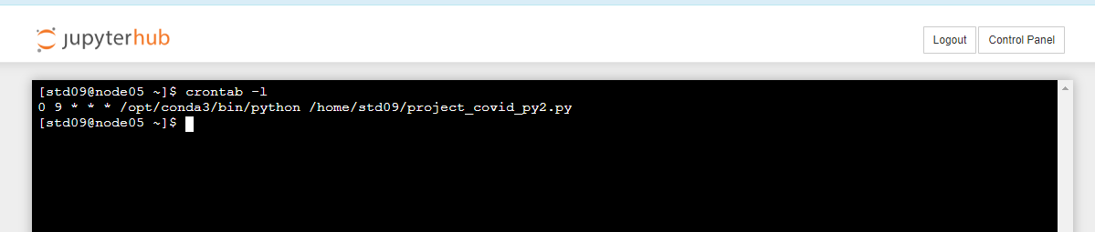

**Grafana**

<https://sberde0623.grafana.net/d/aa920c56-0bda-44ac-897c-9a13c4d48d27/covid?orgId=1&from=1693708698375&to=1693730298375>

