SmartTask
Web Business Application
Final Project Report
Course Title & Code: Web Business Applications / BIS 351
Department: Management Information Systems
College of Business Administration
Imam Abdulrahman Bin Faisal University
Academic Year: 2024-2025
Group Members
Student Name | Student ID
Abdulrhman Albelale | 2240001189
Mohammad Almejnah | 2240000470
Bader Alotaibi | 2240002142
Abdulmohsn Alkhaldi | 2240000769

Table of Contents
Project Overview
2. Introduction and Project Background ........................................................................................ 4
3. Business Problem and Target Market ........................................................................................ 5
4. Proposed Solution and Core Features ........................................................................................ 6
5. System Architecture and Technology Stack ........................................................................................ 7
6. UI/UX Design and Wireframes ........................................................................................ 8
7. GitHub Repository and Development Process ........................................................................................ 9
8. Testing and Validation ........................................................................................ 10
9. Ethical and Legal Considerations ........................................................................................ 11
10. Conclusion and Future Enhancements ........................................................................................ 12
11. References ........................................................................................ 13
12. Appendices ........................................................................................ 14

Project Overview
SmartTask is a browser-based task management web application developed for the BIS 351 Web Business Applications final project. The application addresses a practical business and academic problem: many students and busy users need a simple way to record, prioritize, and follow up on tasks, but many existing tools require accounts, subscriptions, advanced setup, or learning time. SmartTask focuses on a smaller and clearer promise: open the website, add a task, select its priority and due date, connect it to a goal, and continue working without unnecessary steps.
The project was built as a functional front-end prototype using HTML5, CSS3, and JavaScript. Task data is stored in the browser through localStorage, so the application works without a database or server-side login. This technical choice supports the project value proposition: fast access, privacy, low cost, and ease of use. The report explains the business problem, target users, features, system architecture, user interface design, development workflow, testing results, and ethical considerations. It also includes visual evidence such as screenshots, tables, a Gantt chart, and an application structure diagram to meet the project requirements.
Overall, SmartTask demonstrates how a focused business web application can solve a real user need without becoming complicated. The project meets the main course learning outcomes by applying HTML, CSS, and scripting to develop a business-oriented web application and by discussing professional, ethical, and legal responsibilities related to IT usage.

2. Introduction and Project Background
In academic and professional life, people often need to handle many responsibilities at the same time. A university student may have assignments, quizzes, group projects, presentations, registration deadlines, and personal goals. A working person may have meetings, reports, client requests, and follow-up tasks. When these responsibilities are not written down and prioritized clearly, users may miss deadlines, forget important work, or waste time deciding what to do next. Time management literature explains that planning and perceived control over time are strongly connected with performance and lower stress levels (Britton and Tesser, 1991; Macan et al., 1990).
There are many digital productivity tools available in the market, such as Trello, Notion, Todoist, and Microsoft To Do. These tools are useful, but they are not always suitable for a user who wants a quick and lightweight solution. Some require account creation, cloud storage, subscriptions, or a complex workspace structure. In many cases, the tool itself becomes another task to manage. SmartTask was designed to avoid this problem by giving users only the essential features needed for everyday task planning.
The name SmartTask reflects the project objective. The application is not designed to replace full project management platforms. Instead, it is designed for fast personal planning, especially for students and individuals who need clarity more than complexity. The core idea is that task management should be simple enough to use daily and structured enough to improve decision making. By combining task title, description, priority, due date, time, goal link, and reason for importance, SmartTask encourages users to think not only about what they need to do, but also why the task matters.
The project is relevant to Web Business Applications because it solves a real business and user problem through a web interface. It demonstrates the role of front-end technologies in creating useful digital services and shows how business needs can guide technical decisions. The final prototype includes multiple pages, navigation, interactive forms, local data persistence, task editing, completion, deletion, and support information.

3. Business Problem and Target Market

3.1 Problem Statement
The main problem addressed by SmartTask is the lack of a simple, no-login, browser-based task planner for users who need to organize daily and weekly responsibilities without being overwhelmed by advanced project management features. Many users understand that they need a task system, but they do not always continue using existing applications because the setup process is too long, the interface is too crowded, or the useful features are locked behind subscriptions.
The problem can be stated as follows: students and busy individuals need an accessible and privacy-respecting way to add, prioritize, schedule, and review tasks from any browser without creating an account, installing software, or learning a complex productivity platform. This problem is important because poor task management can lead to missed deadlines, stress, lower academic performance, and inefficient daily routines (Claessens et al., 2007).

3.2 Target Users
Target Segment | Main Pain Point | How SmartTask Responds
University students | Many deadlines across different courses and activities | Simple task entry, priority badges, due date options, and goal links
Working professionals | Fast task inflow and need for quick organization | No login, quick browser access, edit/complete/delete actions
Freelancers and small-business users | Need a free lightweight tool without enterprise complexity | Zero-cost front-end solution with local storage
General users | Paper notes get lost and complex apps are hard to maintain | Clean interface with only essential planning features

3.3 Market Gap and Opportunity
The task management market is strong, but most popular products compete by adding more integrations, templates, automation, team dashboards, and paid plans. This creates a gap for users who want the opposite experience: fewer decisions, fewer screens, and faster usage. SmartTask focuses on simplicity and ease of use. It does not try to be the most powerful task platform. Instead, it tries to be the easiest task planner to open and use immediately.
From a business perspective, this position is valuable because it targets an underserved segment. A lightweight tool can attract users who are not ready for complex systems. It can also become a first step before future monetization options such as optional cloud sync, export features, or premium themes. However, the current academic prototype focuses on usefulness and proof of concept rather than revenue generation.

3.4 Data and Information Used for the Report
The report was built using both secondary and project-based information. Secondary information includes academic sources on time management, usability, accessibility, and web storage. These sources support the argument that structured planning improves control, reduces stress, and improves user performance. Project-based information includes the team's own application screens, feature decisions, file structure, and testing observations. Combining these two sources makes the report stronger because it connects theory with the actual SmartTask prototype.
The team also used informal usability observation while reviewing the prototype. The main question during review was not only whether the feature worked, but whether a normal student could understand it quickly. This led to practical decisions such as keeping the task form on one page, using clear priority buttons, highlighting delete in red, and showing completed tasks visually instead of hiding them immediately.

4. Proposed Solution and Core Features
SmartTask solves the identified problem through a multi-page web application that focuses on task creation and task management. The solution is based on five design ideas: simplicity, privacy, accessibility, speed, and motivation. Users should be able to understand the interface without instructions. Their data should stay on their device. The layout should be readable on different screen sizes. Actions should be immediate. Finally, users should be encouraged to connect tasks to their personal goals, not only deadlines.

4.1 Main Pages
- Home page: introduces the application and guides users to start planning.
- Tasks page: contains the main task creation form and the user task list.
- About page: explains the purpose of SmartTask and the team motivation.
- Support page: provides contact options for help and user support.

4.2 Task Creation Functionality
The task creation form is the core feature of the application. It allows the user to enter a task title, description, priority level, due date option, time, linked goal, and reason for importance. The priority selection uses High, Medium, and Low badges so that urgent work can be recognized quickly. Due date options include Today, Tomorrow, Daily, and Custom, allowing both short-term and repeated planning. The optional goal and reason fields are included to support reflective planning and motivation.

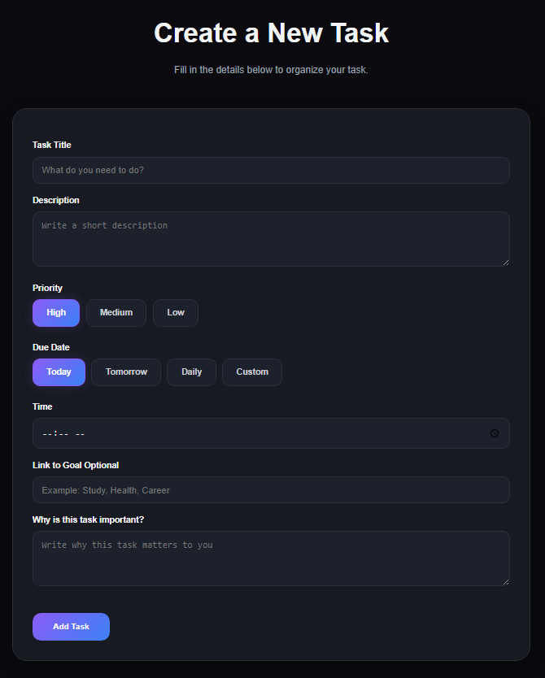
Figure 1: SmartTask task creation form

4.3 Task Management Functionality
After a task is added, it appears in the task list with its full information. The user can mark it as complete, edit it, or delete it. Completion changes the task status and gives immediate visual feedback. Editing reuses the form so the user can update details without creating a duplicate task. Deletion is highlighted clearly because removing a task is a sensitive action that should not happen accidentally. These actions cover the full CRUD cycle: Create, Read, Update, and Delete.

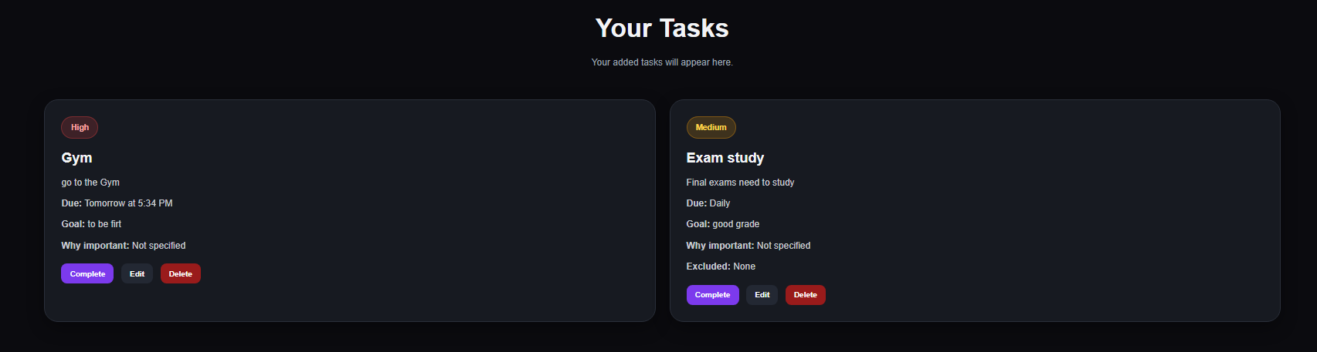
Figure 2: SmartTask user task list with priority cards

4.4 Feature Comparison
Feature | SmartTask | Trello | Notion | Todoist
No login needed for basic use | Yes | No | No | No
Local data storage | Yes | No | No | No
Priority levels | Yes | Yes | Yes | Yes
Goal linkage field | Yes | Limited | Yes | Limited
Zero setup time | High | Medium | Low | Medium
Best fit | Simple personal planning | Kanban projects | Knowledge/workspace management | Task lists and reminders

5. System Architecture and Technology Stack
SmartTask uses a client-side architecture. This means the application runs inside the browser and does not depend on a back-end server, user authentication, or an external database. This architecture is suitable for the project scope because the application is designed for personal task planning rather than enterprise collaboration. It also supports privacy because task data remains stored in the user browser.

5.1 Technology Stack
Technology | Use in SmartTask | Reason for Selection
HTML5 | Builds the page structure, forms, buttons, navigation, and semantic content | It is the standard language for web page structure and supports the course learning outcome
CSS3 | Controls layout, colors, spacing, cards, responsiveness, and visual hierarchy | It allows a polished interface without heavy frameworks
JavaScript | Handles task creation, editing, deletion, completion, dynamic fields, and localStorage | It provides interactivity and business logic on the client side
localStorage | Stores task data in the browser as JSON | It enables persistence without a database or login
GitHub | Stores source code and tracks development history | It supports teamwork, version control, and professional submission

5.2 Application Structure
File / Folder | Purpose
index.html | Landing page and navigation entry point
tasks.html | Main application page for task creation and task list
about.html | Information about the project purpose and team
support.html | Support channels and help information
css/style.css | Global styling and shared layout rules
css/tasks.css | Specific styling for task cards and task form
css/support.css | Specific styling for support page content
js/app.js | Task logic, event listeners, validation, CRUD functions, and localStorage operations
README.md | Project description, setup instructions, screenshots, and repository information

5.3 Data Model and Storage
Each task is represented as a JavaScript object. A typical object contains fields such as title, description, priority, due date, date, time, goal, reason, excluded days, and completion status. The task array is converted to JSON and saved under a localStorage key. When the page loads again, the JavaScript code reads the stored JSON, converts it back to objects, and renders the task cards. This design is simple, transparent, and appropriate for a lightweight prototype.
Simplified task object schema:
{ title, description, priority, due, date, time, goal, reason, excludedDays, completed }

5.4 Architecture Diagram
User Browser | SmartTask Front-End | Browser Storage
User enters task information and clicks Add Task | HTML form + CSS interface + JavaScript validation and CRUD logic | localStorage saves tasks as JSON and reloads them in the next session

6. UI/UX Design and Wireframes
The user interface was designed around clarity and quick usage. The main tasks page uses a card-based layout with a dark theme, strong contrast, rounded containers, and clear button states. Important information is grouped logically: task details first, then priority, then due date, then motivational fields. The user does not need to move across many screens to create a task.

6.1 Design Principles
- Clarity: labels are direct and fields are arranged in the order a user naturally thinks about a task.
- Visual hierarchy: titles, priority badges, action buttons, and due dates are visually separated.
- Responsiveness: the interface is intended to adjust for both desktop and mobile screens.
- Feedback: actions such as completion, edit, and delete give immediate response to the user.
- Accessibility: readable text sizes, labeled form fields, and contrast-conscious color choices improve usability.

6.2 Color and Typography Decisions
Element | Design Choice | Purpose
Primary color | Blue / violet gradient accents | Creates a modern technology feel and highlights main actions
Background | Dark neutral theme | Reduces visual distraction and helps cards stand out
High priority | Red badge | Signals urgent tasks
Medium priority | Amber badge | Signals moderate urgency
Low priority | Neutral/darker badge | Signals lower urgency
Typography | Clean sans-serif in the application; Times New Roman in the report | Supports screen readability in the app and academic formatting in the report

6.3 Wireframe Summary
The initial wireframe followed a simple vertical flow: header navigation, page title, task form, and task list. This design was chosen because it matches the user journey. The user first decides what to add, then reviews what has already been created. Keeping both the form and the list on the same page reduces navigation friction and makes the application more practical for daily use.

7. GitHub Repository and Development Process
The project should be submitted through a GitHub repository containing the full application source code and a README file. GitHub is important because it provides evidence of development progress, allows group members to collaborate, and makes it easier for the instructor to review the project files. Regular commits also show that the work was built progressively rather than assembled at the last moment.

7.1 Repository Requirements
- Repository name: SmartTask or SmartTask-BIS351.
- README.md: project overview, features, technology stack, instructions to run the project, screenshots, and team members.
- Source code folders: html pages, css folder, js folder, and assets folder if needed.
- Commit history: meaningful commit messages such as "Create tasks page", "Add localStorage saving", and "Improve responsive design".
- Live demo link: optional, but recommended if hosted on GitHub Pages.
GitHub repository link: [https://github.com/alkhaldi80/Smart-Task-Planner]

7.2 Gantt Chart and Timeline
Activity | W1-2 | W3-4 | W5-6 | W7-8 | W9-10 | W11-13
Idea & problem | X
UI/UX prototype |  | X | X
GitHub & README |  | X
HTML pages |  |  | X | X
CSS & responsive |  |  | X | X | X
JavaScript logic |  |  |  | X | X
Testing |  |  |  |  | X | X
Report |  |  |  |  | X | X

7.3 Teamwork and Responsibility
A successful group project requires clear responsibilities. The recommended workflow is to assign one member to coordinate the report, one member to manage HTML structure, one member to manage styling and UI improvements, and one member to manage JavaScript logic and testing. All members should still understand the full project because the course policy allows the instructor to ask any student to explain any part of the work individually.

8. Testing and Validation
Testing was planned around the main user journey: open the application, create a task, review the task list, edit a task, complete a task, delete a task, and return later to verify persistence. Because SmartTask is a front-end prototype, manual functional testing is appropriate for the current stage. The testing process focused on accuracy, usability, responsiveness, and data persistence.

8.1 Functional Testing
Test Case | Expected Result | Status
Add a task with all fields completed | Task appears with correct title, priority, date, time, goal, and reason | Pass
Add a task with only required information | Task is created and optional fields show default or empty values | Pass
Select High, Medium, and Low priority | Task card displays the correct badge style | Pass
Mark a task as complete | Task status changes and the card shows completion feedback | Pass
Edit an existing task | Form is populated and saved changes update the task card | Pass
Delete a task | Task is removed from the interface and localStorage | Pass
Close and reopen browser | Saved tasks reload correctly from localStorage | Pass
Test on smaller screen size | Form and cards remain readable and usable | Pass

8.2 Validation Against Project Requirements
Requirement | Evidence in SmartTask
Main pages and navigation | Home, Tasks, About, and Support pages
Core business functionality | Task planning with CRUD operations and local storage
Semantic HTML, CSS, scripting | HTML pages, CSS files, and JavaScript app logic
GitHub repository | Repository should include source code and README
Report with visuals | This report includes tables, screenshots, diagrams, and Gantt chart
Ethical and legal awareness | Privacy, accessibility, intellectual property, and AI disclosure sections

8.3 Limitations Found During Testing
The current prototype has some limitations. localStorage is convenient, but it does not synchronize data across devices. It also depends on the browser; if the user clears browser data, tasks may be removed. The application currently does not send automatic reminders or notifications. These limitations are acceptable for the academic prototype, but they guide the future enhancement plan.

8.4 Project Limitations
The current version of SmartTask is a simple academic prototype. Some features such as cloud synchronization and automatic reminders are not included yet, but they can be added in future versions.

9. Ethical and Legal Considerations
Ethical and legal responsibility is important in any web business application. SmartTask is a small prototype, but it still handles user-entered task information. Even simple task details may include personal goals, deadlines, or private notes. Therefore, the project was designed to limit data collection and avoid unnecessary risk.

9.1 Data Privacy
SmartTask does not require registration and does not send user tasks to an external server. All data is stored locally in the browser. This design follows the principle of data minimization because the application collects only what is necessary for its function. It also reduces privacy risk because there is no central database containing user tasks. However, users should understand that local browser storage is not the same as encrypted cloud storage, so they should avoid entering highly sensitive information.

9.2 Accessibility and Inclusion
The interface uses clear labels and strong visual contrast to support usability. Buttons are named according to their function, and fields are grouped in a predictable order. Future versions should continue improving accessibility by testing keyboard navigation, screen reader behavior, and contrast ratios against WCAG guidance (W3C, 2018).

9.3 Intellectual Property
The application source code and report content should be original work of the group. Any external assets, icons, images, frameworks, or copied code must be credited properly. If the team uses open-source snippets or libraries, the license should be checked before submission. This protects the team from plagiarism and intellectual property issues.

9.4 Generative AI Usage Disclosure
Generative AI tools may be used only within the allowed course limit and only for appropriate support activities such as brainstorming, proofreading, improving language, and understanding concepts. The team remains responsible for the final submission and should be able to explain the code, design choices, and report content orally. The final work should reflect the team's own understanding and implementation.

10. Conclusion and Future Enhancements
SmartTask demonstrates a practical solution to a common task management problem. The project shows that a useful business web application does not always require a complex back-end system or a large technology stack. By focusing on clear user needs, the team created a functional prototype that allows users to add, prioritize, schedule, edit, complete, and delete tasks in a straightforward interface.
The strongest part of SmartTask is its focus. It does not attempt to copy every feature of large productivity platforms. Instead, it provides the essential features that everyday users need most. The use of localStorage supports privacy and removes the need for account creation. The user interface supports quick planning and visual decision making through priority badges and task cards.

10.1 Achieved Objectives
- Developed a functional web application using HTML, CSS, and JavaScript.
- Implemented task creation, reading, editing, completion, deletion, and browser persistence.
- Designed a clear and responsive task management interface.
- Prepared professional documentation with analysis, visuals, testing, and ethical discussion.
- Aligned the project with the BIS 351 focus on web business applications and IT responsibility.

10.2 Future Enhancements
- Task categories and tags: allow users to organize tasks by course, project, work area, or personal goal.
- Browser notifications: remind users before a due time using the Web Notifications API.
- Export options: allow users to export tasks as PDF or CSV for backup and sharing.
- Dark and light mode: give users a choice based on environment and preference.
- Drag-and-drop ordering: allow users to manually rearrange tasks by importance.
- Optional cloud synchronization: provide secure account-based sync for users who need multi-device access.
- Analytics dashboard: show completed tasks, pending tasks, and productivity trends over time.

11. References
Allen, D. (2001) Getting Things Done: The Art of Stress-Free Productivity. New York: Viking.
Britton, B.K. and Tesser, A. (1991) "Effects of time-management practices on college grades", Journal of Educational Psychology, 83(3), pp. 405-410.
Claessens, B.J.C., van Eerde, W., Rutte, C.G. and Roe, R.A. (2007) "A review of the time management literature", Personnel Review, 36(2), pp. 255-276.
Macan, T.H., Shahani, C., Dipboye, R.L. and Phillips, A.P. (1990) "College students' time management: Correlations with academic performance and stress", Journal of Educational Psychology, 82(4), pp. 760-768.
Mozilla Developer Network (2024) Window: localStorage property. Available at: https://developer.mozilla.org/en-US/docs/Web/API/Window/localStorage (Accessed: 10 May 2025).
Nielsen, J. (1994) Usability Engineering. Boston: Academic Press.
W3C (2018) Web Content Accessibility Guidelines (WCAG) 2.1. Available at: https://www.w3.org/TR/WCAG21/ (Accessed: 10 May 2025).

