Here is the execution of the encryption routine. Nothing spectacular, but that is because the cools stuff was written to the disk. All of these files will be submitted with the project. This is why I only took the first 100 lines of the play.

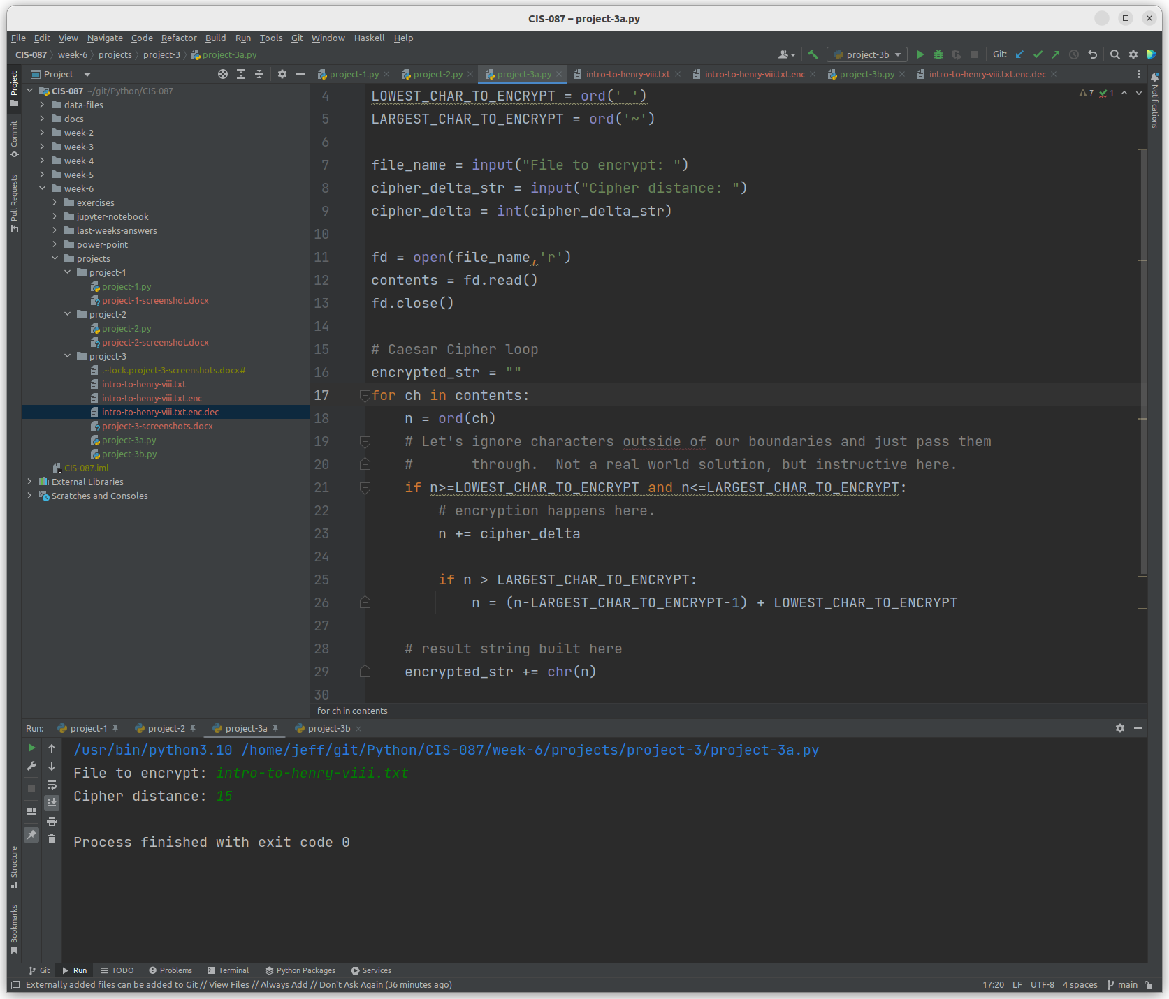

The file that was encrypted begins as shown here:

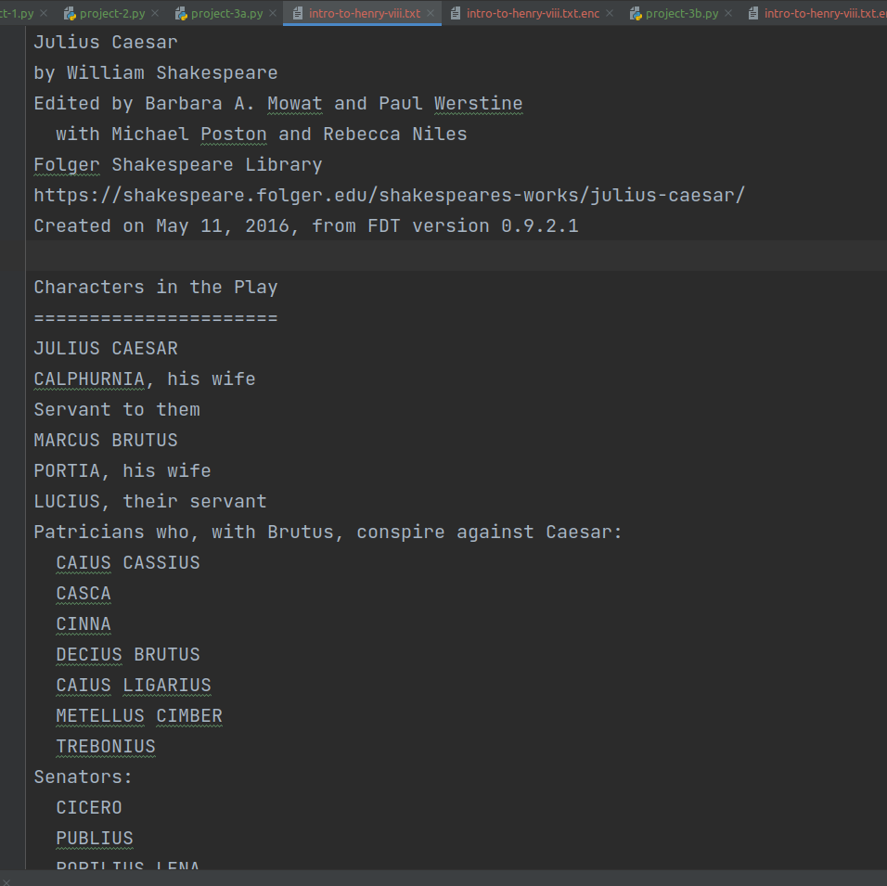

The saved encrypted file begins like this:

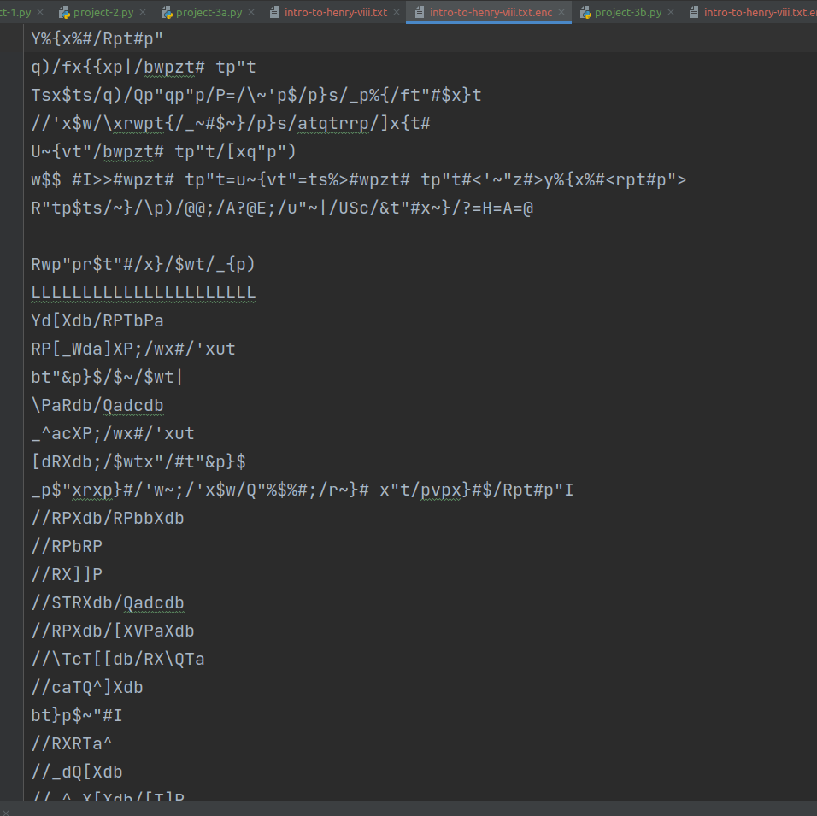

Here is the decryption routine in action. Again nothing exciting because the work is written to the disk.

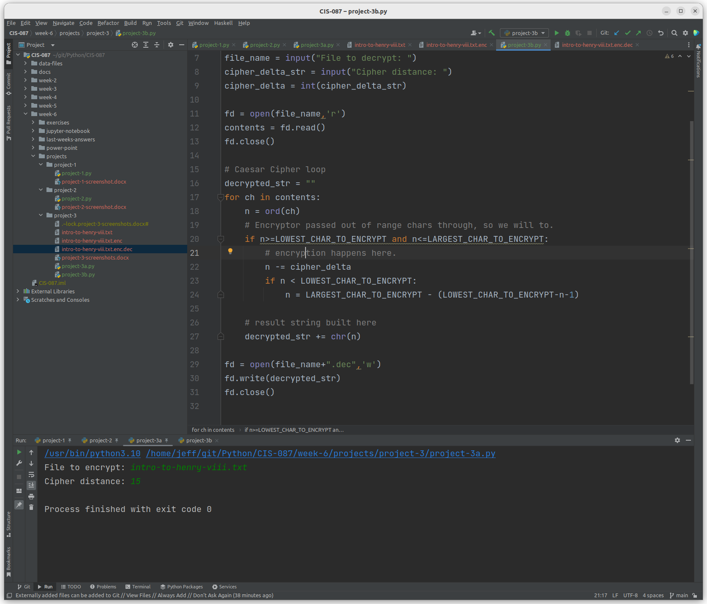

And the contents of the decrypted version of the encrypted version.

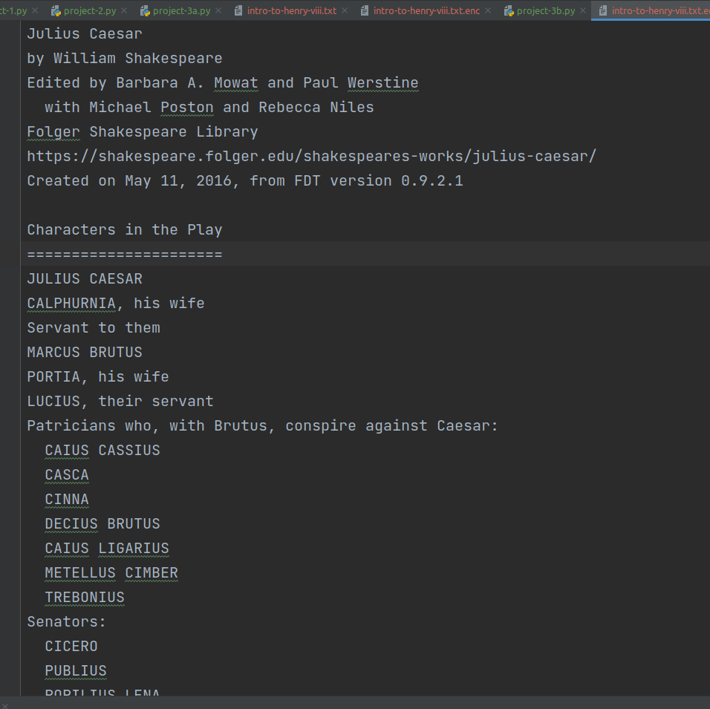

In most situations, it is important that the original file and the decrypted file are exactly the same. Time to check with diff.

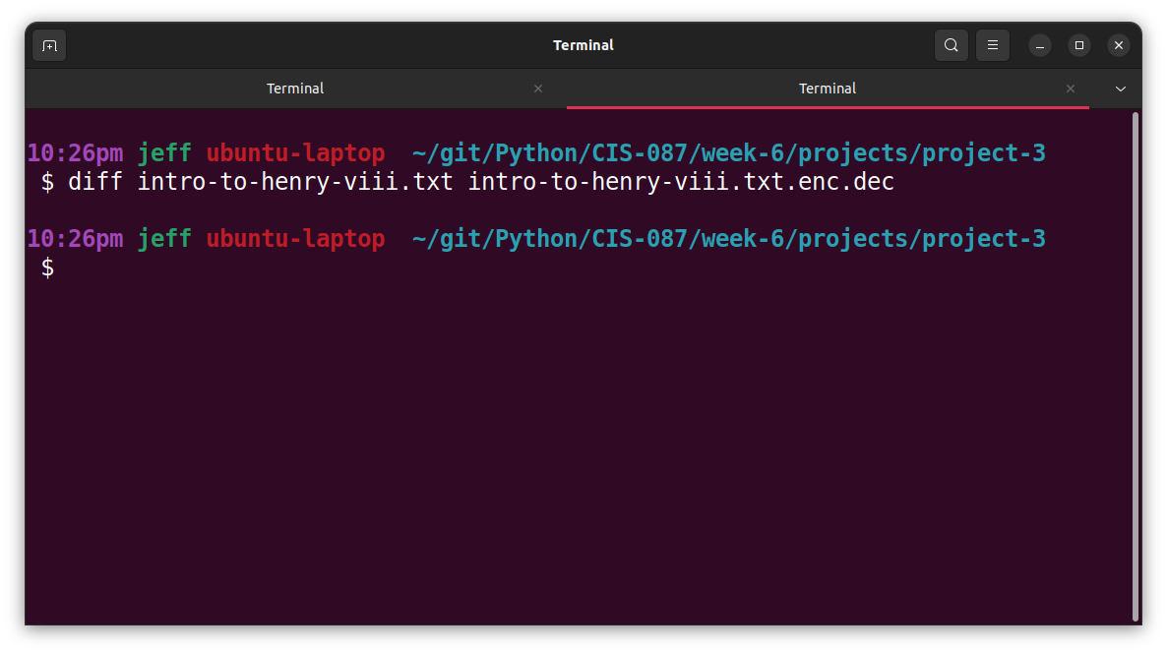

Looks good.