Step 1: Write mode function:

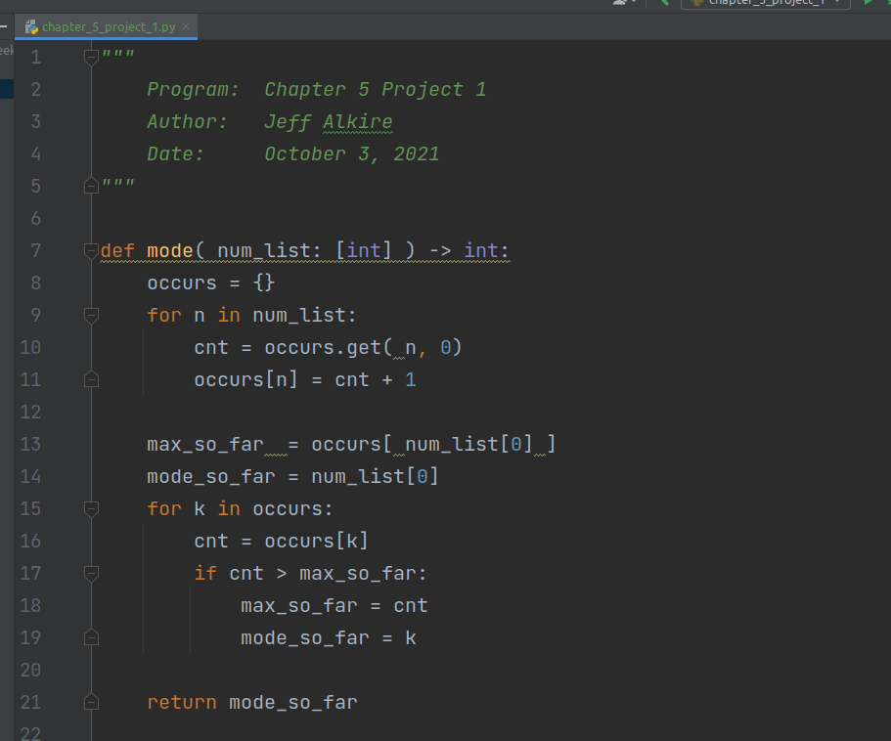

Step 2: Write median function:

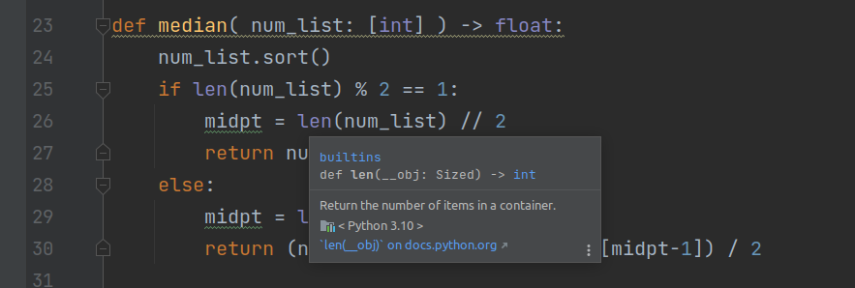

Step 3: Write mean function:

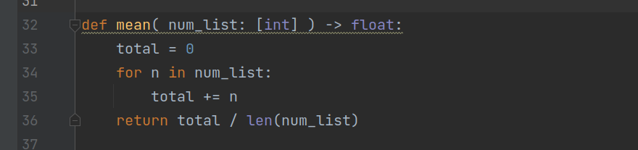

Step 4: Write main function:

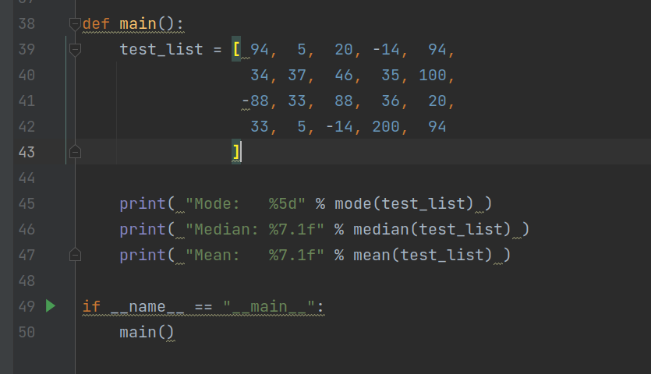

Step 5: Execute

