This was my favorite assignment so far. Modifying existing code is so FUN.

==============

WRITE THE

==============

Anyway, here is what I did:

(1) copy generator.py from the student data disk to my working directory and rename it chapter_5_project_3.py.

(2) Add to the current file comment header:

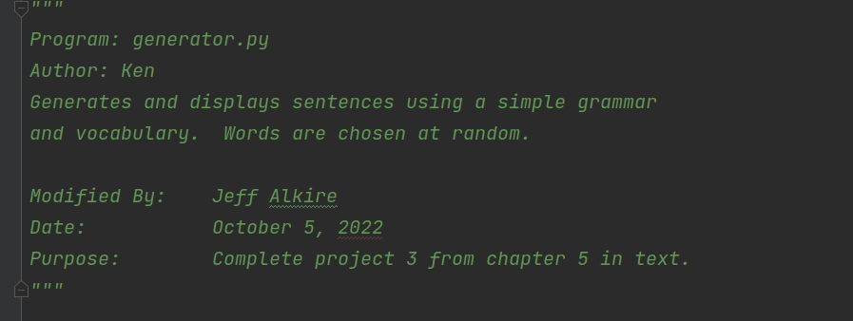

(3) Create the function suggested by the assignment:

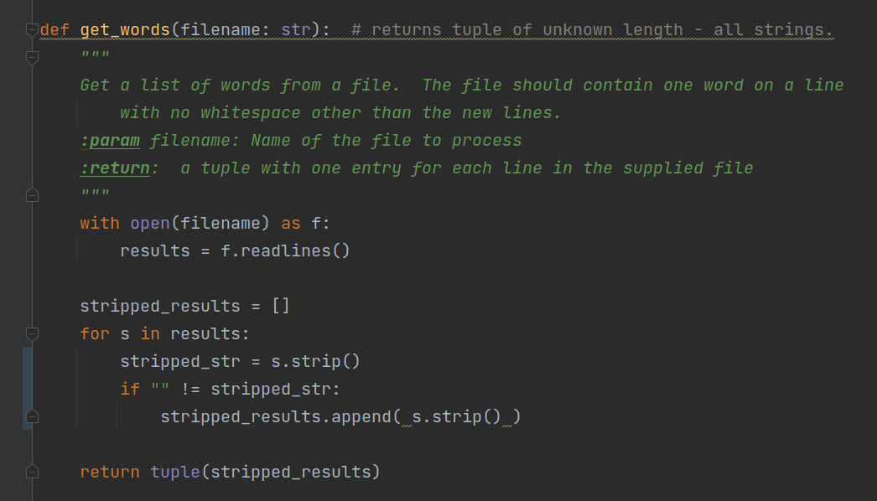

(4) use the function to initialize the articles, nouns, verbs, and prepositions global variables:

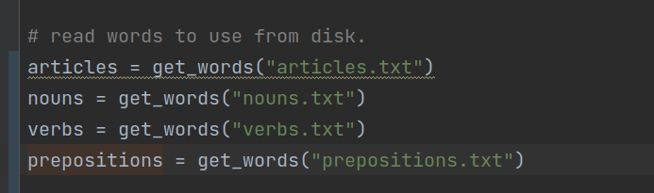

================

TEST THE CODE

================

(1) Execute the program and supply a relatively large number (10) and verify the results.

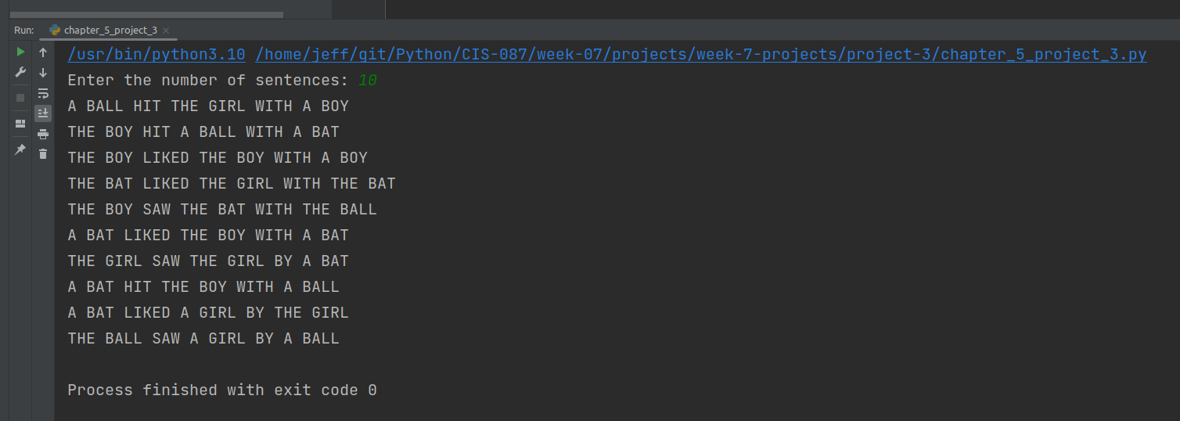

(2) Add values to the lists and test again:

