**USE CASE DOCUMENT**

This document gives direction for use of the CIS-087 Python midterm project submitted by Jeff Alkire.

Using this program requires a setup and an execution step.

SETUP

Note: instructions are given for use with Ubuntu Linux version 22.04. Changes may be necessary if you are using a different version and/or Operating System.

The setup phase of using the episode_posters.py program on Ubuntu Linux is as follows:

1. Open a bash shell.

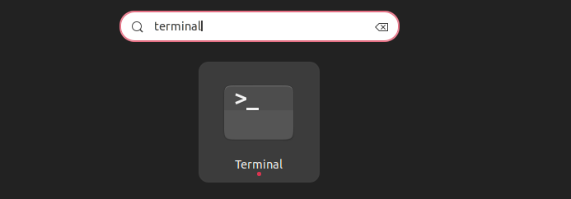

1. Move to the directory the episode_posters.py file is located in.

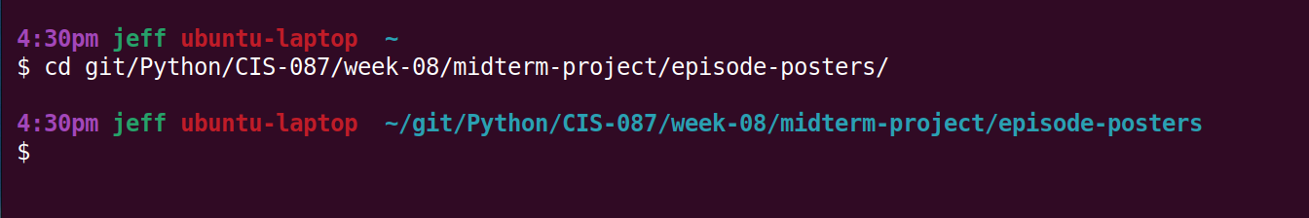

1. Using your favorite editor, edit the directories.txt file. Make sure it includes one line for each directory you want the program to traverse. Each line must be ended with a new line character.



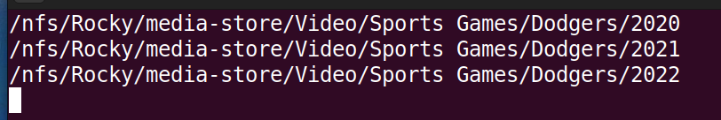

1. Setup is now complete.

EXECUTION

1. Ensure python is in your path. This can be accomplished be executing the command:

python -c ‘print(“hello”)’

Note that the command may be python3 on some systems.

1. If python is not in the path, install it to your system, or add it to the path. See your system administrator for more information.
2. Execute the episode-posters.py file with the following command:

python episode-posters.py

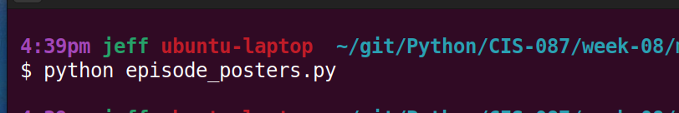

1. You will now see the output from the program indicating the .jpg files that have been added to the directories from the directories.txt files. If all files include as associated .jpg file, then there will be no output from the program.