Here is a screenshot for chapter 6 project #3 showing it working.

It calculates the square root of 50 and then 65 correctly according to Python’s math module. Once a blank answer is returned, the project exits.

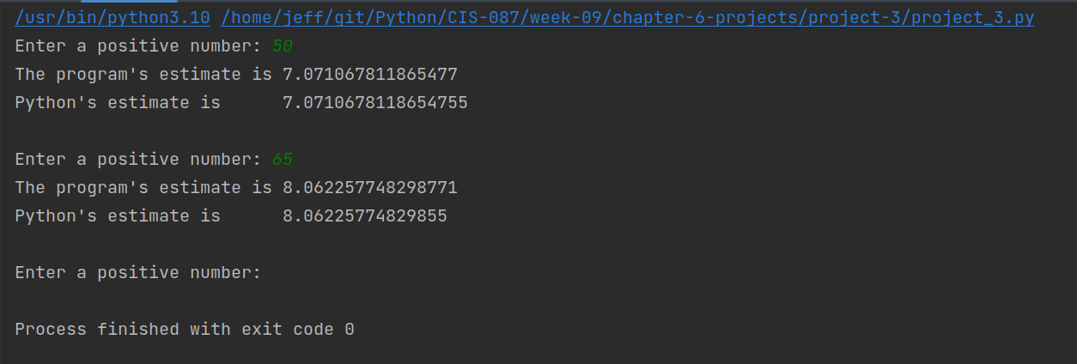

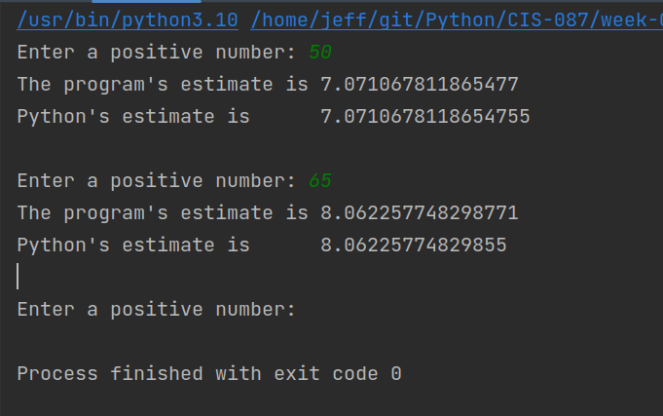

Also note that line 44 does not include an estimate in the function call as per the instructions.

