Chapter 7 Project 1 Screen shots:

Here is the final result. It shows the x and y axes and a circle of radius 50 centered at (50,-50). Note: if the circle looks skewed it is due to stretching in an effort to have the axes show. If either of the axes are not visible, there is a close up at the end of this article or the image can be enlarged to full size.

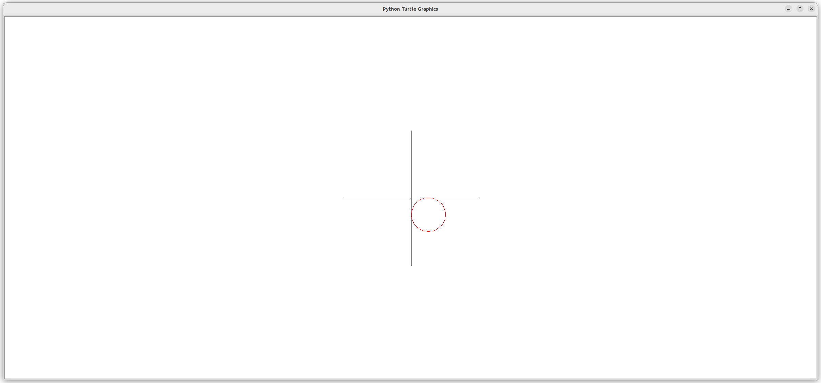

**Step one**: create a method that moves the turtle to the proper location to begin drawing a circle. This will be at 0 degrees which will start RADIUS units to the right of the CENTER. Special care must be taken not to draw during the movement to the start location.

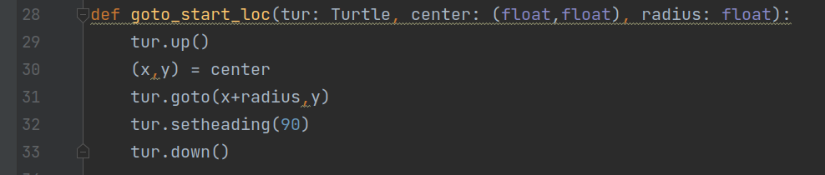

**Step two**: create a method that will calculate the distance for the turtle to move for each of the 120 “sides” of the circle. This formula is given in problem definition.

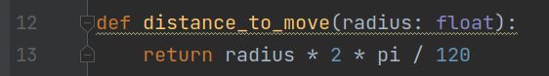

**Step three**: create a method that will draw the circle making use of the previously written functions.

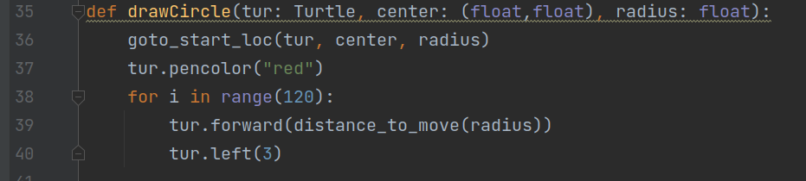

**Step four:** create a main function that will draw the circle.

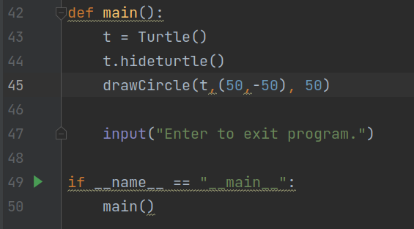

**Step five:** In order to show the correctness of the function, we need to see the axes. So, I created a method to draw the axes and added a draw_axes function call to main().

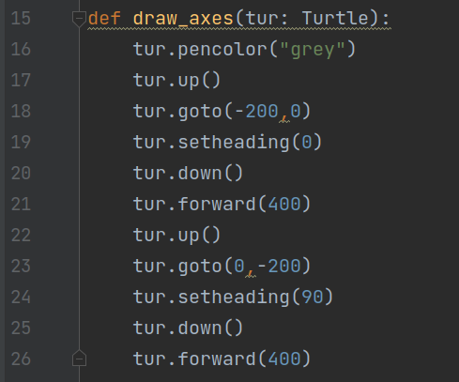

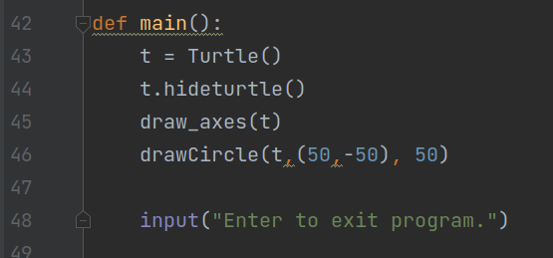

**Step Six**: Run the program one last time to ensure all is well:

