Chapter 7 Project 2:

Final result:

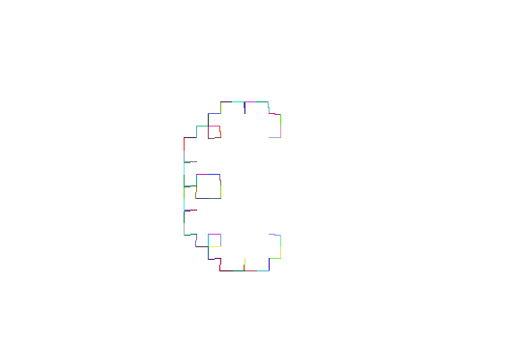

**Step one:** create a function to return a random color in the form of a (r,g,b) triple and add a call to pencolor to set the colors:

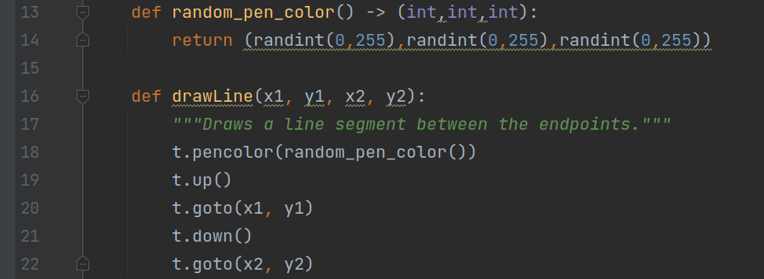

This did not work on its own. It returned an error:

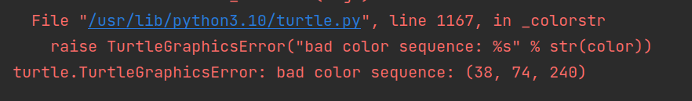

After a little research, I found that by default, pencolor expects the r, g, and b values to be a float between 0 and 1. In order to use integers from 0 to 255 like I expected, a call must be made to the colormode method in the Screen class to change to colormode to 255.

**Step two:** initialize the colormode to 255 in the main() function so that the colors will be accepted the way I expect.

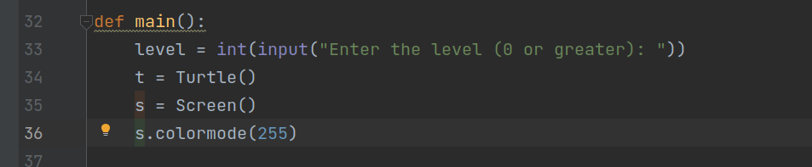

**Step three**: run the program and supply the value 6 to the “Enter level” prompt. Here is the result. Notice the color of each line is randomly chosen.

