Chapter 7 Project 3

Final result: Level 6 Koch Snowflake drawn by my program.

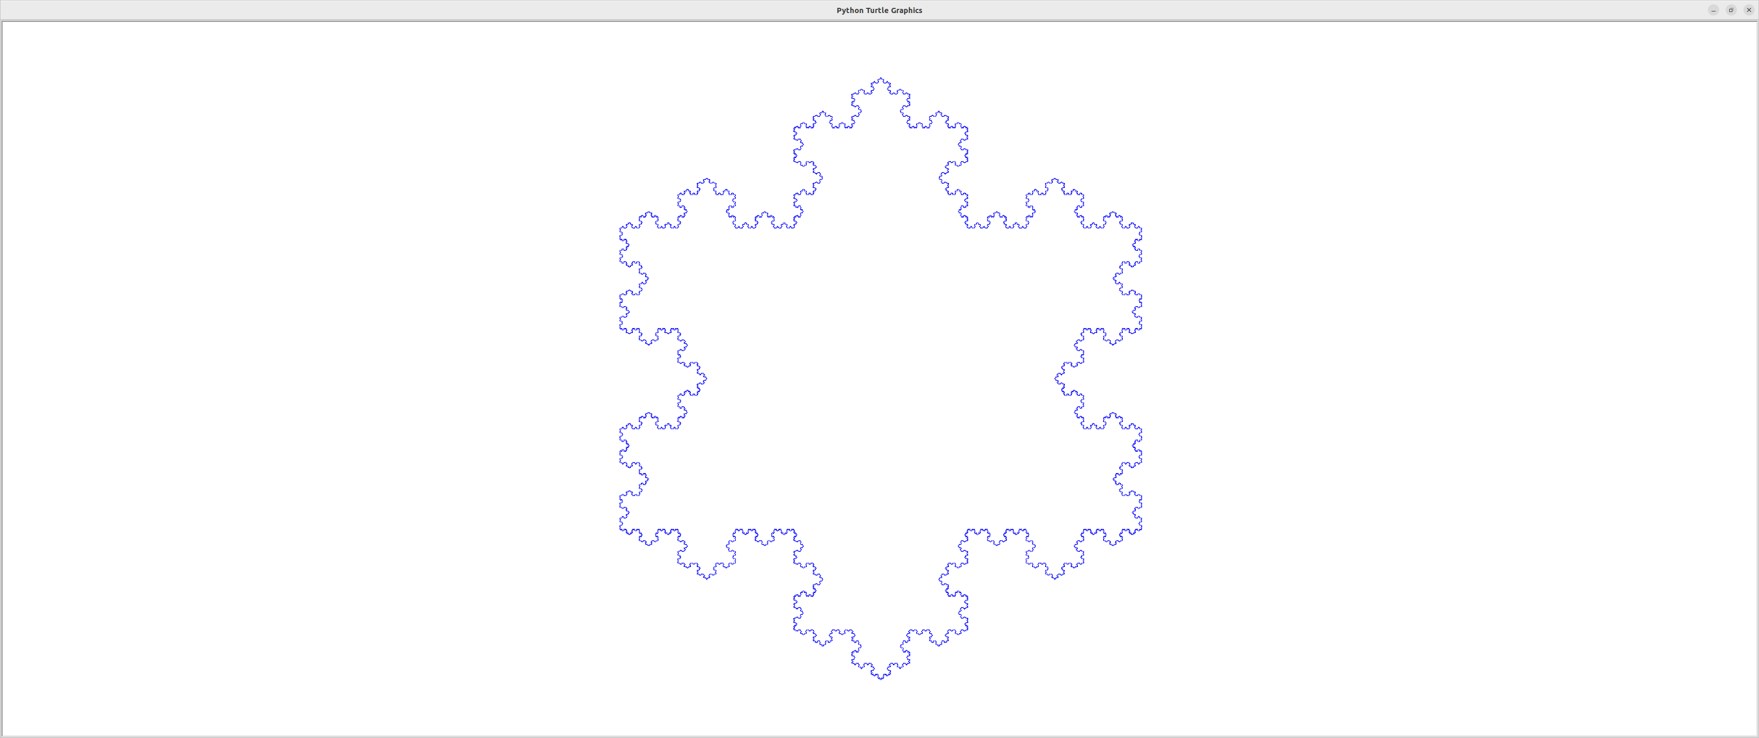

**Step 1:** Create file level comments, import the turtle object and create some constants to make it easy to modify the snowflake drawn. Note that we could take these as command line parameters or request the user to enter the values, but for simplicity, I went with this route.

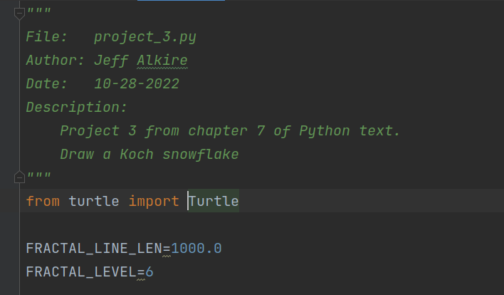

**Step 2:** Initialize the turtle graphics object. We will hide the turtle “cursor”, go as fast as possible, and set the pen color to blue as blue makes me think of winter. Then we will move our starting point from the origin of the axes to a location that will best center large snowflakes on the screen.

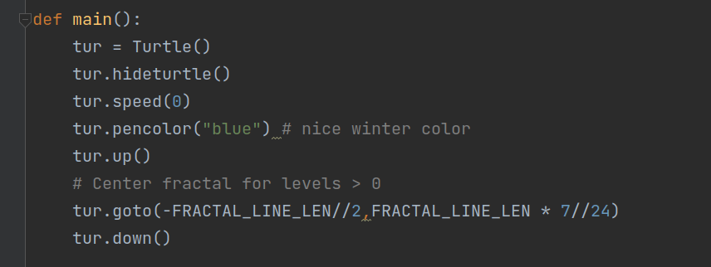

**Step 3**: Create the base case for our recursive fractal function.

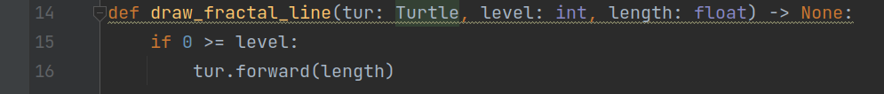

**Step 4:** Complete the main function by adding 3 calls to the recursive draw_fractal_line function. Each line is 120 degrees right turn from the previous line.

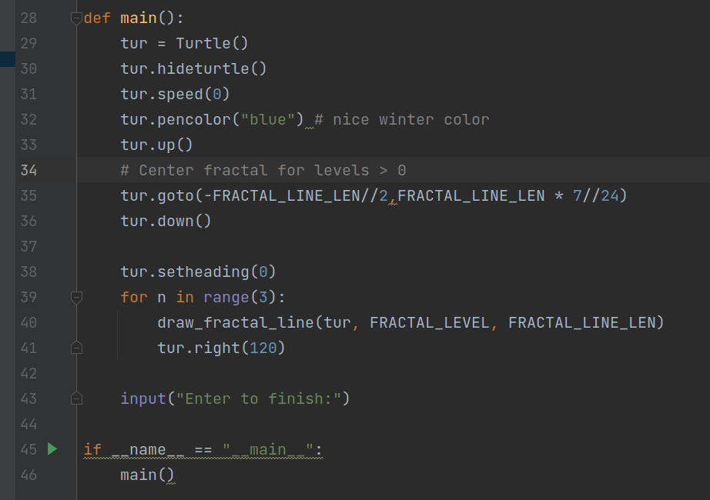

**Step 5**: Complete the recursive function by adding the standard case. This case draws 4 instances of the fractal one level lower than the current level. The left and right turns did require a little trial and error because I forgot the fourth line, but it was quickly figured out.

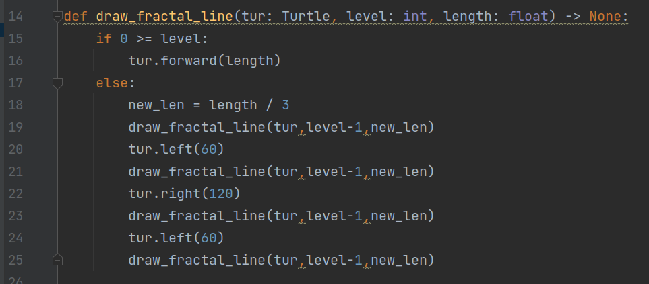

**Step 6**: Execute the program and enjoy the snowflake as it is drawn.

