Chapter 8 Project 1

Step 1: Create program “header” with comments and imports and constants.

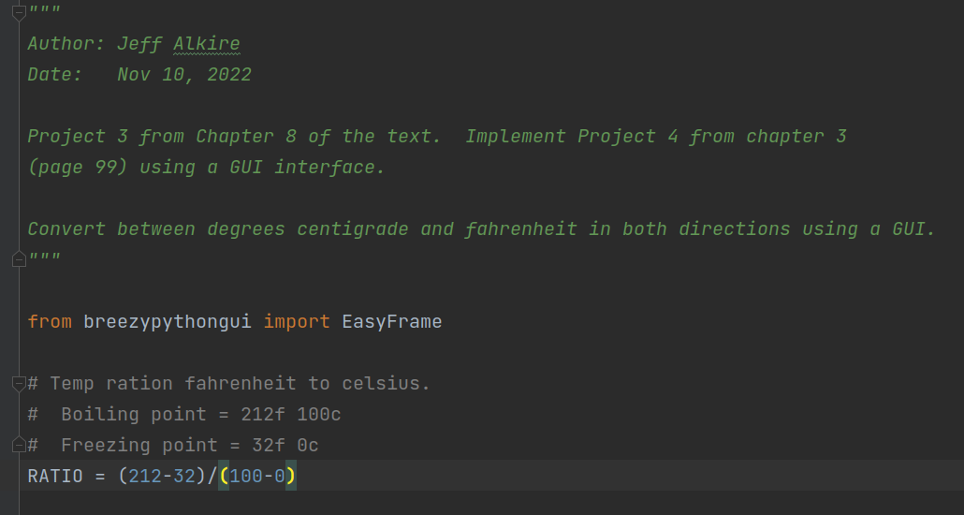

Step 2: Create main function:

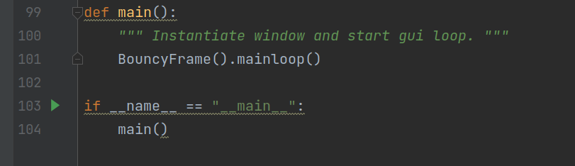

Step 3: Create and add widgets to the window as shown in text.

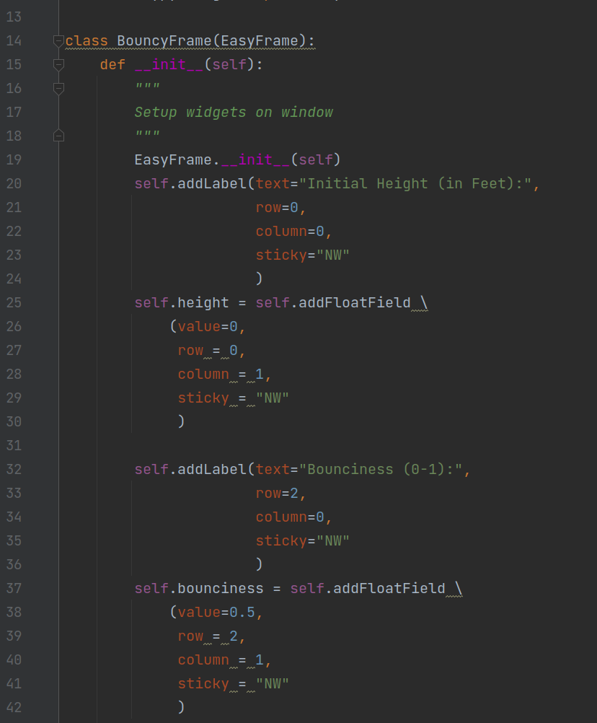

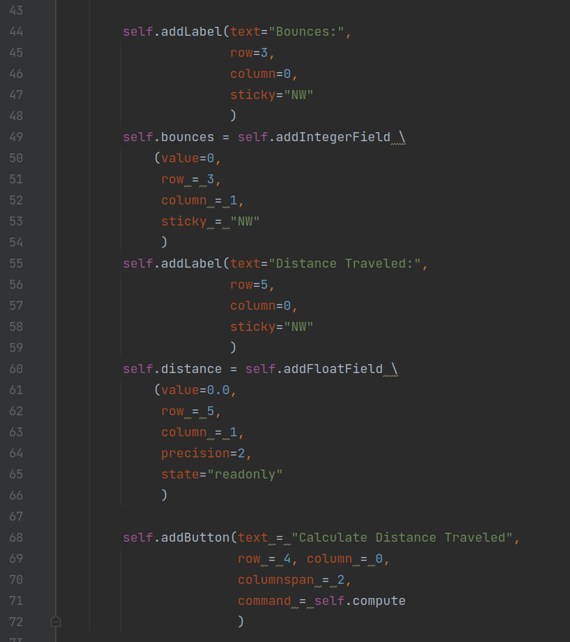

Step 4: Write compute method to update the tax output box when the compute button is pressed:

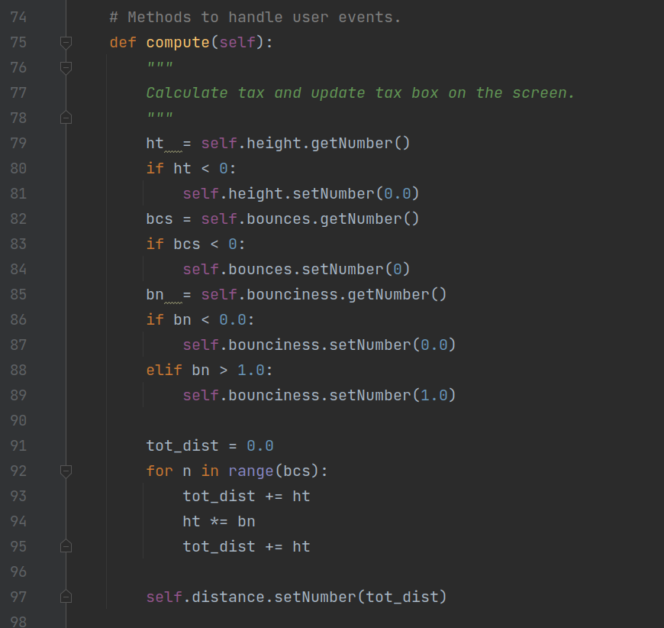

Step 5: execute program and see results:

