Chapter 8 Project 1

Step 1: Create program “header” with comments and imports and constants.

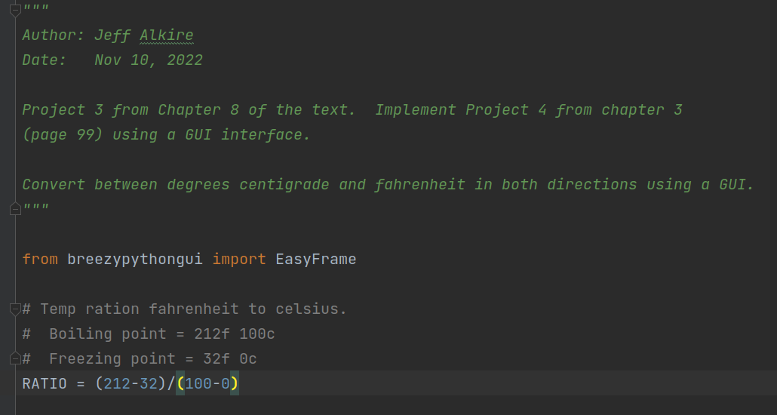

Step 2: Create main function:

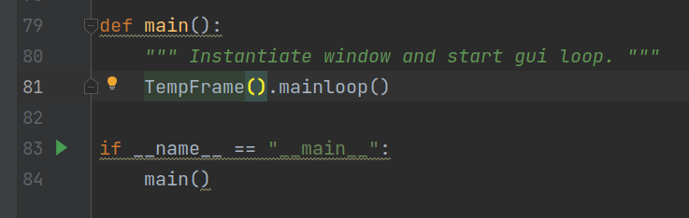

Step 3: Create and add widgets to the window as shown in text.

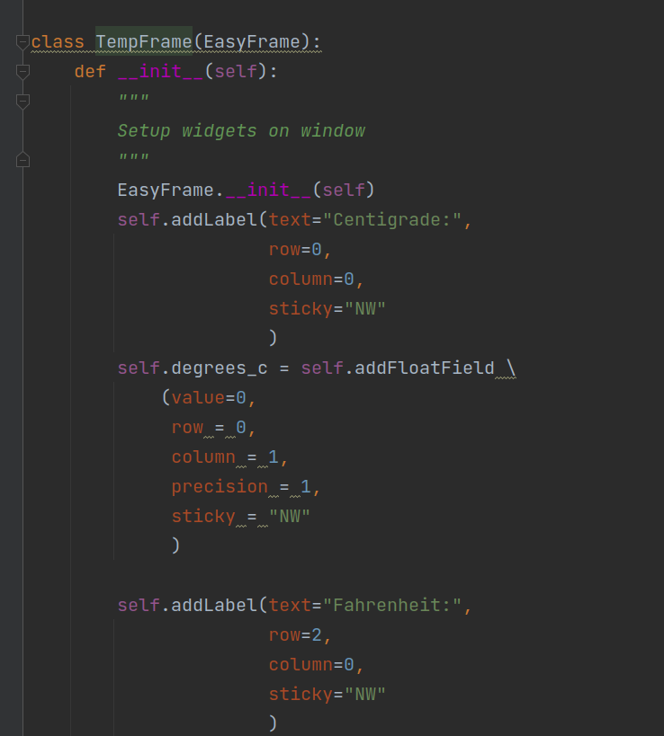

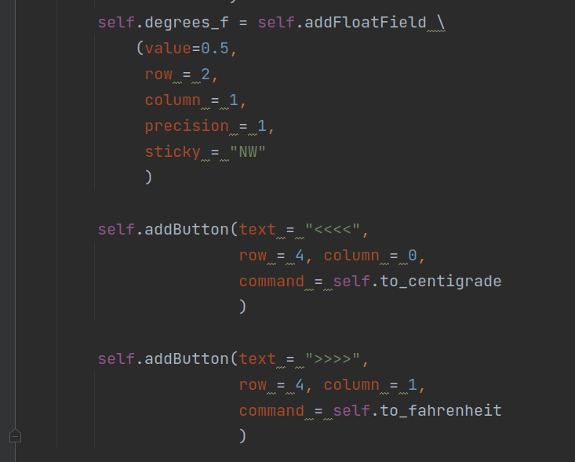

Step 4: Write compute method to update the temps on the screen:

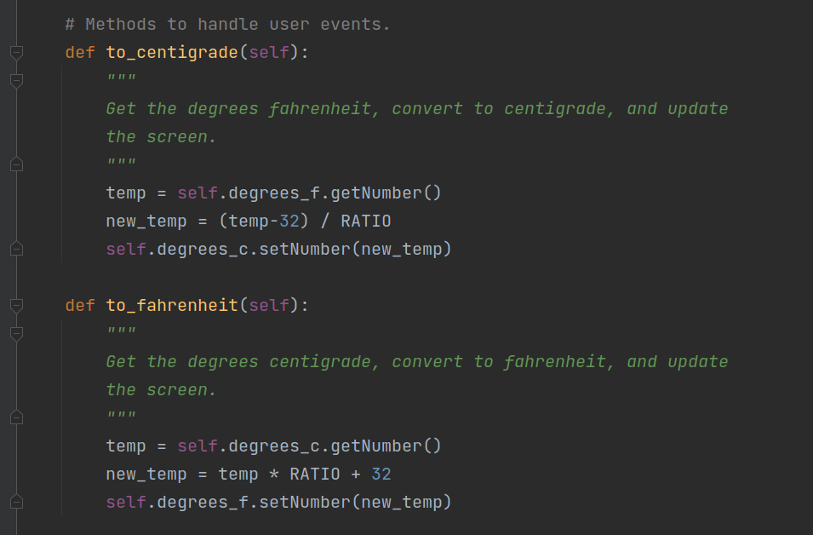

Step 5: execute program and see results part A (from Centigrade to Fahrenheit):

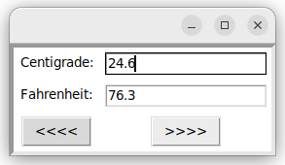

execute program and see results part B (from Fahrenheit to Centigrade):

