Chapter 9 Project 1

Step 1: Modify student.py from text’s data disk by creating comparison functions (__eq__, __lt__, __ge__)

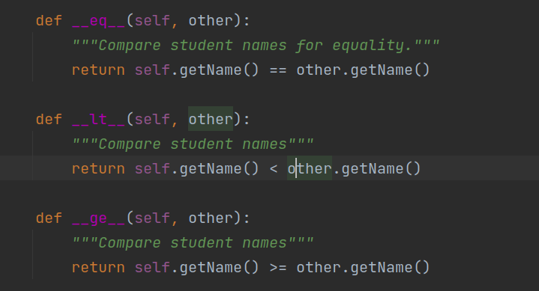

Step 2: Create a helper function to make displaying tests easier.



Step 3: Update main function to include a test for each comparison operator (==, >, <, >=, and <=). This requires creating a second student object. While I generally compared the 2 students, occasionally compared a student to itself to ensure the methods worked on equality properly as well.

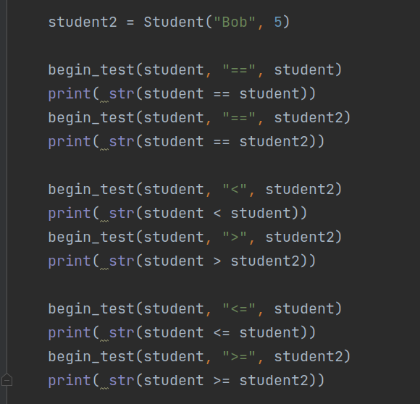

Step 4: Execute and check results

