Chapter 9 Project 1

Step 1: Modify student.py from project 1 by adding a make_student function as we will need to create several students.

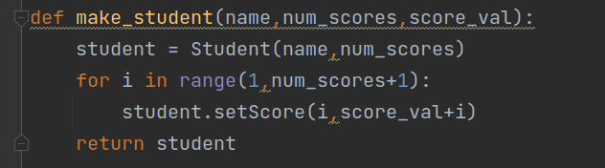

Step 2: Create the student objects in main()

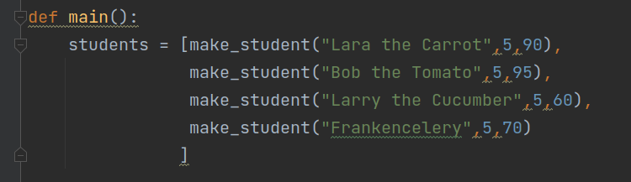

Step 3: Create a print_list function to display the student list.

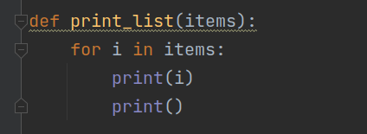

Step 4: Shuffle the list and print the results

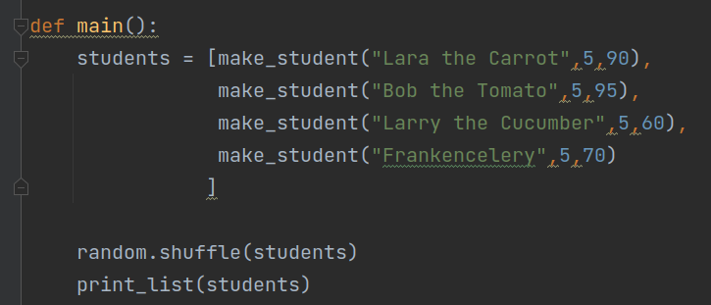

Step 5: Execute and verify all is well.

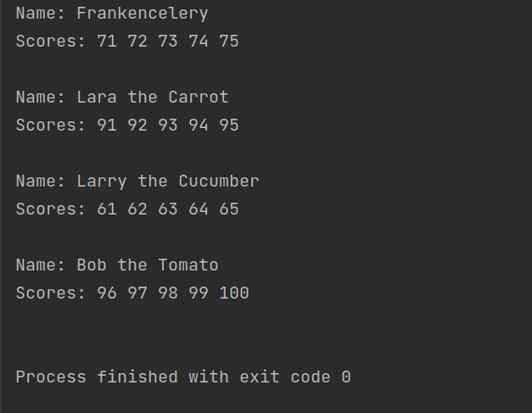The order of the list has changed, so this worked well.

Step 6: Add a separator, sort the list, and print the newly sorted list.

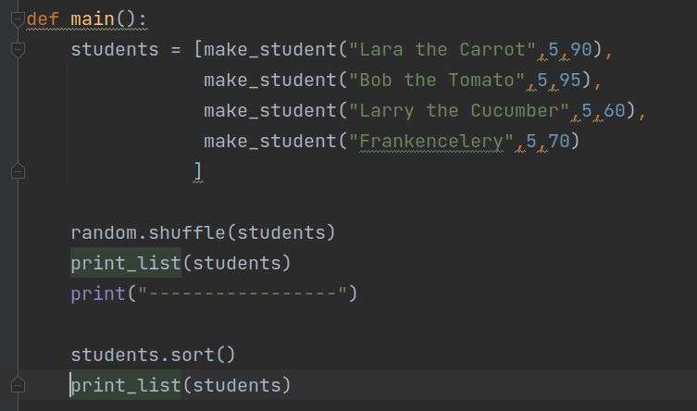

Step 7: Execute again and verify.

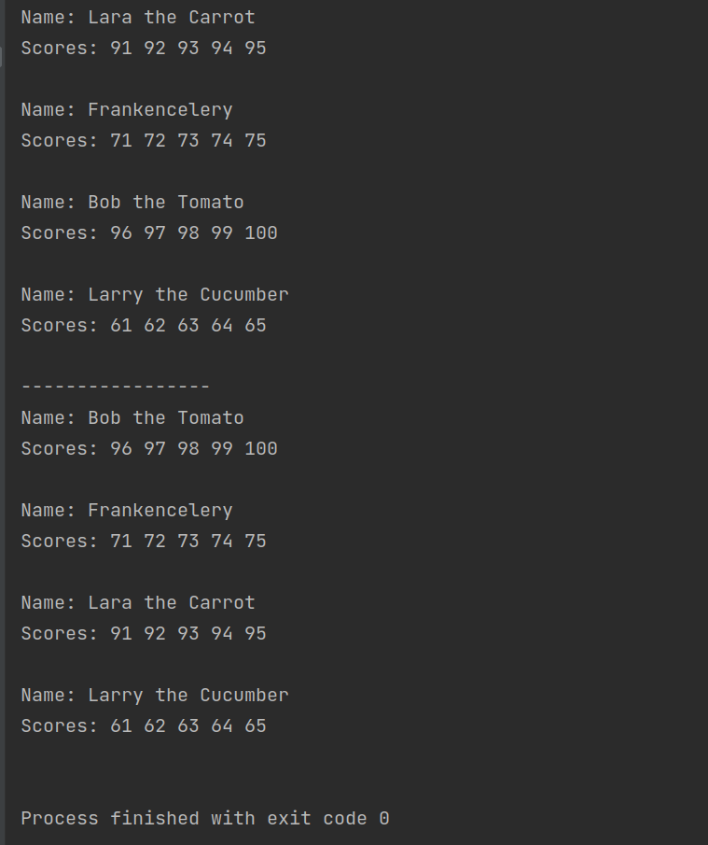

Before the separator things are in a random order. Afterwards they are sorted! Yippee! We have done it.

Step 3: Update main function to include a test for each comparison operator (==, >, <, >=, and <=). This requires creating a second student object. While I generally compared the 2 students, occasionally compared a student to itself to ensure the methods worked on equality properly as well.

