Chapter 9 Project 4

Step 1: Copy atm.py, bank.py, savingsaccount.py, and breezypythonguil.py from the book’s data disk into a working directory.

Step 2: Modify atm.py to add instance variable to track the number of login fails.

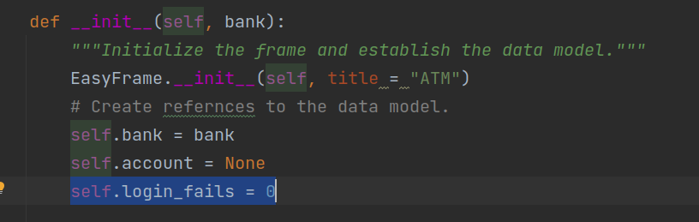

Step 3: Add a class level constant indicating the max # of login fails allowed.

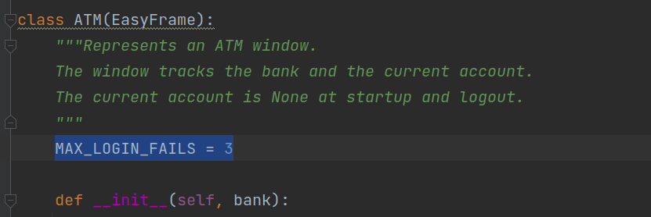

Step 4: Modify code to handle a failed login differently

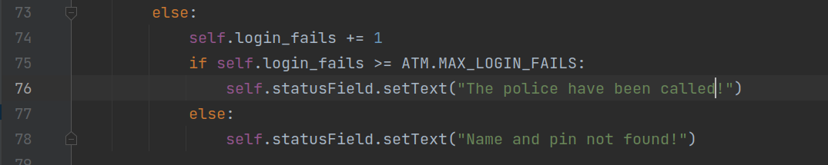

Step 5: Clear fail count when a successful login is found.

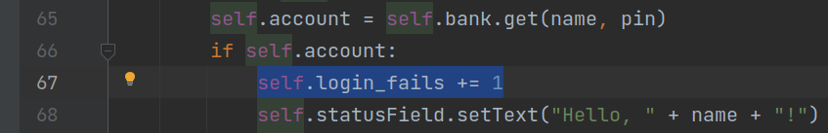

Step 6: Run and test program.

