Chapter 10 Project 2

Step 1: Copy the files timeclient.py and timeclienthandler.py to a working directory. You may want to also copy timeserver2.py depending on how thorough you want to be.

Step 2: Update timeclient.py to handle ConnectionRefusedError.

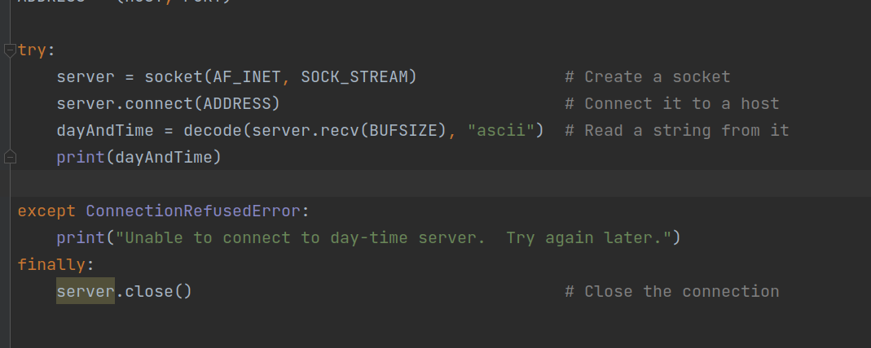

Step 3: Execute code and ensure nice message is printed and not an ugly error message. Note: do not start the timeserver or the error may not occur.

