Chapter 10 Project 3

Step 1: Copy the files timeclient.py, timeclienthandler.py, and timeserver2.py to a working directory. You may want to use the updated version of timeclient.py from project 2.

Step 2: Update timeserver2.py to include the code into a Listener class that is a subclass of Thread.

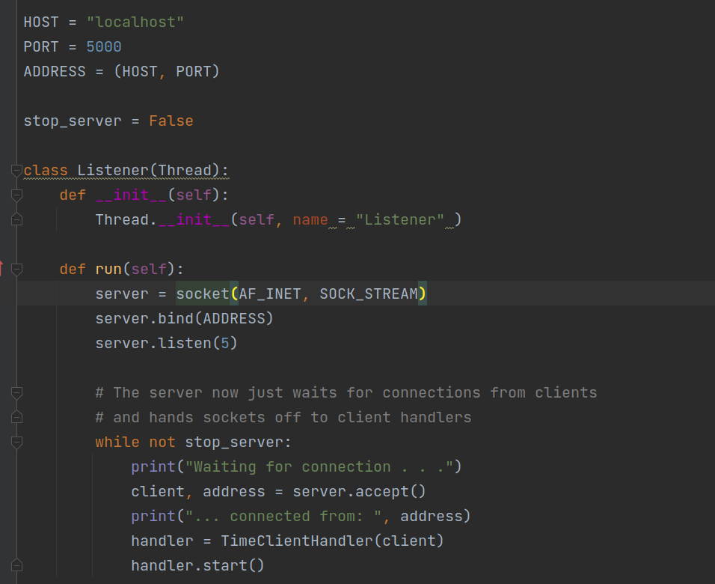

Step 3: add a second Thread class to monitor stdin for a carriage return.

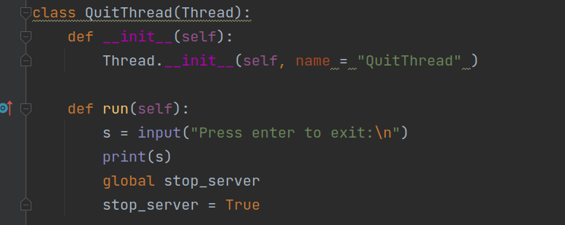

Step 4: Create a main function that starts the threads.

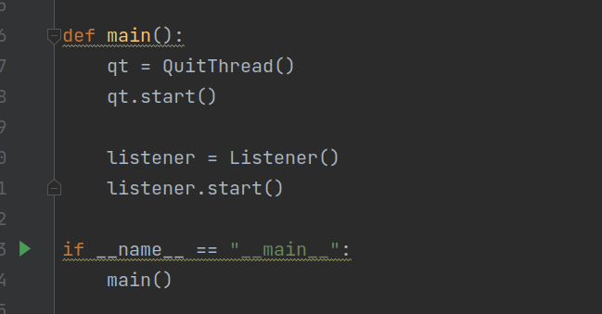

Step 5: Execute and test the server.

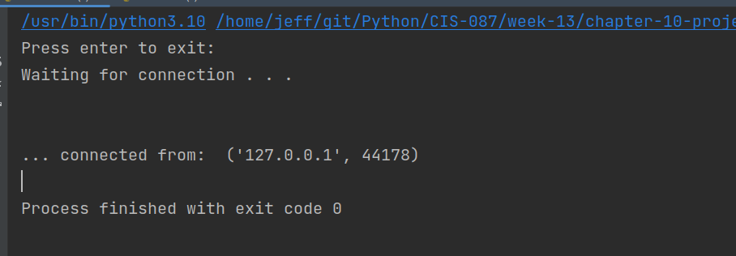

Note that the server process finishes and exits.

Step 3: Execute code and ensure nice message is printed and not an ugly error message. Note: do not start the timeserver or the error may not occur.

