**Chapter 11 Project 1**

Step 1: Create new modified sequential search routine

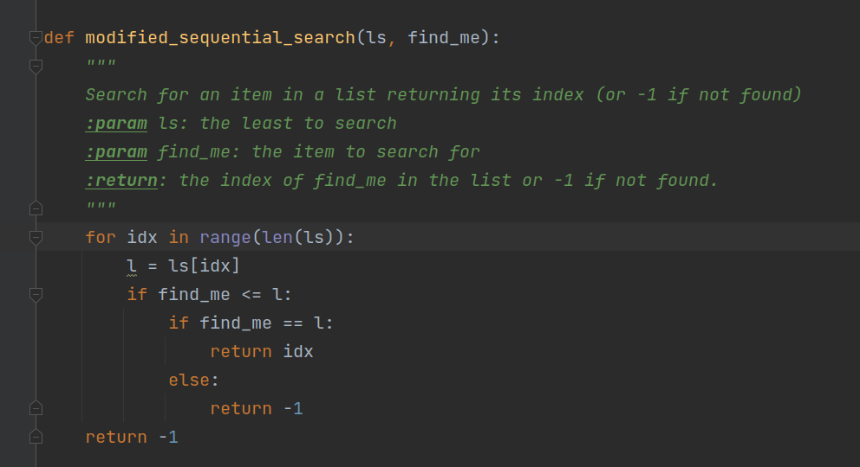

Step 2: Write code to test algorithm.

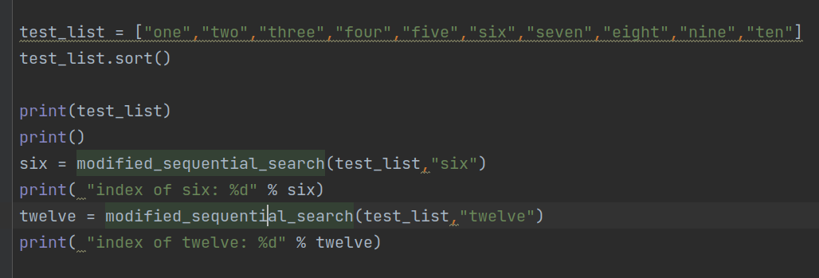

Step 3: Execute code to test algorithm

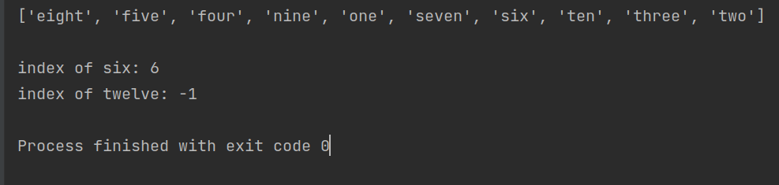

Step 4: Discuss computational complexity of best, worst, and average cases.

Best Case: If the item matches the first item or precedes it, then the routine returns after 1 examination. This is **O(1)**.

Average Case: On average, the search should search about ½ of the list. This is time complexity of ½ n or **O(n)**.

Worst Case: In the worst case, the entire list is searched without finding a match. This is time complexity of n or **O(n)**.

a